About :   
  
Flipkart is an E-commerce website/Virtual shopping store covering all the needs of people from groceries, Home appliances, clothing, Electronics and Electricals, Makeup kits, Sport kits, Stationaries,Toys to much more   
  
Objective :  
  
To Create Flipkart website and to establish the Webpage navigation for one product catrgory end to end using 3 tier architerchtural MERN Stack Development  
  
Tools used :  
  
1) Front end development : Client side   
   
 HTML | CSS – Bootstrap | JS - ReactJs  
   
2) Back end development : Server side  
  
 Node Js – Express JS   
  
3) Database :  
  
 MongoDB  
  
4) Server :   
  
 Node JS   
  
Project link :  
  
  
Porject details :  
  
Chosen product category : Mobile phones | Chosen Brand : Realme   
  
Site mapping :  
  
The site is structured in the following manner   
  
1.) Home page   
2.) Product categories page   
3.) Product List page  
4.) Product details page   
5.) Add to cart page   
6.) Buy now page   
7.) Payment page   
8.) Notification page

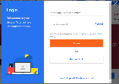 Web – Page flow visualization :

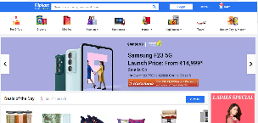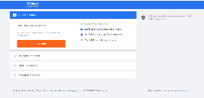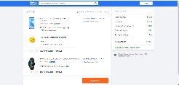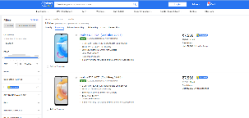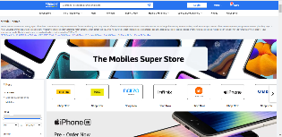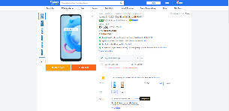

Webpage flow – Brief description :  
  
  
1) User clicks on Flipkart.Com in a browser and ends up in Home page  
  
2) In home page he/she selects one Major category   
  
3) On selecting one he/she lands in Product categories page where-in   
sub-categories/Brands, New launches in all brands etc...are displayed   
  
4) On selecting one brand, he/she lands in Product List page where-in a list of products of that brand is displayed   
  
5) On selecting one product, he/she is directed to the product details page where-in the product details are dispalyed   
   
 Here he/she has two Major options related to purchasing the product   
   
 a) Add to cart   
 b) Buy now   
   
6) On Selecting Add to cart he/she is directed to cart page where-in she can decide the quantity, place the order and get directed to Buy now page   
  
7) On Selecting Buy now he/she is directed to Buy now page  
  
8) Here after giving the necessary inputs on clicking the payment options he/she is directed to payment page   
  
9) After making the payment to keep track of her order there is a notification page wherein the current status of the product is displayed

Webpages In- depth :  
  
Webpages and major sections are mentioned below   
  
1) Home page   
 Header | Categories | New lanches, deals and offers | Footer   
  
2.) Product categories page  
 Header | Categories | Filters | Brands/ Sub – Category | Q n A | Footer   
  
3.) Product List page  
 Header | Categories | Filters | Product lists | Footer   
  
4.) Product details page  
 Header | Categories | Details | Images | Cart and order | Footer   
  
5.) Add to cart page   
 Header | Product list added details | Price detials | Footer   
  
  
6.) Buy now page   
 Header | 4 sub sections – Login / signup , Delivery address , Order summary, Payment options | Simple Footer |   
  
7.) Payment page   
   
8.) Notification page