**Folder Structure**

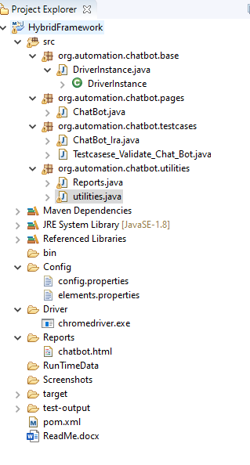

**This is Base package where all the driver instance will be declared**

**Readme file is placed inside the framework for easy accessable**



**Others: Maven dependencies POM and added so that future it can be expanded to mobile or any other technologies**

**Reports and Utilities**



**Modifications of reports** needs to be done here

**Utilities files :** Are for future updates/inclusions.

**All the elements to be declared as Plug and play in elements.properties– We can change without much effort.**

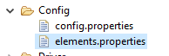

**All the configurations to be declared in config.properties– We can change without much effort.**

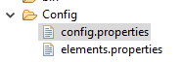

**RunTimeData** – In future this can be used to store the data dynamically and can be reused accordingly