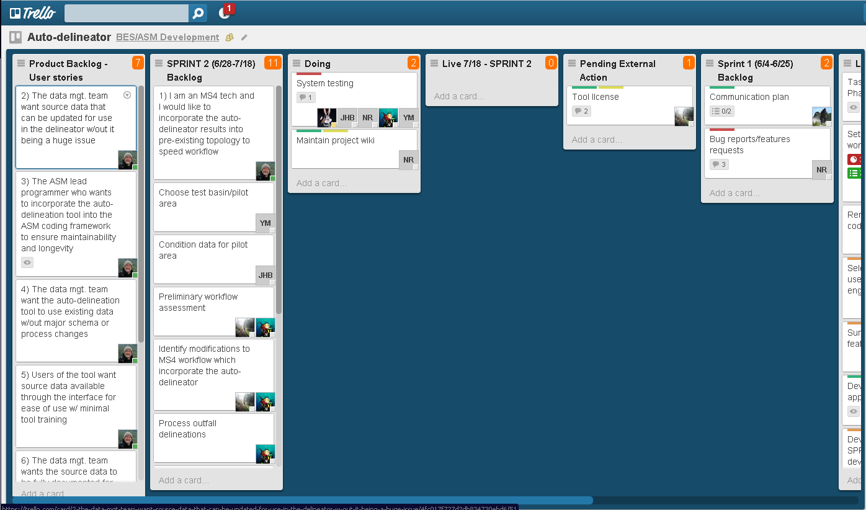
User stories
Tasks from planning meeting here for SPRINT 2
As tasks are worked on, they move here from the backlog
As tasks are completed, they move here
Older lists move right

