
ASM Auto-Delineator
Technical Overview
To | Delineator Development Team
From | Mark Liebe, Daniel Ashney
Date | May 31st, 2012
Project | Internal Order
Subject | Auto-Delineator Development - Technical Overview

General Description
ASM needs a tool to help it create surface water basin boundaries. Up until this point in time, most basin delineation has been done using manual methods, and have been done for a variety of programs and projects. The standards for such delineations vary across the different sets of basin delineations that the group currently uses and maintains. The types of delineations include Explicit Model combined surface sub-catchments, MS-4 drainage basins, and UIC drainage areas. With the advent of a fourth set, stormwater drainage areas for System Planning, the problem of disparate drainage boundaries becomes all the more pronounced. There have been several attempts in the past to reconcile the differences between these data sets, but the effort involved to complete this has been beyond the reach of the group due to time constraints.
Automation of basin delineation has been employed through time by Systems Analysis to help improve its basin delineations, but that has proven difficult to implement in a consistent and easy way. The data has also improved substantially, and not all of the tools have been able to keep up with that. This project is intended to reevaluate the potential for drainage basin auto-delination, and if found feasible, it is hoped will lead to a first step in the development of a more robust and easily applied tool.

Objectives/Proposed Features
These are general statements from a preliminary planning meeting among some members of Systems Analysis. These have not been prioritized.
- Ability to trace through conveyance networks and over surface drainages
- Bi-directional, either starting at an outfall or collection point, or identify the top of a surface drainage boundary and then converge flow to an outfall/inlet point
- Provide for stop points and pipes for system traces
- Be able to specify max/min basin sizes
- Run in batch or interactive mode.
- Fast enough processing speeds to be useable in interactive modes
- Ability to specify varied data sources – either conveyance networks or terrain data sets
- Open architecture and licensing, with access to commented source code
- Ability to add future functionality
- Provide for flexibility in output
- Tool deployable to ASM end users
- Push button interface
- Leverages existing tools, where such makes sense and is cost-effective

Available Tools
EMGAATS basin tracing tool (Arnel Mandilag) - attribute based tracing routine for compiling basin models for the EMGAATS system using links and node connectivity. Creates analysis ready modeling packages in a variety of formats, including Microsoft Access, XP-SWMM data files, and MapInfo GIS files. The system currently is written in MapInfo’s MapBasic.

ArcMAP Model tracer (John Burns) – attribute based model element tracing routine. Builds a selection set of model links based on ending and starting trace points. Currently works within ESRI ArcMAP using the model links database. Probably documented explicitly – see John.

Hydrology portion of the ESRI spatial analyst toolbox (Daniel Ashney)
The ESRI-based process employs a combination of Spatial Analyst “Watershed” tools and geometric network trace capabilities. The overall concept would involve an upstream network trace from user generated start point(s) that would terminate at inlets. These inlets would be tagged with a “trace ID” and would then be the inputs for the topographic watershed delineation. The trace ID would allow figures (area, etc) to be aggregated to the trace results.
The Watershed tools comprise a fairly established process to prepare the elevation source data and create the necessary inputs. There are relatively few places (sink fill depth, pour point snapping distance) within the process where user input would be required.
The network component presents some challenges in connectivity as well as automation. At Arc 10.1 some network python scripting objects have been added but that doesn’t help us here and now. At Arc 9.3/10 it seems all automation will be created from scratch. Data connectivity issues will also need to be resolved as Arc traces are geometry based. Multiple data sources (master links, DME) that are not synced confound the issue.

Rainflow LiDAR flow accumulation routine (Issac Gardner) - Elevation tracing system using SQL procedures. Independently identifies basins and flow paths. Requires pre-processing of LiDAR data into SQL data tables for current operation. See Issac for details.

Stormwater conveyance tracer (Albert Tabino) – tool to trace up through stormwater conveyance networks, and when at terminus it will, where possible, search for nearest neighbor conveyance networks most likely upstream tributary stormwater conveyance networks. See Albert for details.

Urban Catchment Delineation (DHI/ Arnold Engelmann) - Geometry based trace. Provides push-button interface for Arc Hydrology tools along with a few custom bells and whistles. See \\cassio\ASM_Projects\Delineator\DHI_tool\UrbanDelineation_120910\Urban Catchment Delineation Tool.pdf. (Note the numbers in this directory may change as new versions are uploaded.)

Tool Assessment
The DHI Urban Delineation tool has already been shown to successfully capture a majority of the initial project features therefore an in depth assessment of all previous tools (when we already know their general limitations) would be unnecessary.
The DHI Urban Delineation tool will be the basis for further development therefore it will be reviewed by invested members (UIC, MS4, etc) and additional features/ changes will be proposed. The proposed features will go into the development plan.

Potential Source Data
Network Trace

BES Collection System (DME) nodes - EGH_PUBLIC.ARCMAP_ADMIN.collection_points_bes_pdx
BES Collection System (DME) pipes - EGH_PUBLIC.ARCMAP_ADMIN.collection_points_bes_pdx

Note – various definition queries are employed to subset for sanitary/ storm, inlets, etc

Modeled nodes - EGH_PUBLIC.ARCMAP_ADMIN.mst_nodes_bes_pdx
Modeled pipes - EGH_PUBLIC.ARCMAP_ADMIN.mst_links_bes_pdx

Topographic Delineation

Bare Earth, Lidar- Derived 3’ resolution DEM - EGH_Raster.ARCMAP_ADMIN.LIDAR_DEM_2012

Data Caveats
DME pipes and nodes – sometimes inconsistent attribution (Type eg upstream pipe ends can be Trash Racks, Inlets, Open Ends, etc) and geometry not always snapped
Modeled pipes and nodes – source does not contain inlet nodes or leads but is perceived to have better connectivity
Digital Elevation Model – can be unwieldy in file size causing long processing times; sub-setting the DEM could be run beforehand for a set of known, expected extents (e.g. watersheds/ subwatersheds) and/ or clipped as a feature of the tool

Data Preparation
The network input data and elevation model will need to be preprocessed in preparation for use in the DHI tool. Network prep will entail sub-setting/ creating features based on the tool specified inputs as well as user specified ways of categorizing the data. Both pieces can be automated, either within the DHI tool or by using separate database queries.

DME (DCA) – based on the DHI tool requirements it will be necessary that features be lumped into 3 categories:
- Inlets – meaning all upstream nodes which provide access to the piped system. Facilities of type “Inlet” would be included but also Trash Racks, Open Ends, etc. These must exist as a separate feature class for input to the tool.
- Remove – Abandoned facilities, Sanitary system facilities, water way channels and nodes (WWJ, etc)
- Other – All other pipes and nodes that will participate in the geometric network (MHs, sumps, OFs, etc). These must exist as a separate feature class or classes for input to the geometric network but will also be used as manual user input for delineation targets. Note that the features included in the “Inlets” category may also be included in the “Other” category to be used as delineation targets. They do not need to be mutually exclusive.

Subset/ selection process (results need to be verified to ensure inclusion/ exclusion of correct features)

Point Features
Inlets – from Collection Points select
SYMBOL_GROUP IN ('INLETS', 'TRASH RACK', 'DISCHARGE POINTS')

Other – from Collection Points
LAYER_GROUP = 'STORM NODES' AND SYMBOL_GROUP not in ('WATERWAY FEATURES', 'NO ACCESS POINTS', 'DISCHARGE POINTS')

Linear Features
Inlet Leads – from Collection Lines select
LAYER_GROUP = 'INLETS' AND SYMBOL_GROUP NOT IN ( 'ABANDONED INLET LEADS', 'FRENCH DRAIN')

Storm Pipes – from Collection Lines select
SYMBOL_GROUP in ( 'STORM GRAVITY MAIN', 'STORM PRESSURE MAIN', 'CULVERT’)
All of these subsets would be included in the geometric network. However, only the Inlets are required as inputs to the tool along with the geometric network.

DME/ mst_links Hybrid (JHB) – this is the accepted method

It may be useful to utilize the master links collection system network for auto-delineation purposes. Master links has several advantages over the DME in respect to auto-delineation:
- ASM has direct control over data standards in mst_links
- ASM has the ability to quickly modify any errors or inconsistencies in mst_links or to change the schema to support new uses

However, ASM does not currently include any inlets in the mst_links data set. It would be a substantial effort to modify the mst_links data set to include inlets, and it may not be desirable to do this with respect to the primary uses of this data set.

It is possible to create geometric networks in ArcGIS which utilize data from multiple sources. One option for preprocessing mst_links to use with the auto-delineation tool is to incorporate the inlet data set from the DME with the conveyance system network in mst_links.

The following preprocessing steps are required to build a geometric network consisting of both the mst_links conveyance network and the DME inlets. The strategy is to preferentially use mst_links data, especially in regard to spatial locations (geometry). If there are DME inlets that correspond to nodes in the mst dataset, then the mst nodes will be used. Otherwise, the remaining DME inlets that do not exist in the mst dataset will be added to a common feature class so they can be used in the delineation tool (which requires all inlets in the network to be within a single feature class). “Corresponding” nodes will be identified by selecting nodes with common HANSEN IDs or those that are spatially coincident within a tolerance of 0.5 feet.

Load the source data into an ArcGIS session. The data is available via the BES ArcGIS Toolbar. Source data consists of:

- Modeled pipe data: mst_links
- Modeled node data: mst_nodes
- DME pipe data: collection_points_bes_pdx
- DME node data: collection_nodes_bes_pdx

In an ArcGIS session:

- Create a new Personal Geodatabase (PGDB).
- Create a Feature Dataset in the PGDB with the same coordinate system as the input data (1983 HARN State Plane Oregon North – International Feet).
- Query (select) mst_links to remove select only those conveyance system elements which convey stormwater in subsurface pipes. From mst_links use query:
  - PipeFlowType IN ( 'C', 'D') AND LinkType NOT IN ( 'DG', 'DT', 'NC', 'PN', 'SW', 'TC')
- Export mst_links from above query to the new feature dataset in the PGDB.
- Obtain a set of active (not abandoned) inlet lines from the DME
  - From collection_system_lines use query: SYMBOL_GROUP IN ( 'INLET LEADS', 'INLETS') AND SERVSTAT <> 'ABAN'
- Export the selected dme lines to the new feature dataset in the PGDB.
- Obtain a set of active (not abandoned) inflow points from the DME
  - From collection_system_points use query: SYMBOL_GROUP in ( 'INLETS', 'TRASH RACK', 'DISCHARGE POINTS' ) AND SERVSTAT <> 'ABAN'
- Select corresponding points in the mst_nodes:
  - Export selected DME inlet points to a temporary dataset in the PGDB as “dme_inlets_temp”.
  - Add the temporary DME inlet points to the map.
  - Use the Select By Location command to select all mst_nodes within 0.5 feet of the dme inlets.
  - Join the temporary inlet points attribute table to the mst_nodes table using the HANSEN ID: “Node” in mst_nodes and “UNITID” (alias “Hansen Unit ID”) in the dme inlets.
  - Then add to the selection all records in mst_nodes using query: dme_inlets_temp.UNITID IS NOT NULL
- Export all selected features in the mst_nodes to the new feature dataset in the PGDB as “inlet_nodes”
- Reverse selection and export remaining mst_nodes as new feature class to feature dataset. These nodes will act as non-inlet nodes for the geometric network.
- Add “inlet_nodes” to map.
- Select remaining dme inlets:
  - Use Select By Location command to select all dme_inlets_temp nodes that are within 0.5 feet of the inlet_nodes.
  - Join the inlet_nodes to the dme_inlets_temp table using HANSEN ID: dme_inlets_temp.UNITID and inlet_nodes.Node
  - Add to selection all records in dme_inlets_temp where: inlet_nodes.Node IS NOT NULL
  - Switch selection.
- Export all selected features in dme_inlets_temp to “dme_inlets”
- Use Data Loader in ArcCatalog to add dme_inlets to “inlet_nodes” (since they need to be in the same feature class). If instructions are followed here, the inlet_nodes will have all attributes from the dme points.
- All temporary datasets can now be deleted.
- Create a Geometric Network in the Feature Dataset containing mst_links, dme_lines, inlet_nodes, and mst_nodes.

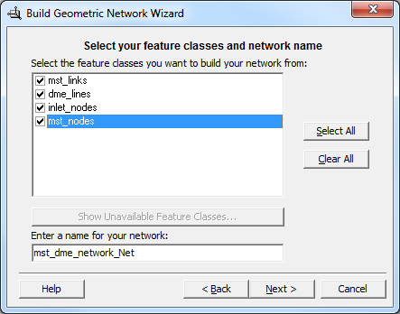

- Choose “Complex Edges” for the mst_links and dme_lines layers. This allows dme inlet lines to connect to pipes in the mst_links layer at the middle of the pipe rather than only the up- and downstream ends.

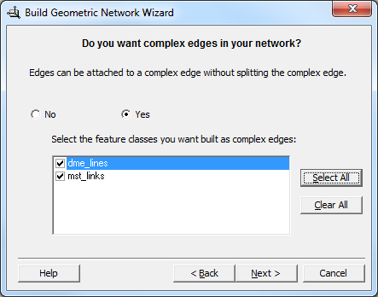

- Apply a snapping tolerance of 0.5’ (determined by trial and error):

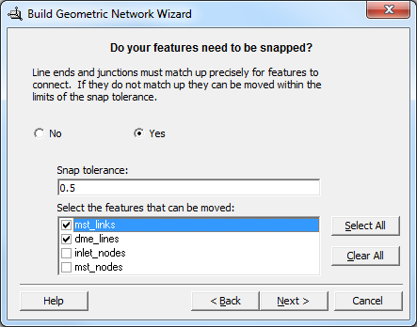

- Finish the “Build Geometric Network” process using defaults.
- The Geometric Network is now ready for use in the auto-delineation tool.

Disabling UIC Endpoints
Normally, the autodelineation tool will treat all downstream endpoints as “outlets” that are assumed to dump water back out onto the surface. However, UIC’s, by definition do not release water onto the surface, and are thus not outlets. To prevent the tool from delineating up through a UIC, the UIC endpoint should be disabled. This prevents the tool from tracing up through a UIC if it happens to be within a catchment that drains to another storm sewer. This should always be done, not just for UIC catchment delineations.

To do this, select the UIC points by location and then set the “Enabled” property to false:

- Add the Active UIC endpoints to the map using the BES Toolbar: BES Layers – ALL -> UIC -> BES Managed UICs (EGH_PUBLIC.ARCMAP_ADMIN.uic_bes_pdx).
- Select only active points: (Ops_Status = 'AC')
- Use “Select By Location” from the Selection menu in ArcMap. You’ll want to select from all node layers, including the “orphan” junctions feature class (in this case called “mst_dme_hybrid_Net_Junctions”). Since spatial registration between these layers are not accurate, you’ll want to select within a distance of about 12 feet (this number needs to be verified, but seems to be about the distance needed).

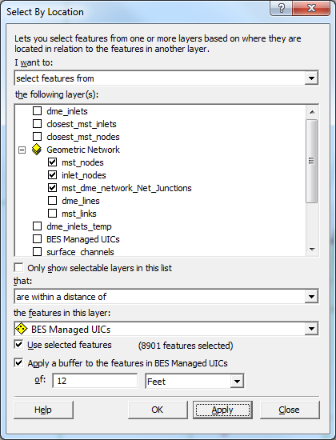

- Then, for each node layer in the network (mst_nodes, inlet_nodes, and mst_dme_hybrid_Net_Junctions), use the Field Calculator to set the “Enabled” field to false. When asked if you want to remove Undo/Redo information, it is recommended you select “No”. This is because the information is not transferred to the geometric network if you select “Yes”. This appears to be a bug in ArcGIS. The delineation tool has been written to work around this bug and work with the values in the Enabled field, regardless of what choice you make, but selecting “No” is cleaner, even though it takes longer.

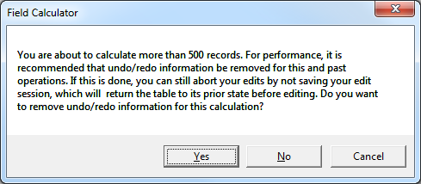

MS4 Considerations
The MS4 regulations do not include water from combined sewers, so combined sewer pipes should likewise be disabled when making delineations for MS4 only. Select all mst_links with PipeFlowType = ‘C’ and set the Enabled property to false.

When operating the tool, always check “Stop tracing at disabled features.”

Elevation Model
The elevation model has been shown to be quite good in capturing natural flow paths, however, certain important details which affect flow are not always captured due to the DEM resolution. In particular curbs and road crowns are often not distinct enough in the dataset to block flow across roads where they would not normally pass. Also, with further testing of the datasets, it was discovered that many ditches are also not captured. Therefore, it is proposed that road crowns, curbs, and ditches be “burned in” to the DEM prior to using it with the tool.

In addition, water bodies should be eliminated (set to null) so that flow paths end at these water bodies and avoid filling, so that flow paths do not “spill” overland. This is particularly important in the Columbia Slough area.

The following procedures can be used. These steps can be automated, if they prove to be useful.

- Select datasets for burning in. These are all feature classes on sde:sqlserver:gisdb1.rose.portland.local.
  - Curbs: ASSETS_PDOT.ARCMAP_ADMIN.curb_pdx
  - Roads: EGH_PUBLIC.ARCMAP_ADMIN.streets_pdx
  - Open Channels: EGH_PUBLIC.ARCMAP_ADMIN.mst_links_bes_pdx
  - Water Bodies: EGH_PUBLIC.ARCMAP_ADMIN.waterbodies_pdx

Process curbs in ArcMap:
- Add curb layer to map.
  - BES ArcGIS Toolkit: CGIS Enterprise Hub – All Layers -> Transportation - StreetFeatures -> Curbs & Shoulders.
- Add definition query to exclude road shoulders which do not affect flow.
  - CurbType <> 3140
- Use ArcToolbox -> Conversion Tools -> To Raster -> Feature to Raster. Convert to raster using the same extent and cell size as the DEM being processed. The extent is set by clicking the “Environments…” button. Both “Extent” and “Snap Raster” should be set to the DEM.

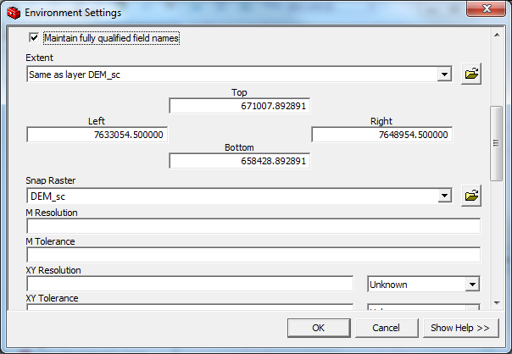

Use any field which is fully populated (has no null values). In this case “CurbType” will work. Output can be to any temporary location:

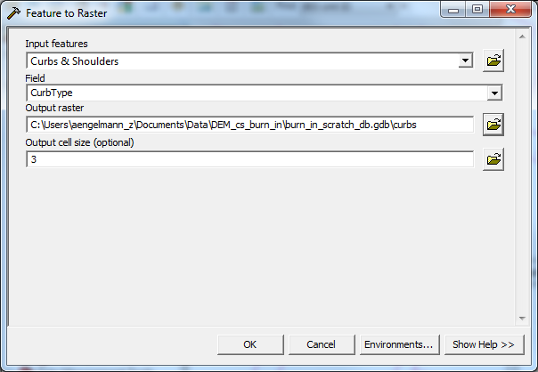

- Change the curb raster to elevation adjustments. Curbs will be burned in to the DEM by lowering the elevation by 0.5 feet. The result should be zero values everywhere except where curbs are located, where they should be -0.5. Use the Raster Calculator:
  - curbs_adj = Con(IsNull([curbs]), 0.0, -0.5)

Process open channels in a similar way:
- Add master links layer to map (mst_links_bes_pdx).
  - BES ArcGIS Toolkit: BES Layers - ALL -> Asset Systems Management -> Modeled Sewer Pipes.
- Create definition query with only open channels: PipeFlowType IN ( 'C', 'D') AND LinkType IN ( 'DG', 'DT', 'NC', 'PN', 'SW', 'TC')
- Convert to raster. Use the LinkType field as value. Use same cell size and extent as the DEM.
- Convert to elevation adjustments. Road centerlines will be lowered by 0.5 feet.
  - open_adj = Con(IsNull([open]), 0.0, -0.5)

Process road center lines in a similar way:
- Add road (centerlines) layer to map.
  - BES ArcGIS Toolkit: CGIS Enterprise Hub – All Layers -> Transportation - Streets -> All Streets.
- Convert to raster. In this case, no definition query is needed. Use the TYPE field as value. Use same cell size and extent as the DEM.
- Convert to elevation adjustments. Road centerlines will be raised by 0.5 feet.
  - streets_adj = Con(IsNull([streets]), 0.0, 0.5)

Create a mask for water bodies:
- Add water bodies layer to map.
  - BES ArcGIS Toolkit: CGIS Enterprise Hub – All Layers -> Hydro -> Regional Waterbodies.
- Convert to raster. In this case, no definition query is needed. Use any numerical field (e.g. LLID) as value. Use same cell size and extent as the DEM.

Finally combine rasters using the raster calculator:
  - dem_adj = [dem] + [curbs_adj] + [open_adj] + [streets_adj]
  - dem_final = SetNull(IsNull([water]) == 0, [dem_adj])

Note: The “0” in the last formula is independent of any attribute values. It is the equivalent of “false” in the result of the “IsNull” function. The formula sets any area in the water raster that is not null (InNull == 0) to null in the final output. This is the same as setting all water bodies to null.

Data Maintenance
DME pipes/ nodes – these features are being constantly revised both at the attribute and schema level although attribute changes are much more common

Modeled pipes/ nodes – these features are based on the DME and therefore are subject to similar concerns

Elevation Model – Lidar derived; this source would not change until a new Lidar flight is contracted. There are no plans for a re-flight in the immediate future.

