Code Architecture Overview:

The CCSP Data Management Process is composed of two different class types, Business and DataIO, and the User Interface. The Business class performs the business logic in memory. The DataIO class is responsible for pulling data from all sources to be processed. Finally, the user interface allows user input to direct some parts of the code. This architecture is designed to accommodate future applications within the CCSP program.

**Insert basic software diagram**

Test Driven development:

Code production methodology to create self-documenting code by creating small tests and writing the code to pass those tests. **Insert better summary here**

**Insert figure here**

Model Catalog : Business classes databases and DataIO for tracking models, designed to be flexible enough to track any type of model that ASM may use.

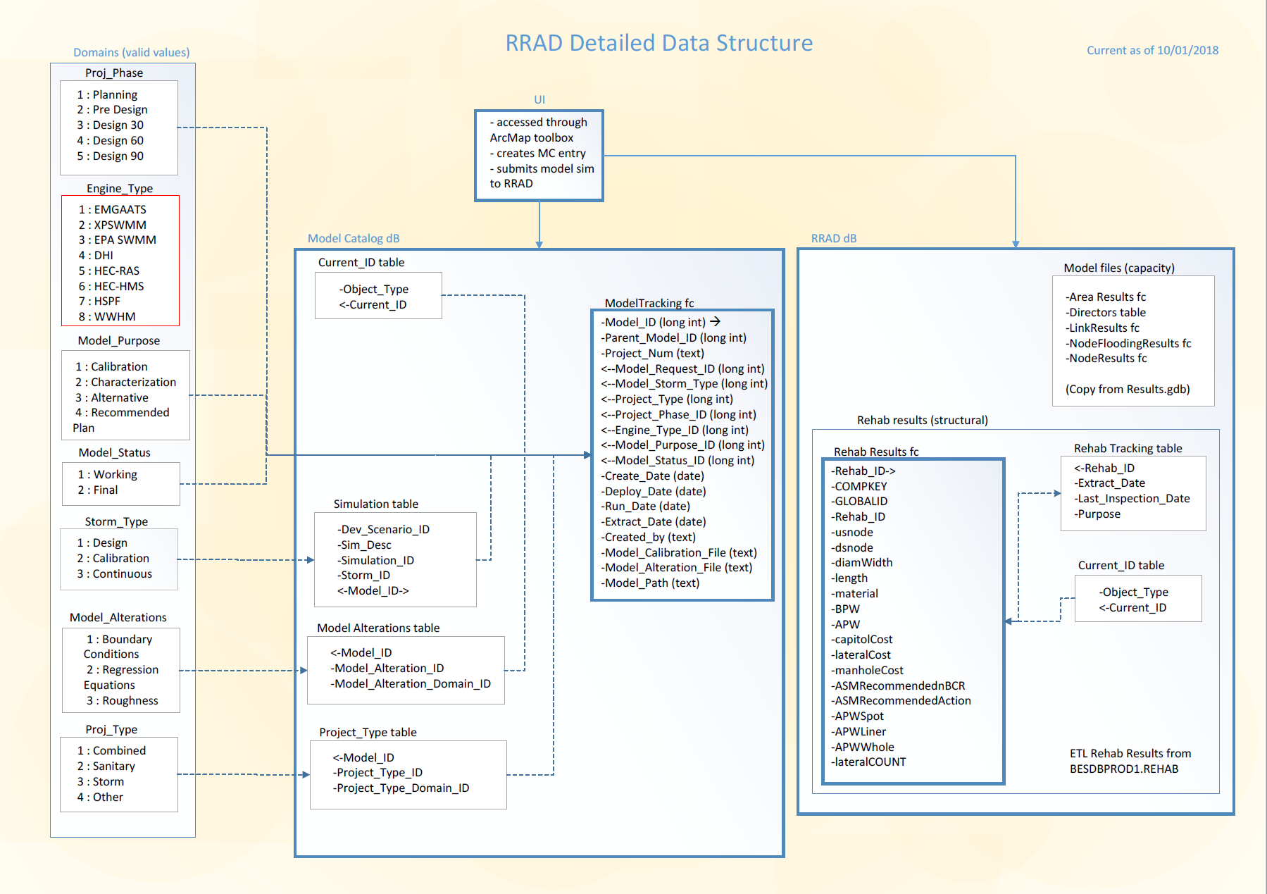

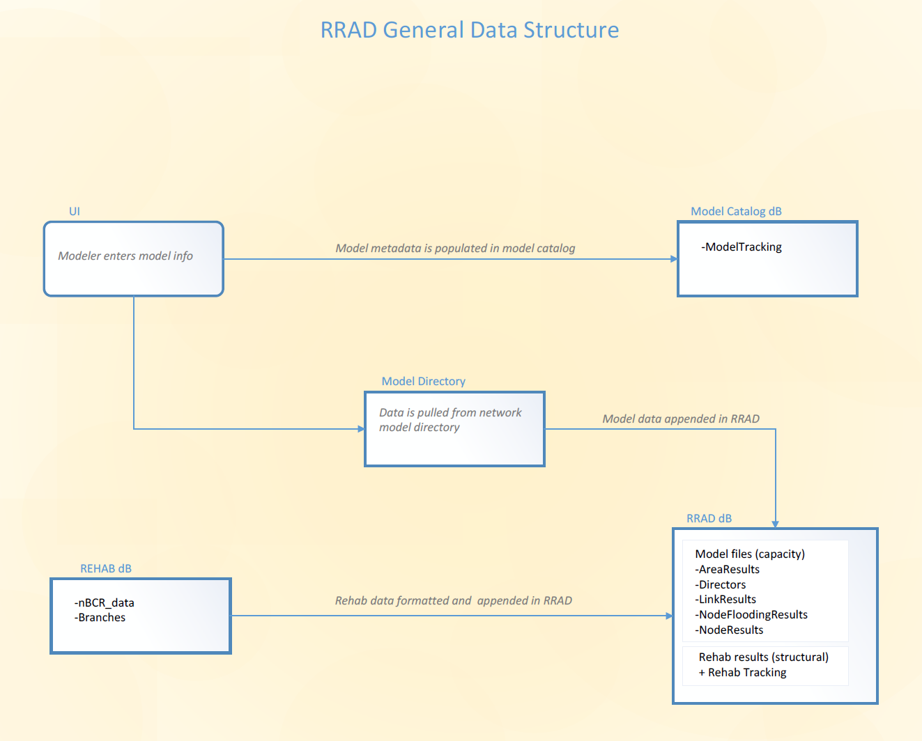

What to pass on for user testing (tool box with short description on how it works)

Application: User interface to allow users to register EMGAATS models from Arc Toolbox and places the results in the RRAD

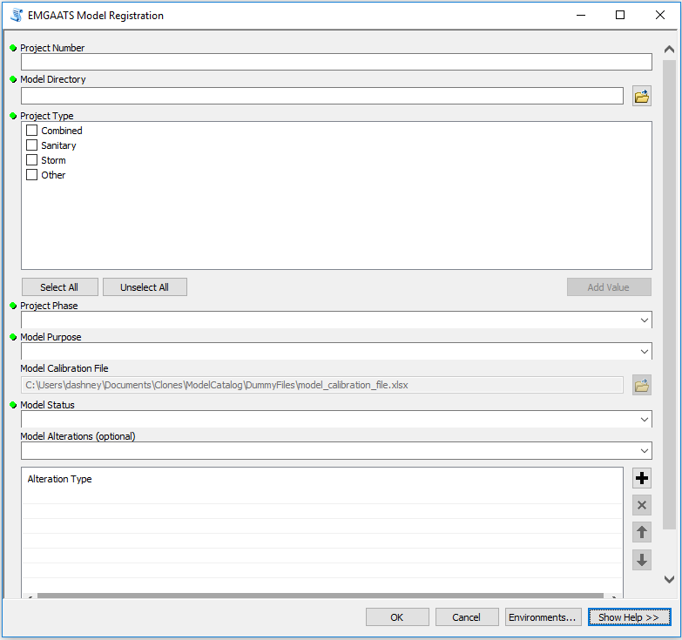

Explain what each of the input fields allow th tool to do and what does not work yet From tool help g

<file:///C:/Users/bfreeman/AppData/Roaming/ESRI/Desktop10.3/ArcToolbox/Dlg/MdToolHelp.htm>

performance limitations…

RRAD (Risk Registry Asset Database): repository of both capacity and structural pipe information. Capacity information is derived from models. Structural information is derived from the Rehab database.

EMGAATS Model Registration Tool: Tool registers an EMGAATS model with the Model Catalog and adds associated simulation results to the Risk Registry Asset Database (RRAD).