Code Architecture Overview:

The CCSP Data Management Toolbox is composed of two different class types, Business and DataIO, and the User Interface. The Business class performs the business logic in memory. The DataIO class is responsible for pulling data from all sources to be processed. Finally, the user interface allows user input to direct some parts of the code. This architecture is designed to accommodate future applications within the CCSP program.

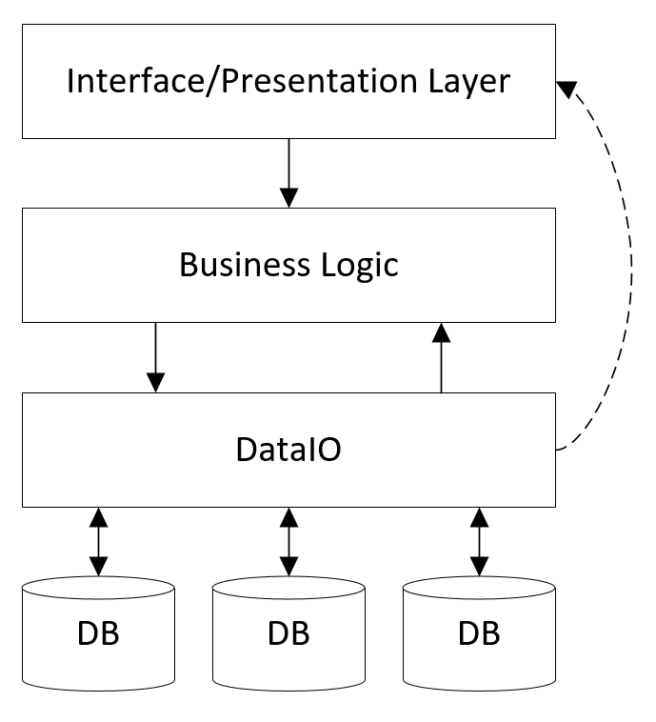

Test Driven development:

Software development methodology to create working code in a short development cycle. The process involves first writing short unit tests, then writing the corresponding code to pass that test, followed by refactoring code as necessary. This attempts to force clean, self-documenting, and working code during the.

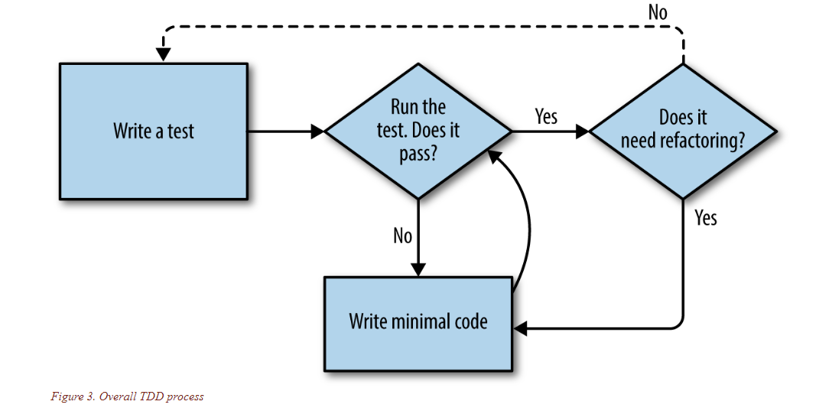

These tools were written using Python in order to easily integrate with the ArcGIS Python library. Development can be much quicker with Python as it has a shallow learning curve. Limitations with Python are that the processing time is generally slower than with other languages.

Overall architecture of the CCSP Data Management is intended to pull data from external sources and output data

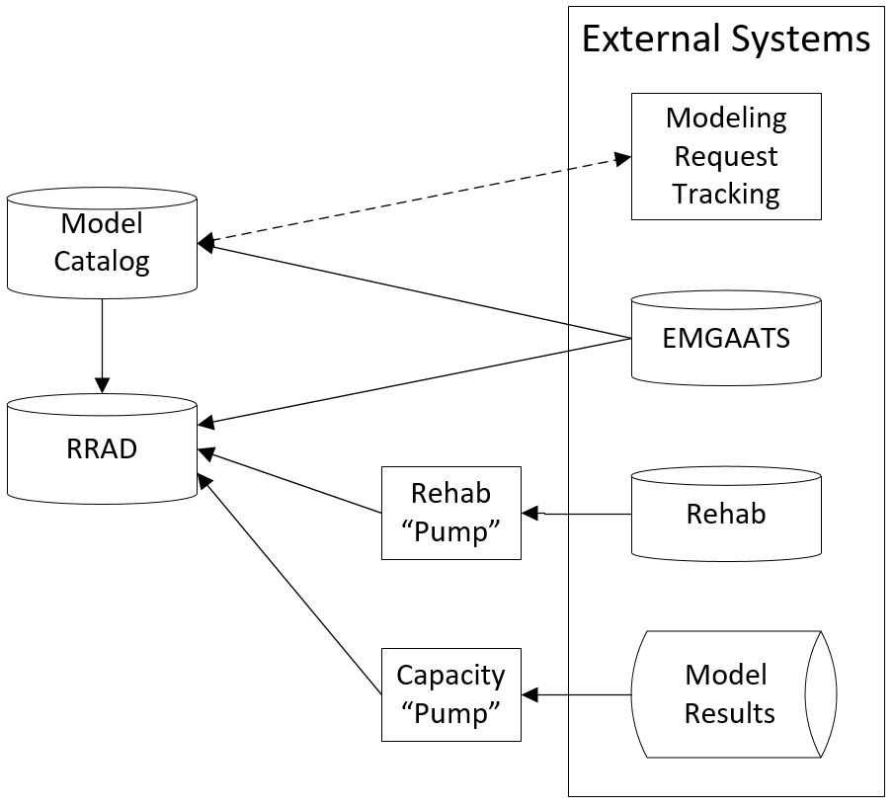

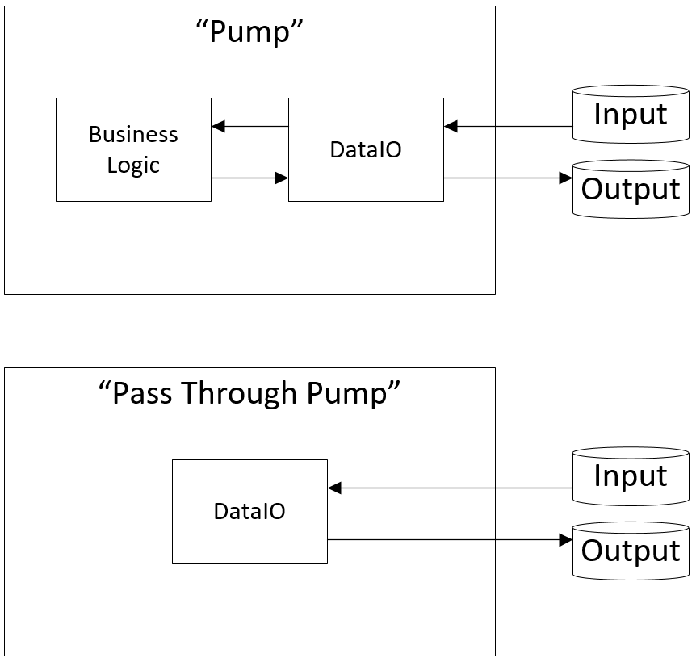

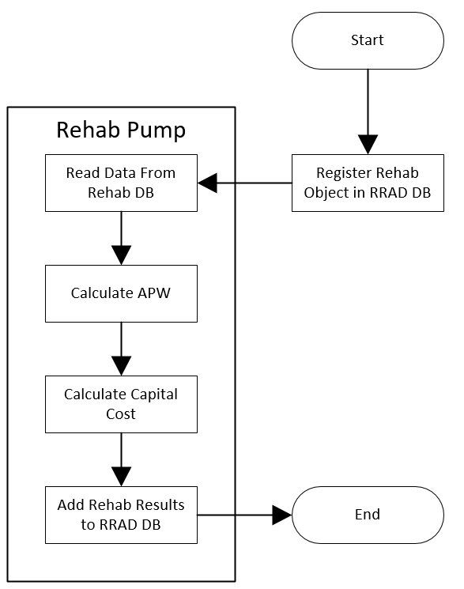

EMGAATS Model Registration:

This ArcGIS tool can be used to register an EMGAATS model with the Model Catalog and adds associated simulation results to the Risk Registry Asset Database (RRAD).

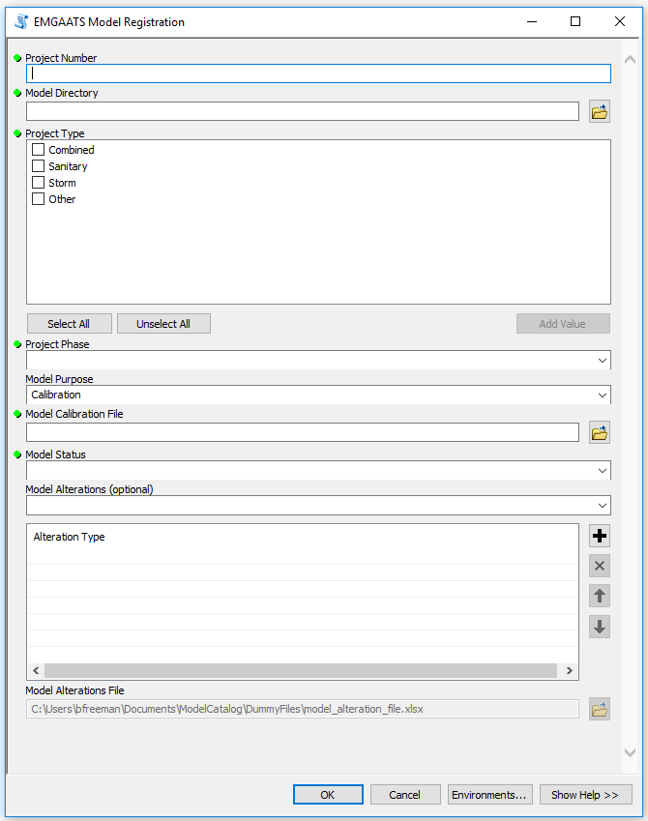

User defined Project Number, entered as CIP Secondary Project ID (eg E10349) or custom model ID (eg ALD_09)

Entered by or navigate to top level directory path for model location

Check boxes to select Project Type: Combined, Sanitary, Storm or Other

Drop down menu to select Project Phase of Planning, CIP Pre-Design, 30, 60, 90 percent

Drop Down menu to select Model Purpose of Calibration, Characterization, Alternative, or Recommended Plan

Enter or navigate to Model Calibration file location

Drop Down Menu to add optional Model Alterations

Enter or navigate to Model Alterations file location

Drop Down Menu to select Model Status of Working, or Final

Code logic of this tool is as the following:

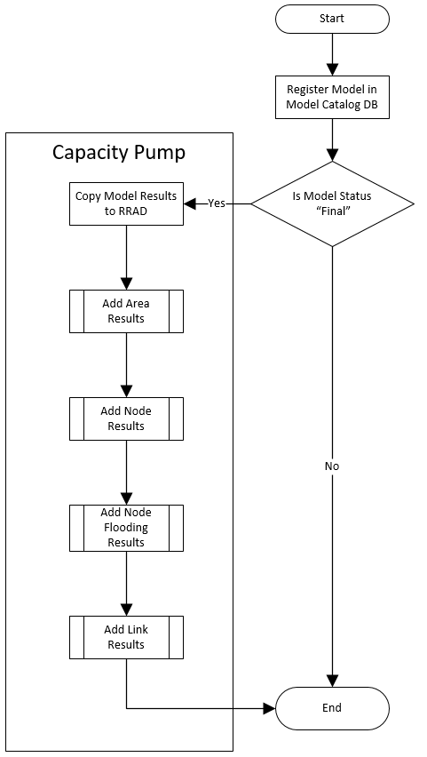

Functionality of the tool is as shown below:

|  |  |  |  |
| --- | --- | --- | --- |
| Capabilities | Working | Planned | Comment |
| Records Project Number/Model Work Order Number | X |  |  |
| Stores user defined Model Directory Path | X |  |  |
| Allows input for Project types of Combined, Sanitary, Storm and User Defined | X |  |  |
| Accepts Project Phases of: Planning, Pre-Design, 30, 60, and 90 percent | X |  |  |
| Accepts Model Purpose of Calibration, Characterization, Alternative, Recommended Plan | X |  |  |
| Prompts for and Stores Calibration File path if Model Purpose "Calibration" is selected | X |  |  |
| Prompts for Model Status of Working or Final | X |  |  |
| Working Models are registered in Model Catalog | X |  |  |
| Final Models are registered in Model Catalog and capacity results are copied to RRAD | X |  |  |
| Allows Optional Model Alterations of Boundary Conditions, Regression Equations and Roughness | X |  |  |
| Prompts for and Accepts, Model Alterations File when Model Alterations are selected |  | X | Option available in GUI DB Table Exists Code still required |
|  |  |  |  |

When tool is executed results are written to the appropriate database Model Catalog and/or RRAD) located on the BESDBTEST1 server. This tool is currently process intensive and may take more than 20 minutes for small models and much longer for large models.

RRAD Database Schema:

