Fragility work.

Work order 8802

10/19/2018

New process.

Adapt from old process.

1. Use existing citywide WB result (has not changed) and apply landslide patch to this.

* Get a count of the affected pipes that have been patched.

1. Using MacJac spine result (has not changed) apply MacJac spine stamp on to result of #1. Get count of affected pipes AND count of those from MacJac that did not get applied because of bad key field

* Change script so that it does not just overwrite values. Need to retain ALL values flagged with source in the field name and then have a FINAL value. This allows users track process through the values.

Basic script order:

1. Fragility – runs calcs for WB data, citywide – separate fc
2. Fragility_MacJac – runs calcs for MJ data, spine only (that’s what they provided) – separate fc
3. Landslide_depth_patch – adds and calculates field values based on depth criteria – separate fc
4. Fragility_Stamper – adds and calculates field values using MJ data – same fc as #3
5. Fragility_final_Values – adds and calculates field values based on priority logic (landslide/depth patch trumps WB Fragility but MJ data trumps it all) – same fc as #3

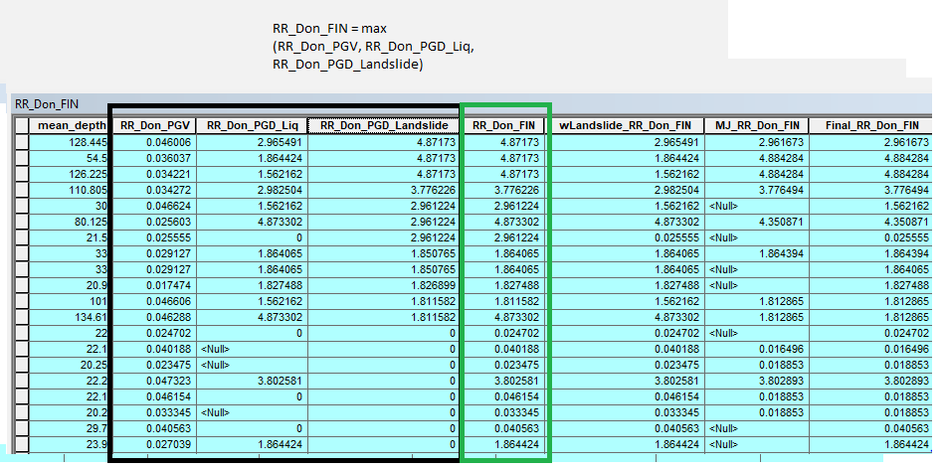

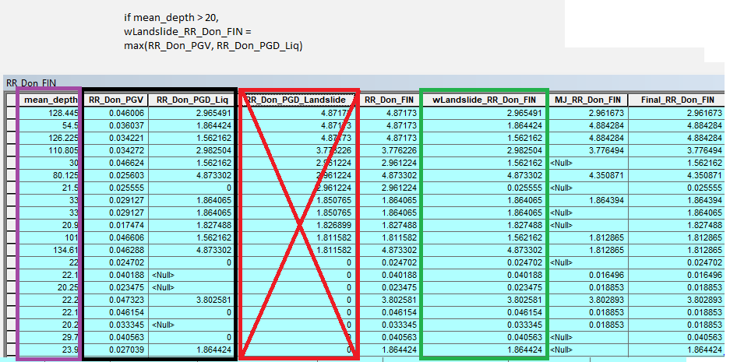

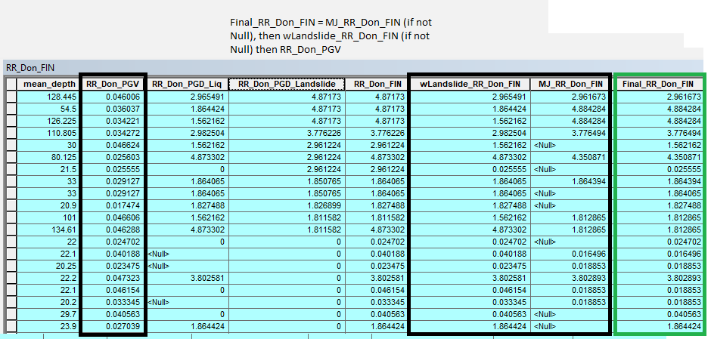

Improvements for future:

1. Create config file and refactor inputs / move to config file
2. Create ‘master’ file to run all sub-processes. Will need to refactor some/ create params from some things to make this work. This would allow the user to run all at once and formalize the process order in one file.

# ----------------------------------------------------------------------------------------------------------------------------------------

Data management – want to move output to BESGEORPT, same location as the Resiliency Spine. This way it is in an authoritative location which can be pointed to from the Layer Manager, we can use View/Query Layer to subset the Fragility result using the Resiliency Spine, something currently done through a COMPKEY filter (= bad).

Once Nishant is ok with the result above, we’ll want to get the thumbs up to relocated to the server.