 | Explicit Model Document  EMD-094

Title: Report Generator

Category: Model Output

Status: Draft
Reviewed By: To Be Reviewed
Date: July 10, 2008
Author: John Burns
Category: Model Output 1
Status: Draft 1
1 Summary 1
2 Xml Specification 2
2.1 Report Templates 2
2.2 Valid Elements 2
2.3 Style Sheet 3
3 Executing Functions 4
3.1 Report Libraries 4
3.2 Auxiliary Data 4
3.3 Parameters 4
3.3.1 Optional Parameters 4
3.3.2 Expanding Rows or Tables 5
4 Generating Reports 7
4.1 Choosing the Study Area 7
4.2 Executing the Report 7
4.3 Report Output 7
4.4 Generating CSSP Recommended Plan Report 7
5 Managing Model Catalog 16
6 Appendix A—Object Model Documentation 17

Summary
The Report Generator tool reads data from a variety of data sources, manipulates the data, and creates standard tables for including in reports. The Report Generator is particularly useful for instances where the same data needs to be summarized for a variety of areas, for instance a standard set of tables for each sewer basin.
Additional information on the Report Generator can be found on the Systems Analysis wiki:
http://twiki.bes-sa.org/bin/view/Modeling/ReportGenerator

Xml Specification

Report Templates
A report template is an xml file containing static formatting elements and dynamic function elements. The static formatting elements are consistent for all instances of a report. The dynamic function elements are calculated by the report generator and inserted into the final report. There are three primary dynamic elements within an xml template: Function, which contain a collection of parameters and return a single value; MultiRows, which create multiple rows within a table to display a list of data; and MultiTables, which create multiple tables to display multiple instances of a table.
Default report templates are included in the Report Generator installation. Custom templates can be imported via the user interface. Default reports can be found in the \xml directory within the Report Generator project. To add a new default report, place the .xml template in the \xml directory and be sure to include it within the Report Generator installation package.

Valid Elements
Table 1 lists the required and optional elements to create a report template. When creating a new report template it may be more effective to start with an existing template rather than creating a template from scratch.
Table 1. Xml Elements for Report Templates
Elements / Attributes |  |  |  |  |  |  | Allowable Instances | Required Attribute | Dynamic Element | Valid Values
<ReportGenerator> |  |  |  |  |  |  | 1
 | reportName |  |  |  |  |  |  | yes | no | String
 | studyArea |  |  |  |  |  |  | yes | yes | Set by Report Generator
 | <CharacterizationTable> |  |  |  |  |  | 1…n
 |  | tableNumber |  |  |  |  |  | yes | no | String
 |  | tableTitle |  |  |  |  |  | yes | no | String
 |  | columnCount |  |  |  |  |  | yes | no | Integer
 |  | isMultiTable |  |  |  |  |  | no | no | Boolean
 |  | multiTableKey |  |  |  |  |  | no | yes | See (1) Below
 |  | <Header> |  |  |  |  | 1
 |  |  | <Cell> |  |  |  | 1…n
 |  |  |  | cellType |  |  |  | yes | no | Any cell type defined in the stylesheet
 |  |  |  | data |  |  |  | yes | no | String
 |  |  |  | footerID |  |  |  | no | no | String
 |  |  | </Cell>
 |  | </Header>
 |  | <Row> |  |  |  |  | 1…n
 |  |  | isMultiRow |  |  |  |  | no | no | Boolean
 |  |  | multiRowKey |  |  |  |  | no | yes | See (2) Below
 |  |  | multiRowFilterName |  |  |  |  | no | no | See (3) Below
 |  |  | multiRowFilterValue |  |  |  |  | no | yes
 |  |  | <Cell> |  |  |  | 1…n
 |  |  |  | cellType |  |  |  | yes | no | See (4) Below
 |  |  |  | data |  |  |  | yes | yes | See (5) Below
 |  |  |  | footerID |  |  |  | no | no | String
 |  |  |  | <Function> |  |  | 0…1 | no | no | See (6) Below
 |  |  |  |  | functionName |  |  | yes | no | See (7) Below
 |  |  |  |  | library |  |  | yes | no | See (8) Below
 |  |  |  |  | format |  |  | no | no | .NET format string
 |  |  |  |  | suffix |  |  | no | no | String
 |  |  |  |  | <Parameter> |  | 0…n
 |  |  |  |  |  | parameterName |  | yes | no | Name of a function parameter
 |  |  |  |  |  | parameterValue |  | yes | no | Value of a function parameter
 |  |  |  |  | </Parameter>
 |  |  |  | </Function>
 |  |  | </Cell>
 |  | </Row>
 |  | <Footer> |  |  |  |  | 0…n
 |  |  | footerID |  |  |  |  | yes | no | String
 |  |  | footerText |  |  |  |  | yes | no | String
 |  | </Footer>
 | </CharacterizationTable>
<ReportGenerator>
1: Any multiTableKey implemented in CharacterizationEngine.getMultiTableKeyList(string multiTableKey); "PumpStationID" is implemented
2: Any multiRowKey implemented in CharacterizationEngine.getMultiRowKeyList(string multiRowKey); "FECID", "FocusArea", "PumpStationID" and "DIVERSIONID" are implemented.
3: Any multiRowFilter implemented in CharacterizationEngine.getFilteredMultiRowKeyList(…); "WetWellIndex", "ForceMainIndex" and "PumpIndex" are implemented.
4: Any cell type defined in the stylesheet, or "FUNCTION"
5: Attribute required if cellType != "FUNCTION", otherwise dynamically created
6: Attribute required if cellType = ”FUNCTION”, otherwise not allowed
7: Name of a function in SystemsAnalysis.Reporting.ReportLibraries.LibraryName that has signature "public object functionName(IDictionary<string, Parameter> parameters"
8: Class in SystemsAnalysis.Reporting.ReportLibraries that contains the function to execute

Style Sheet
A default style sheet is provided for transforming an xml report into formatted tables for publication. The default style sheet is located at:
\\Cassio\Modeling\Model_Programs\bin\ReportGenerator\excel_char.xsl
A custom style sheet can be specified in a report template. Future improvements should allow user-selectable style sheets via the Report Generator interface.

Executing Functions
When a function in a report template is parsed by the report engine, all xml data between <function> and </function> is parsed by the Characterization Engine. Parameters are read into an IDictionary containing the parameter names and the parameter values.
After a function is evaluated, all xml data between the <function> tags is removed from the report. The result of the function is placed in the data attribute of <Cell> tag.

Report Libraries
Functions to be executed by the Characterization Engine are contained within classes that inherit from the ReportBase class. The ReportBase class provides delegate methods for executing function via reflection. This allows extensible report libraries to be added to the Report Generator, and for a variety of function and parameters to be specified via the xml report template.

Auxiliary Data
Report libraries may require auxiliary data that is not included in one of the master repositories. An example is an Alternative package created by the Alternatives Toolkit. To create a report summarizing an alternative, in addition to master modeling data and model results, it is necessary to specify the alternative of interest.
The ReportBase class, from which all report libraries must inherit, contains a subclass called ReportInfo. The ReportInfo class allows a library to provide data to a user interface regarding the name of the report and any additional data the report may require. The advantage of using the ReportInfo subclass is that constructing a new instance of a report library often requires loading large amounts of data. When a user is browsing a list of available reports it is useful to share information about required auxiliary data without the overhead of constructing the entire report library object.

Parameters
Unfortunately, all functions called within a report library require function parameters to be contained in a generic dictionary class. This is because all functions are required to have the same signature when executed via reflection (in the present implementation).
If parameters could be implemented directly it would allow for more generic report libraries – For instances, a Link class or Model class could report their attribute data directly to the report generator. Instead, the current implementation requires a report library wrapping all model data to be reported on, as discussed in the next section.

Optional Parameters
Many functions contain optional parameters. This allows calculated data to be filtered by a variety of criteria. Optional parameters are implemented by checking for the existence of a parameter, and then applying that parameter as a criterion only if it is present.
For example, reports often summarize basement flooding risk within a study area. This data may optionally be broken down by zoning classification of the properties; If a function includes the parameter <LandUse>COM</LandUse> then basement flooding statistics will only be reported for commercial properties. If the <LandUse> tags are not present, no filtering will occur. When calling a function from an xml template, check the source code for all required and optional parameters that may be included.

Expanding Rows or Tables
MultiRow and MultiTable parameters are used when an unknown number of elements need to be included in a report. For instance, the number of pump stations within a study area is not known until the study area is chosen. It may be desirable to create one row in a table summarizing each pump station, or a separate table for each pump station

MultiRow Parameters
To implement an expandable multi-row within a table, the row property in the template should include attributes isMultiRow=”true” and multiRowKey=”multiRowKeyName”, where multiRowKeyName is a hard-coded parameter for an implemented multi-row parameter.
When the template is processed, one row will be created for each multi-row parameter in the study area. Additionally, each multi-row includes a parameter field that is used as a input to multi-row functions. When a multi-row is processed, each instance of the parameter field is replaced by a unique value that identifies the multi-row. In the case of a pump station multi-row, the parameter field is the pump station id. The pump station id is an input to the pump report functions that select wet well volume or pump station capacity.
Table 2. Implemented MultiRow Keys
MultiRow Key | MultiRow Parameter | Description | Report Library
FECID | @FECID | Returns a unique row for each Flow Estimation Catchment within the study area | FecReport
FocusArea | @FocusArea | Returns a unique row for each Alternative Focus Area within the study area | AlternativeReport
PumpStationID | @PumpStationID | Returns a unique row for each Pump Station within the study area | PumpStationReport
PumpIndex | @PumpIndex |  | PumpStationReport
WetWellIndex | @WetWellIndex |  | PumpStationReport
ForceMainIndex | @ForceMainIndex |  | PumpStationReport
DiversionMultiRow | @DiversionID | Returns a unique for each Diversion Structure within the study area | ModelReport

MultiTable Parameters
To implement a multi-table, where a single table template will create an arbitrary number of output tables, the table property in in the template should include attributes isMultiTable=”true” and multiTableKey=”multiTableKeyName”, where multiTableKeyName is a hard-coded parameter for an implemented multi-table parameter.
Table 3. Implemented MultiTable Keys
MultiTable Key | MultiTable Parameter | Description | Report Library
PumpStationID | @PumpStationID | Returns a unique table for each Pump Station within the study area | PumpStationReport

When creating a multi-table it may be necessary to include a multi-row table within each table created by the multi-table. For instance, a multi-table may be used to create a table for each pump station. Within each pump station table, a row is needed to report each pump within the pump station. In order to retrieve a collection of pumps, it is necessary to know the pump station id. In essence, a multi-table needs to pass its multi-table parameter to a multi-row. This can be accomplished using a multi-row filter. In this example, the collection of pumps could be retrieved via a multi-row, but the pump collection needs to be filtered to retrieve only those pumps associated with a particular pump station.
When a multi-row filter is processed, the Report Generator replaces the multi-row filter parameter with the appropriate parameter value for each row created by the multi-row filter.
Table 4. MultiRow Filters for MultiTable
MultiTable Key | MultiRow Filter | MultiRow Filter Parameter | Description | Report Library
PumpStationID | WetWellIndex | @WetWellIndex | Returns a unique row for Wet Well within the current Pump Station multi-table | PumpStationReport
PumpStationID | ForceMainIndex | @ForceMainIndex | Returns a unique row for each Force Main within the current Pump Station multi-table | PumpStationReport
PumpStationID | PumpIndex | @PumpIndex | Returns a unique row for each Pump within the current Pump Station multi-table | PumpStationReport

Generating Reports

Choosing the Study Area
The Report Generator focuses on creating reports for specific areas of the sewer system. An area to report on is therefore created by tracing the pipe network to identify the study area. The Report Generator features an ArcGIS interface to visualize the selected study area.
There is a future need for selecting more generic study areas. For instance, a report summarizing UIC data cannot be effectively delineated using a network trace. Future enhancements to the tool should include the ability to select a study area by importing existing polygons are by interactively drawing a polygon.

Executing the Report
When a report is executed, the user is prompted for a location to store the output report. The output report has the same basic structure as the report template. During execution all dynamic values are calculated by the report generator and inserted into the output report. As discussed above, dynamic values are processed as follows:
- <Table> element with isMultiTable = true are replaced with a 0 or more tables. The multiTable parameter is replaced in any child <function> elements containing the multiTable parameter.
- <Row> elements with isMultiRow = true are expanded with 0 or more rows. The multiRow parameter is replaced in any child <function> elements containing the multiRow parameter.
- If the multiRow is contained within a multiTable, then the multiRowFilter parameter is replaced in any child <function> elements containing the multiRowFilter parameter.
- <Function> elements are parsed and the result of the function is placed in the data attribute of the parent <Cell> element. The <function> tag and all child data is stripped from the output report.

Report Output
Report output can be opened in any valid xml reader. The default style sheet works well for viewing in Excel or Internet Explorer. Word version 2003 and above can open xml content directly. To import to earlier version of Word, first open the report in Excel and then copy/paste to Word.

Generating CSSP Recommended Plan Report
Directions for Creating a Recommended Plan Report using the Gremlin

- Open the Gremlin software. If you do not know how to open it or it is not installed, check with Ruben G. for assistance.
- Click on the “Create Report” tool in the main form window (Figure 1).

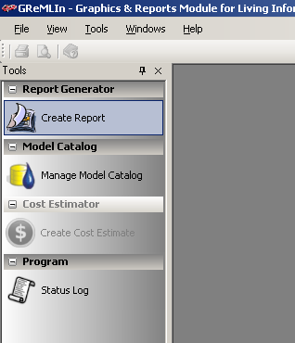
Figure 1: Creating a Report—Click on ‘Create Report’ in the Main Explorer Window

- Fill in the Study Area Name field in the report form (Figure 2). For the Recommended Plan reports, using the following naming convention may be helpful:

“XXX_CSSP_RP”, where “XXX” is the three-letter basin code (e.g., “ALD” for the Alder basin)

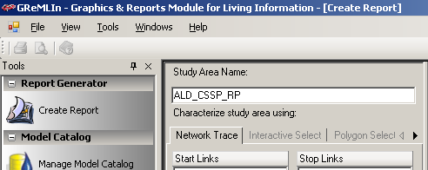
Figure 2: Specifying Study Area Name

- In the drop-down box next to the text “Choose a report”, select the “CSSP Recommended Plan Report” (Figure 3).

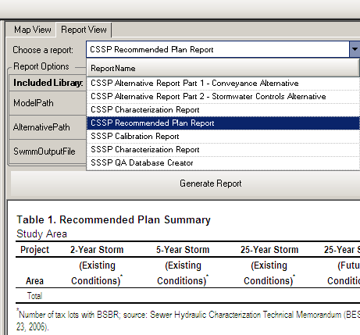
Figure 3: Choosing CSSP Recommended Plan Report
- In the ModelPath text box, browse to the model.ini file in the RP model directory (Figure 4).

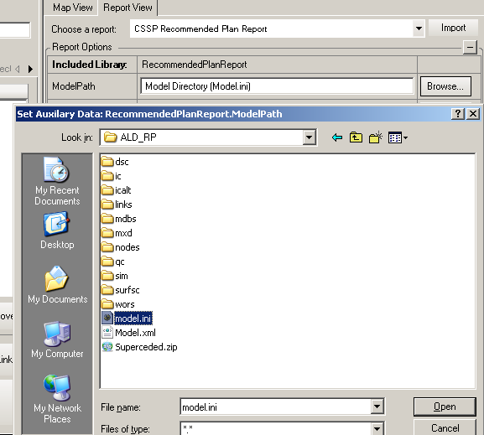
Figure 4: Choosing the model.ini File from the RP Model Directory
- In the AlternativePath text box, browse to the alternative_package.mdb file, located in the alternatives folder of the model used to build the RP model (typically the FU or FU_2011 model, see Figure 5).

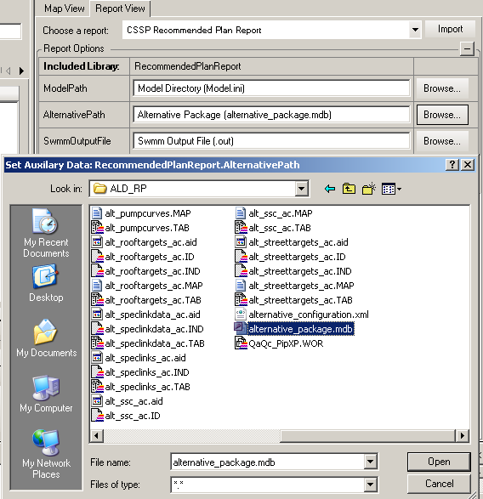
Figure 5: Choosing the alternative_package.mdb File from the RP Alternative Directory
- This next step is necessary in order to perform an existing work-around of a bug in the program: In the AlternativePath text box, delete the file name “alternative_package.mdb”, leaving the directory path where the database file exists (Figure 6).

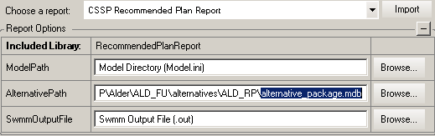
Figure 6: Removing the “alternative_package.mdb” String from the Alternative Path

- In the SwmmOutputFile text box, browse to the RP 4S6 output file (Figure 7).

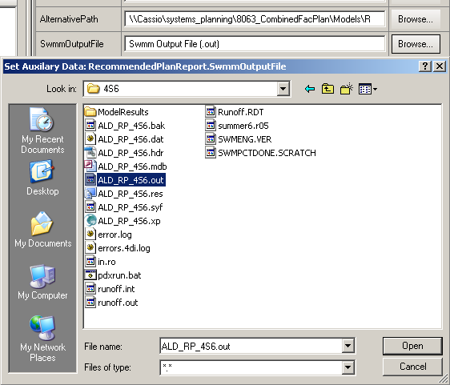
Figure 7: Choosing the 4S6.out File from the RP ‘sim’ Directory
- Click on the ‘Generate Report’ button. The program will ask where to save the file. By default, the file is saved with the Study Area Name given in Step 3 above (Figure 8).

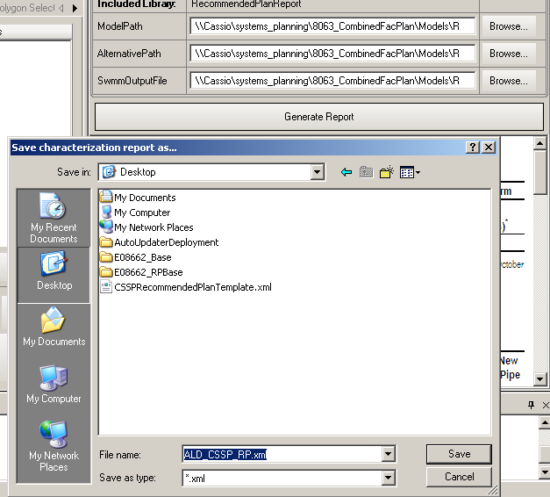
Figure 8: Specifying Report Output Location
- The report can be easily viewed from within the Gremlin, but in order to open the newly save file in a viewable format. It is recommended that the user download the “XML Reader” file. This is done by clicking on the ‘Download XML Reader’ tool in the main tool window (Figure 9). The program will ask you where to save the file. By default it is stored in C:\temp. The user can specify anywhere to save it, but be sure to remember where it is save, because you’ll need it for the next step.

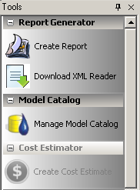
Figure 9: Downloading the XML Reader for the RP Report

- Open the Gremlin output report in Word. Word will automatically ask you f you want to use an XML data view file. Browse to the newly downloaded XML Report Reader file and the report should appear as a series of tables in the document (Figure 10).

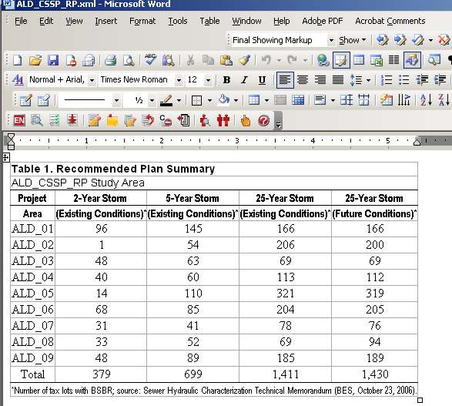
Figure 10: Final Report in Word Document

Managing Model Catalog
The Report Generator tool contains an interface for uploading model results to the model results repository on the Modeling_Dev server.

Appendix A—Object Model Documentation

