Project 1

CAT FIGHT

CSC-5

Patrick De La Cruz

July 21, 2014

Introduction

This is a text base fighting game.

Basically you just type in one of the provided commands to attack.

Your enemy, which is the computer, will also randomly attack simultaneously.

Each attack command is assigned a damage and a percentage success rate.

The less the chance of the chosen attack of landing, the higher the damage and vice versa.

The player and the computer have the same health to start and first one to zero loses.

Summary

Lines of code: about 200

Number of variables: 18

I must have restarted this project half a dozen times. This is my first ever programming class and I had no idea how to even begin. How to use programming tools I have barely even grasped to make something of my own. Honestly if it wasn’t for the internet and all its tutorials I would have dropped this class the first week. Every time I came up with an idea and would start to code, I would not know which tools to get the job done if it was even possible in the first place. I would read up and watch videos on things we have not even discussed in class. So instead of driving myself crazy I just decided I would I would only use things I have learned in class so far since I still needed practice with them. The only thing I used that may not have been thoroughly discussed in class was “strings”, a quick video online how to use strings at a basic level. I used “if” and “else if” statements, “while” and “do while” loops, “rand()” and “switch” functions. Before this project most homework I have done had at most maybe 30-50 lines of code. I would easily get confused at all the brackets, missing libraries, not knowing what the error means or wants me to do. I have been working on this project for over 2 weeks but only came to stick with this text base fighting game maybe 3 or 4 days ago. I had many problems along the way, most of them just syntax errors. It sometimes would take me an hour or 2 just to realize that one of my while statements were supposed to be inside or outside a certain bracket. Even now I am not 100% certain and easily get confused about loops and statements. I’m sure with more practice I will be able to implement many other things we have discussed in class that I was not able or capable of using, in the future.

FLOWCHART

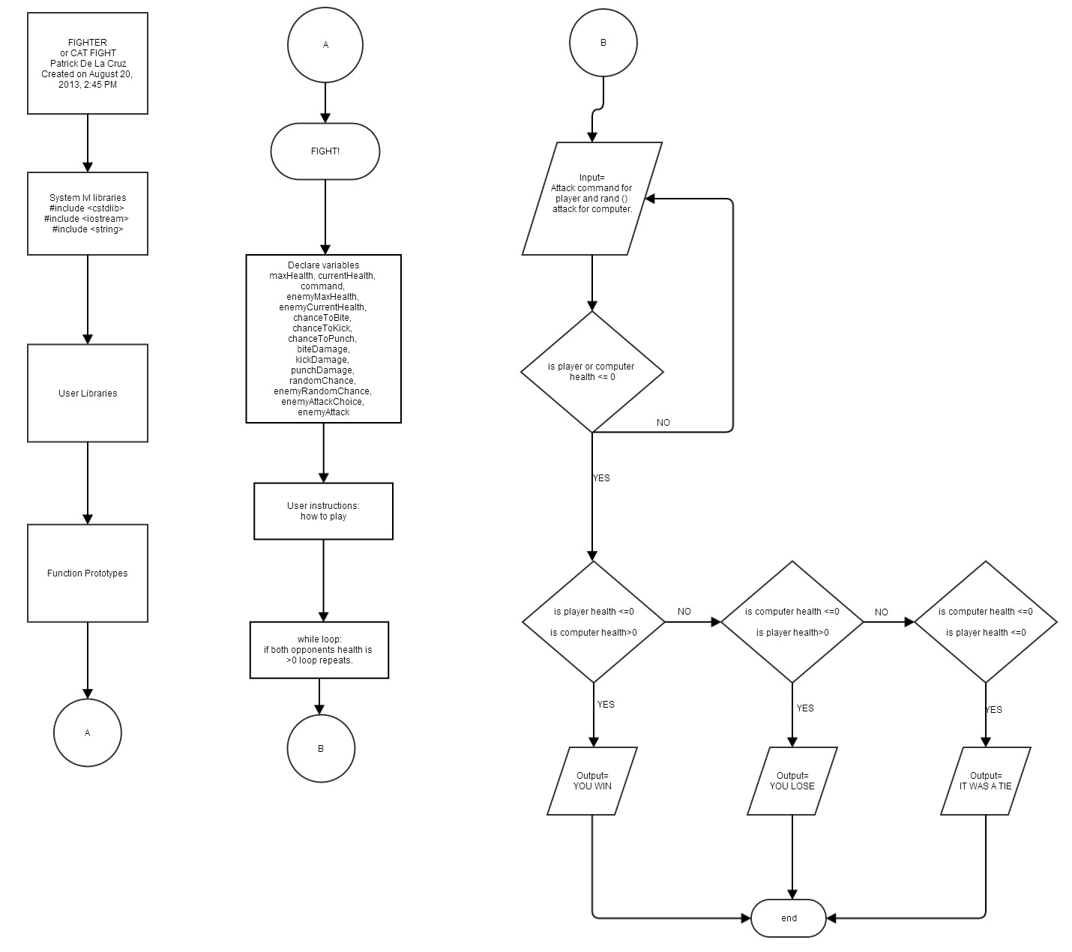

PROGRAM

#include <cstdlib>

#include <iostream>

#include <string>

using namespace std;

/\*

\*

\*/

int main(int argc, char\*\* argv)

{

//player stats

float maxHealth=50;

float currentHealth=50;

string command;

//Enemy stats

float enemyMaxHealth=50;

float enemyCurrentHealth=50;

//hit chance

int chanceToBite=25;

int chanceToScratch=50;

int chanceToPullHair=75;

int chanceToPunch=10;

//damage from hit

float biteDamage=20;

float scratchDamage=10;

float pullDamage=5;

float punchDamage=45;

//chance is out of 100

int randomChance;

int enemyRandomChance;

int enemyAttackChoice;

string enemyAttack;

//exit game

string out;

//Title page

cout<<" .@@@@@; 8@@@ i@@@@@@@@@ "<<endl;

cout<<" @@@. i@ ;@@@@. @@L "<<endl;

cout<<" @@@ @@ 1@@ @@L "<<endl;

cout<<" @@C @@t @@@ @@L "<<endl;

cout<<" @@@ t@@@@@@@@; @@L "<<endl;

cout<<" ,@@@i t@ @@. G@@ @@L "<<endl;

cout<<" ,@@@@0 8@G @@8 @@t "<<endl;

cout<<""<<endl;

cout<<" @@@@@ @@ @@@@8@ C@. @@ @@@@@@@@ "<<endl;

cout<<" @@ @@ @@ C@. @@ @@ "<<endl;

cout<<" @@@@@ @@ @@ 00@@ C@0000@@ @@ "<<endl;

cout<<" @@ @@ i@@ @@ C@. @@ @@ "<<endl;

cout<<" @@ @@ .@@@G C@ @@ GG "<<endl;

cout<<" C, : "<<endl;

cout<<" ;@8 ,8 "<<endl;

cout<<" t880 .08: "<<endl;

cout<<" .888C t88C "<<endl;

cout<<" 0888 ;8@@ ; "<<endl;

cout<<" ,888 @@@0 .0 "<<endl;

cout<<" ;888, 8888: ;8. "<<endl;

cout<<" t880 8888G 180 "<<endl;

cout<<" @8@; 88888 t@@L "<<endl;

cout<<" ;88t :@888 @88i i "<<endl;

cout<<" C88. .18888. ,@8@ @ "<<endl;

cout<<" C8@ ;@88@ @881 ,@0 "<<endl;

cout<<" . L8G L8881 @@8@ .@8f "<<endl;

cout<<" C@. .@88@ @888; 888: "<<endl;

cout<<" t8 18@@C @888 .@@@ "<<endl;

cout<<" .f 888@. :@888 .@@f "<<endl;

cout<<" , L8@f G888. ;@88 "<<endl;

cout<<" i8C ,888f L880 "<<endl;

cout<<" ,@ @88@ @881 "<<endl;

cout<<" 0 888: i88L "<<endl;

cout<<" i 080 G88 "<<endl;

cout<<" f@, 88@ "<<endl;

cout<<" :@ 08G "<<endl;

cout<<" 8 08. "<<endl;

cout<<" f 08 "<<endl;

cout<<" ;1 "<<endl;

cout<<" i "<<endl;

do{

do

{

//User instructions

cout<<"FIGHT!"<<endl;

cout<<"Commands are 'punch', 'scratch', 'bite', 'pullhair'"<<endl;

cout<<"Enter 'info' for damage statistics"<<endl;

cout<<"Enter 'play' to start game"<<endl;

cout<<"Enter 'exit' to end game"<<endl<<endl;

cin>>out;

if(out=="info")

{

cout<<"Commands\t\tDamage\t\tsuccess rate\n";

cout<<"======================================\n";

cout<<"pull hair\t\t5\t\t75 percent\n";

cout<<"Enter 'info' for damage statistics"<<endl;

cout<<"Enter 'play' to start game"<<endl;

cout<<"Enter 'exit' to end game"<<endl<<endl;

cin>>out;

}

if(out=="exit")

{

cout<<"Thank you for playing";

return 0;

}

if(out!="play"&&out!="info"&&out!="exit")

{

cout<<"Invalid command"<<endl;

}

if(out=="play")

{

//While you and enemy are still alive

currentHealth=50;

enemyCurrentHealth=50;

while(enemyCurrentHealth > 0 && currentHealth > 0 )

{

cout<<"Your health: "<<currentHealth<<"/"<<maxHealth<<endl;

cout<<"Enemy health: "<<enemyCurrentHealth<<"/"<<enemyMaxHealth<<endl;

cin>>command;

cout<<endl;

//Input commands

if(command=="pullhair")

{

randomChance=rand()%100+1;

if(randomChance<=chanceToPunch)

{

enemyCurrentHealth-=pullDamage;

}

}

else if(command=="scratch")

{

randomChance=rand()%100+1;

if(randomChance<=chanceToScratch)

{

enemyCurrentHealth-=scratchDamage;

}

}

else if(command=="bite")

{

randomChance=rand()%100+1;

if(randomChance<=chanceToBite)

{

enemyCurrentHealth-=biteDamage;

}

}

else if(command=="punch")

{

randomChance=rand()%100+1;

if(randomChance<=chanceToPunch)

{

enemyCurrentHealth-=punchDamage;

}

}

else

{

cout<<"Not a valid command"<<endl;

}

//enemy attack

enemyRandomChance=rand()%100+1;

enemyAttackChoice=rand()%4+1;

//attacks performed by enemy

switch(enemyAttackChoice)

{

case 1:{

enemyAttack="punch";

break;

case 2:

enemyAttack="pullhair";

break;

case 3:

enemyAttack="scratch";

break;

case 4:

enemyAttack="bite";

break;

}

}

//damage dealt by enemy

if(enemyAttack=="punch")

{

enemyRandomChance=rand()%100+1;

if(enemyRandomChance<=chanceToPunch)

{

currentHealth-=punchDamage;

cout<<"punched you in the face!"<<endl;

}

}

else if(enemyAttack=="scratch")

{

enemyRandomChance=rand()%100+1;

if(enemyRandomChance<=chanceToScratch)

{

currentHealth-=scratchDamage;

cout<<"you got scratched"<<endl;

}

}

else if(enemyAttack=="bite")

{

enemyRandomChance=rand()%100+1;

if(enemyRandomChance<=chanceToBite)

{

currentHealth-=biteDamage;

cout<<"you got bit"<<endl;

}

}

else if(enemyAttack=="pull hair")

{

enemyRandomChance=rand()%100+1;

if(enemyRandomChance<=chanceToPullHair)

{

currentHealth-=pullDamage;

cout<<"pulled your hair"<<endl;

}

}

}

//who wins or loses

if(currentHealth <= 0 && enemyCurrentHealth > 0)

{

cout<<"YOU LOST"<<endl;

cout<<"Your health: "<<currentHealth<<"/"<<maxHealth<<endl;

cout<<"Enemy health: "<<enemyCurrentHealth<<"/"<<enemyMaxHealth<<endl<<endl;

}

else if(enemyCurrentHealth <= 0 && currentHealth > 0)

{

cout<<"YOU WIN"<<endl;

cout<<"Your health: "<<currentHealth<<"/"<<maxHealth<<endl;

cout<<"Enemy health: "<<enemyCurrentHealth<<"/"<<enemyMaxHealth<<endl<<endl;

}

else

{

cout<<"IT WAS A TIE"<<endl;

cout<<"Your health: "<<currentHealth<<"/"<<maxHealth<<endl;

cout<<"Enemy health: "<<enemyCurrentHealth<<"/"<<enemyMaxHealth<<endl<<endl;

}

}

}while (currentHealth<=0||enemyCurrentHealth<=0);

}while (out!="play"&&out!="info"&&out!="exit");

}