# Presentation

***I am sorry because my computer’s microphone doesn’t work.***

***So I have a video without sounds.***

## Database diagram.

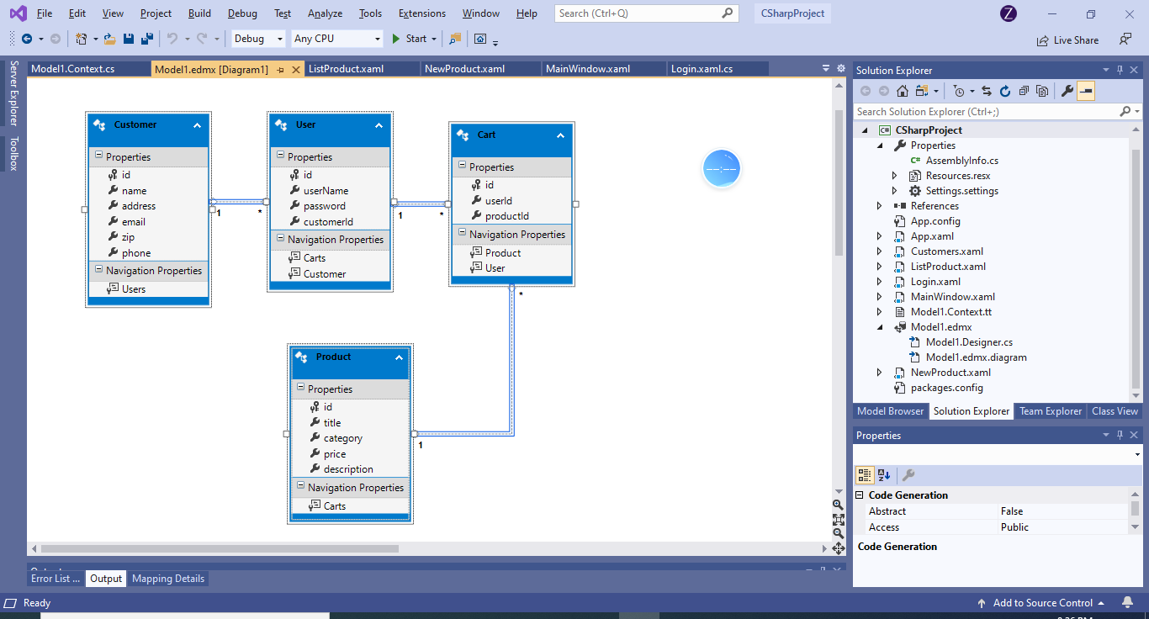

## Database scrips

See document file (2_Shop_Online_DB_Scrip)

## Run my application

See video file (6_Video_Presantation)