Pandas Homework Results and analysis

District Summary Results:

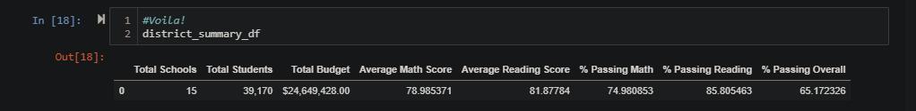

School Summary Results:

Top Performing Schools Results:

Bottom Performing Schools Results:

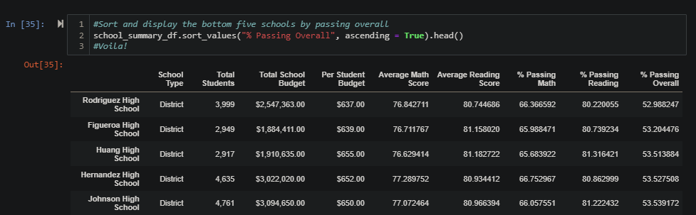

Math Scores by Grade Results:

Reading Score by Grade Results:

Scores by School Spending Results:

Scores by School Size Results:

Scores by School Type Results:

Summary:

In analyzing this data, we can see that that the type and size of the school has the most impact on student performance. As we can see by both the analysis of performance and school type, Charter schools outperformed District schools. Additionally, the size of the schools had a direct correlation to the performance, with small and medium sized schools achieving higher scores per student than large and small schools. Analyzing performance by Grade did not show any significant statistical variance from 9th through 12th grade. Interestingly, the smallest budget per student had the highest grades, which was quite unexpected. Cabrera High School was the top performing school overall and had the lowest budget per student.

My conclusion is that smaller schools yield higher student scores, and this is independent of budget per student. Additionally, Charter schools outperformed District schools. It should be noted that the largest schools were also District schools, so I would say the most important factor in educational excellence is the size of the school. Both medium and small schools had very similar scores per student, with a statistically insignificant difference in performance. Once the 2,000-student threshold was passed, there was a steep decline in performance, with the schools approaching 5,000 students having the worst scores overall.