Introducing Cray OpenSHMEMX
 | 21-March-2018
Abstract
OpenSHMEM is a Partitioned Global Address Space (PGAS) library interface specification, which is the culmination of a standardization effort among many implementers and users of SHMEM programming model. SHMEM has a long history as a parallel programming model. It is extensively used since 1993, starting from Cray T3D systems. For the past two decades SHMEM library implementation in Cray systems evolved through different generations. The current generation of the SHMEM implementation for Cray XC and XK systems is called Cray SHMEM. Cray SHMEM is a proprietary SHMEM implementation from Cray Inc., which is OpenSHMEM standard compliant. In this paper, we introduce the next generation OpenSHMEM implementation for current and future generation Cray systems. We call this new implementation Cray OpenSHMEMX. In this paper, we provide a brief design overview of the implementation along with the usage details, functional differences and performance optimizations over the existing Cray SHMEM implementation.

© 2018 Cray Inc. All Rights Reserved. This manual or parts thereof may not be reproduced in any form unless permitted by contract or by written permission of Cray Inc.
U.S. GOVERNMENT RESTRICTED RIGHTS NOTICE
The Computer Software is delivered as "Commercial Computer Software" as defined in DFARS 48 CFR 252.227-7014.
All Computer Software and Computer Software Documentation acquired by or for the U.S. Government is provided with Restricted Rights. Use, duplication or disclosure by the U.S. Government is subject to the restrictions described in FAR 48 CFR 52.227-14 or DFARS 48 CFR 252.227-7014, as applicable.
Technical Data acquired by or for the U.S. Government, if any, is provided with Limited Rights. Use, duplication or disclosure by the U.S. Government is subject to the restrictions described in FAR 48 CFR 52.227-14 or DFARS 48 CFR 252.227 7013, as applicable.
Cray, LibSci, UNICOS and UNICOS/mk are federally registered trademarks and Active Manager, Cray Apprentice2, Cray C++ Compiling System, Cray Fortran Compiler, Cray SeaStar, Cray SeaStar2, Cray SHMEM, Cray Threadstorm, Cray X1, Cray X1E, Cray X2, Cray XD1, Cray XMT, Cray XT, Cray XT3, Cray XT4, CrayDoc, CRInform, Libsci, RapidArray, UNICOS/lc and UNICOS/mp are trademarks of Cray Inc.
OpenSHMEM

Table of Contents
Introduction………………………………………………………………………………………………………..5
Background………………………………………………………………………………………………………...5
Cray OpenSHMEMX Usage Information and Product Details…......…………………………...........................5
Cray OpenSHMEMX Supported Features and Enhancements………………………………...………………...6
Backward Compatibility Information……………………………………………………………………………..9
Roadmap to Cray OpenSHMEMX version 8.0.0....….....………………………………………………………..11
Performance Regression Analysis Report……….………………………………………………………………..12
Reporting Bugs.............................………………………………………………………………………………..14
Conclusion………………………………………………………………………………………………………..14

Introduction
Cray OpenSHMEMX is a new proprietary SHMEM library implementation for the current and future generation Cray architectures by Cray Inc. It is OpenSHMEM standard compliant and it is an enhanced version of the current Cray SHMEM library implementation. Apart from the regular OpenSHMEM compliant features, we have imported all the existing Cray specific features from the Cray SHMEM library. We have either provided the same performance or optimized the performance of many features compared against the Cray SHMEM library. We have also expanded the support to different architectures. The major part of this paper covers:
- basic background information for the Cray OpenSHMEMX library;
- itemizes the list of enhancements in Cray OpenSHMEMX library comparing against the Cray SHMEM library;
- full complete backward compatibility details of the new Cray OpenSHMEMX library against the existing Cray SHMEM library; and
- early performance regression analysis of the different Remote Memory Access (RMA) and Atomic Memory Operations (AMO) using OSU OpenSHMEM microbenchmarks.

Background
The current generation SHMEM library implementation for Cray Systems is Cray SHMEM. Cray SHMEM is based on an underlying communication library called DMAPP. DMAPP supports logically shared, distributed memory programming model targeting Cray-developed Gemini and Aries interconnect architectures. In anticipation of future Cray system architectures, we extended the Cray SHMEM library implementation to support different underlying communication libraries. The name of this new extended SHMEM library implementation is called Cray OpenSHMEMX. Apart from providing support for different underlying communication libraries, Cray OpenSHMEMX also provides support for different processor architectures and other enhanced features.

Cray OpenSHMEMX Usage Information and Product Details
The current version of Cray OpenSHMEMX is not released as a replacement library for the existing Cray SHMEM library. Cray OpenSHMEMX is released as a separate product from Cray SHMEM on different Cray systems with plans to supersede the existing Cray SHMEM library in near future.
We will continue to provide support for both Cray SHMEM and Cray OpenSHMEMX on the supported Cray systems. This support is intended to provide stability for the existing Cray SHMEM users to migrate towards the new product. The current ‘major.minor’ version number of the Cray SHMEM library are in the 7.7 series. To indicate that Cray OpenSHMEMX is a superset of Cray SHMEM, we start the ‘major.minor’ version number of Cray OpenSHMEMX with 8.0 series. The following table provides different information for using Cray OpenSHMEMX on Cray systems.

Processor Type | Cray SHMEM | Cray OpenSHMEMX
Official Product Name | Cray SHMEM | Cray OpenSHMEMX
Module name | cray-shmem | cray-openshmemx
C wrapper | cc | cc
C++ wrapper | CC | CC
Fortran wrapper | ftn | ftn
Supported Programming Environments (X86) | CCE, Intel, GNU, PGI | CCE, Intel, GNU, PGI
Supported Programming Environments (AARCH64) | - NA - | CCE, GNU
Current Version Info (Format: minor.minor.release) | 7.7.* | 8.0.*
The following steps in Figure:1 provides information on using the Cray OpenSHMEMX library for running a simple OpenSHMEM example program.

>> cat example.c

#include <stdio.h>
#include <shmem.h>
int main(void) {
shmem_init();
printf(“Hello from %d of %d\n”, shmem_my_pe(), shmem_n_pes());
shmem_finalize();
return 0;
}
>> module load cray-openshmemx
>> cc example.c -o example.out
>> aprun -n2 -N1 ./example.out
Figure 1: Information on using Cray OpenSHMEMX library for running a simple OpenSHMEM example program

Cray OpenSHMEMX Supported Features and Enhancements
In this section, we itemize the supported features in Cray OpenSHMEMX and the enhancements added to Cray OpenSHMEMX compared to Cray SHMEM library.

Processor Type | Cray SHMEM | Cray OpenSHMEMX
Intel Xeon | YES | YES
Intel Xeon Phi | YES | YES
ARM (AARCH64) | NO | YES
The following table provides a brief overview of the different supported architectures. Apart from providing support for the regular Xeon and Xeon Phi systems as Cray SHMEM, Cray OpenSHMEMX provides extended support for ARM based systems.

Features | Cray SHMEM | Cray OpenSHMEMX
OpenSHMEM (OSH) Compliance | OpenSHMEM-1.3 | OpenSHMEM-1.4
- OSH-1.4 Contexts and Sync | NO | YES
- OSH-1.4 Ext Typed RMA, AMO | YES | YES
- OSH-1.4 shmem_test | YES | YES
- OSH-1.4 shmem_calloc | YES | YES
- OSH-1.4 Bitwise AMOs | YES | YES
Cray specific Teams | YES | YES
Cray specific Team based collectives | YES | YES
Cray specific Thread Hot | YES | YES
Cray specific Memory Partitions | YES | Pending Enhancement
Cray specific Non-blocking AMOs | YES | YES
Cray specific Put-with-Signal | YES | YES
Cray specific Local Node Queries | YES | YES
Cray specific AlltoAllv | YES | YES
Cray specific AlltoAllv_packed | YES | YES
Cray specific Generics | YES | YES
Fortran 2008 Wrapper | NO | Pending Enhancement
The above list itemizes the different supported features in Cray SHMEM and Cray OpenSHMEMX. The features are explained in brief in the following sections.
OpenSHMEM Compliance: Cray SHMEM is officially OpenSHMEM standard version-1.3 compliant and Cray OpenSHMEMX is officially OpenSHMEM standard version-1.4 compliant. In addition to being version-1.3 compliant, Cray SHMEM also supports different features like OpenSHMEM extended typed RMA and AMOs, bitwise Atomics, shmem_test and shmem_calloc routines from the OpenSHMEM standard version-1.4.
OpenSHMEM Communication Contexts and Synchronization Operation: Communication contexts is one of the most important flagship features added to the OpenSHMEM standard version-1.4. Communication contexts allows users to create multiple independent streams of communication within the same application and provide opportunities for thread isolation by eliminating synchronization overheads on multithreaded OpenSHMEM applications. Cray OpenSHMEMX provides support for OpenSHMEM Communication Contexts and the synchronization routines (shmem_sync and shmem_sync_all) associated with it. Cray SHMEM doesn’t provide support for this feature.
Cray specific Teams Creation and Team Management Routines: Teams are the features provided exclusively in the current Cray SHMEM implementation to create flexible PE-subsets. This Cray specific feature is being discussed in the OpenSHMEM standard for inclusion. Cray OpenSHMEMX continues to provide support for all the Team creation and Team management routines including cartesian based (shmem_team_split_2d, shmem_team_split_3d), strided (shmem_team_split_strided), and color based (shmem_team_split) Team creation routines.
Cray specific Team-based Collective Operations: The current OpenSHMEM collective operations like AllReduce, Alltoall, Broadcast, Barrier, Collect, and FCollect are Active Set based. Active set is defined by the arguments PE_start, logPE_stride, and PE_size. PE_start is the starting PE number, a log (base 2) of logPE_stride is the stride between PEs, and PE_size is the number of PEs participating in the Active set. Only PEs which are part of the Active set can be part of the collective operation. Active set based collectives are restrictive in terms of creating flexible PE-subsets. Cray SHMEM provided users with the flexibility for using Teams for collectives instead of relying on Active sets. Cray OpenSHMEMX continues to provide support for this feature. This feature is also being discussed in the OpenSHMEM standard for inclusion.
Cray specific Thread-hot Function using Thread Register and Deregister Approach: Thread-hot is feature through which Cray provided support for separate resource allocation for each thread involved in the multithreaded SHMEM application. This is a Cray specific feature and has huge performance benefits on multithreaded applications using certain threading models like OpenMP and Pthreads. This feature is superseded by the Communication Contexts in OpenSHMEM standard. But, Cray SHMEM continues to provide support for this feature for backward compatibility reasons and Cray OpenSHMEMX follows the same approach.
Cray specific Non-blocking AMOs: Both Cray SHMEM and Cray OpenSHMEMX continues to provide support for non-blocking AMOs. The only difference is that Cray OpenSHMEMX has extended the support for different data types as introduced in the Table 6 available on the OpenSHMEM standard version-1.4. This is a Cray specific feature and it is currently under discussion in the OpenSHMEM standard.
Cray specific Put-with-signal Operations: Put with Signal is an operation, where a RMA put operation is followed by a signal operation to the same PE to notify the completion of the put operation through the signal. This routine allows implementations to make use of the hardware optimizations as well as avoid the shmem_fence operation between the put and signal. This is a Cray specific feature and it is available in both Cray SHMEM and Cray OpenSHMEMX. This feature is also actively discussed in the OpenSHMEM standard and is expected to be part of the official OpenSHMEM standard version-1.5
Cray specific Local Node Queries: Cray OpenSHMEMX provides support for local node based queries like shmem_local_npes, shmem_local_pes, and shmem_local_ptr
Cray specific AlltoAllv and AlltoAllv-packed Operations: Alltoallv and Alltoallv_packed are Cray specific collectives which are available as part of both Cray SHMEM and Cray OpenSHMEMX.
Cray specific Symmetric Memory Partitions: Symmetric Memory partitions enables users to create multiple symmetric heaps per PE and with each HEAP its own properties like kind of memory (high-bandwidth, DDR), page size and size. This Cray specific feature is not currently supported in Cray OpenSHMEMX, but is planned for addition in future releases.
Support for Fortran: As of OpenSHMEM version-1.4, the support for Fortran is deprecated in the standard. Cray continues to provide support for Fortran language bindings and we extended this support with a new Fortran 2008 Bind(C) wrapper interface. This new extended Fortran 2008 interface is planned to be proposed into the OpenSHMEM standard.

Backward Compatibility Information
By default, Cray OpenSHMEMX supports all the features which are supported by Cray SHMEM, but all these features but are not backward compatible with respect to the routines through which they can be accessed.
Pre-OpenSHMEM standard version-1.3, implementation specific features (in our case Cray specific features) are supported through SHMEM_ prefixed routines in all the available SHMEM implementations. But from OpenSHMEM standard version-1.3, all implementation specific routines are expected to be named only with SHMEMX_ prefix and grouped into the shmemx.h header. For backward compatibility reasons, in Cray SHMEM we provided support for Cray specific features with both SHMEM_ prefixed and SHMEMX_ prefixed routines. We removed this duplication in Cray OpenSHMEMX and provided support only for the SHMEMX_ prefixed routines. There are internal options available to override this change that are not documented now. Please create an information requests, if more details on the available internal override options are needed.
The following table provides a comprehensive list on the Cray specific features for which SHMEM_ prefixed routine support is removed and only the SHMEMX_ prefixed routine support is available in Cray OpenSHMEMX. The Routines column provides the SHMEMX_ prefixed routine names.

Features | Routines
Local node Queries | shmemx_local_npes, shmemx_local_pes, shmemx_local_npes
Event Operations | shmemx_clear_event, shmemx_set_event, shmemx_test_event, shmemx_wait_event
Put with Signal | shmemx_##TYPENAME##_put_with_signal, shmemx_##TYPENAME##_put_with_signal_nb  NOTE: TYPENAME is the DATATYPE as supported by OpenSHMEM-1.4 Table 3
Old Cray specific NB RMAs | shmemx_##TYPENAME##_put_nb, shmemx_##TYPENAME##_get_nb  NOTE: TYPENAME is the DATATYPE as supported by OpenSHMEM-1.4 Table 3
AMOs with short Datatype support | shmemx_short_swap_nb, shmemx_short_cswap_nb, shmemx_short_finc_nb, shmemx_short_inc_nb, shmemx_short_fadd_nb, shmemx_short_add_nb
Non-blocking AMOs | shmemx_##TYPENAME##_swap_nb, shmemx_##TYPENAME##_cswap_nb, shmemx_##TYPENAME##_finc_nb, shmemx_##TYPENAME##_inc_nb, shmemx_##TYPENAME##_fadd_nb, shmemx_##TYPENAME##_add_nb  NOTE: TYPENAME is the DATATYPE as supported by OpenSHMEM-1.4 Table 6
Team creation and management | shmemx_team_split, shmemx_team_split_2d, shmemx_team_split_3d, shmemx_team_split_color, shmemx_team_split_strided  shmemx_team_free, shmemx_team_n_pes, shmemx_team_my_pe , shmemx_team_translate_pe
Collectives with Generic types | shmemx_alltoall, shmemx_alltoallv, shmemx_alltoallv_packed
Team-based collectives | shmemx_team_barrier  shmemx_team_alltoall, shmemx_team_alltoallv, shmemx_team_alltoallv_packed  shmemx_team_##TYPENAME##_(and/max/min/sum/prod/or/xor)_to_all
Apart from the above listed routines, all the Cray specific generic RMA and AMO routines are supported only through the SHMEMX_ prefixed routines. The SHMEM_ prefixed routines are superseded in the OpenSHMEM standard through the C11 generic routines.

Roadmap to Cray OpenSHMEMX version 8.0.0
The first official Cray OpenSHMEMX product is a pre-release to version-8.0.0. There are some missing features in this pre-release version-8.0.0.5. The following list provides a brief overview on some planned changes in the Cray OpenSHMEMX library from the version-8.0.0.5 through version-8.0.0.

Features | Roadmap
Manpage | Cray OpenSHMEMX does not provide support for manpage in the pre-release version-8.0.0.5 but it will be added in version-8.0.0
OpenSHMEM Communication Contexts | Cray OpenSHMEMX does not provide support for optimized resource allocation for the OpenSHMEM Communication Contexts feature in pre-release version-8.0.0.5 but it will be added in version-8.0.0
Symmetric Memory Partitions | Cray OpenSHMEMX does not provide support for the multiple symmetric heap creation per PE with different properties in the pre-release version-8.0.0.5 but it will be added in version-8.0.0
Old Fortran Bindings | Cray OpenSHMEMX does not provide support for the old OpenSHMEM deprecated Fortran bindings in the pre-release version-8.0.0.5 but it will be added in version-8.0.0. The old OpenSHMEM standard deprecated Fortran bindings are accessed through the shmem.fh header file.
Fortran 2008 Bind(C) Wrapper | Cray OpenSHMEMX does not provide support for the new OpenSHMEM proposed Fortran 2008 Bind(C) wrapper interface in the pre-release version-8.0.0.5 but it will be added in version-8.0.0. The new Fortran 2008 Bind(C) wrapper interface provided in Cray OpenSHMEMX can be accessed through the mod files provided in the package.
Optimizing OpenSHMEM Collectives | Cray OpenSHMEMX does not provide support for different Cray optimized collective algorithms in the pre-release version-8.0.0.5 and these algorithms will be imported from the Cray SHMEM library and made available in the version-8.0.0
Please raise an information request in JIRA for more details on the planned release dates for the different versions and for any request for new features.

Performance Analysis Report
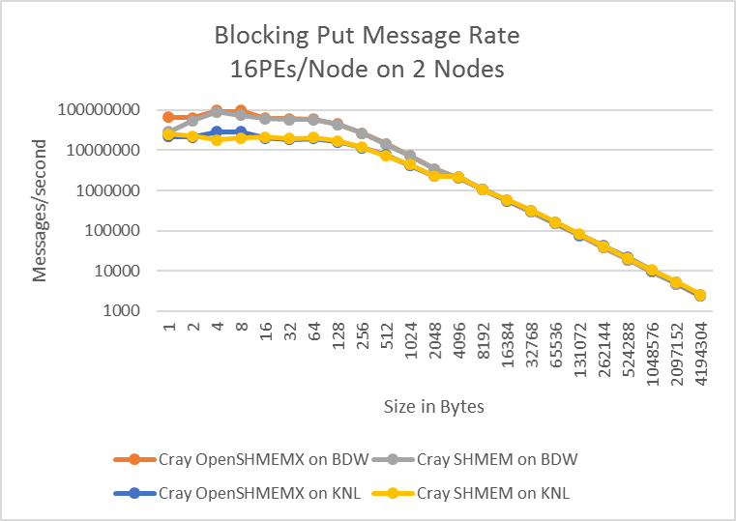
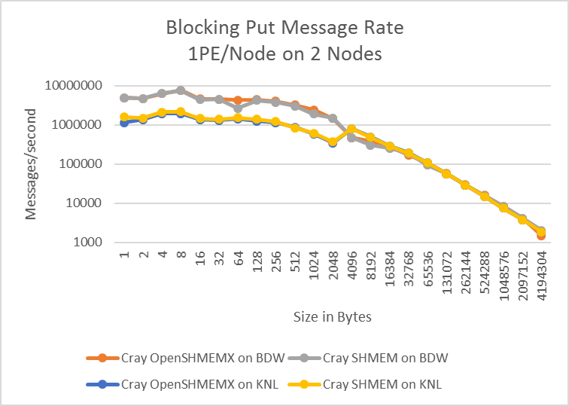
Figure 2 (a) and (b) – Measuring the Message Rate of the Blocking Put RMA Operation on Intel Broadwell and Intel KNL processors using OSU Microbenchmarks
We used OSU Microbenchmark suite version 3.4.1 to test the performance regression between the existing Cray SHMEM against the new Cray OpenSHMEMX library. We performed regression tests for measuring the latency and message rate of the blocking put, blocking get, non-blocking put and non-blocking get operations. We performed these tests using Cray SHMEM version 7.7.0 and Cray OpenSHMEMX version 8.0.0.5 on Cray XC system with Intel Broadwell and Intel KNL processors using Cray Programming Environment. In general, there were no performance degradation. The performance of the new Cray OpenSHMEMX library is on-par with the production grade Cray SHMEM library.
Figure 2(a) and 2(b), shows the results of the message rate obtained from the blocking put operation with 1 PE per node and 16 PEs per node using 2 Nodes respectively. The x-axis represents the message size in bytes and the y-axis the number of messages per secon. We can see that the performance of Cray OpenSHMEMX is on-par with the Cray SHMEM library or within a 3% variance. For very small message sizes line 4 and 8 bytes, we can see that the performance of the Cray OpenSHMEMX library is improved by 12% compared against the Cray SHMEM library on Intel KNL processors. This performance improvements can be attributed to the optimizations in the number of instruction counts it takes to reach the DMAPP communication call.
Similar performance regression analysis were performed on other OpenSHMEM RMA operations like blocking get, non-blocking put and non-blocking get operations. In general, the performance variance is kept below the 3% difference.
We measured the latency of different AMO operations on Intel Broadwell processors and Figure 3 shows the analysis of these results. The x-axis represents the number of PEs per node and y-axis the latency in seconds. We used 2 nodes for this analysis. In general, the performance variation between the Cray SHMEM and Cray OpenSHMEMX library are maintained below 3%. This difference is also same on the Intel KNL based systems.
We measured the performance of different collectives. Figure 4, shows the results of the all-reduce collective operation on a 300 Node Cray XC system with different configurations like 1 PEs per Node, 16 PEs per Node and 32 PEs per Node. We can see that the performance of the All-reduce collective in the Cray OpenSHMEMX and Cray SHMEM are similar for very small message sizes and the performance of the Cray OpenSHMEMX degrades for medium and very large message sizes. This performance degradation can be attributed to the unavailability of the Cray optimized collective algorithms in the Cray OpenSHMEMX library. This performance analysis is performed using Cray OpenSHMEMX version 8.0.0.5, which is an early pre-release to the official 8.0.0 release. The performance of all OpenSHMEM collectives will be optimized in the official 8.0.0 release.
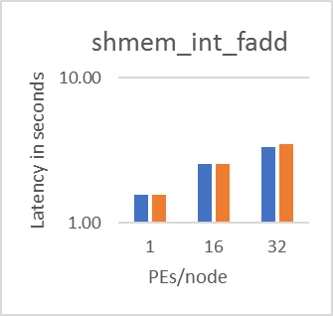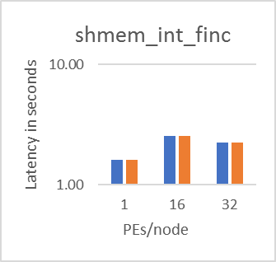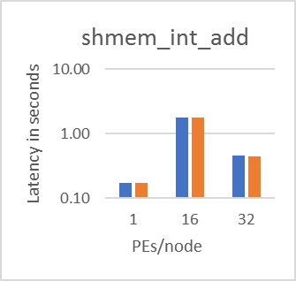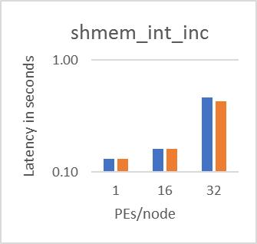
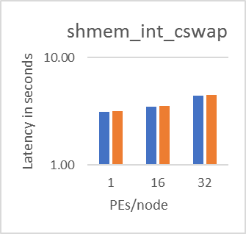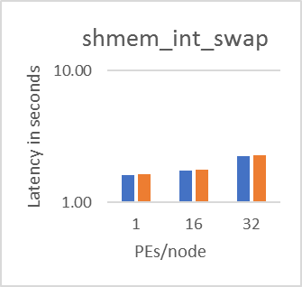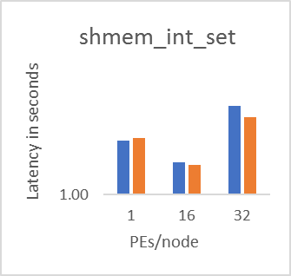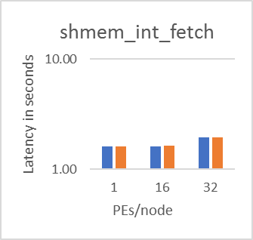
Figure 3: (a), (b), (c), (d), (e), (f), (g) and (h) – Measuring the Latency of the Different AMO Operations on Intel Broadwell processors using OSU Microbenchmarks
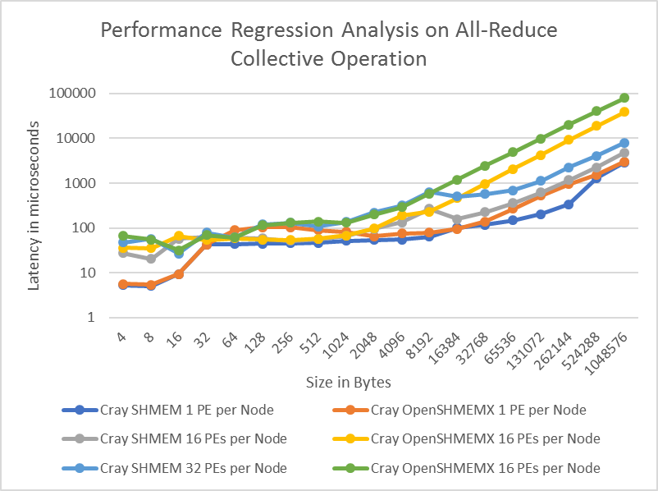

Figure 4: Measuring the Latency of the All-reduce Collective Operation on Intel Broadwell processors using OSU Microbenchmarks on 300 Nodes

Reporting Bugs
Currently, Cray SHMEM is the official production ready OpenSHMEM library for all current Cray systems supported by Cray Inc. We will continue to provide support for Cray SHMEM on all systems.
Cray OpenSHMEMX is a new product which is planned to supersede the Cray SHMEM library in near future. Early access to this new library is provided for existing users to start migrating towards the new library.
As with any new and existing Cray software products, any Bugs, Information Requests and Request for new features are accepted through the JIRA tracking system. Please use the following information for creating JIRAs against Cray SHMEM and Cray OpenSHMEMX library.
Please use the following information for creating JIRAs against Cray SHMEM library:
Components Name: MPT shmem
Labels: Cray-SHMEM
Please use the following information for creating JIRAs against Cray OpenSHMEMX library:
Components Name: MPT shmem
Labels: Cray-OpenSHMEMX

Conclusion
Cray OpenSHMEMX is the new software library product from Cray Inc. It is planned to supersede the current production ready Cray SHMEM library on future Cray systems. Apart from importing all the existing Cray specific features from Cray SHMEM library, Cray OpenSHMEMX is designed as a highly modular SHMEM implementation to support the current and future OpenSHMEM standard specification. Cray OpenSHMEMX has support for different system architectures like X86 and AARCH64 along with other new features like Fortran 2008 Bind(C) interface. Early access to the Cray OpenSHMEMX library is provided for users to start migrating their existing applications to the new library.

