StyleCop report

Presentation layer

Before code style updates:

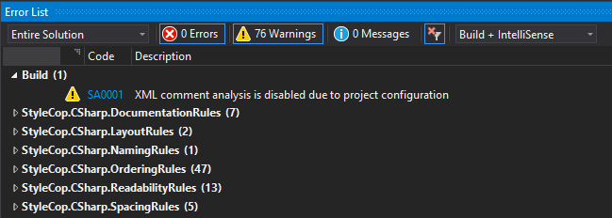

After code style update:

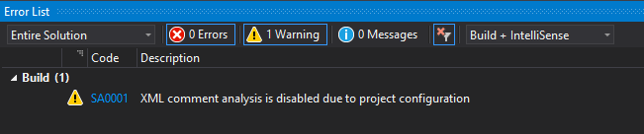

Business logic layer

Before code style update:

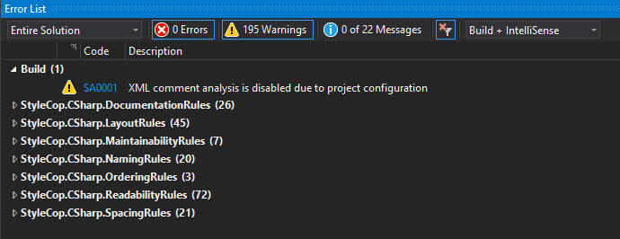

After code style update: