Software Requirements Specification

Purpose

The purpose of this document is to build a desktop application that will engage people in reading. The app will allow the user to add a book to the list of Planned/read books, write revues, and view statistics of books/pages read, as well as remind about scheduled books.

Intended audience and reading suggestions

This document describes an app for reading tracking. This will be useful for people who want to take control of their reading life. Whether you're a book lover, collector, or even just a student this is the book management app for you. Overall, the app is designed to organize your book list, increase your productivity, and save time.

Project scope

The application is a desktop WPF application.

The purpose of the application is to help people track books.

Product features

1. The user can add a book to the list of books they are currently reading.

1.1.The user must enter the title, author, total number of pages and how much he has already read.

1.2. If the user has not filled in the required field, the system will notify him and ask the user to enter the data.

1.3. The user can edit the entered information.

2. The user can remove a book from the list of books that they are currently reading.

3. The user can add a book to his wish list.

3.1.The user must enter the title, author, and total number of pages. By default, the number of pages read is zero.

3.2. If the user has not filled in the required field, the system will notify him and ask the user to enter the data.

3.3. The user can edit the entered information.

3.4. If the user changes the number of pages read, this book will automatically go to the list of books that the user is currently reading or to the list of books read (provided that the total number and number of pages read are equal).

4. The user can remove the book from the wish list.

5. The user can add a book to the list of books he have read.

5.1.The user must enter the title, author, and total number of pages. If desired, user writes a review.

5.2. If the user has not filled in the required field, the system will notify hand ask the user to enter the data.

5.3. The user can edit the entered information.

5.4. When the total number and number of pages read are equal, the book will automatically move from the list of books that the user is currently reading to the list of books read.

6. The user can remove a book from the list of books he have read.

7.The user can view a graph of pages read for a specific period (day / week / month).

8. The user can enable or disable notifications about scheduled books.

8.1. The user enters a convenient time, and at this time reminders will be sent every day.

8.2. The user can edit the entered time.

Nonfunctional Requirements

* The design should be characterized by simplicity and intuitive use, regardless of the experience, education, language level and age of users. The design should be easy to understand and use for people with different levels of capabilities.
* The system must meet the maximum number of user needs.
* The system must display the data correctly.
* Users can add books / view book lists throughout the week at any time of the day. In case of unplanned system downtime, all functions will be available again in one working day.
* Supported systems: Windows 7-10.
* Language: Ukrainian

User class and characteristics

User classes and characteristics can be demonstrated by use case UML diagram:

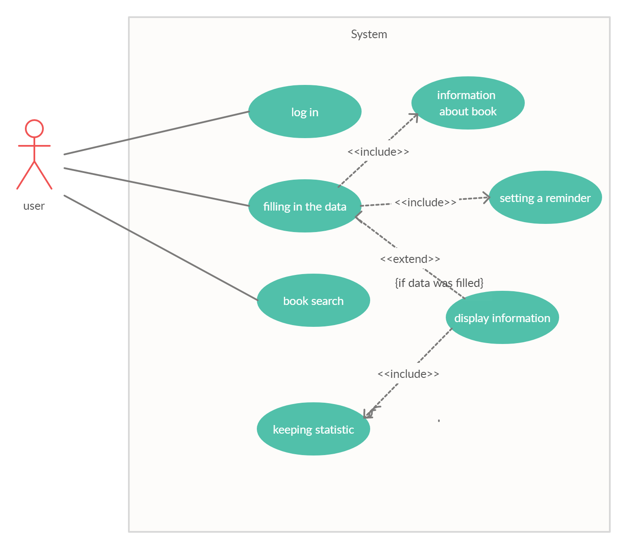

User Interfaces

Homepage

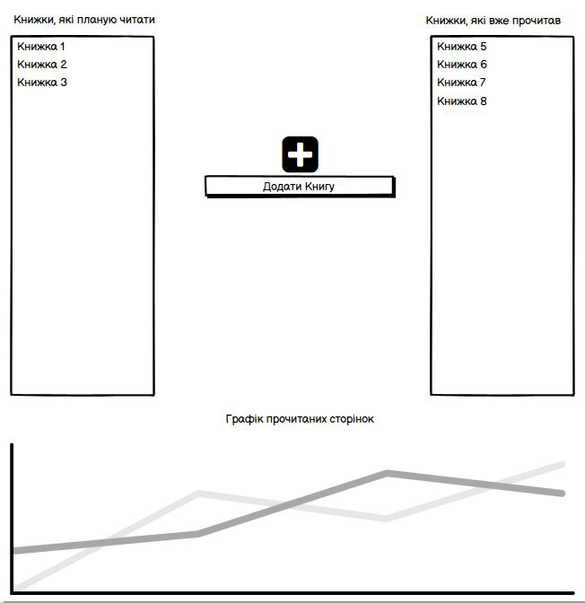

Changing information about the book

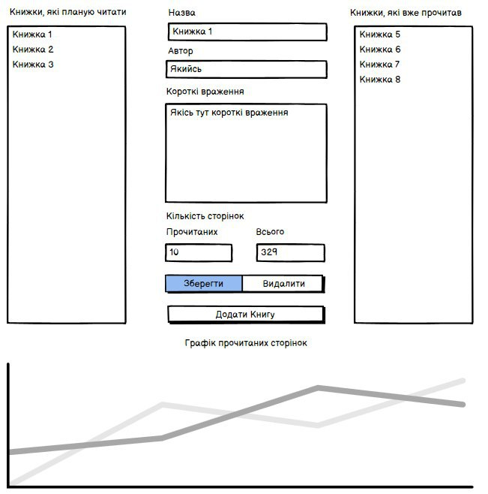

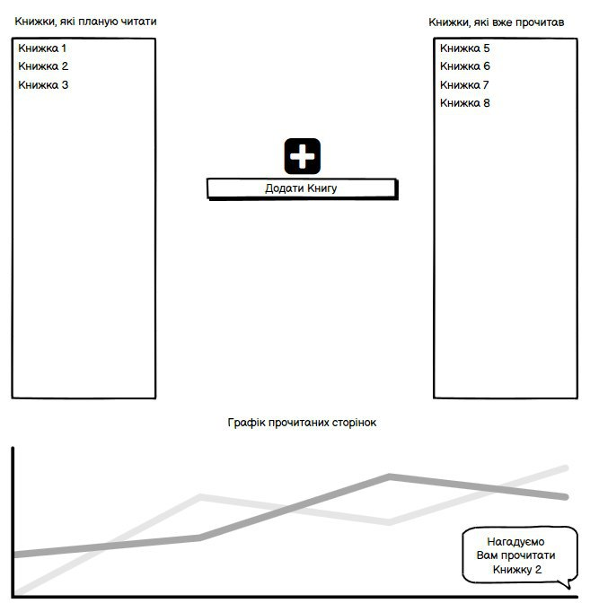Daily Reminders

Settings Menu

