**BLL**

Before(96 warnings)

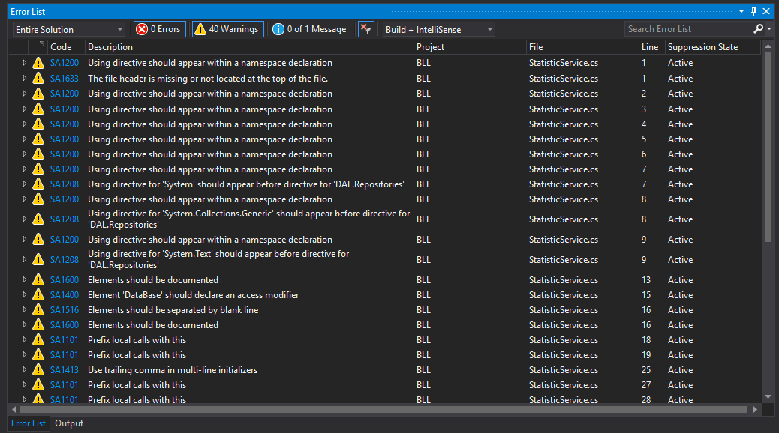

After (StyleCop warnings fixed)

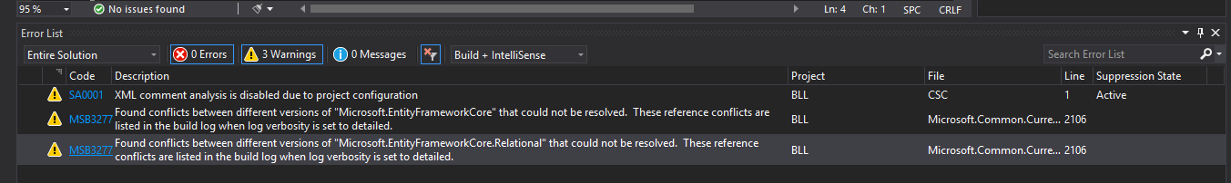

**DAL**

Before(193 warnings)

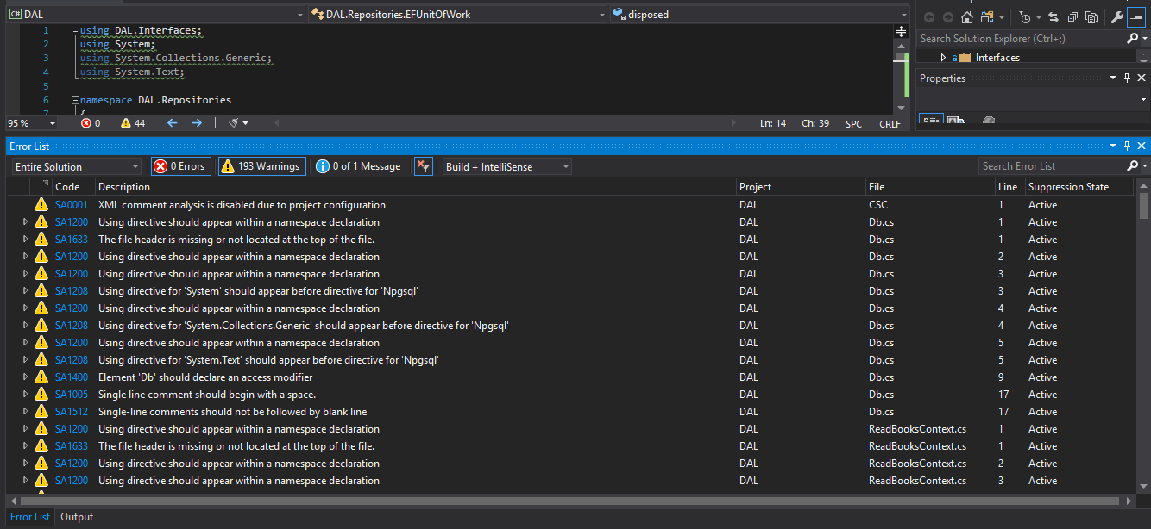

After (StyleCop warnings fixed)

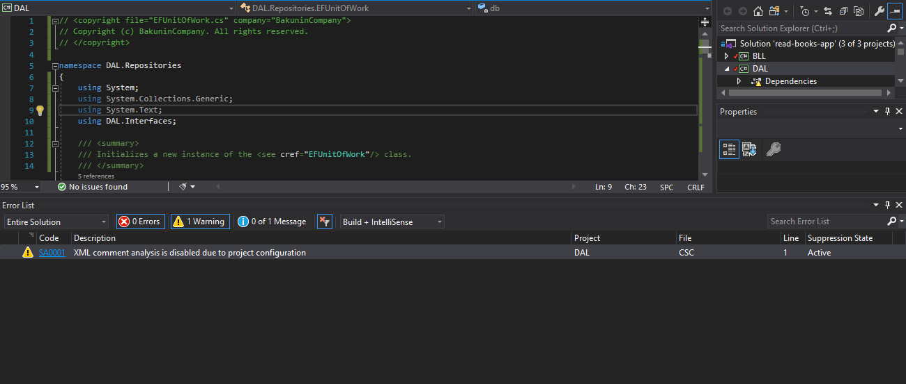

**Presentation**

Before (210 warnings)

After (StyleCop warnings fixed)

