AI TRAINING – ASSIGNMENT 01
AI Fundamentals: Explore, Understand & Explain
Self-Exploration Assignment | Beginner Level
Topic Area | AI overview, AI vs ML vs DL vs GenAI, use cases, and career map
Mode | Self-exploration + research + practical thinking
Suggested Time | 2–3 hours
Submission | One document / PDF containing your answers, examples, and reflections

1. What is this assignment about?
This is not a memorization assignment. Your goal is to explore AI yourself, understand the basic concepts, and explain them in simple words. You are expected to search, watch short videos if needed, use AI tools for clarification, and compare information from multiple sources.
Important: Do not simply copy an AI-generated answer. Use AI as a learning assistant, then rewrite the ideas in your own words and add your own examples.

2. Learning Goals
- Understand what Artificial Intelligence means at a high level.
- Clearly distinguish AI, Machine Learning, Deep Learning, and Generative AI.
- Identify real-world AI use cases across different industries.
- Understand the major career paths available in AI and related technology roles.
- Explain the concepts in your own words instead of relying on textbook definitions.
- Apply the concepts to a practical real-world example.
- Identify common misunderstandings or errors and improve your explanation.

3. Your Mission
Imagine that a friend who knows nothing about AI asks you: “What exactly is AI, what is the difference between AI, ML, DL and GenAI, where is AI used, and what can I become if I learn AI?”
Your job is to create a beginner-friendly answer that your friend can understand in 10 minutes.

4. Step 1 – Explore: What is AI?
Do your own research and answer the following questions:
- What is Artificial Intelligence in your own words?
A)Artificial Intelligence is a technology to make computers or machines to perform tasks that usually require human intelligence.AI is used to solve problems ,understand languages.
- What makes a system 'intelligent'?
A)A system intelligent when system learn from data ,experience, to solve problems , make decisions .
- Give at least 5 examples of AI that you may interact with in daily life.
A)1.Spam message/E-Mail checking
2.Weather prediction
3.product recommendation
4.Google maps
5.Voice recommendations (Alexa)
4. Choose one AI example and explain what the system is doing.
A)Spam Message/Email checking
- Get the message
Example :you won cash prize .Touch this link to claim it
- Learn the features or patterns

It checks the words ,features ,link and senders address.
3.Analyze the message
Ai compare the message with it’s previous spam patterns and real messages.
4.Classify the message
AI classify the message is spam or not.
5.perform the action
If the message is spam it moves the message to spam folder or move to the inbox.
5.Is every software application an AI application? Explain why or why not.
A) NO ,All software applications not AI applications .In software applications, it follows the programmer rules and logics .But Ai applications can learn from data and make decisions and learn patterns.
All AI applications are software applications.

6. What are 2 things AI can do well and 2 things AI may struggle with?
A) Ai can understand large amount of data easily and perform tasks
AI can translate the language
AI may struggle with:
It may not understand the human emotions
It does not have the human intelligence
Research rule: Use at least 3 learning sources. These can be articles, videos, official documentation, or educational websites.
Tip: Try searching for simple explanations first. If two sources disagree, investigate why.

5. Step 2 – The Big Picture: AI vs ML vs DL vs GenAI
This is the most important part of the assignment. Do not memorize definitions. Build a mental model.
First, complete this comparison table in your own words:
Concept | What is it? | How does it learn/work? | Simple example | Relationship | Your analogy
AI | It is to make machine to perform tasks | It works by rules ,logics and data | It can recommend products | Ai is a large field .ML, DL and GENAI are related to AI | Big house
Machine Learning (ML) | ML is subset of AI .Learn patterns from data to make predictions. | It learn patterns from data .use those patterns to make predictions | Weather prediction | ML is subset of AI | A room inside the big house
Deep Learning (DL) | DL is subset of ML .It uses the neural networks with multiple layers to learn complex patterns from data | It uses the neural networks with multiple layers to learn complex patterns from large amount of data | Face recognition | DL is subset of ML. | A room inside the ML room like a secret room
Generative AI (GenAI) | GENAI is AI and it can generate the new content ,images ,videos | It learn patterns from large amount of data .to generate new content and images using a prompt | chatgpt | GENAI is a type of AI .It uses the deep learning models . | IT is a creative room where new things are create

Now answer these questions:
- Is ML a part of AI? Explain with a simple example.
A)YES, ML is subset of AI .Example movie recommendation ,If a user watches a particular kind of movies, then AI recommend those kind of movies to the user
- Is Deep Learning a type of Machine Learning? Explain.
A)YES. Deep learning is a type of Machine learning .DL uses the neural networks with multiple layers to learn complex patterns.
- Is Generative AI the same thing as AI? Why?
A)No. GENAI and AI are different things .GENAI is a type of AI .GENAI can generate new content ,images, videos based on a prompt.
- Can an AI system exist without Machine Learning? Research and explain one example.
A)Yes. An AI system an exist without machine learning .The traditional AI uses the logics ,techniques and methods to perform tasks.
Ex: Rule based systems works by using rules written by programmers.
- Draw a simple diagram showing the relationship between AI, ML, DL and GenAI.

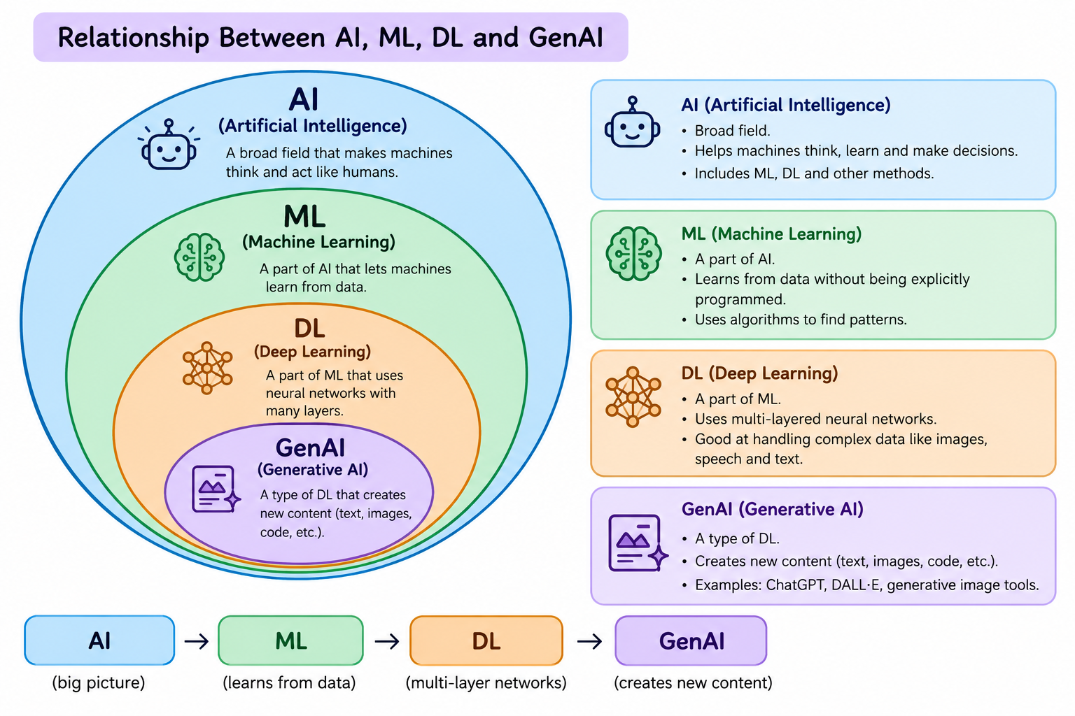

- Create one real-world analogy to explain all four concepts together.
A)Restaurant is like an AI
Learning customer food preferences like a ML.
Based on customer food preferences the chef prepare food.
Generate new recipes by using ingredients .

6. Step 3 – Use Case Hunt
Find AI applications in different industries. Do not use only ChatGPT examples.
Industry | AI use case | AI / ML / DL / GenAI? | Who benefits? | What could go wrong?
Banking / Finance | Find the fraud transactions | ML | Banks and customers | Identify the correct transaction as fraud  transaction
Healthcare | Detect the disease by using images of medical reports | DL | Doctors and patients | If AI predict the wrongly it leads to wrong decisions.
Education | Self learning, recommendation of websites to learn | ML | Students | Sometimes the recommendations are not math the student needs
Retail / E-commerce | Recommending products | ML | Customers and sellers | It may recommend unsuitable products
Manufacturing | Detect the defects in products | DL | Manufacturers and customers | If the defect is incorrectly detected
Agriculture | Detect diseases in crops | DL | Farmers | if it detect disease wrongly
Transportation | Predict the traffic on the route | ML | Drivers and Pssengers | If it predict wrongly it may lead to time being waste
Entertainment / Media | Generate new content | GenAI/ML | users | Ai may generate incorrect content

Challenge: Find one AI use case that you think is surprisingly useful and explain why.
Agriculture – Protecting Crops from Animals
AI can detect when an animal enters a farmer's field using a camera. When an animal is detected, the system sends an alert message to the farmer and activates a speaker that produces a safe warning sound to encourage the animal to leave the field.
Flow:
Camera -> AI detects animal -> Alert farmer ->Speaker produces sound -> Animal leaves the field

7. Step 4 – Mini Practical Exercise: Design an AI Solution
Choose ONE problem from your college, personal life, local community, or a business you know. Design a simple AI-based solution. You do not need to build the software.
- What problem are you trying to solve?
A) of crop from Animals eating or destroying the crop
- Who faces this problem?
A) Farmers
3. What information/data would your system need?
A)Where the field is located, farmer mobile number, images(or) videos of the field to identify the animals
4.Would you use AI, ML, DL, GenAI, or a combination? Why?
A) I would use ML because it can learn patterns from images or videos and identify animals .
5. What would the system take as input?
A) Images or videos of the crop captured by camera

6.What would the system produce as output?
A) A message to the framer’s mobile and a sound that encourages the animals to leave the field
7.Give one example of how a user would interact with it.
A) A farmer receives a alert message when animal enter the field.
8.What could go wrong with your solution?
A) If the system identifies an object or some thing else as an animal it may lead to wrong decision

9. How would you reduce or handle that risk?
A) I would train the Ml model with more images or videos to detect animals correctly and test it properly.
Example idea (do not copy): A college assistant that answers student questions about assignments, attendance rules, and course material.

8. Step 5 – Career Map: Where Can AI Take You?
Explore AI-related career paths. The goal is not to decide your career today; it is to understand what different roles actually do and what skills they require.
Role | What do they do? | Key skills | Typical tools/technologies | Would I explore it? Why?
AI / ML Engineer |  | Python, ML, problem-solving | Python, TensorFlow, PyTorch, Scikit-learn | Yes. I would explore it because I am interested in AI
  Builds and develops AI/ML models and applications.
Data Scientist | Analyzes data and uses it to find patterns and make predictions. | Python, statistics, data analysis | Python, Pandas, NumPy, SQL | Yes. I would explore it because I like working with data.
Data Analyst | Analyzes data and creates reports to help businesses make decisions | Excel, SQL, data analysis | Excel, SQL, Power BI, Tableau | Yes. I would explore it because data analysis is useful in many companies.
Generative AI / LLM Engineer | Builds applications using generative AI and large language models. | Python, AI, prompt engineering | Python, APIs, LLMs, LangChain | Yes. I would explore it because GenAI is interesting to me.
AI Product Manager | Plans and manages AI-based products and works with technical teams. | Communication, planning, AI knowledge | Jira, product tools, analytics tools | Maybe. I would explore it because it combines technology and management.
AI Researcher | Researches new AI methods and develops new AI techniques. | Mathematics, programming, research | Python, PyTorch, TensorFlow | Maybe. I would explore it if I become interested in AI research.
Computer Vision Engineer | Develops systems that understand images and videos | Python, computer vision, deep learning | OpenCV, PyTorch, TensorFlow | Yes. I would explore it because I am interested in image-based AI
NLP Engineer | Develops systems that understand and process human language. | Python, NLP, ML | Python, NLTK, spaCy, Transformers | Yes. I would explore it because language-based AI is interesting.
MLOps / AI Platform Engineer | Deploys, monitors, and maintains ML/AI systems. | Python, cloud, DevOps, ML | Docker, Kubernetes, AWS/Azure/GCP | Maybe. I would explore it after learning more about ML and cloud technologies.
AI Application Developer | Builds applications that use AI features. | Programming, AI, software development | Python, Java, APIs, AI tools | Yes. I would explore it because I want to develop AI-based applications.

9. Step 6 – Career Self-Check
Based on your exploration, answer:
Which AI-related role interests you most right now?
A)AI application Developer
Why does it interest you?
A) Because I learn most of those tools/tecnologies
What skills do you already have that may help?
A)python ,java
What are 3 skills you need to learn next?
A)APIs,AI tools
What would your 2-month learning roadmap look like?
A)Month1:learn basics of python,ai,ml.And learn how to use APIs.
Month2:how to build ai application ,and learn basics of GENAI and prompt engineering and Build simple project
What would you like to build after learning the basics?
- I would like to build an AI application that solves a real-world problem.

10. Step 7 – Common Errors: Find and Fix Them
For each statement below, decide whether it is correct, partially correct, or incorrect. Then explain why.
- “AI and Machine Learning are exactly the same thing.”
A) NO,AI is a technology to make computers or machines used to solve tasks that usually require human intelligence But ML is subset of AI used to make predictions without being explicitly programmed for every task
2.“Deep Learning is unrelated to Machine Learning.”
A) NO,DL is subset of ML. Dl use the multiple neural networks to learn complex patterns from large amount of data
3. “ChatGPT is just a search engine.”
A) No, chatgpt is a Ai system that can understand the question and generate answers ,and summarize the text and generate images and it also search web when it is available.
4. “Generative AI always gives correct answers.”
A)NO, Sometimes GEN Ai can generate incorrect or misleading answers ._so we should verify important information without blindly follow the ai answers.
5._”More data automatically means a better AI systems_.”_
A)NO, More data automatically can not mean a better system .The quality ,accuracy and relevance are also important.
Ex: A model trained on a lot of incorrect data may give poor results, even though it has a large amount of data
6.“If a company uses AI, it does not need humans anymore.”
A)NO, if a company use Ai ,it doesn’t mean that humans are no longer required .The humans are require to solve problems, make decisions ,and manage AI systems.
7.Data automatically means a better AI system.”
A)No ,Data automatically doesn’t means a better AI system_.The data must be relevant and quality.If the data is poor quality then AI system give wrong results.

11. Step 8 – Teach It Back
Pretend you are the trainer. Explain the following in a way that a Class 10 student can understand:
1. What is AI?:
A)AI(Artificial Intelligence) is computer technology to make computer (or) machnines _to perform tasks the usually require human intelligence.AI is used to understand the languages ,generate images, and solve problems.
2. AI vs ML:
A) AI is tecnnology to make machnies or computers to perform tasks the usually require human intelligence._
ML is a subset of AI used to learn patterns from the data and make predictions_without being explicitly Programmed for every task.
3.ML _vs DL:

A)ML(Meachine Learning) is a subset of AI used to learn patterns from the data and make predictions_.
DL(Deep Learning) is a subset of Ml that uses neural networks with multiple layers to learn complex patterns from large amount data. EX :Face recognition.
4. What is Generative AI?:
A)Generative AI is used generate the new content based___ on our prompt EX: generate the text , generate images, generate videos_. For example if we give a prompt like “Write a story about farmer”_. Then GENAI can a story.
5. One real-world AI use case:
A)Spam E-Mail/_Message checking _.If we send a message or Email to the ML model ,the model can predict if it is a spam message or not..
For Example :You won a cash price .Click this link to claim it.
6. One AI career path:
A)Programming language(python)->learn mathematics/statistics->learn AI->learn ML->learn DL->BUILD projects

12. Final Challenge – 5-Minute AI Explanation
Record a 3–5 minute video or prepare a 1-page explanation as if you are teaching a friend. You must cover: AI → ML → DL → GenAI → real-world use case → career path.
Optional: Use a diagram, analogy, or story. Avoid reading a copied definition.

13. What to Submit
- AI explanation in your own words
- AI vs ML vs DL vs GenAI comparison table
- Relationship diagram
- 8-industry use-case table
- One AI solution design
- AI career map
- Career self-check
- Common errors and corrected explanations
- Teach-it-back answers
- Final 3–5 minute explanation OR 1-page summary

14. Self-Evaluation Checklist
I can... | Yes | Need More Practice | Notes
Explain AI without using a memorized definition. | yes | ☐
Explain the relationship between AI, ML, DL and GenAI. | yes | ☐
Give real-world examples of AI. | yes | ☐
Identify whether a use case involves ML, DL or GenAI. | ☐ | ☐need more practice
Explain at least 5 AI career roles. | ☐ | ☐need more practice
Design a basic AI solution for a real problem. | ☐yes | ☐
Identify common AI misconceptions. | ☐ | ☐need more practice
Teach the basics of AI to another person. | ☐yes | ☐

15. Rules for Using AI During This Assignment
- You MAY use ChatGPT, Gemini, Claude, Perplexity, YouTube, Google, and other learning resources.
- Use AI to explain, compare, question, and give examples—not to blindly copy your submission.
- If you use an AI-generated explanation, verify it using another source.
- Your final answers should be written in your own words.
- If you discover that an AI tool gave you an incorrect answer, mention the mistake and explain the correction. This is part of the learning.
- Add sources/links for important information you researched.

16. Trainer's Evaluation Guide
Area | What to look for | Suggested Weight
Concept understanding | Correct distinction between AI, ML, DL and GenAI | 25%
Own explanation | Simple language, examples, analogies, not copied definitions | 20%
Use cases | Relevant and correctly classified examples | 15%
Practical thinking | Problem → data → AI approach → output → risks | 20%
Career exploration | Understanding of roles and skills | 10%
Reflection & error correction | Can identify and fix misconceptions | 10%

Remember: The goal is not to know everything about AI today. The goal is to learn how to explore, question, understand, and explain AI.

