AI TRAINING – DAY 3 ASSIGNMENT
Python Operators & Strings: Manipulate → Extract → Clean → Format
Practical + MCQ + Debugging + String Utility Project

1. Learning Goals
- Understand arithmetic, comparison, logical, assignment and membership operators.
- Understand strings, indexing, slicing and common string methods.
- Use f-strings to create readable dynamic output.
- Identify common operator and string errors.
- Combine all topics to build a practical text utility.
- Explain your solution in your own words.

2. Assignment Rules
- Type the programs yourself. Do not copy complete solutions.
- Before running code, predict the output.
- Test strings with spaces, uppercase/lowercase, empty input and unexpected input.
- You may use AI to explain a concept or error after attempting it yourself.
- For every practical problem write Input → Processing → Output.
- Keep at least one error you faced and explain how you fixed it.

3. Part A – Operators Exploration
Create operators.py and experiment with each group. Write at least 2 examples for every group.
Operator group | Operators / your observation
Arithmetic | + - * / // % **  Observation: Arithmetic operators are used to perform mathematical calculations.
Comparison | == != > < >= <=  Observation: comparison operators compare two values and return True or False.
Logical | and or not  Observation: Logical operators combine or reverse conditions and return True or False.
Assignment | = += -= *= /=  Observation: Assignment operators assign and update values in a variable.
Membership | in / not in  Observation: Membership operators check whether a value exists in a sequence.

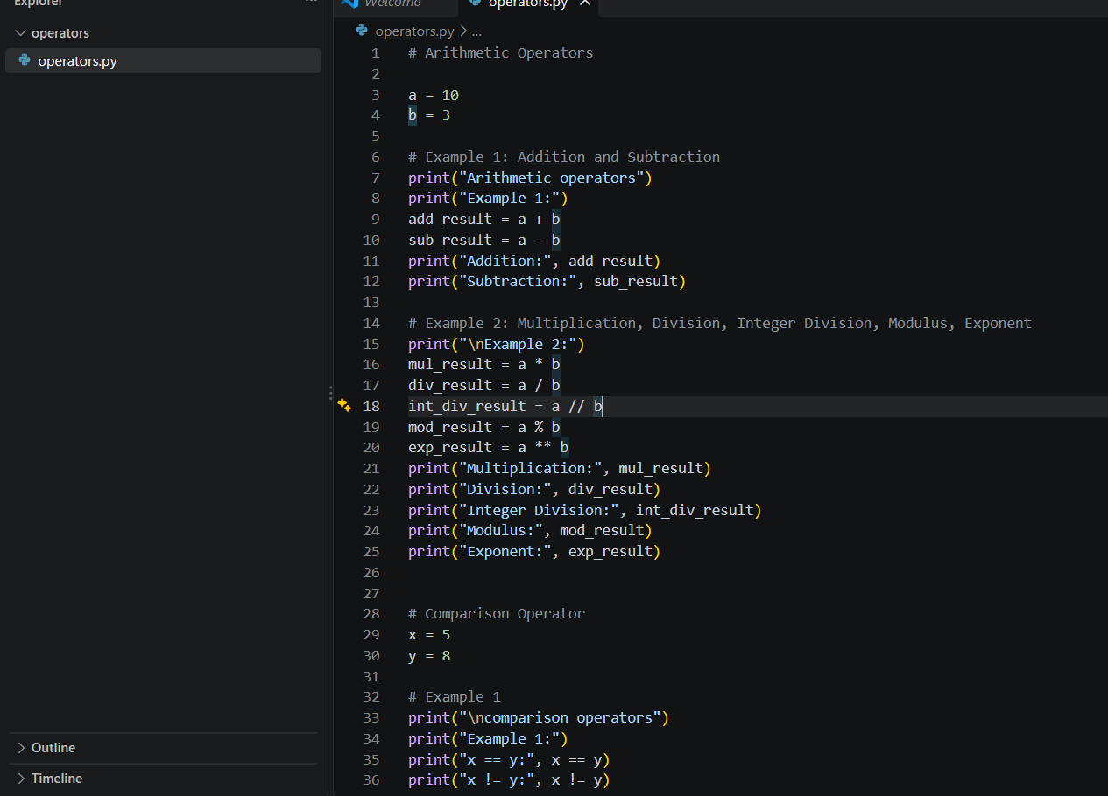
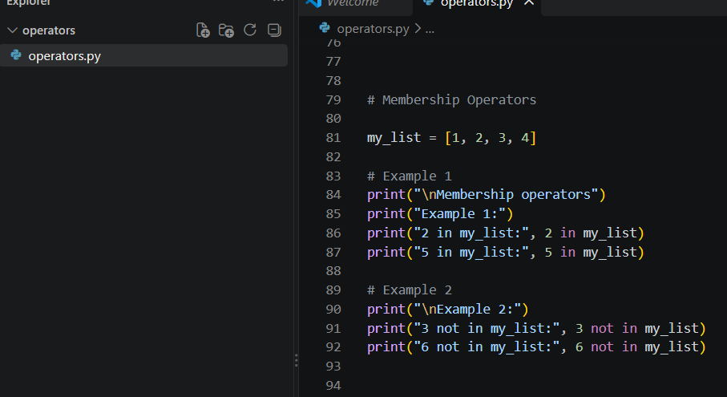
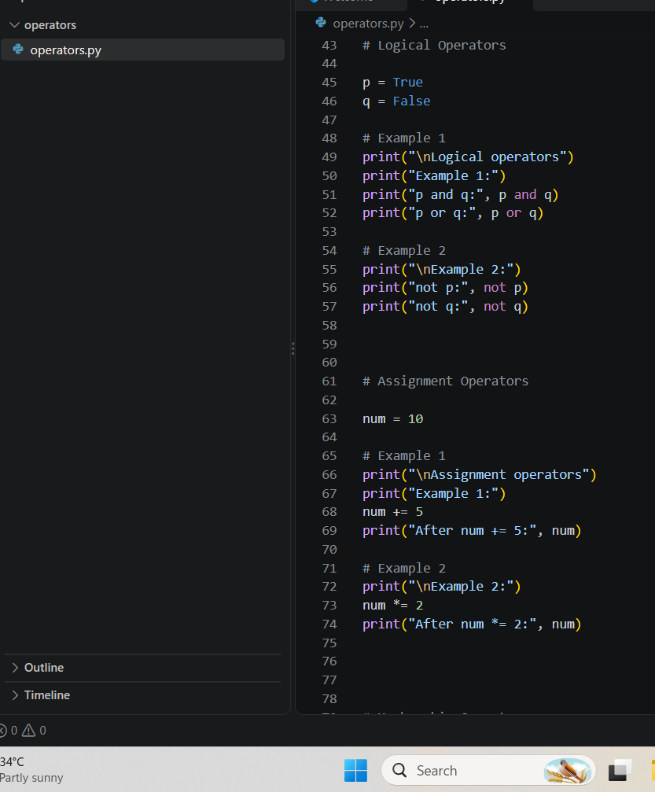
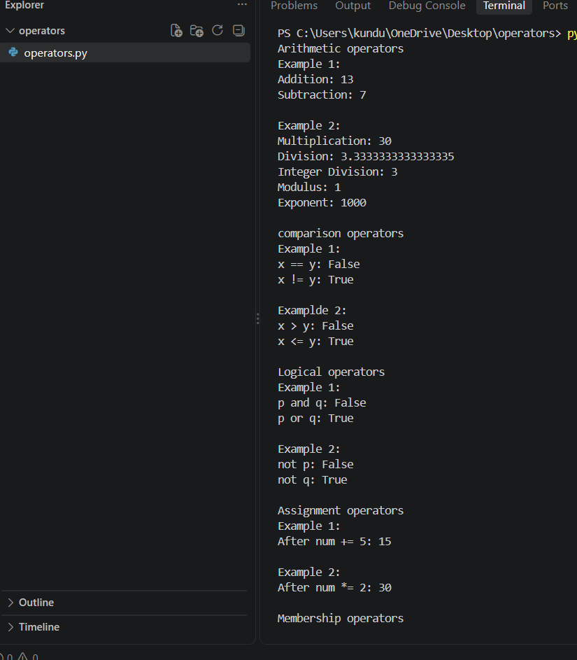
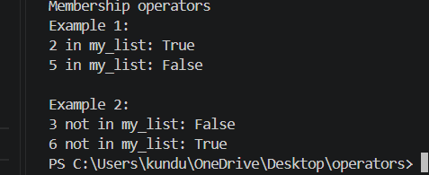

4. Part B – Operator Thinking
- What is the difference between / and //?
- / it performs division operation and gives the quotient as output as a float. // is performs floor division and gives the quotient rounded down.
- When would % be useful in a real application?
- % gives the remainder after division. It is useful in checking whether a number is even or odd.
- What does ** do?
- ** is the exponentiation operator. It is used to represent the power and calculates power.
- What is the difference between = and ==?
- = is a assignment operator and it is used to assign a value to a variable. == is a comparison operator and it is used to check whether two values are equal.
- What is the difference between != and not?
- != checks whether two values are not equal.
not is used to reverse a Boolean value or result.
- What is the result of 10 > 5 and 3 < 2? Explain.
- Result: False.
And returns True when both the conditions are true only.
- What is the result of 10 > 5 or 3 < 2? Explain.
- Result: True.
Or returns true when at least one condition is true.
- What does not True produce?
- False.
not reverse the Boolean value.
- What does 'Python' in 'I am learning Python' return?
- True.
The in operator checks whether the given value is in the sequence of string or not.
- When would not in be useful?
A. not in is useful when we want to check that the value does not exist in the sequence of string.

5. Part C – String Basics Lab
Use your own name or another sentence and run these experiments.
- Create a string and print it.
- name = “Sujatha”
Print(name)
Output: sujatha
- Print its length using len().
- name = “Sujatha”
Print(len(name))
Output: 6
- Print the first character using [0].
A. name = “Sushma”
print(name[0])
output: s
- Print the last character using [-1].
- name = “soni”
Print(name[-1])
Output: i
- Print the first 3 characters using slicing.
- name = “Surekha”
print(name[0:3])
output: sur
- Print the last 3 characters using slicing.
- name = “Surekha”
print(name[-3:])
output: kha

- Print every second character.
- name = “Sujatha”
Print(name[::2])
Output: sjta
- Reverse the string using slicing.
- name = “Sujatha”
Print(name[::-1])
Output: ahtajus
- Try an invalid index. What error occurs?
- name = “Sujatha”
Print(name[10])
Output:
IndexError.
- Try changing one character directly. What happens and why?
name = “Sujatha”
name[3] = “t”
It causes an TypeError, because of in python strings are immutable.
Output: TypeError

6. Part D – String Methods Lab
Experiment with these methods and explain what each one does.
Method | Your example | What does it do?
lower() | “SUJATHA” . lower()”sujatha” | Converts all letters to lowercase.
upper() | “Sujatha” . upper()”SUJATHA” | Converts all letters to uppercase.
title() | “hello Sujatha” . title()”Hello Sujatha” | Capitalizes the first letter of each word.
strip() | “ soni “ . strip()”soni” | Removes spaces from the start and end of the word.
replace() | “my name is Sujatha” . replace(“Sujatha”,”soni”)”my name is soni” | Replaces the value in the text to another value.
split() | “apple, banana” . Split(“,”)[‘apple,’banana’] | Splits a string to a list.
join() | “-“.join([“A”,”B”,”C”])”A-B-C” | Joins the list of items to a string.
startswith() | “Surekha”.startswith(“su”)True | Checks whether a given value is starts with specific text.
endswith() | “Sujatha”.endswith(“ha”)True | Checks whether a given value is ends with a specific text.
find() | “Hello python”.find(“python”)6 | Returns the position or index where the text is found.
count() | “Sujatha”.count(“a”)2 | Counts and return how many times a character occurs in a value.

7. Part E – Indexing & Slicing Challenge
Use: text = "Artificial Intelligence"
- Print the first character.
- Print(text[0])
Output: A
- Print the last character.
- Print([text[-1])
Output: e
- Print the first 10 characters.
- Print(text[0:11])
Output: Artificial
- Extract the word Intelligence.
- Print(text[11:])
Output: Intelligence
- Reverse the complete string.
- Print(text[::-1])
Output: ecnegilletnI laicifitrA
- Print every second character.
- Print(text[::2])
Output: Atfca nelgne
- Print characters from index 3 to 12.
- Print(text[3:13])
Output: ificial In
- Find the index of the first 'i'.
- Print(text.find(“i”))
Output: 3
- Count the number of 'i' characters.
- Print(text.count(“i”))
Output: 4
- Predict what text[100] will do, then run it.
- print(text[100])
The string don’t have index 100 so the python will returns IndexError.
Output: IndexError

8. Part F – f-Strings
- Create name, age and city variables and display them in one sentence using an f-string.
- name = “sujatha”
age = 20
city = kandukur
print(f”my name is {name} , I am {age} years old and I live in {city}”)
output:
my name is Sujatha, I am 20 years old and I live in kandukur.
- Create a product, price and quantity and display a formatted bill.
- Product = “pen”
Price = 5
quantity = 3
Total = price * quantity
Print(f”product: {product}”)
Print(f”price: {price}”)
Print(f”quantity: {quantity}”)
Print(f”total: {total}”)
Output:
Product: pen
Price: 5
Quantity: 3
Total: 15

- Display student name, total marks and average.
- student_name = “Sujatha”
total_marks = 450
average = 90
print(f”student_name: {student_name}”)
print(f”total_marks: {total_marks}”)
print(f”average: {average}”)
output:
student_name: Sujatha
total_marks: 450
average: 90
34.Use an f-string to display a calculation result.
A. a = 50
b = 100
result = a + b
print(f”{a} + {b} = {result}”)
output:
50 + 100 = 150
35.Research decimal formatting and display a price with exactly 2 decimal places.
A. price = 73.6
Print(f”price: {price:.2f}”)
Output: price: 73.60

9. Part G – MCQs: Basic
1. Which operator means multiplication?
- A. x
- B. *
- C. %
- D. //
2. What does % return?
- A. Division
- B. Quotient
- C. Remainder
- D. Power
3. What is the first string index?
- A. 0
- B. 1
- C. -1
- D. first
4. What is len('Python')?
- A. 5
- B. 6
- C. 7
- D. Error
5. Which gets the last character?
- A. text[0]
- B. text[-1]
- C. text[last]
- D. text[1]
6. Which converts text to lowercase?
- A. lower()
- B. small()
- C. down()
- D. lowercase
7. Which removes leading/trailing spaces?
- A. trim()
- B. clean()
- C. strip()
- D. remove()
8. Which checks membership?
- A. inside
- B. in
- C. has
- D. contains
9. Which is an f-string?
- A. f"Hello {name}"
- B. "f Hello"
- C. format f(name)
- D. string(name)
10. Which compares equality?
- A. =
- B. ==
- C. ===
- D. equals

10. Part H – MCQs: Medium
1. What is 17 // 5?
- A. 3
- B. 3.4
- C. 2
- D. 4
2. What is 17 % 5?
- A. 3
- B. 2
- C. 3.4
- D. 0
3. What does 'Python'[1:4] return?
- A. Pyt
- B. yth
- C. ytho
- D. tho
4. What does 'Python'[-3:] return?
- A. tho
- B. hon
- C. yth
- D. Python
5. What does ' hello '.strip() return?
- A. ' hello'
- B. 'hello '
- C. 'hello'
- D. Error
6. What does 'hello'.upper() return?
- A. hello
- B. HELLO
- C. Hello
- D. Error
7. What does 'a,b,c'.split(',') return?
- A. abc
- B. ['a','b','c']
- C. ('a','b','c')
- D. Error
8. Which checks if AI occurs in text?
- A. text.contains('AI')
- B. 'AI' in text
- C. text.has('AI')
- D. contains(text,'AI')
9. What happens with text[50] when text has 10 characters?
- A. None
- B. ''
- C. IndexError
- D. False
10. Why use f-strings?
- A. Insert values/expressions into strings cleanly
- B. Make strings immutable
- C. Convert values to int
- D. Remove spaces

11. Part I – MCQs: Thinking
1. Which is true about strings?
- A. They can always be changed character-by-character
- B. They are immutable
- C. They only contain letters
- D. They cannot be sliced
2. Best way to clean ' PHANI gorantla ' for display?
- A. strip().title()
- B. title().strip()
- C. Both A and B
- D. clean()
3. What does text[::-1] do?
- A. Deletes text
- B. Reverses text
- C. Sorts text
- D. Gets first character
4. Best simple test for '@' in an email?
- A. '@' in email
- B. email == '@'
- C. email.contains('@')
- D. email.has('@')
5. replace() generally:
- A. Returns a transformed string
- B. Always changes the original string in place
- C. Converts to list
- D. Deletes the variable
6. x='5', y=2. Which gives numeric 10?
- A. x*2
- B. int(x)*2
- C. str(x)*2
- D. x+2
7. Which formats 12.5 as 12.50?
- A. f'{price:.2f}'
- B. f'{price:2}'
- C. f'{price.float}'
- D. f'{price.decimal(2)}'
8. What should usually happen before validating text entered with spaces?
- A. strip()
- B. reverse()
- C. split() always
- D. replace with None
9. A common cause of IndexError is:
- A. Invalid index
- B. Using an f-string
- C. lower()
- D. +
10. Why keep raw input and cleaned input conceptually separate?
- A. It makes transformations easier to test
- B. Python requires it
- C. Strings cannot be stored
- D. It prevents every error

12. Part J – 5 Practice Problems
Problem | Task | Topics
Practice 1 – Username Cleaner | Ask for a username, remove surrounding spaces, convert to lowercase and display the cleaned value. | strip + lower + f-string
Practice 2 – Name Formatter | Ask first and last names in random case and display a properly formatted full name. | strip + title + f-string
Practice 3 – Word Analyzer | Ask for a sentence. Display length, first character, last character, spaces count and vowel count. Do not use loops. | len + indexing + count
Practice 4 – Email Inspector | Ask for an email. Check '@', check whether it ends with '.com' or '.in', and show the position of '@'. | in + endswith + find
Practice 5 – Product Code Extractor | For code IND-MOB-2026-001, extract country, category, year and serial using slicing. | indexing + slicing + f-string
For each: Input → Expected Output → Code → 2 test cases → 1 edge case → explanation.
Practice 1 – Username Cleaner
Input
SUJATHA
Expected Output
Cleaned username: sujatha
Code
username = input("Enter username: ")

cleaned_username = username.strip().lower()

print(f"Cleaned username: {cleaned_username}")
Test Case 1
Input: SUJATHA
Output: Cleaned username: sujatha
Test Case 2
Input: sujatha123
Output: Cleaned username: sujatha123
Edge Case
Input:
Output: Cleaned username:
Explanation
strip() removes spaces from the beginning and end. lower() converts the username to lowercase. The f-string displays the cleaned value.

Practice 2 – Name Formatter
Task
Ask first and last names in random case and display a properly formatted full name.
Input
First name: sUJAtHa
Last name: kUNDuRu
Expected Output
Full name: Sujatha kunduru
Code
first_name = input("Enter first name: ")
last_name = input("Enter last name: ")

full_name = f"{first_name.strip().title()} {last_name.strip().title()}"

print(f"Full name: {full_name}")
Test Case 1
Input: sUJatHa, KUnDUru
Output: Full name: Sujatha kunduru
Test Case 2
Input: rAhUl, kUmAr
Output: Full name: Rahul Kumar
Edge Case
Input: First name = sujatha , Last name = kunduru
Output: Full name: Sujatha kunduru
Explanation
strip() removes extra spaces and title() converts the first letter of each word to uppercase. The f-string combines the first and last names.

Practice 3 – Word Analyzer
Task
Ask for a sentence. Display length, first character, last character, spaces count and vowel count. Do not use loops.
Input
Python is easy
Expected Output
Length: 14
First character: P
Last character: y
Spaces: 2
Vowels: 5
Code
sentence = input("Enter a sentence: ")

length = len(sentence)
first_character = sentence[0]
last_character = sentence[-1]
spaces = sentence.count(" ")

vowels = (
sentence.lower().count("a")
+ sentence.lower().count("e")
+ sentence.lower().count("i")
+ sentence.lower().count("o")
+ sentence.lower().count("u")
)

print(f"Length: {length}")
print(f"First character: {first_character}")
print(f"Last character: {last_character}")
print(f"Spaces: {spaces}")
print(f"Vowels: {vowels}")
Test Case 1
Input: Python is easy
Output: Length = 14, First = P, Last = y, Spaces = 2, Vowels = 5
Test Case 2
Input: Hello World
Output: Length = 11, First = H, Last = d, Spaces = 1, Vowels = 3
Edge Case
Input: A
Output:
Length: 1
First character: A
Last character: A
Spaces: 0
Vowels: 1
Explanation
len() finds the length. Indexing [0] gets the first character and [-1] gets the last character. count(" ") counts spaces. The count() method is used to count each vowel, so no loop is required.

Practice 4 – Email Inspector
Task
Ask for an email. Check @, check whether it ends with .com or .in, and show the position of @.
Input
sujatha@gmail.com
Expected Output
Contains @: True
Valid ending: True
Position of @: 7
Code
email = input("Enter email: ")

has_at = "@" in email
valid_ending = email.endswith(".com") or email.endswith(".in")
at_position = email.find("@")

print(f"Contains @: {has_at}")
print(f"Valid ending: {valid_ending}")
print(f"Position of @: {at_position}")
Test Case 1
Input: sujatha@gmail.com
Output:
Contains @: True
Valid ending: True
Position of @: 7
Test Case 2
Input: student@gmail.in
Output:
Contains @: True
Valid ending: True
Position of @: 7
Edge Case
Input: sujatha@gmail
Output:
Contains @: True
Valid ending: False
Position of @: 7
Explanation
in checks whether @ exists. endswith() checks whether the email ends with .com or .in. find() returns the position of @. Python indexing starts from 0.

Practice 5 – Product Code Extractor
Task
For the code IND-MOB-2026-001, extract country, category, year and serial using slicing.
Input
IND-MOB-2026-001
Expected Output
Country: IND
Category: MOB
Year: 2026
Serial: 001
Code
code = "IND-MOB-2026-001"

country = code[0:3]
category = code[4:7]
year = code[8:12]
serial = code[13:16]

print(f"Country: {country}")
print(f"Category: {category}")
print(f"Year: {year}")
print(f"Serial: {serial}")
Test Case 1
Input: IND-MOB-2026-001
Output:
Country: IND
Category: MOB
Year: 2026
Serial: 001
Test Case 2
Input: USA-LAP-2025-123
Output:
Country: USA
Category: LAP
Year: 2025
Serial: 123
Edge Case
Input: A product code with an unexpected format, such as:
IND-MOB-26
Result: The slicing positions may not produce the expected values because the code format is different.
Explanation
Slicing is used to extract specific parts of the product code. For example, code[0:3] extracts IND. The f-string displays each extracted value clearly.

13. Part K – Debugging Lab

Bug 1
name = input('Name: ')
print(name[20])
Why can this fail? Fix it.
In python indexing starts from 0. name[20] means the 21 character . if the entered name has less than 20 characters then it will gives an IndexError.
Corrected code / explanation:
name = input(“Name: “)
_if len(name) > 20:
Print(name[20])
else:
print(“Name is short”)

Bug 2
age = '20'
print(f'Age: {age + 1}')
Fix it.
Age is a string, not an integer. You cannot add 1 to a string.
Corrected code / explanation:
Age = ‘20’
Age = int(age)
Print(f’Age: {age + 1}”)
Output:
Age: 21

Bug 3
name = 'phani'
age = 30
print('Hello ' + name + age)
Identify the type problem and fix it.
name is a string, but age is an integer. Python cannot concatenate a string and an integer using +.
Corrected code / explanation:
Name = ‘phani’
Age = 30
Print(‘Hello’ + name + ‘ ‘ + str(age))_
Output:
Hello phani 30

Bug 4
email = input('Email: ')
print(email.endswith('.com'))
Test with 3 inputs and explain.
Corrected code / explanation:
Input 1:
email: python123@gmail.comTrue
Input 2:
email: java@gmail.com True
Input 3:
email:c123@gmail.com True

Bug 5
code = 'IND-MOB-2026-001'
print(code[20])
Find the valid index range and fix the requirement.
The string does not have 21 characters. So it causes an IndexError.
Corrected code / explanation:
Code = ‘ IND-MOB-2026-001’
Print(code[-2])
Output:
0

Bug 6
text = ' hello world '
print(text.upper().strip())
Does it work? Explain the order of operations.
Yes it works.
The operations will perform from left to right.
Corrected code / explanation:
Text = ‘hello world’
Print(text.upper().strip())
Output:
HELLO WORLD

14. Part L – Main Project: Text-Cleaning & Profile Formatter
Build a practical Python program that accepts messy profile information and converts it into a clean, readable profile.

Scenario
A company receives profile data in inconsistent formats. Names may contain extra spaces, emails may use mixed cases, and cities may be entered randomly. Your program should clean the data and generate a professional profile summary.

Required Inputs
- Full name
- Email address
- Phone number
- City
- Job role
- Short bio

Must-Have Requirements
- Remove leading/trailing spaces.
- Format the full name using title().
- Convert email to lowercase.
- Format city and job role neatly.
- Calculate bio character count.
- Check whether the email contains '@'.
- Check whether the email ends with a supported domain such as .com or .in.
- Extract first name from the full name.
- Extract last name using string logic.
- Display the profile using f-strings.
- Show a small data-quality section.
- Test with messy uppercase/lowercase and extra spaces.

Expected Output Example
================ PROFILE ================
Name : Phani Gorantla
First Name : Phani
Email : phani@example.com
Phone : 9876543210
City : Hyderabad
Role : Software Developer
Bio Length : 42 characters
------------- DATA QUALITY -------------
Email Valid : Yes
=========================================
Do not hard-code the example. The program must work with any user's input.

full_name = input("Enter your full name: ")
email = input("Enter your email address: ")
phone = input("Enter your phone number: ")
city = input("Enter your city: ")
job_role = input("Enter your job role: ")
bio = input("Enter a short bio: ")
# Remove leading and trailing spaces
full_name = full_name.strip()
email = email.strip()
phone = phone.strip()
city = city.strip()
job_role = job_role.strip()
bio = bio.strip()
# Format full name using title()
full_name = full_name.title()
# Convert email to lowercase
email = email.lower()
# Format city and job role neatly
city = city.title()
job_role = job_role.title()
name_parts = full_name.split()
if len(name_parts) >= 1:
first_name = name_parts[0]
else:
first_name = ""
if len(name_parts) >= 2:
last_name = name_parts[-1]
else:
last_name = ""
bio_length = len(bio)
# Check whether email contains '@'
has_at = "@" in email
# Supported email domains
supported_domains = (".com", ".in")
# Check whether email ends with .com or .in
has_supported_domain = email.endswith(supported_domains)
# Final email validation
email_valid = has_at and has_supported_domain
# Convert Boolean result into Yes/No
if email_valid:
email_status = "Yes"
else:
email_status = "No"
print()
print("================ PROFILE ================")
print(f"Name : {full_name}")
print(f"First Name : {first_name}")
print(f"Last Name : {last_name}")
print(f"Email : {email}")
print(f"Phone : {phone}")
print(f"City : {city}")
print(f"Role : {job_role}")
print(f"Bio : {bio}")
print(f"Bio Length : {bio_length} characters")

print()
print("------------- DATA QUALITY -------------")
print(f"Email Valid : {email_status}")
print("=========================================")
Example test:
Enter your full name: suJAtha kUNDURu
Enter your email address: EXAMPLE@gmail.com
Enter your phone number: 1234567890
Enter your city: KANDUKur
Enter your job role: sOFTWARE dEVELOPER
Enter a short bio: Python developer interested in AI and ML.
The program cleans it and produces:
================ PROFILE ================
Name : Sujatha kunduru
First Name : sujatha
Last Name : kunduru
Email : example@gmail.com
Phone : 1234567890
City : kandukur
Role : Software Developer
Bio : Python developer interested in AI and ML.
Bio Length : 42 characters

------------- DATA QUALITY -------------
Email Valid : Yes

15. Project Bonus Challenges
- Clean repeated spaces inside a name.
- Validate phone number length.
- Check that the full name contains at least two words.
- Generate initials from the name.
- Generate a username from the person's name.
- Create a one-line professional bio using an f-string.
- Display a simple data-quality percentage.

16. Project Test Cases

16. Project Test Cases
Test | Input condition | Expected behaviour | Actual result
1 | Normal clean input | Clean profile | profile processed correctly
2 | Extra spaces around fields | Spaces removed | extra spaces removed
3 | Random uppercase/lowercase | Proper formatting | text formatted correctly
4 | Invalid-looking email | Flag data quality | invalid email identified
5 | Short/missing optional data | Program should handle it sensibly | program handle missing data

17. Explain Your Project
- What is the difference between cleaning data and formatting data?
Answer: Data cleaning removes unwanted or incorrect data, such as extra spaces or invalid values. Formatting makes the data consistent, such as converting names to proper case.
- Which string methods did you use and why?
Answer: I used strip() to remove extra spaces, lower() and upper() to change letter case, title() to format names, replace() to replace unwanted text, split() to separate text, and join() to combine text.
- Where did you use indexing?
Answer: I used indexing to access specific characters or positions in a string, such as checking the first character or accessing a particular part of an email or text.
- Where did you use slicing?
Answer: I used slicing to extract a portion of a string without changing the original string.
- Why are f-strings useful here?
Answer: F-strings make it easy to insert variables and calculated values into output messages clearly and neatly.
- What error did you face?
Answer: I faced IndexError when trying to access an index that did not exist. I also learned that incorrect data types can cause TypeError.
- How did you test edge cases?
Answer: I tested extra spaces, different uppercase/lowercase combinations, invalid-looking emails, empty or missing optional data, and strings with unusual input.
- If this processed 1 lakh profiles, what would you improve first?
Answer: I would improve the program's efficiency, add stronger input validation, handle errors properly, and process the profiles efficiently in batches.

18. Final Self-Check
Skill | Yes | Need Practice | Notes
Use arithmetic/comparison/logical operators | Yes |  | Can use =, -, *, /, >, <, and, or
Explain = vs == | yes |  | = assigns a value ; == compares values.
Manipulate strings | Yes |  | Can work with and modify strings using methods
Use positive and negative indexing | Yes |  | Positive starts from 0; negative starts from -1
Use slicing | Yes |  | Example: text[1:5]
Use string methods | Yes |  | Lower(), upper(), strip(), replace(), and so on.
Use in/not in | Yes |  | Checks whether something exists in a string
Use f-strings | Yes |  | Example: f”Hello{name}”
Debug IndexError/type problems | yes |  | Check indexes and data types.
Build the final text utility | yes |  | Combine the string concepts learnedpassed

19. Submission Checklist
- Operator experiments
- Operator questions
- String exploration
- String-method table
- Indexing/slicing challenge
- f-string exercises
- 30 MCQ answers
- 5 practice programs
- Debugging Lab
- Text-Cleaning & Profile Formatter
- Project test cases
- Project explanation and self-check

