AI TRAINING – DAY 3 ASSIGNMENT
Python Operators & Strings: Manipulate → Extract → Clean → Format
Practical + MCQ + Debugging + String Utility Project

1. Learning Goals
- Understand arithmetic, comparison, logical, assignment and membership operators.
- Understand strings, indexing, slicing and common string methods.
- Use f-strings to create readable dynamic output.
- Identify common operator and string errors.
- Combine all topics to build a practical text utility.
- Explain your solution in your own words.

2. Assignment Rules
- Type the programs yourself. Do not copy complete solutions.
- Before running code, predict the output.
- Test strings with spaces, uppercase/lowercase, empty input and unexpected input.
- You may use AI to explain a concept or error after attempting it yourself.
- For every practical problem write Input → Processing → Output.
- Keep at least one error you faced and explain how you fixed it.

3. Part A – Operators Exploration
Create operators.py and experiment with each group. Write at least 2 examples for every group.
Operator group | Operators / your observation
Arithmetic | + - * / // % **  Observation: Arthimetic Operators are used perform mathematical calculations.
Comparison | == != > < >= <=  Observation: Comparison Operators compare two values and return True or False.
Logical | and or not  Observation: Logical Operators combine conditions and return True or False.
Assignment | = += -= *= /=  Observation: Assignment Operators assign update values in a variable.
Membership | in / not in  Observation: Membership Operators check whether a value exist in a sequence.

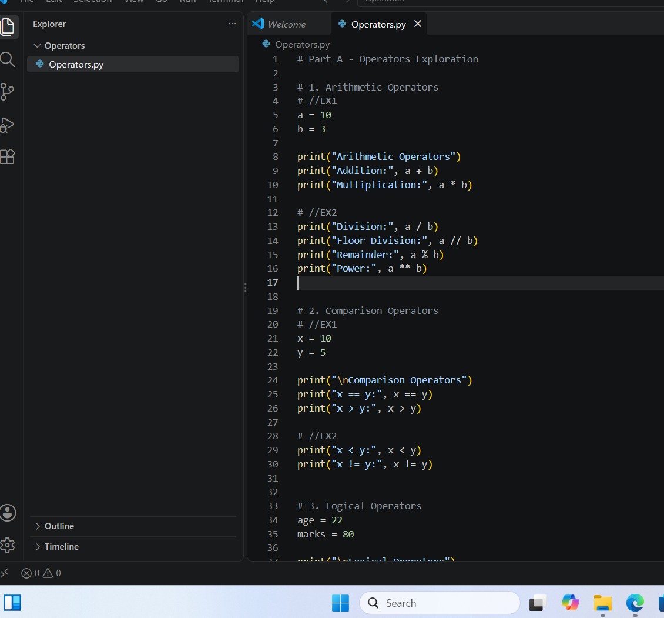

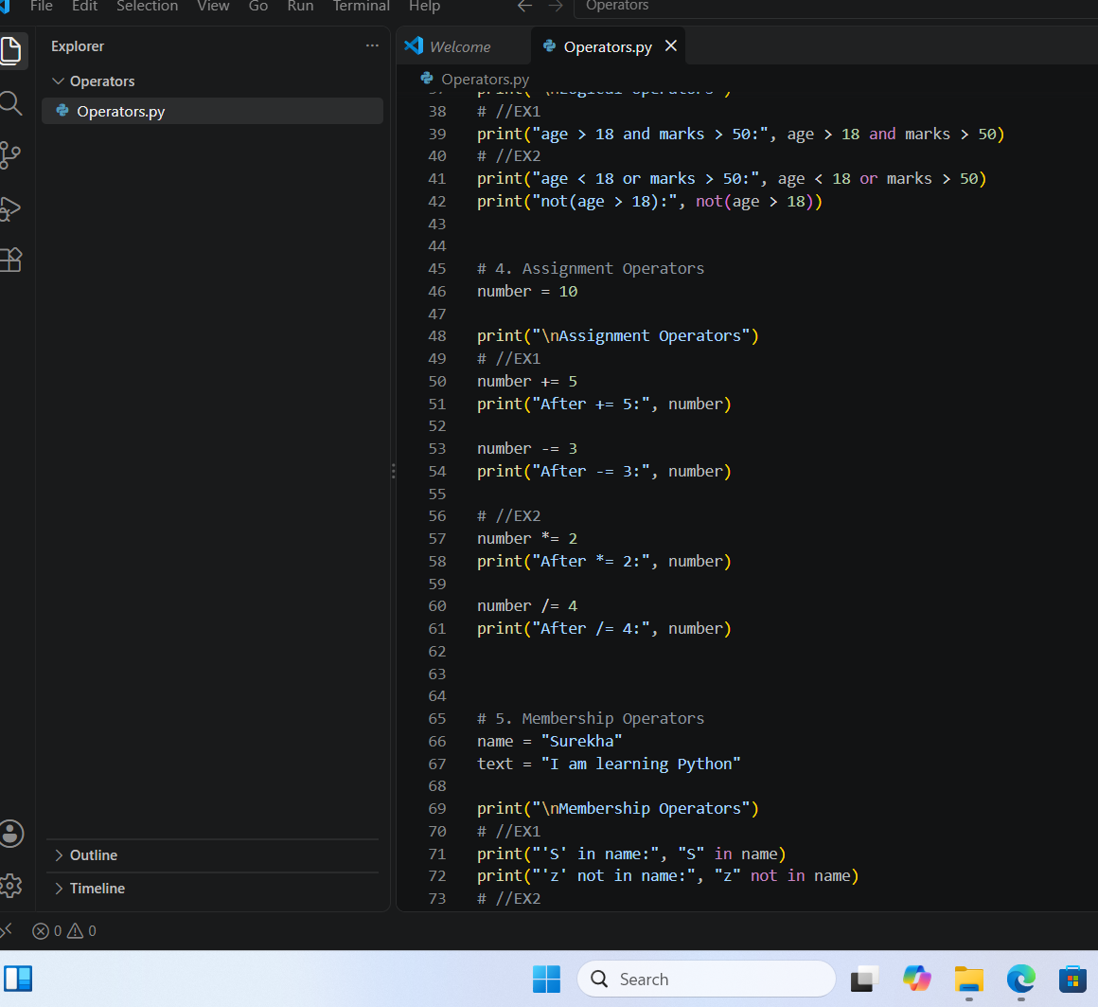
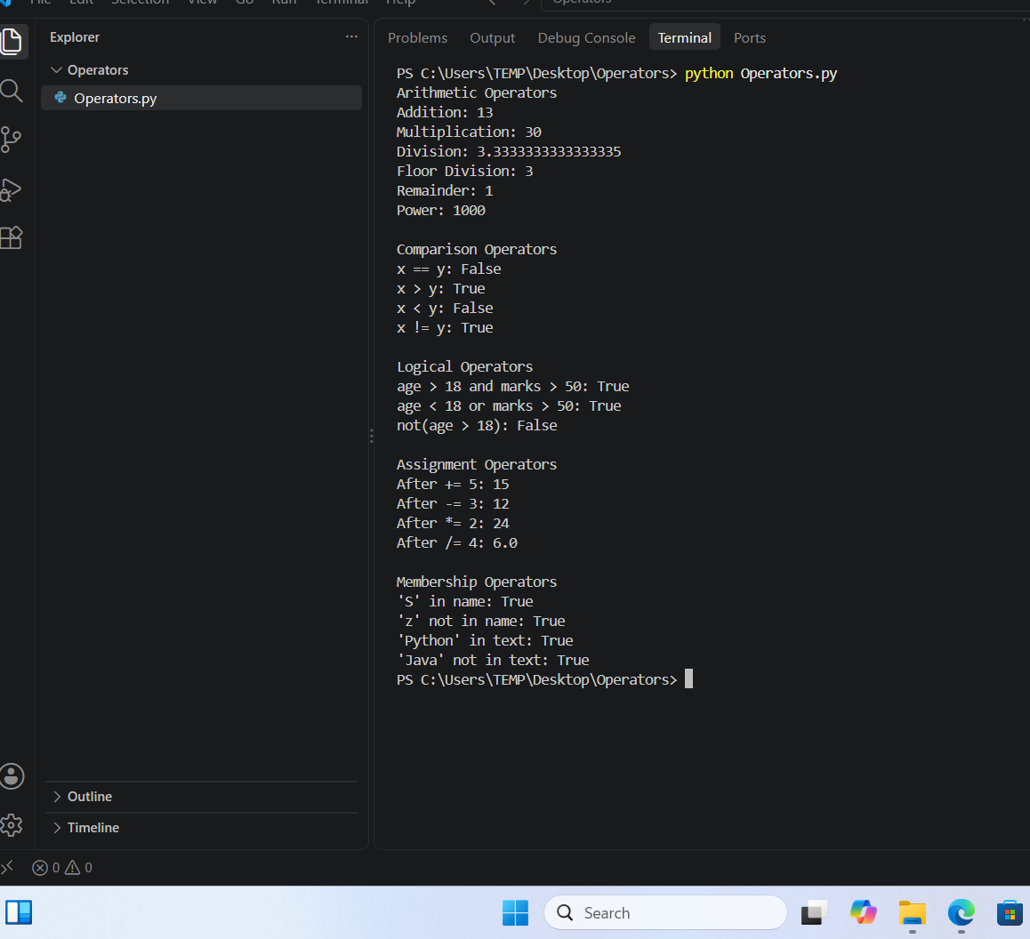

4. Part B – Operator Thinking
- What is the difference between / and //?
Ans: / performs the normal division and returns decimal value and // performs floor division and rounds the quotient value.
- When would % be useful in a real application?
Ans: % is gives remainder after division and check whether the number tis even or odd.
- What does ** do?
Ans: It is exponentiation operator and it is used to calculate powers.
- What is the difference between = and ==?
Ans: = is used to assign a value to variable
== is used to compare the two values.
- What is the difference between!= and not?
Ans: != checks whether two values are not equal
Not refers to reverse a Boolean from true to false.
- What is the result of 10 > 5 and 3 < 2? Explain.
Ans: False because where 10>5 is true, 3<2 is false by using and,the both conditions must be true.
- What is the result of 10 > 5 or 3 <2? Explain.
Ans: True because where 10>5 is true, 3<2 is false by using or atleast one condition must be true.
- What does not True produce?
Ans: It produces False because not reverse the Boolean value.
- What does 'Python' in 'I am learning Python' return?
Ans: It returns true because ‘python’ is in the string.
- When would not in be useful?
Ans: not in is useful when we want check the value or text is not present in a sequence.

5. Part C – String Basics Lab
Use your own name or another sentence and run these experiments.
- Create a string and print it.
Ans: name : “Surekha”
Print(name)
Output: Surekha
- Print its length using len().
Ans : name: “Supraja”
Print(len(name))
Output: 7
- Print the first character using [0].
Ans: name : “Sumiya”
Print(name[0] )
Output: S
- Print the last character using [-1].
Ans: name : “Sumiya”
Print(name[-1])
Output: a
- Print the first 3 characters using slicing.
Ans: name: “Surekha”
Print(name[0:3])
Output: Sur
- Print the last 3 characters using slicing.
Ans: name: “Surekha”
Print(name[-3:] )
Output: kha
- Print every second character.
Ans: text = “Python”
Print(text[::2] )
Output: pto
- Reverse the string using slicing.
Ans: word : “Java”
Print(word[::-1] )
Output: avaJ
- Try an invalid index. What error occurs?
Ans: name = “Surekha”
Print(name[10] )
Output: Index Error because string index is out of range.
- Try changing one character directly. What happens and why?
Ans: name = “Surekha”
name[4] = “e”
Output: It causes Type error , because in python strings are immutable

6. Part D – String Methods Lab
Experiment with these methods and explain what each one does.
Method | Your example | What does it do?
lower() | “PYTHON” .lower()”python” | Converts upper case letters to lower case letters.
upper() | “surekha” .upper()”SUREKHA” | Converts lower case letters to upper case letters.
title() | “python programming” .tittle()”Python Programming” | Convert the first letter of each word to upper case.
strip() | “ Java “ .strip()”Java” | Removes extra spaces from beginning and end of the string.
replace() | “ I like python” .replace(“python”, “Java”)”I like Java” | Replace one word or character to another.
split() | “I like Chocolate” .split()[’I’, ‘like’, ‘Chocolate’] | Splits a string into a list or words.
join() | “ “ .join(“I”, “like”, “Chocolate”)”I like Chocolate” | Joins elements of a list into a string.
startswith() | “python” .startswith(“ py ”)True | Checks whether a string starts with particular value.
endswith() | “python” .endswith(“ on “)True | Checks whether a string ends with particular value.
find() | “Java” .find( “ v”)2 | Finds the position of a character or word.
count() | “ Banana” .count(“ a “)3 | Counts how many times whether a character or sword occur in a string.

7. Part E – Indexing & Slicing Challenge
Use: text = "Artificial Intelligence"
- Print the first character.
Ans: Print(text[0])
Output: A
- Print the last character.
Ans: Print(text[-1])
Output: e
- Print the first 10 characters.
Ans: print(text[10])
Output: Artificial
- Extract the word Intelligence.
Ans: print(text[11:])
Output: Intelligence
- Reverse the complete string.
Ans: print(text[::-1])
Output: ecnegillental laicitrA
- Print every second character.
Ans: print(text[::2])
Output: Atfca neligne
- Print characters from index 3 to 12.
Ans: print(text[3:13])
Output: ificial In
- Find the index of the first 'i'.
Ans: print(text.find(“i”))
Output:2
- Count the number of 'i' characters.
Ans: print(text.count(“i”))
Output: 3
- Predict what text[100] will do, then run it.
Ans: print(text[100])
Output: Index Error: string index is out of range

8. Part F – f-Strings
- Create name, age and city variables and display them in one sentence using an f-string.
Ans: name = “Surekha”
Age = 21
City = “Kandukur”
Print(f”My name is {name} , I am {age} years old, and I live in {city}.“)
Output: My name is Surekha, I am 21 years old, and I live in Kandukur.
- Create a product, price and quantity and display a formatted bill.
Ans: product = “Laptop”
price = 50000
quantity = 2
print(f”product: {product}”)
print(f”price: {price}”)
print(f”quantity: {quantity}”)
print(f”Total: {price * quantity} “)
Output: product : Laptop
Price: 50000
Quantity: 2
Total: 100000
- Display student name, total marks and average.
Ans: name = “ Sujatha”
total_marks = 450
average = 90
print(f”Student Name: {student}”)
print(f”Total_marks: {total_marks}”)
print(f”Average: {average}”)
Output: Student Name: Surekha
Total Marks: 450
Average: 90
- Use an f-string to display a calculation result.
Ans: a = 10
b = 20
print(f” The sum of {a} and {b} is {a + b} “.)
Output: The sum of 10 and 20 is 30.
- Research decimal formatting and display a price with exactly 2 decimal places.
Ans: price = 99.5
Print(f”price: {price: .2f}”)
Output: price:99.50

9.Part G – MCQs: Basic
1. Which operator means multiplication?
- A. x
- B. *
- C. %
- D. //
2. What does % return?
- A. Division
- B. Quotient
- C. Remainder
- D. Power
3. What is the first string index?
- A. 0
- B. 1
- C. -1
- D. first
4. What is len('Python')?
- A. 5
- B. 6
- C. 7
- D. Error
5. Which gets the last character?
- A. text[0]
- B. text[-1]
- C. text[last]
- D. text[1]
6. Which converts text to lowercase?
- A. lower()
- B. small()
- C. down()
- D. lowercase
7. Which removes leading/trailing spaces?
- A. trim()
- B. clean()
- C. strip()
- D. remove()
8. Which checks membership?
- A. inside
- B. in
- C. has
- D. contains
9. Which is an f-string?
- A. f"Hello {name}"
- B. "f Hello"
- C. format f(name)
- D. string(name)
10. Which compares equality?
- A. =
- B. ==
- C. ===
- D. equals

10. Part H – MCQs: Medium
1. What is 17 // 5?
- A. 3
- B. 3.4
- C. 2
- D. 4
2. What is 17 % 5?
- A. 3
- B. 2
- C. 3.4
- D. 0
3. What does 'Python'[1:4] return?
- A. Pyt
- B. yth
- C. ytho
- D. tho
4. What does 'Python'[-3:] return?
- A. tho
- B. hon
- C. yth
- D. Python
5. What does ' hello '.strip() return?
- A. ' hello'
- B. 'hello '
- C. 'hello'
- D. Error
6. What does 'hello'.upper() return?
- A. hello
- B. HELLO
- C. Hello
- D. Error
7. What does 'a,b,c'.split(',') return?
- A. abc
- B. ['a','b','c']
- C. ('a','b','c')
- D. Error
8. Which checks if AI occurs in text?
- A. text.contains('AI')
- B. 'AI' in text
- C. text.has('AI')
- D. contains(text,'AI')
9. What happens with text[50] when text has 10 characters?
- A. None
- B. ''
- C. IndexError
- D. False
10. Why use f-strings?
- A. Insert values/expressions into strings cleanly
- B. Make strings immutable
- C. Convert values to int
- D. Remove spaces

11. Part I – MCQs: Thinking
1. Which is true about strings?
- A. They can always be changed character-by-character
- B. They are immutable
- C. They only contain letters
- D. They cannot be sliced
2. Best way to clean ' PHANI gorantla ' for display?
- A. strip().title()
- B. title().strip()
- C. Both A and B
- D. clean()
3. What does text[::-1] do?
- A. Deletes text
- B. Reverses text
- C. Sorts text
- D. Gets first character
4. Best simple test for '@' in an email?
- A. '@' in email
- B. email == '@'
- C. email.contains('@')
- D. email.has('@')
5. replace() generally:
- A. Returns a transformed string
- B. Always changes the original string in place
- C. Converts to list
- D. Deletes the variable
6. x='5', y=2. Which gives numeric 10?
- A. x*2
- B. int(x)*2
- C. str(x)*2
- D. x+2
7. Which formats 12.5 as 12.50?
- A. f'{price:.2f}'
- B. f'{price:2}'
- C. f'{price.float}'
- D. f'{price.decimal(2)}'
8. What should usually happen before validating text entered with spaces?
- A. strip()
- B. reverse()
- C. split() always
- D. replace with None
9. A common cause of IndexError is:
- A. Invalid index
- B. Using an f-string
- C. lower()
- D. +
10. Why keep raw input and cleaned input conceptually separate?
- A. It makes transformations easier to test
- B. Python requires it
- C. Strings cannot be stored
- D. It prevents every error

12. Part J – 5 Practice Problems
Problem | Task | Topics
Practice 1 – Username Cleaner | Ask for a username, remove surrounding spaces, convert to lowercase and display the cleaned value. | strip + lower + f-string
Practice 2 – Name Formatter | Ask first and last names in random case and display a properly formatted full name. | strip + title + f-string
Practice 3 – Word Analyzer | Ask for a sentence. Display length, first character, last character, spaces count and vowel count. Do not use loops. | len + indexing + count
Practice 4 – Email Inspector | Ask for an email. Check '@', check whether it ends with '.com' or '.in', and show the position of '@'. | in + endswith + find
Practice 5 – Product Code Extractor | For code IND-MOB-2026-001, extract country, category, year and serial using slicing. | indexing + slicing + f-string

Practice 1 – Username Cleaner

Task
Ask for a username, remove surrounding spaces, convert it to lowercase, and display the cleaned value.

Input:

SUREKHA

Expected Output: Cleaned username: surekha

Code:

Test Case 1
Input: SUREKHA
Output: Cleaned username: surekha

Test Case 2
Input: Surekha123
Output: Cleaned username: surekha123

Edge Case
Input:
Output: Cleaned username:

Explanation:

strip() removes spaces from the beginning and end. lower() converts the username to lowercase. The f-string displays the cleaned value.

Practice 2 – Name Formatter

Task: Ask first and last names in random case and display a properly formatted full name.

Input:
First name: sUrEkHa
Last name: pAdArThI

Expected Output:
Full name: Surekha Padarthi

Code:
first_name = input("Enter first name: ")
last_name = input("Enter last name: ")

full_name = f"{first_name.strip().title()} {last_name.strip().title()}"

print(f"Full name: {full_name}")

Test Case 1:

Input: sUrEkHa, pAdArThI
Output: Full name: Surekha Padarthi

Test Case 2:
Input: rAhUl, kUmAr
Output: Full name: Rahul Kumar

Edge Case:
Input: First name = surekha ,
Last name = padarthi
Output: Full name: Surekha Padarthi

Explanation:
strip() removes extra spaces and title() converts the first letter of each word to uppercase. The f-string combines the first and last names.

Practice 3 – Word Analyzer

Task:
Ask for a sentence. Display length, first character, last character, spaces count and vowel count. Do not use loops.

Input:
Python is easy

Expected Output:
Length: 14
First character: P
Last character: y
Spaces: 2
Vowels: 5

Code:
sentence = input("Enter a sentence: ")

length = len(sentence)
first_character = sentence[0]
last_character = sentence[-1]
spaces = sentence.count(" ")

vowels = (
sentence.lower().count("a")
+ sentence.lower().count("e")
+ sentence.lower().count("i")
+ sentence.lower().count("o")
+ sentence.lower().count("u")
)

print(f"Length: {length}")
print(f"First character: {first_character}")
print(f"Last character: {last_character}")
print(f"Spaces: {spaces}")
print(f"Vowels: {vowels}")

Test Case 1
Input: Python is easy
Output: Length = 14, First = P, Last = y, Spaces = 2, Vowels = 5

Test Case 2
Input: Hello World
Output: Length = 11, First = H, Last = d, Spaces = 1, Vowels = 3

Edge Case
Input: A
Output:
Length: 1
First character: A
Last character: A
Spaces: 0
Vowels: 1

Explanation:
len() finds the length. Indexing [0] gets the first character and [-1] gets the last character. count(" ") counts spaces. The count() method is used to count each vowel, so no loop is required.

Practice 4 – Email Inspector

Task
Ask for an email. Check @, check whether it ends with .com or .in, and show the position of @.

Input
surekha@gmail.com

Expected Output:
Contains @: True
Valid ending: True
Position of @: 7

Code:
email = input("Enter email: ")

has_at = "@" in email
valid_ending = email.endswith(".com") or email.endswith(".in")
at_position = email.find("@")

print(f"Contains @: {has_at}")
print(f"Valid ending: {valid_ending}")
print(f"Position of @: {at_position}")

Test Case 1
Input: surekha@gmail.com
Output:
Contains @: True
Valid ending: True
Position of @: 7

Test Case 2
Input: student@gmail.in
Output:
Contains @: True
Valid ending: True
Position of @: 7

Edge Case
Input: surekha@gmail
Output:
Contains @: True
Valid ending: False
Position of @: 7

Explanation:
in checks whether @ exists. endswith() checks whether the email ends with .com or .in. find() returns the position of @. Python indexing starts from 0.

Practice 5 – Product Code Extractor

Task
For the code IND-MOB-2026-001, extract country, category, year and serial using slicing.

Input
IND-MOB-2026-001

Expected Output:
Country: IND
Category: MOB
Year: 2026
Serial: 001

Code:
code = "IND-MOB-2026-001"

country = code[0:3]
category = code[4:7]
year = code[8:12]
serial = code[13:16]

print(f"Country: {country}")
print(f"Category: {category}")
print(f"Year: {year}")
print(f"Serial: {serial}")

Test Case 1
Input: IND-MOB-2026-001
Output:
Country: IND
Category: MOB
Year: 2026
Serial: 001

Test Case 2
Input: USA-LAP-2025-123
Output:
Country: USA
Category: LAP
Year: 2025
Serial: 123

Edge Case:
Input: A product code with an unexpected format, such as:
IND-MOB-26
Result: The slicing positions may not produce the expected values because the code format is different.

Explanation:
Slicing is used to extract specific parts of the product code. For example, code[0:3] extracts IND. The f-string displays each extracted value clearly.

13. Part K – Debugging Lab

Bug 1
name = input('Name: ')
print(name[20])
Why can this fail?
It can fails because the name may contain fewer 21 characters, python indexes starts from 0, so index 20 requires atleast 21 characters.
Corrected code : name =input(“Name: “)
If len(name) > 20:
Print(name[20])
Else :
Print((“name is too short”)
Explanation: We check the length before accessing index 20. this prevents an IndexError.

Bug 2
age = '20'
print(f'Age: {age + 1}')
Fix it.
The problem is Age is string and 1 is a integer, so python cannot directly add string and integer.
Corrected code : age = 20
Print(f’Age: {int(age) + 1}’)
Explanation: int(age) converts the string “20” into an integer.

Bug 3
name = 'phani'
age = 30
print('Hello ' + name + age)
Identify the type problem and fix it.
The problem is name is string and age is a integer, in python we cannot use + directly to concatenate string and integer.
Corrected code : name = ‘phani’
age = 30
print(f”Hello {name},your age is {age}’)
Explanation: An f- string allows directly to combine string and numbers.

Bug 4
email = input('Email: ')
print(email.endswith('.com'))
Test with 3 inputs and explain.
Test1: surekhapadarthi@gmail.com True
Test2: Padarthi21@gmail.com True
Test3: surekha@gmail.com True
Corrected code : email = input(“Email: “)
Print(email.endswith(“ .com”))
Explanation: It returns true ,because the email ends with .com, otherwise it returns false.

Bug 5
code = 'IND-MOB-2026-001'
print(code[20])
Find the valid index range and fix the requirement.
Index 20 is the outside the valid range of the string.
Corrected code : code = ‘ IND-MOB-2026-001’
Print(code[14])
Explanation: The string has 15 characters so index 20 is invalid and causes indexerror.

Bug 6
text = ' hello world '
print(text.upper().strip())
Does it work? Explain the order of operations.
Yes, it works
Explanation: Python performs the operations from left to right.

14. Part L – Main Project: Text-Cleaning & Profile Formatter
Build a practical Python program that accepts messy profile information and converts it into a clean, readable profile.

Scenario
A company receives profile data in inconsistent formats. Names may contain extra spaces, emails may use mixed cases, and cities may be entered randomly. Your program should clean the data and generate a professional profile summary.

Required Inputs
- Full name
- Email address
- Phone number
- City
- Job role
- Short bio

Must-Have Requirements
- Remove leading/trailing spaces.
- Format the full name using title().
- Convert email to lowercase.
- Format city and job role neatly.
- Calculate bio character count.
- Check whether the email contains '@'.
- Check whether the email ends with a supported domain such as .com or .in.
- Extract first name from the full name.
- Extract last name using string logic.
- Display the profile using f-strings.
- Show a small data-quality section.
- Test with messy uppercase/lowercase and extra spaces.

Expected Output Example
================ PROFILE ================
Name : Phani Gorantla
First Name : Phani
Email : phani@example.com
Phone : 9876543210
City : Hyderabad
Role : Software Developer
Bio Length : 42 characters
------------- DATA QUALITY -------------
Email Valid : Yes
=========================================
Code:
Full_name = input(“Enter the full name: ”).strip().tittle()
email = input("Enter email: ").strip().lower()
phone = input("Enter phone number: ").strip()
city = input("Enter city: ").strip().title()
job_role = input("Enter job role: ").strip().title()
bio = input("Enter short bio: ").strip()
name_parts = full_name.split()
if (len(phone) > 10):
print("Invalid phone number")
else:
print("Phone number is valid")
if (len(name_parts) >= 2):
print("Full name is valid")
else:
print("Please enter first and last name")
username = full_name.lower().replace(" ", "")
print(f"Username: {username}")
professionalBio = (f"{full_name} is a {job_role} from {city}." )
print(professionalBio)
first_name = name_parts[0]
bio_length = len(bio)
has_at = "@" in email
supported_domain = email.endswith(".com") or email.endswith(".in")
if has_at and supported_domain:
email_valid = "Yes"
else:
email_valid = "No"
print("\n============ PROFILE =============")
print(f"Name : {full_name}")
print(f"First Name : {first_name}")
print(f"Last Name : {last_name}")
print(f"Email : {email}")
print(f"Phone : {phone}")
print(f"City : {city}")
print(f"Role : {job_role}")
print(f"Bio Length : {bio_length} characters")
print("\n------------- DATA QUALITY -------------")
print(f"Email Valid : {email_valid}")
print("=======================")

15. Project Bonus Challenges
- Clean repeated spaces inside a name.
- Validate phone number length.
- Check that the full name contains at least two words.
- Generate initials from the name.
- Generate a username from the person's name.
- Create a one-line professional bio using an f-string.
- Display a simple data-quality percentage.

16. Project Test Cases

16. Project Test Cases
Test | Input condition | Expected behaviour | Actual result
1 | Normal clean input | Clean profile | Profile cleaned successfully
2 | Extra spaces around fields | Spaces removed | Extra spaces removed successfully
3 | Random uppercase/lowercase | Proper formatting | Text converted to proper format successfully
4 | Invalid-looking email | Flag data quality | Invalid email format
5 | Short/missing optional data | Program should handle it sensibly | Program handled it without crashing

17. Explain Your Project
- What is the difference between cleaning data and formatting data?
Ans: Cleaning data means removing unwanted spaces and formatting data means making the data consistent and converting data in proper upper case.
- Which string methods did you use and why?
Ans: I used strip(), split(), upper(), lower(), join(), replace(), tile(), because to remove extra spaces, change text format, and clean names.
- Where did you use indexing?
Ans: I used indexing to access individual characters such as first character of name.
- Where did you use slicing?
Ans: I used slicing to get a part of a string or extracting a name, text.
- Why are f-strings useful here?
Ans: F-strings are useful because they combine the variables and text.
- What error did you face?
Ans: I faced index error because when I tried to access a string index that does not exist.
- How did you test edge cases?
Ans: I tested empty input, extra spaces, short names, uppercases and lowercases text, invalid email formats & missing data make sure the program handled without crashing.
- If this processed 1 lakh profiles, what would you improve first?
Ans: I would improve the processing speed and memory usage first and I process the profiles and avoid unnecessary operations.

18. Final Self-Check
Skill | Yes | Need Practice | Notes
Use arithmetic/comparison/logical operators | Yes |  | I can use different operations to perform different calculations.
Explain = vs == | Yes |  | = is used for assignment  == is used for comparison
Manipulate strings | Yes |  | I can modify and work with strings using different techniques.
Use positive and negative indexing | Yes |  | I can access characters using both positive and negative indexes.
Use slicing | Yes |  | By using slicing we can extract the parts os strings.
Use string methods | Yes |  | I can use methods such as upper(), lower(), strip(), and replace().
Use in/not in | Yes |  | By using in/not in checks whether a word exist or not exist
Use f-strings | Yes |  | I can format and display variables using f-strings.
Debug IndexError/type problems | Yes |  | I can identify and correct common errors.
Build the final text utility | Yes |  | I can combine these concepts to create a useful text-processing.

19. Submission Checklist
- Operator experiments
- Operator questions
- String exploration
- String-method table
- Indexing/slicing challenge
- f-string exercises
- 30 MCQ answers
- 5 practice programs
- Debugging Lab
- Text-Cleaning & Profile Formatter
- Project test cases
- Project explanation and self-check

