AI TRAINING – DAY 2 ASSIGNMENT
Python Fundamentals: Setup → Variables → Data Types → Input/Output → Type Conversion
Practical + MCQ + Debugging + Mini Challenge
Level | Beginner → Medium
Suggested Time | 3–4 hours
Primary Goal | Understand Python basics by writing and fixing programs
Programs | 10 required programs + debugging + challenge
Submission | One document/PDF + .py files or screenshots/output

1. Learning Goals
- Set up Python and verify it works.
- Understand variables and Python values.
- Understand int, float, str, bool and None.
- Understand input() and print().
- Understand why input() normally returns a string.
- Convert values between common data types.
- Write small programs independently.
- Read and fix simple Python errors.
- Explain every program in your own words.

2. Rules for This Assignment
- Type every program yourself; do not copy complete solutions.
- You may use AI to explain an error after attempting it yourself.
- For every program write: Input → Processing → Output.
- Test every program with at least 2 different inputs.
- Keep track of errors you faced and what you changed.
- Use Python 3.

3. Part A – Python Setup
1. Install Python 3 or use an online Python environment.
2. Verify the Python version from the terminal/command prompt.
3. Create a folder named Day02_Python_Basics.
4. Create hello.py and print: Hello, Python!
5. Run the file successfully.
6. Take a screenshot showing the version and successful output.
Expected evidence: Python version + hello.py + output.
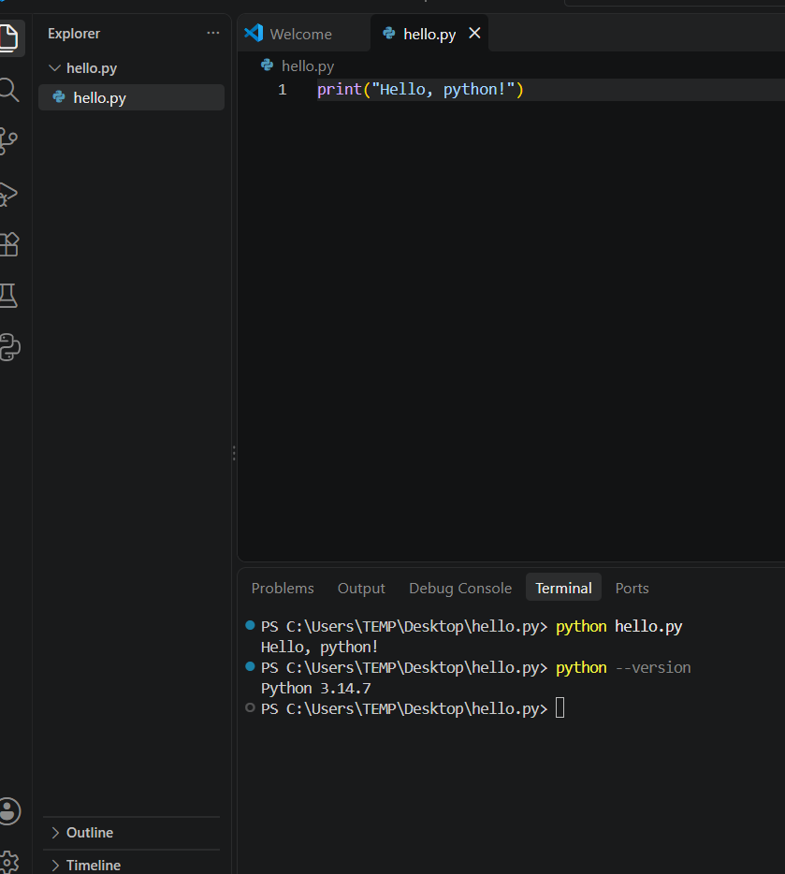

4. Part B – Explore Before Coding
1. What does type(variable) tell you?
Ans. It tells us the data type of the value stored in variable.
2. Create an int, float, str, bool and None value. Check their types.
Ans. a = 10
b=25.5
c=”Hello”
d=True
e=None
print(type(a))
print(type(b))
print(type(c))
print(type(d))
print(type(e))
Output:
<class ‘int’>
<class ‘float’>
<class ‘str’>
<class ‘bool’>
<class ‘NoneType’>
3. What happens when you add an int and a float?
Ans. python adds them and the result is a float.
Ex: 10 + 12.5 = 12.5.
4. What happens when you join two strings with +?
Ans. The strings are concatenated.
Ex: ‘Hello’+‘World’ =’HelloWorld’.
5. What type does input() return when the user enters 25?
Ans. str, Even though 25 is a number, but input () returns text.
6. What happens with 10 + input('Enter number: ')? Why?
Ans. It is TypeError, because 10 is an int and input () returns only text.
7. What is the difference between 10 and '10'?
Ans. 10 is an integer, while ‘10’ is a string containing character from 1to 0.
8. What is the difference between True and 'True'?
Ans. True is a boolean value, ‘True’ is a string.
9. What does int('25') produce?
Ans. It produces the integer 25.
10. What does int ('25.5') do? Test it.
Ans. It gives Value Error because ’25.5’ is not a valid integer string.
Correct Way: int(float(’25.5’))
Output: 25.
11. What does str(25) produce?
Ans. It Produce the string ‘25’.
12. What do bool(0), bool(1), bool('') and bool('hello') produce?
Ans. bool(0)--False,
bool(1)--True,
bool('') --False,
bool('hello') --True
13. What does None mean? Give one practical example.
Ans. None means there is no value assigned for that input.
Ex: phone = None
Print(phone)
Output : None

5. Part C – Concept Understanding
Concept | Explain in your own words
Variable | In python, variable is a name is used to store value.  Ex: name = “Surekha”.
int | An int is data type it consist of whole numbers.  Ex: age = 20.
float | Float is a data type it consist of decimal numbers.  Ex: marks = 40.6
str | String is a data type it is a sequence of characters.  Ex: name = “supraja”.
bool | Boolean is a data type it contains two values either True or False.  Ex: is_student = True.
None | None means that a variable currently has no value.  Ex: result = None
input() | Input () is used to take information from the user .  Ex: input(“ Enter your age:”)
print() | Print () is used to display the information or output on the screen.  Ex: print(“Hello World”)
Type conversion | Type Conversion means converting one data type into another data type.  Ex: age = int(“20”)

6. Part D – MCQs: Basic Level
1. Which function displays output?
- A. input()
- B. print()
- C. output()
- D. show()
2. Which stores whole numbers?
- A. float
- B. str
- C. int
- D. bool
3. What is 10.5?
- A. int
- B. float
- C. str
- D. bool
4. Which is a string?
- A. 25
- B. 25.0
- C. True
- D. '25'
5. Which is a boolean?
- A. yes
- B. TRUE
- C. True
- D. 'True'
6. What is type(None)?
- A. null
- B. NoneType
- C. empty
- D. bool
7. Which gets user input?
- A. scan()
- B. read()
- C. input()
- D. get()
8. What does str(100) produce?
- A. int 100
- B. 100.0
- C. '100'
- D. True
9. What does int('20') produce?
- A. '20'
- B. 20
- C. 20.0
- D. Always error
10. Which is a valid variable name?
- A. 2name
- B. student-name
- C. student_name
- D. class

7. Part E – MCQs: Medium Level
1. What type is input('Age: ')?
- A. int
- B. float
- C. str
- D. bool
2. What happens in 10 + '5'?
- A. 15
- B. 105
- C. TypeError
- D. 10.5
3. What is int(12.9)?
- A. 13
- B. 12
- C. 12.9
- D. Error
4. What is float('10')?
- A. 10
- B. '10.0'
- C. 10.0
- D. Error
5. What is str(True)?
- A. True
- B. 'True'
- C. 1
- D. '1'
6. What is bool(0)?
- A. True
- B. False
- C. 0
- D. Error
7. What is 5 + 2.5?
- A. 7
- B. 7.5
- C. '7.5'
- D. Error
8. Correct integer input?
- A. int(input())
- B. input(int())
- C. integer(input())
- D. input().int()
9. What is x after x=None?
- A. 0
- B. False
- C. ''
- D. None
10. Which can fail if user enters abc?
- A. int(input())
- B. str(input())
- C. input()
- D. print(input())

8. Part F – MCQs: Thinking Level
1. Why does age=input() not work with age+5?
- A. input is slow
- B. input returns str
- C. + is unsupported
- D. age becomes None
2. Type conversion means:
- A. Changing a variable name
- B. Changing a value's data type
- C. Deleting a variable
- D. Printing a value
3. What is int('10.5')?
- A. 10
- B. 10.5
- C. ValueError
- D. TypeError
4. Which produces 25.0?
- A. float('25')
- B. int('25')
- C. str(25)
- D. bool(25)
5. None represents:
- A. zero
- B. False
- C. absence of a value
- D. empty string
6. x='5', y=2. Which gives 52?
- A. x+y
- B. int(x)+y
- C. x+str(y)
- D. float(x)+y
7. Marks for an average should normally be:
- A. str
- B. bool
- C. int or float
- D. None
8. price=input(); total=price*2 means:
- A. always numeric
- B. string multiplication may repeat text
- C. price becomes float
- D. Python converts automatically
9. Best first step for a TypeError?
- A. Delete code
- B. Ignore it
- C. Read the error and inspect types
- D. Restart PC
10. Which is true?
- A. Variables have fixed types forever
- B. Variables can refer to values of different types
- C. Python has no types
- D. input is automatically int

9. Part G – 10 Required Practical Programs
Program | Task | Topics | Level
1 – Personal Introduction | Ask name, age and city. Print a simple introduction. | str + int + input + print | Basic
2 – Basic Calculator | Ask two numbers. Print sum, difference, product and division. | int/float + arithmetic | Basic
3 – Shopping Bill | Ask item name, quantity and price. Calculate total. | str + int + float + conversion | Basic
4 – Temperature Converter | Ask Celsius and convert to Fahrenheit. | float + arithmetic | Basic
5 – Student Marks | Ask 3 subject marks. Calculate total and average. | numbers + conversion | Basic → Medium
6 – Age Calculator | Ask age and show age after 5, 10 and 20 years. | int + arithmetic | Medium
7 – Type Inspector | Show what input() returns, then convert the value to int/float where possible. | str + type + conversion | Medium
8 – Bill Splitter | Ask bill, number of people and tip %. Calculate total and per-person amount. | float + int + conversion | Medium
9 – Data Type Challenge | Create int, float, str, bool and None. Print values/types. Convert selected values and explain. | All required types | Medium
10 – Mini Profile Generator | Ask name, age, height, student status and optional phone. Display values and types. | All topics | Medium
1-Personal Introduction
Problem statement: Ask the user for their name, age & city and display a simple introduction.
Input: Name, age, city.
Processing / formula: store the entered information and display it.
Output : Enter your name: surekha
Enter your age: 20
Enter your city: kandukur
My name is surekha. Age is 20 and I live in kandukur.
Your code: name=input(“Enter your name:”)
Age=int(input(“Enter your age:”))
City=input(“Enter your city:”)
Print(f”My name is {name} . age is {age} and I live in {city} .”)
Test case 1 : Input: surekha, 20,kandukur.
Output: My name is surekha. Age is 20 and I live in kandukur.
Test case 2 : Input: sumiya ,21, kanigiri
Output: My name is sumiya. Age is 21 and I live in kanigiri.
Error faced and fix : Age was coming as text, so use the int().
One thing learned: I learned how to take different types of input.
2– Basic Calculator
Problem statement:
Ask two numbers and find their sum, difference, product and division.
Input:
Two numbers.
Processing / formula:
used operators
Output:
Sum, difference, product and division.
Your code:
a = float(input("Enter first number:"))
b = float(input("Enter second number:"))
print("Sum:", a + b)
print("Difference:", a - b)
print("Product:", a * b)
print("Division:", a / b)
Test case 1:
Input: 5,5
Output: 10, 0, 25, 1
Test case 2:
Input: 20, 4
Output: 24, 16, 80, 5.0
Error faced and fix:
At first I used input directly. I converted the values using float().
One thing learned:
I learned basic operations in Python.
3 – Shopping Bill
Problem statement:
Ask the item name, quantity and price and calculate the total bill.
Input:
Item name, quantity and price.
Processing / formula:
Total = quantity × price
Output:
Item name and total price.
Your code:
item = input("Enter item name:")
quantity = int(input("Enter quantity:"))
price = float(input("Enter price:"))
total = quantity * price
print("Item:", item)
print("Total:", total)
Test case 1:
Input: Pen, 3, 10
Output: Total = 30
Test case 2:
Input: Book, 2, 50
Output: Total = 100
Error faced and fix:
Quantity and price were text, so I converted them to numbers.
One thing learned:
I learned how to calculate a simple bill.

4 – Temperature Converter
Problem statement:
Take temperature in Celsius and convert it into Fahrenheit.
Input:
Celsius temperature.
Processing / formula:
Fahrenheit = (Celsius × 9 / 5) + 32
Output:
Temperature in Fahrenheit.
Your code:
Celsius = float(input("Enter temperature in Celsius:"))
Fahrenheit = (Celsius * 9 / 5) + 32
print("Temperature in Fahrenheit:", Fahrenheit)
Test case 1:
Input: 0
Output: 32.0°F
Test case 2:
Input: 100
Output: 212.0°F
Error faced and fix:
I first forgot the conversion formula. I checked the formula and corrected it.
One thing learned:
I learned how to use a formula in Python.
5 – Student Marks
Problem statement:
Ask marks of three subjects and calculate total and average.
Input:
Marks of three subjects.
Processing / formula:
Total = mark1 + mark2 + mark3
Average = Total / 3
Output:
Total marks and average.
Your code:
mark1 = float(input("Enter first subject mark:"))
mark2 = float(input("Enter second subject mark:"))
mark3 = float(input("Enter third subject mark:"))
total = mark1 + mark2 + mark3
average = total / 3
print("Total:", total)
print("Average:", average)
Test case 1:
Input: 80, 70, 90
Output: Total = 240, Average = 80
Test case 2:
Input: 60, 75, 85
Output: Total = 220, Average = 73.5
One thing learned:
I learned how to calculate total and average.

6 – Age Calculator
Problem statement:
Ask the current age and show the age after 5, 10 and 20 years.
Input:
Current age.
Processing / formula:
Add 5, 10 and 20 to the current age.
Output:
Future ages.
Your code:
age = int(input("Enter your age:"))
print("After 5 years:", age + 5)
print("After 10 years:", age + 10)
print("After 20 years:", age + 20)
Test case 1:
Input: 20
Output: 25, 30, 40
Test case 2:
Input: 30
Output: 35, 40, 50
One thing learned:
I learned how to use a value for future calculations.

7 – Type Inspector
Problem statement:
Check what type of value we get from input() and convert it into a number.
Input:
A number from the user.
Processing / formula:
Use type() and int().
Output:
Original type and converted type.
Your code:
value = input("Enter something:")
print("Value:", value)
print("Type after input():", type(value))
number = int(value)
print("After conversion:", number)
print ("New type:", type(number))
Test case 1:
Input: 25
Output: First type = str, new type = int
Test case 2:
Input: 100
Output: First type = str, new type = int
One thing learned:
I learned that input() always gives a string.

8 – Bill Splitter
Problem statement:
Calculate the total bill with tip and divide it between people.
Input:
Bill amount, number of people and tip percentage.
Processing / formula:
Tip = Bill × Tip% / 100
Total = Bill + Tip
Per person = Total / People
Output:
Tip, total bill and amount for each person.
Your code:
bill = float(input("Enter bill amount:"))
people = int(input("Enter number of people:"))
tip_percent = float(input("Enter tip percentage:"))
tip = bill * tip_percent / 100
total = bill + tip
per_person = total / people
print("Tip:", tip)
print("Total bill:", total)
print("Each person pays:", per_person)
Test case 1:
Input: 1000, 2, 10%
Output: Total = 1100, Each person = 550
Test case 2:
Input: 500, 5, 10%
Output: Total = 550, Each person = 110
Error faced and fix:
I was confused about the tip calculation, so I used the percentage formula.
One thing learned:
I learned how to calculate percentage and split a bill.

9 – Data Type Challenge
Problem statement:
Create different data types and check their values and types.
Input:
No user input is needed.
Processing / formula:
Create int, float, str, bool and None values and use type().
Output:
Values and their types.
Your code:
a = 20
b = 25.5
c ="surekha"
d = True
e = None
print(a, type(a))
print(b, type(b))
print(c, type(c))
print(d, type(d))
print(e, type(e))
x = int("50")
y = float("25.5")
print(x, type(x))
print(y, type(y))
Test case 1:
a = 20 → int
b = 25.5 → float
Test case 2:
c ="surekha" → str
d = True → bool
One thing learned:
I learned about different data types and type conversion.

10 – Mini Profile Generator
Problem statement:
Ask some personal details and display them with their types.
Input:
Name, age, height and phone number.
Processing / formula:
Convert age to int and height to float.
Output:
Profile details and their types.
Your code:
name = input("Enter your name:")
age = int(input("Enter your age:"))
height = float(input("Enter your height:"))
student = True
phone = input("Enter your phone number (optional):")
print("My Profile")
print("Name:", name)
print("Age:", age)
print ("Height:", height)
print("Student:", student)
print("Phone:", phone)
print("Types")
print("Name type:", type(name))
print("Age type:", type(age))
print("Height type:", type(height))
print("Student type:", type(student))
print("Phone type:", type(phone))
Test case 1:
Input: surekha, 21, 5.8, 7854398327
Output: Profile details with correct types.
Test case 2:
Input: sumiya, 20, 5.7, 8976534259
Output: Profile details with correct types.
Error faced and fix:
I forgot to convert age and height, so I used int() and float().
One thing learned:
I learned how to use different data types together in one program.
10. Part H – Debugging Lab

Bug 1
age=input('Enter age: ')
print(age+5)
Explain and fix.
Corrected code : age = int(input(“Enter age: “))
Print(age + 5)
Explanation: We use int() to convert the input string into an integer.

Bug 2
price=input('Price: ')
quantity=input('Quantity: ')
print(price*quantity)
Explain and fix.
Corrected code : price = float(input(“ price: “))
quantity = int(input(“ quantity: “)
print(price * quantity)
Explanation: We convert price to float and quantity to int before multiplication.

Bug 3
marks='90'
print(marks+10)
Explain and fix.
Corrected code : marks = ‘90’
Print(int(marks) + 10)
Explanation: We use int () to convert it into a number before adding 10

Bug 4
temperature=float(input('Temperature: '))
print('Temperature is '+temperature)
Explain and fix.
Corrected code : temperature = Float(input(“Temperature”)
Print(“Temperature is “, temperature)
Explanation: A string and float cannot be joined using +, so we use comma or convert the float to a string .

Bug 5
number=int(input('Number: '))
print('Number: '+number)
Explain and fix.
Corrected code : number = int(input(“Number: “))
Print(“Number:”, number)
Explanation: A string and integer cannot be joined using +, so we use comma or convert the integer to a string.

Bug 6
value=int(input('Number: '))
print(float(value))
Does this work? Explain why.
Explanation: Yes , this code works because an integer can be converted into a float using float().

11. Part I – Medium Challenge: Student Result Calculator
- Ask student name.
- Ask marks in 5 subjects and convert them to numbers.
- Calculate total and average.
- Display name, total and average.
- Create result_status as a boolean showing the calculation is completed.
- Create remarks=None first, then assign a suitable message.
- Display the type of important variables.
- Test with at least 3 different mark sets.
- Bonus: support decimal marks using float.

SOLUTION :

name = input(“Enter student name: “)
mark1 = float(input(“Enter mark1: ”))
mark2 = float(input(“Enter mark2: ”))
mark3 = float(input(“Enter mark3: ”))
mark4 = float(input(“Enter mark4: ”))
mark5 = float(input(“Enter mark5: ”))
Total = mark1 + mark2 + mark3 + mark4 + mark5
Average = Total / 5
Result status = True
remarks = None
if average >= 90:
remarks = "Excellent"
elif average >= 75:
remarks = "Very Good"
elif average >= 50:
remarks = "Good"
else:
remarks = "Needs Improvement"
print("\n--- Student Result ---")
print("Name:", name)
print("Total:", total)
print("Average:", average)
print("Result Status:", result status)
print("Remarks:", remarks)
print("\n--- Variable Types ---")
print("Name type:", type(name))
print("Total type:", type(total))
print("Average type:", type(average))
print("Result status type:", type(result status))
print("Remarks type:", type(remarks))
TEST CASES1:
name : Surekha
marks: 90, 85, 95, 88, 92
Total: 450
Average: 90.0
Result Status: True
Remarks: Excellent
TEST CASES2:
name :Ravi
marks: 80, 75, 78, 82, 85
Total: 450
Average: 80.0
Result Status: True
Remarks: Very Good
TEST CASES3 :
name : Supraja
marks: 55, 60, 50, 65, 70
Total: 300
Average: 60.0
Result Status: True
Remarks: Good
12. Part J – Programmer Thinking
Why doesn't Python automatically convert '25' to 25?
Answer: ‘25’ is a string and 25 is a integer. Python keeps different data types separate, so we need to convert it using int() when it required.
When would you choose int instead of float?
Answer: We choose int when we need whole numbers without decimal values, such as age, quantity, or number of students.
Why is 'False' different from False?
Answer: ‘False’ is a string, while False is a boolean value. They have different data types.
Why is None useful?
Answer: None is useful when a variable has no value yet or when a value is not available.
What is the difference between a syntax error and a type-related error?
Answer: syntax error means the code is written incorrectly. While a type-related error happens when we try to perform an operation with incompatible data types.
Which concept was easiest? Why?
Answer: variables concept was easiest for me because they are simple to understand.
Which was confusing and what experiment helped?
Answer: Type conversion was a little confusing, especially when using input(). Testing examples like int("25"), float("25"), and "25" + 5 helped me understand the difference.

13. Self-Check
Skill | Yes | Need Practice | Notes
Run a Python file | Yes |  | I can run a python program.
Create variables | Yes |  | Store values in variables.
Identify int/float/str/bool/None | Yes |  | I understand the basic data types.
Explain input() | Yes |  | Input() normally returns a string.
Use print() | Yes |  | Display the values
Perform type conversion | Yes |  | Use int(), float(),str().
Understand bool conversion | Yes |  | I understand TRUE or FALSE .
Read a simple error | Yes |  | Identify basic type errors
Write a small program independently | Yes |  | Create simple python programs
Explain your own code | Yes |  | I can explain the basic logic in simple text.

14. Submission Checklist
- Setup screenshot
- Exploration answers
- Concept table
- 30 MCQ answers
- 10 programs + 2 tests each
- Debugging corrections
- Medium challenge
- Reflection answers
- Self-check

15. Suggested Evaluation
Area | What is evaluated | Weight
Concepts + MCQs | Basic understanding | 20%
10 Programs | Logic, input/output, conversion | 35%
Debugging | Error identification and correction | 15%
Medium Challenge | Combining concepts | 20%
Explanation | Can explain own code | 10%
Day 2 principle: Don't memorize Python. Run it, break it, understand the error, fix it, and explain why it works.

