AI TRAINING – DAY 3 ASSIGNMENT
Python Operators & Strings: Manipulate → Extract → Clean → Format
Practical + MCQ + Debugging + String Utility Project

1. Learning Goals
- Understand arithmetic, comparison, logical, assignment and membership operators.
- Understand strings, indexing, slicing and common string methods.
- Use f-strings to create readable dynamic output.
- Identify common operator and string errors.
- Combine all topics to build a practical text utility.
- Explain your solution in your own words.

2. Assignment Rules
- Type the programs yourself. Do not copy complete solutions.
- Before running code, predict the output.
- Test strings with spaces, uppercase/lowercase, empty input and unexpected input.
- You may use AI to explain a concept or error after attempting it yourself.
- For every practical problem write Input → Processing → Output.
- Keep at least one error you faced and explain how you fixed it.

3. Part A – Operators Exploration
Create operators.py and experiment with each group. Write at least 2 examples for every group.
Operator group | Operators / your observation
Arithmetic | + - * / // % **  Observation: Arithmetic operators are used to perform mathematical calculations.
Comparison | == != > < >= <=  Observation: Comparison operators compare two values and return True or False.
Logical | and or not  Observation: Logical operators is combine or reverse conditions and return True or False.
Assignment | = += -= *= /=  Observation: Assignment operators assign and update values in a variable.
Membership | in / not in  Observation: Membership operators check whether a value exists in sequence.

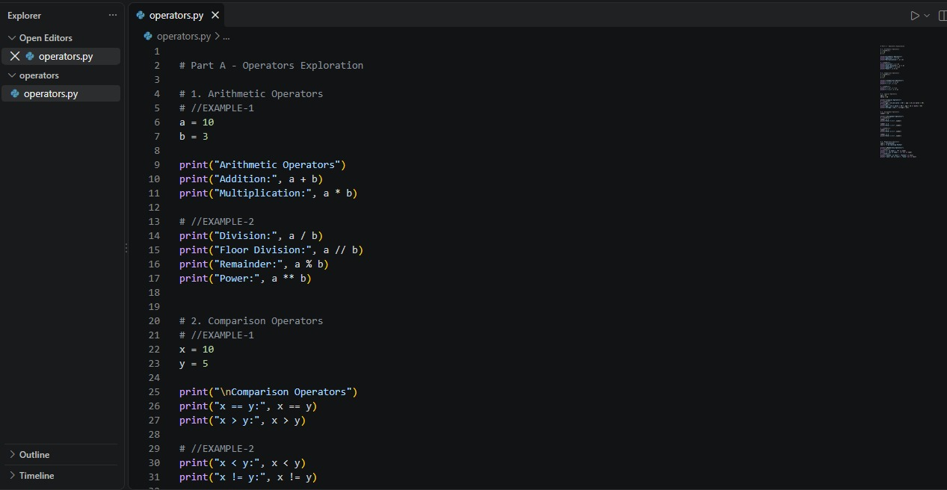

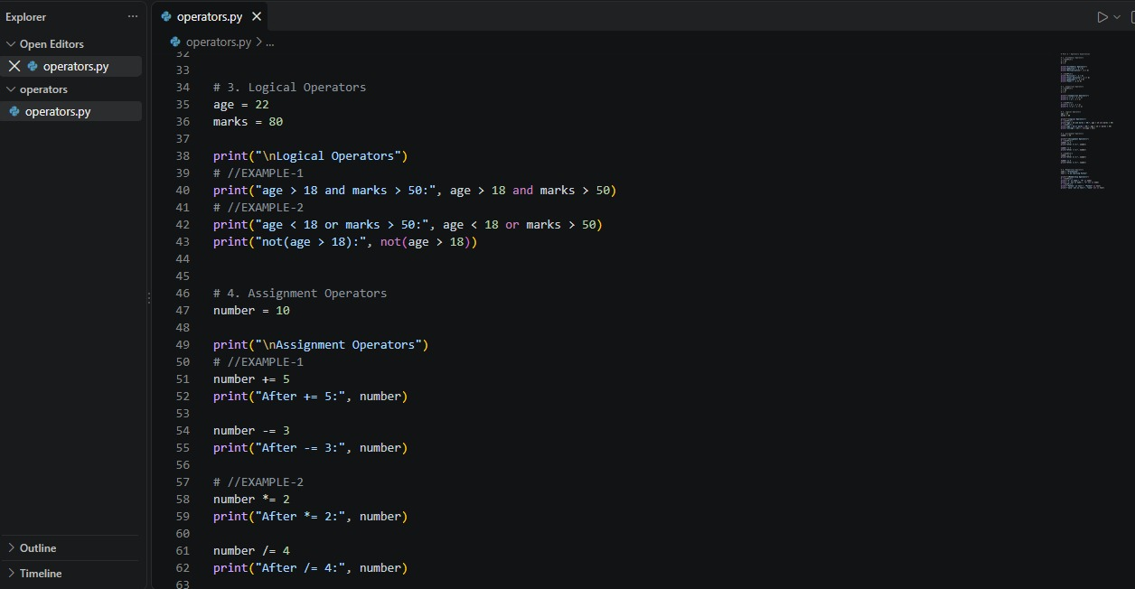
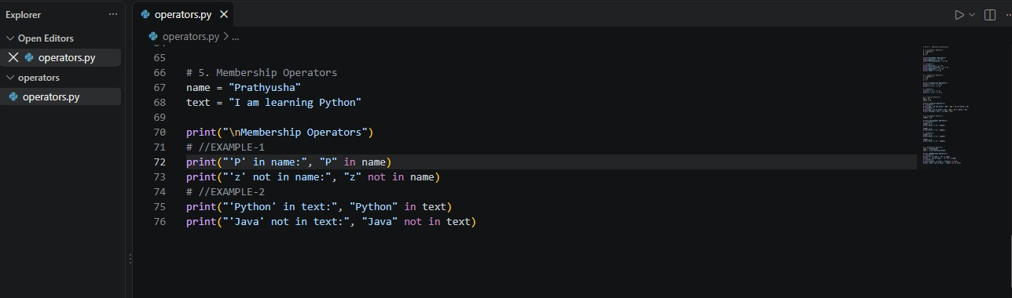

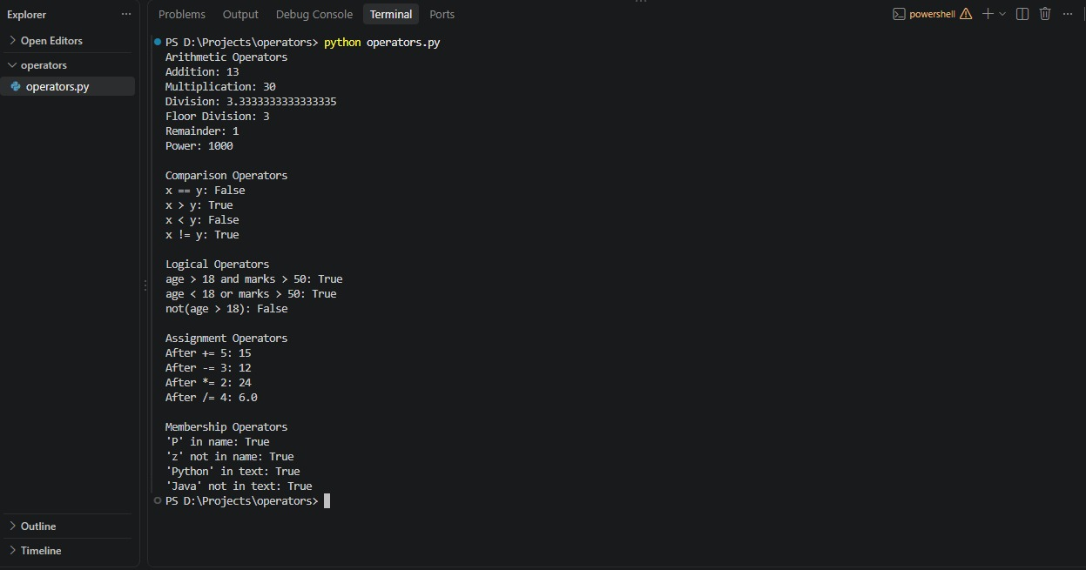

4. Part B – Operator Thinking
- What is the difference between / and //?
Ans: / is a normal division and returns decimal values.
Example:
print(10 / 3)
Output: 3.3333
// is a floor division and returns the quotient rounded down.
Example:
print(10 / / 3)
Output: 3
- When would % be useful in a real application?
Ans: % gives remainder.
Example:
number = 10
print(number % 2 == 0)
Output: True
- What does ** do?
Ans: ** is gives exponential power.
Example:
print(10 ** 3)
Output: 1000
- What is the difference between = and ==?
Ans: = is used to assign the values.
Example:
age = 20
== is use for comparison. It checks whether the two values are equal.
age = 20
print(age == 20)
Output: True
- What is the difference between != and not?
Ans: != is checks whether two values are not equal.
Example:
print(10 != 2)
Output: True
not is reverse the Boolean values or conditions.
Example:
print(not True)
Output: False
- What is the result of 10 > 5 and 3 < 2? Explain.
Ans: Code:
print(10 > 5 and 3< 2)
Output: False
Explanation: and returns True only both two conditions are True.
- What is the result of 10 > 5 or 3 < 2? Explain.
Ans: Code:
print(10 > 5 or 3 < 2)
Output: True
Explanation: or returns True if at least one condition is True.
- What does not True produce?
Ans: Code:
print(not True)
Output: False
Explanation: not reverse the Boolean value.
- What does 'Python' in 'I am learning Python' return?
Ans: Code:
print(‘Python’ in ‘I am learning Python’)
Output: True
Explanation: The in operator checks whether a value is present inside another value or not.
- When would not in be useful?
Ans: not is used when we want to check that something is not present.
Code:
text = “I am learning Python”
print(“Java” not in text)
Output: True

5. Part C – String Basics Lab
Use your own name or another sentence and run these experiments.
- Create a string and print it.
Code:
name = “Prathyusha”
Print(name)
Output: Prathyusha
- Print its length using len().
Code:
name = “Prathyusha”
Print(len(name))
Output: 10
- Print the first character using [0].
Code:
name = “Prathyusha”
print(name[0])
Output: P
- Print the last character using [-1].
Code:
name = “Prathyusha”
print(name[-1])
Output: a
- Print the first 3 characters using slicing.
Code:
name = “Prathyusha”
print(name[:3])
Output: Pra
- Print the last 3 characters using slicing.
Code:
name = “Prathyusha”
print(name[-3:])
Output: sha
- Print every second character.
Code:
name = “Prathyusha”
print(name[::2])
Output: Pahuh
- Reverse the string using slicing.
Code:
name = “Prathyusha”
print(name[::-1])
Output: ahsuyhtarP
- Try an invalid index. What error occurs?
Code:
name = “Prathyusha”
print([20])
Output:
IndexError: String index out of range
- Try changing one character directly. What happens and why?
Code:
name = “Prathyusha”
name[0] = “x”
Output:
TypeError: ‘str’ object does not support item assignment
- Because of python strings are immutable. That means we cannot directly change one character of an existing string.

6. Part D – String Methods Lab
Experiment with these methods and explain what each one does.
Method | Your example | What does it do?
lower() | name = “PRATHYUSHA”  result = name.lower()  print(result) | It converts all uppercase letters into lowercase letters.
upper() | name = “prathyusha”  result = name.upper()  print(result) | It converts all lowercase letters into uppercase letters.
title() | name = “prathyusha pujala”  print(name.title()) | It converts the first letter of each word to uppercase.
strip() | name = “ prathyusha “  print(name.strip()) | Removes extra spaces from the beginning and end of string.
replace() | text = “I like java”  result = text.replace(“java”, “python”)  print(result) | It replaces one part of a string another part of a string.
split() | text = “python is easy to learn”  words = text.split()  print(words) | It breaks a string multiple parts and return them as a list.
join() | a =[ “sita”,“ramam”]  result = “ “.join(a)  print(result) | It combines multiple strings from a list into one string.
startswith() | name = “prathyusha”  print(name.startswith(“pra”)) | It checks whether a string starts with a particular word or character.
endswith() | name = “pujala”  print(name.endswith(“ala”)) | It checks whether a string ends with a particular word or character.
find() | name = “I am learning python”  print(name.find(“learning”)) | It searches for a word or character inside a string and returns its position.
count() | name = “prathyusha”  print(name.count(“a”)) | It is a string method used to count how many times a particular character or substring occurs in a string.

7. Part E – Indexing & Slicing Challenge
Use: text = "Artificial Intelligence"
- Print the first character.
print(text[0])
Output: A
- Print the last character.
print(text[-1])
Output: e
- Print the first 10 characters.
print(text[:10])
Output: Artificial
- Extract the word Intelligence.
print(text[11:])
Output: Intelligence
- Reverse the complete string.
print(text[::-1])
Output: ecnegilletnI laicifitrA
- Print every second character.
print(text[::2])
Output: Atfca nelgne
- Print characters from index 3 to 12.
Print(text[3:12])
Output: ificial I
- Find the index of the first 'i'.
print(text.index(“I”))
Output: 3
- Count the number of 'i' characters.
print(text.count(“I”))
Output: 4
- Predict what text[100] will do, then run it.
print(text[100])
Output:
IndexError: string index out of range

8. Part F – f-Strings
- Create name, age and city variables and display them in one sentence using an f-string.
name = “prathyusha”
age = 20
city = “kanigiri”
print(f”My name is {name}, I am {age} years old and I live in {city}”)
Output: My name is prathyusha, I am 20 years old and I live in kanigiri.

- Create a product, price and quantity and display a formatted bill.
product = “Tab”
price = 34000
quantity = 2
total = price * quantity
print(f”Product: {product}”)
print(f”Price: {price}”)
print(f”Quantity: {quantity}”)
print(f”Total: {total}”)
Output:
Produce: Tab
Price: 34000
Quantity: 2
Total: 68000

- Display student name, total marks and average.
name = “Prathyusha”
total_marks = 440
average = 93
print(f” Student: {name}, Total marks: {total_marks}, Average: {average}”)
Output: Student: Prathyusha, Total marks: 440, Average: 93

- Use an f-string to display a calculation result.
a = 15
b = 35
result = a + b
print(f” {a} + {b} = {result}”)
Output: 15 + 35 = 50

- Research decimal formatting and display a price with exactly 2 decimal places.
price = 40000
print(f” Price: {price: .2f}”)
Output: Price: 80000

9. Part G – MCQs: Basic
1. Which operator means multiplication?
- A. x
- B. *
- C. %
- D. //
Ans: B. *
2. What does % return?
- A. Division
- B. Quotient
- C. Remainder
- D. Power
Ans: C. Remainder
3. What is the first string index?
- A. 0
- B. 1
- C. -1
- D. first
Ans: A. 0
4. What is len('Python')?
- A. 5
- B. 6
- C. 7
- D. Error
Ans: B. 6
5. Which gets the last character?
- A. text[0]
- B. text[-1]
- C. text[last]
- D. text[1]
Ans: B. text[-1]
6. Which converts text to lowercase?
- A. lower()
- B. small()
- C. down()
- D. lowercase
Ans: A. lower()
7. Which removes leading/trailing spaces?
- A. trim()
- B. clean()
- C. strip()
- D. remove()
Ans: C. strip()
8. Which checks membership?
- A. inside
- B. in
- C. has
- D. contains
Ans: B. in
9. Which is an f-string?
- A. f"Hello {name}"
- B. "f Hello"
- C. format f(name)
- D. string(name)
Ans: A. f"Hello {name}"
10. Which compares equality?
- A. =
- B. ==
- C. ===
- D. equals
Ans: B. ==

10. Part H – MCQs: Medium
1. What is 17 // 5?
- A. 3
- B. 3.4
- C. 2
- D. 4
A. 3
2. What is 17 % 5?
- A. 3
- B. 2
- C. 3.4
- D. 0
B. 2
3. What does 'Python'[1:4] return?
- A. Pyt
- B. yth
- C. ytho
- D. tho
Ans: B. yth
4. What does 'Python'[-3:] return?
- A. tho
- B. hon
- C. yth
- D. Python
Ans: B. hon
5. What does ' hello '.strip() return?
- A. ' hello'
- B. 'hello '
- C. 'hello'
- D. Error
Ans: C. 'hello'
6. What does 'hello'.upper() return?
- A. hello
- B. HELLO
- C. Hello
- D. Error
Ans: HELLO
7. What does 'a,b,c'.split(',') return?
- A. abc
- B. ['a','b','c']
- C. ('a','b','c')
- D. Error
Ans: B. [‘a’,’b’,’c’]
8. Which checks if AI occurs in text?
- A. text.contains('AI')
- B. 'AI' in text
- C. text.has('AI')
- D. contains(text,'AI')
Ans: ‘AI’ in text
9. What happens with text[50] when text has 10 characters?
- A. None
- B. ''
- C. IndexError
- D. False
Ans: IndexError
10. Why use f-strings?
- A. Insert values/expressions into strings cleanly
- B. Make strings immutable
- C. Convert values to int
- D. Remove spaces
Ans: A. Insert values/expressions into strings cleanly

11. Part I – MCQs: Thinking
1. Which is true about strings?
- A. They can always be changed character-by-character
- B. They are immutable
- C. They only contain letters
- D. They cannot be sliced
Ans: B. They are immutable
2. Best way to clean ' PHANI gorantla ' for display?
- A. strip().title()
- B. title().strip()
- C. Both A and B
- D. clean()
Ans: C. Both A and B
3. What does text[::-1] do?
- A. Deletes text
- B. Reverses text
- C. Sorts text
- D. Gets first character
Ans: Reverse text
4. Best simple test for '@' in an email?
- A. '@' in email
- B. email == '@'
- C. email.contains('@')
- D. email.has('@')
Ans: ‘@’ in email
5. replace() generally:
- A. Returns a transformed string
- B. Always changes the original string in place
- C. Converts to list
- D. Deletes the variable
Ans: A. Returns a transformed string
6. x='5', y=2. Which gives numeric 10?
- A. x*2
- B. int(x)*2
- C. str(x)*2
- D. x+2
Ans: B. int(x)*2
7. Which formats 12.5 as 12.50?
- A. f'{price:.2f}'
- B. f'{price:2}'
- C. f'{price.float}'
- D. f'{price.decimal(2)}'
Ans: A. f'{price:.2f}'
8. What should usually happen before validating text entered with spaces?
- A. strip()
- B. reverse()
- C. split() always
- D. replace with None
Ans: A. strip()
9. A common cause of IndexError is:
- A. Invalid index
- B. Using an f-string
- C. lower()
- D. +
Ans: Invalid index
10. Why keep raw input and cleaned input conceptually separate?
- A. It makes transformations easier to test
- B. Python requires it
- C. Strings cannot be stored
- D. It prevents every error
Ans: A. It makes transformations easier to test

12. Part J – 5 Practice Problems
Problem | Task | Topics
Practice 1 – Username Cleaner | Ask for a username, remove surrounding spaces, convert to lowercase and display the cleaned value. | strip + lower + f-string
Practice 2 – Name Formatter | Ask first and last names in random case and display a properly formatted full name. | strip + title + f-string
Practice 3 – Word Analyzer | Ask for a sentence. Display length, first character, last character, spaces count and vowel count. Do not use loops. | len + indexing + count
Practice 4 – Email Inspector | Ask for an email. Check '@', check whether it ends with '.com' or '.in', and show the position of '@'. | in + endswith + find
Practice 5 – Product Code Extractor | For code IND-MOB-2026-001, extract country, category, year and serial using slicing. | indexing + slicing + f-string
For each: Input → Expected Output → Code → 2 test cases → 1 edge case → explanation.
Practice 1: Username Cleaner
Input: PRATHYUSHA
Test Case 1
Input: PRATHYUSHA
Expected Output
Cleaned username: prathyusha
Code
username = input("Enter username: ")
cleaned_username = username.strip().lower()
print(f"Cleaned username: {cleaned_username}")
Test Case 1:
Input: PRATHYUSHA
Output: Cleaned username: prathyusha
Test Case 2:
Input: Prathyusha123
Output: Cleaned username: prathyusha123
Edge Case
Input:
Output: Cleaned username:
Explanation
strip() removes spaces from the beginning and end. lower() converts the username to lowercase. The f-string displays the cleaned value.
Practice 2 – Name Formatter
Task
Ask first and last names in random case and display a properly formatted full name.
Input
First name: pRaThYuShA
Last name: pUjAlA
Expected Output
Full name: Prathyusha Pujala
Code
first_name = input("Enter first name: ")
last_name = input("Enter last name: ")
full_name = f"{first_name.strip().title()} {last_name.strip().title()}"
print(f"Full name: {full_name}")
Test Case 1
Input: pRaThYuShA, pUjAlA
Output: Full name: Prathyusha Pujala
Test Case 2
Input: rAhUl, kUmAr
Output: Full name: Rahul Kumar
Edge Case:
Input: First name = prathyusha , Last name = pujala
Output: Full name: Prathyusha Pujala
Explanation: strip() removes extra spaces and title() converts the first letter of each word to uppercase. The f-string combines the first and last names.
Practice 3 – Word Analyzer
Task:
Ask for a sentence. Display length, first character, last character, spaces count and vowel count. Do not use loops.
Input:
Python is easy
Expected Output:
Length: 14
First character: P
Last character: y
Spaces: 2
Vowels: 5
sentence = input("Enter a sentence: ")
length = len(sentence)
first_character = sentence[0]
last_character = sentence[-1]
spaces = sentence.count(" ")
vowels = (
sentence.lower().count("a")
+ sentence.lower().count("e")
+ sentence.lower().count("i")
+ sentence.lower().count("o")
+ sentence.lower().count("u")
)
print(f"Length: {length}")
print(f"First character: {first_character}")
print(f"Last character: {last_character}")
print(f"Spaces: {spaces}")
print(f"Vowels: {vowels}")
Test Case 1:
Input: Python is easy
Output: Length = 14, First = P, Last = y, Spaces = 2, Vowels = 5
Test Case 2:
Input: Hello World
Output: Length = 11, First = H, Last = d, Spaces = 1, Vowels = 3
Edge Case:
Input: A
Output:
Length: 1
First character: A
Last character: A
Spaces: 0
Vowels: 1
Explanation:
len() finds the length. Indexing [0] gets the first character and [-1] gets the last character. count(" ") counts spaces. The count() method is used to count each vowel, so no loop is required.
Practice 4 – Email Inspector
Task:
Ask for an email. Check @, check whether it ends with .com or .in, and show the position of @.
Input:
prathyusha@gmail.com
Expected Output:
Contains @: True
Valid ending: True
Position of @: 7
Code:
email = input("Enter email: ")

has_at = "@" in email
valid_ending = email.endswith(".com") or email.endswith(".in")
at_position = email.find("@")

print(f"Contains @: {has_at}")
print(f"Valid ending: {valid_ending}")
print(f"Position of @: {at_position}")
Test Case 1:
Input: prathyusha@gmail.com
Output:
Contains @: True
Valid ending: True
Position of @: 7
Test Case 2
Input: student@gmail.in
Output:
Contains @: True
Valid ending: True
Position of @: 7
Edge Case
Input: prathyusha@gmail
Output:
Contains @: True
Valid ending: False
Position of @: 7
Explanation:
in checks whether @ exists. endswith() checks whether the email ends with .com or .in. find() returns the position of @. Python indexing starts from 0.

Practice 5 – Product Code Extractor
Task:
For the code IND-MOB-2026-001, extract country, category, year and serial using slicing.
Input:
IND-MOB-2026-001
Expected Output:
Country: IND
Category: MOB
Year: 2026
Serial: 001
Code:
code = "IND-MOB-2026-001"
country = code[0:3]
category = code[4:7]
year = code[8:12]
serial = code[13:16]
print(f"Country: {country}")
print(f"Category: {category}")
print(f"Year: {year}")
print(f"Serial: {serial}")
Test Case 1
Input: IND-MOB-2026-001
Output:
Country: IND
Category: MOB
Year: 2026
Serial: 001
Test Case 2
Input: USA-LAP-2025-123
Output:
Country: USA
Category: LAP
Year: 2025
Serial: 123
Edge Case
Input: A product code with an unexpected format, such as:
IND-MOB-26
Result: The slicing positions may not produce the expected values because the code format is different.
Explanation: Slicing is used to extract specific parts of the product code. For example, code[0:3] extracts IND. The f-string displays each extracted value clearly.

13. Part K – Debugging Lab

Bug 1
name = input('Name: ')
print(name[20])
Why can this fail?
It can fail because the name may contain fewer than 21 characters. Python indexes start from 0, so index 20 requires at least 21 characters.
Corrected code:
name = input(“Name: “)
if len(name) > 20:
print(“Name is too short”)
explanation:
We check the length before accessing index 20. This prevents an IndexError.

Bug 2
age = '20'
print(f'Age: {age + 1}')
Fix it: age is a string, but 1 is an integer. Python cannot directly add a sting and an integer.
Corrected code:
age = ‘20’
print(f” Age: {int(age) + 1:”)
Output: Age: 21
explanation: int(age) converts the string “20” into the integer 20.

Bug 3
name = 'phani'
age = 30
print('Hello ' + name + age)
Identify the type problem
name is a string, while age is an integer, we cannot use + directly to concatenate a string and an integer.
Corrected code:
name = “phani”
age = 30
print(f” Hello {name}, your age is {age}”)
Output: Hello phani, your age is 30
explanation: An f-string allows us to easily combine strings and numbers.
Bug 4
email = input('Email: ')
print(email.endswith('.com'))
Test with 3 inputs and explain.
No, The code works correctly. endswith() checks whether the email ends with .com
Test-1:
prathyusha@gmail.com
Output: True
Test-2:
prathyusha@gmail.in
Output: False
Test-3:
prathyusha@yahoo.com
Output: True
explanation: endswith(“.com”) returns True if the email ends with .com; otherwise, it returns False.

Bug 5
code = 'IND-MOB-2026-001'
print(code[20])
Find the valid index range and fix the requirement.
Index 20 is outside the valid range of the string.
Corrected code:
Print(code[14])
Output: 1
explanation:

Bug 6
text = ' hello world '
print(text.upper().strip())
Does it work? Explain the order of operations.
Yes, it works
Output: Hello World
explanation: Python performs the operations from left to right.

14. Part L – Main Project: Text-Cleaning & Profile Formatter
Build a practical Python program that accepts messy profile information and converts it into a clean, readable profile.

Scenario
A company receives profile data in inconsistent formats. Names may contain extra spaces, emails may use mixed cases, and cities may be entered randomly. Your program should clean the data and generate a professional profile summary.

Required Inputs
- Full name
- Email address
- Phone number
- City
- Job role
- Short bio

Must-Have Requirements
- Remove leading/trailing spaces.
- Format the full name using title().
- Convert email to lowercase.
- Format city and job role neatly.
- Calculate bio character count.
- Check whether the email contains '@'.
- Check whether the email ends with a supported domain such as .com or .in.
- Extract first name from the full name.
- Extract last name using string logic.
- Display the profile using f-strings.
- Show a small data-quality section.
- Test with messy uppercase/lowercase and extra spaces.

Expected Output Example
================ PROFILE ================
Name : Phani Gorantla
First Name : Phani
Email : phani@example.com
Phone : 9876543210
City : Hyderabad
Role : Software Developer
Bio Length : 42 characters
------------- DATA QUALITY -------------
Email Valid : Yes
=========================================
Code:
full_name = input("Enter full name: ").strip().title()
email = input("Enter email: ").strip().lower()
phone = input("Enter phone number: ").strip()
city = input("Enter city: ").strip().title()
job_role = input("Enter job role: ").strip().title()
bio = input("Enter short bio: ").strip()
name_parts = full_name.split()
if (len(phone) > 10):
print("Invalid phone number")
else:
print("Phone number is valid")
if (len(name_parts) >= 2):
print("Full name is valid")
else:
print("Please enter first and last name")
username = full_name.lower().replace(" ", "")
print(f"Username: {username}")
professionalBio = (f"{full_name} is a {job_role} from {city}." )
print(professionalBio)
first_name = name_parts[0]
bio_length = len(bio)
has_at = "@" in email
supported_domain = email.endswith(".com") or email.endswith(".in")
if has_at and supported_domain:
email_valid = "Yes"
else:
email_valid = "No"
print("\n============ PROFILE =============")
print(f"Name : {full_name}")
print(f"First Name : {first_name}")
print(f"Last Name : {last_name}")
print(f"Email : {email}")
print(f"Phone : {phone}")
print(f"City : {city}")
print(f"Role : {job_role}")
print(f"Bio Length : {bio_length} characters")
print("\n------------- DATA QUALITY -------------")
print(f"Email Valid : {email_valid}")
print("=======================")

15. Project Bonus Challenges
- Clean repeated spaces inside a name.
- Validate phone number length.
- Check that the full name contains at least two words.
- Generate initials from the name.
- Generate a username from the person's name.
- Create a one-line professional bio using an f-string.
- Display a simple data-quality percentage.

16. Project Test Cases
Test | Input condition | Expected behaviour | Actual result
1 | Normal clean input | Clean profile | Profile cleaned successfully.
2 | Extra spaces around fields | Spaces removed | Extra spaces removed successfully.
3 | Random uppercase/lowercase | Proper formatting | Text converted to proper format flagged.
4 | Invalid-looking email | Flag data quality | Invalid email format flagged.
5 | Short/missing optional data | Program should handle it sensibly | Program handled missing/ short data without crashing.

17. Explain Your Project
- What is the difference between cleaning data and formatting data?
Ans: Cleaning data means removing unwanted spaces, missing or incorrect data. Formatting data means making the data look consistent, such as converting names to proper case.
- Which string methods did you use and why?
Ans: I used strip(), split(), join(), lower(), replace(), and title(). I used them to remove extra spaces, change text format, create usernames, and clean names.
- Where did you use indexing?
Ans: I used indexing to access individual characters, such as the first character of a name to generate initials.
- Where did you use slicing?
Ans: I used slicing to get a part of a string, such as extracting a portion of a name or text.
- Why are f-strings useful here?
Ans: F-strings are useful because they make it easy to combine text and variables in a clear and readable way.
- What error did you face?
Ans: I faced an IndexError because they when I tried to access a string index that does not exist.
- How did you test edge cases?
Ans: I tested empty input, extra spaces, short names, uppercase and lowercase text, invalid email formats, and missing data to make sure the program handled them without crashing.
- If this processed 1 lakh profiles, what would you improve first?
Ans: I would improve the processing speed and memory usage first. I would process the profiles efficiently in batches and avoid unnecessary operations.

18. Final Self-Check
Skill | Yes | Need Practice | Notes
Use arithmetic/comparison/logical operators | Yes |  | I can use basic operators.
Explain = vs == | Yes |  | = is assigns a value, == is compares value.
Manipulate strings | Yes |  | I concatenate and modify strings.
Use positive and negative indexing | Yes |  | I can access characters using indexes.
Use slicing | Yes |  | I can extracts parts of a string using slicing.
Use string methods | Yes |  | I can use methods such as upper(), lower(), and count().
Use in/not in | Yes |  | I can check whether text exists in a string.
Use f-strings | Yes |  | I can format variables and expressions in strings.
Debug IndexError/type problems | Yes |  | I can read the error and check indexes and data types.
Build the final text utility | Yes |  | I can combine the concepts into a small Python program.

19. Submission Checklist
- Operator experiments
- Operator questions
- String exploration
- String-method table
- Indexing/slicing challenge
- f-string exercises
- 30 MCQ answers
- 5 practice programs
- Debugging Lab
- Text-Cleaning & Profile Formatter
- Project test cases
- Project explanation and self-check

