**Entity-Relationship Diagram**

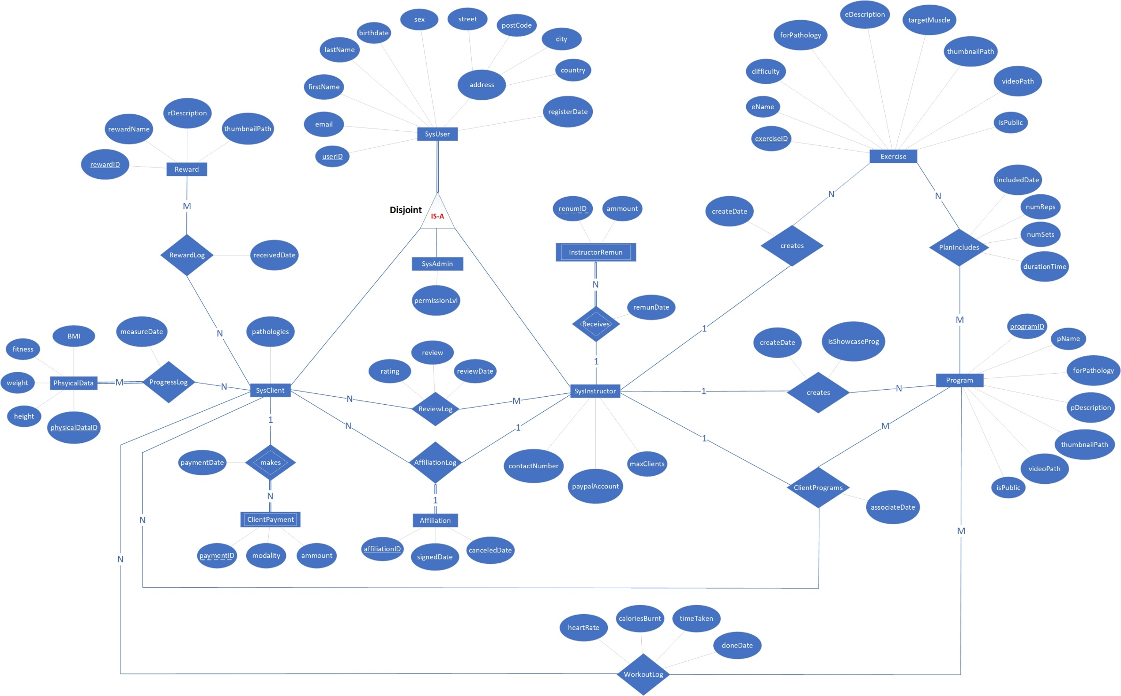

**Relation Keys**

|  |  |  |  |
| --- | --- | --- | --- |
| Relation | Candidate Keys | Primary Key | Foreign Keys |
| SysUser | {userID}, {Email} | {userID} | **-** |
| SysAdmin | {adminID} | {adminID} | {adminID} |
| SysInstructor | {instructorID} | {instructorID} | {instructorID} |
| SysClient | {clientID} | {clientID} | {clientID} |
| Exercise | {exerciseID} | {exerciseID} | {creatorIntsID} |
| Program | {programID} | {programID} | {creatorIntsID} |
| PhysicalData | {physicalDataID} | {physicalDataID} | **-** |
| Affiliation | {affiliationID} | {affiliationID} | **-** |
| Reward | {rewardID} | {rewardID} | **-** |
| ClientPayment | **-** | {paymentID} + {paidClientID} | {paidClientID} |
| InstructorRemun | **-** | {renumID} + {receivedInstID} | {receivedInstID} |
| PlanIncludes | **-** | {progID} + {exeID} | {progID}, {exeID} |
| ClientPrograms | **-** | {forClientID} + {instID} + {progID} | {forClientID}, {instID}, {progID} |
| WorkoutLog | **-** | {doneByClientID} + {progID} | {doneByClientID}, {progID} |
| ProgressLog | **-** | {progClientID} + {progDataID} | {progClientID}, {progDataID} |
| AffiliationLog | **-** | {affID} + {affClientID} + {affInstID} | {affID}, {affClientID}, {affInstID} |
| ReviewLog | **-** | {revClientID} + {revIntsID} | {revClientID}, {revIntsID} |
| RewardLog | **-** | {rewID} + {rewClientID} | {rewID}, {rewClientID} |

|  |  |
| --- | --- |
| Relation R | Relational Schema r(R) |
| SysUser | userID, email, firstName, lastName, birthdate, sex, street, postCode, city, country, registerDate |
| SysAdmin | adminID, permissionLvl |
| SysInstructor | instructorID, contactNumber, paypalAccount, maxClients |
| SysClient | clientID, pathologies |
| Exercise | exerciseID, eName, difficulty, forPathology, eDescription, targetMuscle, thumbnailPath, videoPath, isPublic, createDate, creatorIntsID |
| Program | programID, pName, forPathology, pDescription, thumbnailPath, videoPath, isPublic, createDate , isShowcaseProg, creatorIntsID |
| PhysicalData | physicalDataID, height, weight, fitness, BMI |
| Affiliation | affiliationID, signedDate, canceledDate |
| Reward | rewardID, rewardName, rDescription, thumbnailPath |
| ClientPayment | paymentID, paidClientID, modality, ammount, paymentDate |
| InstructorRenum | renumID, receivedInstID, ammount, remunDate |
| PlanIncludes | progID, exeID, numSets, numReps, durationTime, includedDate |
| ClientPrograms | forClientID, instID, progID, associateDate |
| WorkoutLog | doneByClientID, progID, timeTaken, heartRate, caloriesBurnt, doneDate |
| ProgressLog | progClientID, progDataID, measureDate |
| AffiliationLog | affID, affClientID, affInstID |
| ReviewLog | revClientID, revIntsID, rating, review, reviewDate |
| RewardLog | rewID, rewClientID, receivedDate |

**Relational Schema**