SESSION-01 (Cover entire video)
- Small STORY
- The SDLC
- Waterfall vs agile vs DevOps
- What is DevOps?
- Why Linux?

SMALL STORY:-
SMS School Management System
Stakeholders in SMS are Teachers, Parents, and Students
100 years back Final exam
- Teachers Not serious to complete syllabus from DAY-1
- Parents Yes. Worried about, whether they pass or not from Day-1
- Students Not serious to study from DAY-1
Final pass percentage at the end is 30%
Process Changed
UNIT TEST-I, II, III, IV
Q, H, Pre-Final, Final
UNIT TEST-I 30 days
Teachers They should be serious from DAY-1 to complete syllabus for UNIT TEST-I
Students One week before they start reading for UNIT TEST-I
Parents They are waiting for UNIT TEST-I results
Final pass percentage at the end is 80%

Software Development Life cycle (SDLC):-
- Requirements analysis
- Planning (or) feasibility study
- Design General requirements to technical requirements
- Implementation
- Testing
- Deployment
- Maintenance
Parents Clients
Teachers IT Management
Students Developers, Operations team, testing team
Waterfall:-
- Requirements analysis
- Planning
- Design General requirements to technical requirements
- Implementation
- Testing
- Deployment
- Maintenance
Requirements Phase-I
Once you are in Phase-II, You can't go back and change the requirements.
6 months for development Testing and Deployment
100 defects 10 invalid defects
50 defects 6 invalid defects
Ambassador (we delivered Ambassador but client’s expecting BMW)
Agile:-
- Requirements analysis
- Planning
- Design General requirements to technical requirements
- Implementation
- Testing
- Deployment
- Maintenance
Modules Signup, Login, Menu, Order, Shipping, Delivery, Payments
Signup 1 month
2 weeks for development, 2 weeks for testing and deployment it is called sprint
Development is serious from DAY-1
20 defects 5 invalid defects
Honda City (we delivered Honda City but client’s expecting BMW)
- Waterfall 10 times testing 100(bugs are identified in testing)
- Agile 30 times testing 101 (bugs are identified in testing)
- DevOps 100 times testing 102
Agile is a part of DevOps:-
Modules Signup, Login, Menu, Order, Shipping, Delivery, Payments.
Signup 1 month
DAY-1 100 lines of code enter your first name, enter your last name
Deploy this 100 lines test this 100 lines
DAY-2
---- And so on till Day-9------
DAY-10 we should deploy and test everything.
DevOps is a process of building, testing and releasing code on the same day when developer writes something.
- Through this process we can achieve Co-operation, Co-ordination, and Collaboration between teams.
- Faster releases and
- Less defects.
- Speed and Accuracy

In different organisations or projects having different environments like.
DEV, PROD
DEV, QA, PROD
DEV, QA, UAT, PRE-PROD, PROD
DEV, QA, UAT, PERF, SECURITY, PRE-PROD, PROD

Linux (It is a case sensitive):-
Windows VS Linux:-
We need to restart sometimes It can run for years
Too many graphics Time to load No graphics Super performance
More Resource consumption less resource consumption
Not that much secure Secure
Costly Free
Not open source Open source

Tomorrow we will discusses below topics.
Server Creation, Linux Commands, Editors, User creation, Install software’s, Service management.
AWS Account creation https://youtu.be/F4jF88UkxV4 -- Video link to create AWS account.
Basic laptop specifications to practice this course:
i3, 8GB ram
i5, 16GB
i7, 16GB

Session-2 (just focus till 1hour 17mints)
What is a Computer?
Client-Server Architecture
Authentication mechanisms
Public key and Private Key
Firewall creation @16 mints
Import Key pair
Instance Creation
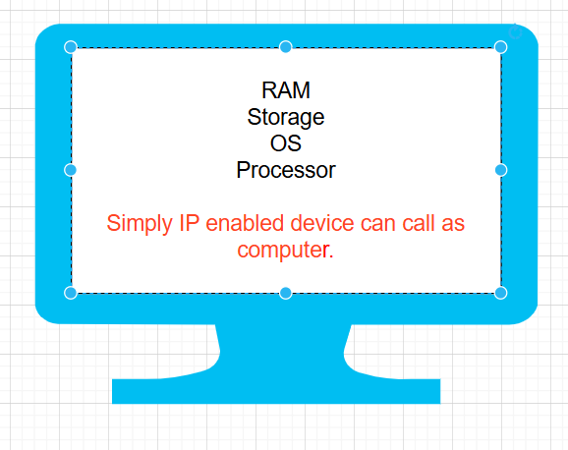
- Server The device which is used to host an application
Port forwarding you can deploy application in your laptop and open it in internet (we can see this option in modems)
Facebook.com Facebook application in fb servers
Browser Client software
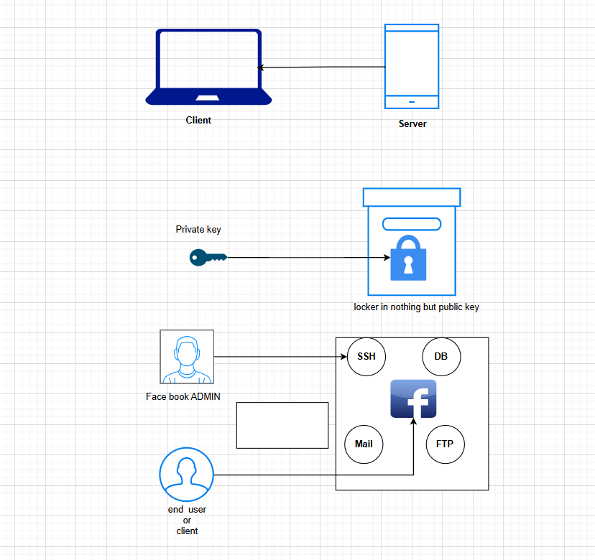
For any server companies (like AWS, Azure) below things are primary to set their business.
- Region HYD, Mumbai, Singapore, US, EU
- Available Zone (AZ) North HYD, South HYD minimum 2 AZ High availability
Instance OR Server OR node (all are same only but different words).
LAUNCHING OF EC2 INSTANCE ON AWS PLATFORM:-
Firewall OR Security Group (all are same only but different words).
Allow everyone one through firewall
Inbound incoming traffic
Outbound outgoing traffic
0.0.0.0/0 means every computer in the internet
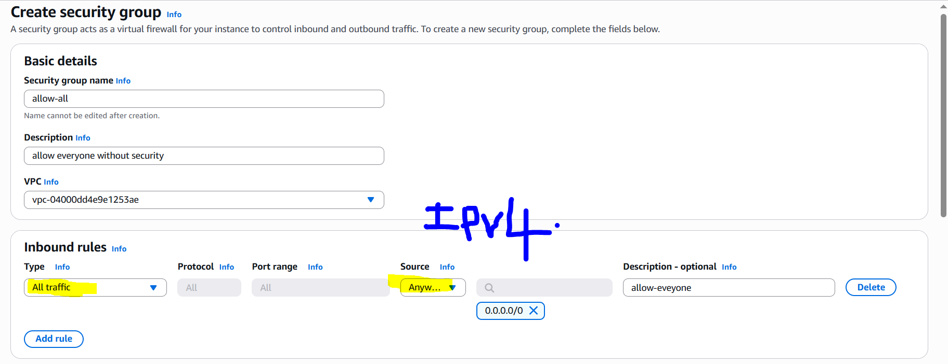
AMI (Amazon Machine Image) devops-practice
Red Hat Enterprise Linux (RHEL) == Centos == Amazon Enterprise Linux == Fedora == Alma Linux
.iso The International Organization for Standardization
- ISO stands for The International Organization for Standardization.
- which is nearly followed by 91 nations(countries)
- Here .iso is a type of file extension.
It will create entire operating system C:\Windows

Previously back in 1980s.
Mac Hardware locking you are buying both hardware and Mac OS
Servers == UNIX
Laptops == IBM BIOS (BIOS stands for Basic Input/Output System.) The Epson HX-20 was the first laptop.
Linus Torvalds is the Inventor of Linux
OS (operating system) == Kernel + User Interface
Kernel == Brain of OS == C language is used develop kernel of Linux.
Linux (Kernel) C language Open Source

Linux Implementations or Distributions or Flavours of Linux:-
RHEL Commercial (Enterprise)
IBM AIX
Ubuntu most popular open source OS.
Fedora
Solaris
Suse
Android

Open Source Vs Enterprise
Here's a clear comparison of Open Source vs Enterprise software:
Feature | Open Source | Enterprise (Proprietary)
Source Code | Available and modifiable by anyone | Closed and owned by the company
Cost | Usually free or low-cost | Typically requires a paid license or subscription
Customization | High – can be modified as needed | Limited – changes need vendor support
Support | Community-driven (forums, contributors) | Professional support from the vendor
Security | Transparent but may need expert management | Managed by vendor; security patches are provided
Updates | Frequent, by the community | Regular, controlled updates from the vendor
Ease of Use | May require technical skills | User-friendly, designed for businesses
Examples | Linux, Apache, MySQL, LibreOffice | Windows Server, Oracle DB, Microsoft Office 365

Summary:
- Open Source is ideal for flexibility, control, and cost-saving.
- Enterprise Software is better for businesses needing professional support, warranties, and ease of use.

AWS Linux 2023 AMI
t3.micro/t2.micro these are the free tire options for launching EC2 instance.
Authentication:-
- What you know Username and Password
- What you have Username and token/OTP
- What you are Fingerprints, Retina, Palm, etc.
Public Key and Private Key
Lock and Key
Lock Public (.pub extension file)
Key Private (.pem extension file)
Git bash SSH Client, Git Client, Mini Linux
~ Home directory
pwd Present working directory
C:\Users\<your-username> Windows format of paths
/c/Users/sivasai Linux format of paths
ls -l List sub directory in current path
ssh-keygen -f <file-name> this command line will gives us public key and private key
ssh-keygen –f sai this generates two files sai, sai.pub.
ssh-rsa
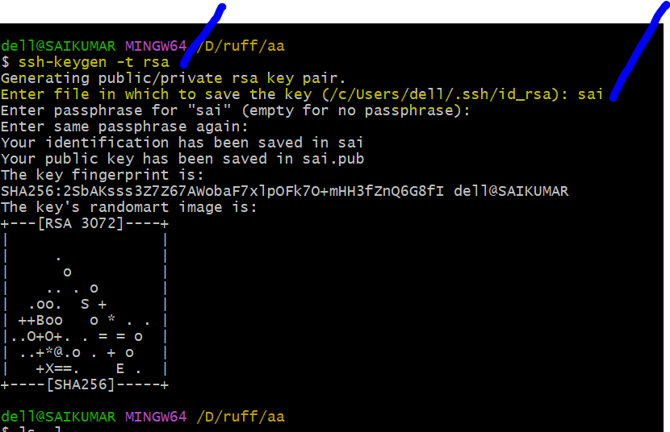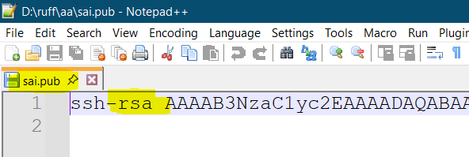
ssh-ed25519
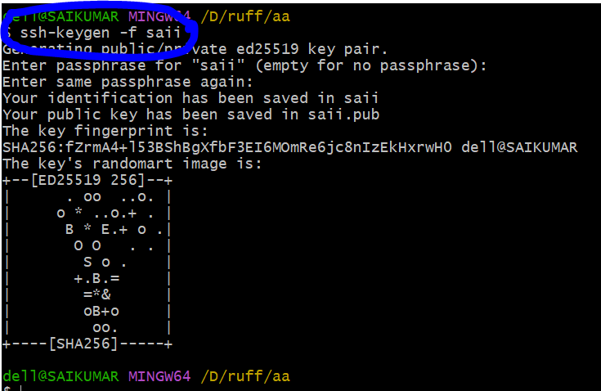
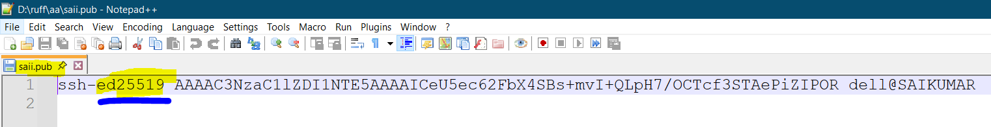
Any one of above words (ssh-ed25519 or ssh-rsa) can be a part of public keys.

Enable extension
Control Panel\All Control Panel Items
File Explore options
View
Uncheck Hide extensions for known file type.
jul-payslip.pdf
jul-payslip

.pub extension refers to public key
.pem extension refers to private key

Public IP == 34.227.191.107 (we have to access the server, with public IP address only).
AWS Linux 2023 AMI ec2-user is default user ID and our private key is the passwords for logging into the server
IP, Username, password, protocol, port

HTTP facebook.com/IP, Username, Password, 80(it is default port number for HTTP)
Similarly for HTTPS-----443 (it is default port number for HTTPS)

Facebook.com/IP, Username, Password/Private Key, SSH, 22
Secure Shell (SSH) --> it will give full access to the server and default port number for this protocol is 22.
Delhi --> HYD
f:no, apartment name, pin code
siva, 523764

ssh -i <private-key> ec2-user@IP

Task to complete after the class:-
1. Create public and private keys
2. Import public key
3. Create firewall
4. Create Instance
5. Connect to Instance
6. Terminate when not using.

Session-3 (just focus till 1 hour 10mints)
- Linux basic commands

uname gives us kernel name
echo "Hello world" this is preferable to print on the screen itself
echo 'Hello world' this command also can print but not preferable
ssh -i <path-to-your-private-key> ec2-user@IPcommand to login to the server from git-bash by using private key
absolute path and relative path
/c/devops/daws-82s/daws-82s.pem absolute path
ssh -i /D/Devops/DAWS-82S/Key_Pairs/sai_test.pem ec2-user@18.207.125.78
daws-82s/daws-82s.pem relative path
cd /D/Devops/DAWS-82S/Key_Pairs/
ssh -i sai_test.pem ec2-user@18.207.125.78
clear clears the current console
$ denotes normal user
sudo su root access
# denotes admin/root user
/home/<user-name> normal user home folder
sudo su - lands into root user’s home folder. (/root)
/root root user home folder (type sudo su enter. If we type CD then enter we will land in to root’s home directory)
cd / we will land in to root folder of the server (it is like THIS PC of the windows)
<command-name> <options> <inputs>
- We can give single char
-- We need to give word
ls list subdirectories
ls -l long listing format with more details
ls -lr reverse alpha order
ls -lt new files on top
ls -ltr old files on top
ls -ltrh human readable
ls -la display all files including hidden files and folders

drwx------ d means directory
-rw-r--r-- - means file
lrw-r--r-- l means Link files

touch <file-name> creates empty file(any file we can create with it but take care of file extensions)

cat devops.txt to open or view the file
cat > devops.txt enter the text, once done enter and then press ctrl+d
>> append, adds to the current text
Example: cat >> devops.txt

rm devops.txt to remove the file from server in relative path
rm -rf devops.txt for force delete of file

mkdir <name> creates directory
rmdir <name> removes only empty directory
rm -r devops recursively delete everything inside devops folder
cd .. One step back from current folder or directory

=======================at 32mints ===================
cp <source-file> <destination> we can use this command when we are in FROM folder and we are PUSING THE FILE.
cp passwd /home/ec2-user--------(I performed it from /etc folder)

=======================at 46mints ===================
cp <source file along with path> <save as the file in your current path> coping file with name we want PULLLING THE FILE PROCESS
cp /etc/passwd passwd--------(I performed it from /home/ec2-user)
cp /etc/passwd passwddddd

curl and wget
wget <URL> Downloads the file
curl <URL> Shows the content on the screen
curl <URL> -o <save as> it will downloads the content and saves the file as the name we provided

Raw text URL from git:-
https://raw.githubusercontent.com/DAWS-82S/notes/refs/heads/main/session-02.md
In above url / Separator or delimiter or fragments

Sivakumar Reddy M
In above name, space is the separator or delimiter

At 46mints sir explained HOW TO CHECK NUMBER OF USERS CONNECTED TO THIS SERVER, (/etc/passwd we should only check in this file but don’t corrupt the file).
grep <word-to-search> <file>
grep ec2-user passwd
Piping
| pipe
cat <file-name> | grep <word-to-search>
cat passwd | grep ec2-user
Cut command:-
Command: echo "https://raw.githubusercontent.com/DAWS-82S/notes/refs/heads/main/session-02.md" | cut -d "/" -f1
Output: https:
Command: echo "https://raw.githubusercontent.com/DAWS-82S/notes/refs/heads/main/session-02.md" | cut -d "/" -f9
Output: session-02.md
awk command: -
Command: echo "https://raw.githubusercontent.com/DAWS-82S/notes/refs/heads/main/session-02.md" | awk -F "/" '{print $NF}'
Output: session-02.md (NF always gives us last fragment).
Command: echo "https://raw.githubusercontent.com/DAWS-82S/notes/refs/heads/main/session-02.md" | awk -F "/" '{print $1F}'
Output: https: (1F always gives us last fragment).
How can I get all the users in Linux Server?
awk -F ":" '{print $1F}' passwd for total user names
awk -F ":" '{print $3F}' passwd for total user Ids.

man <any key word you want to search> this command is like manual book of key words
q Quit from manual mode

head passwd top 10 lines from top
tail passwd last 10 lines from Bottom

tail -n 4 passwd last 4 lines from bottom
head -n 3 passwd top 3 lines from top

head -n 10 passwd | tail -n 7 this query displays lines from line 4 to 10
head –n 10 fileName | tail (10-4)+1======some kind of formula=======

Since we are searching in root folder we must need root access then only it will work
find <which-location> -name "<file-name>"
find / -name "passwd" this command gives us all files, all directories with this name.
find / -type f -name "passwd" this command gives us only files with this name.
find / -type d -name "passwd" this command gives us only directories with this name.
or
find <which-location> -type f "<File name>"
find / -type f -name "**mm**"
or
find <which-location> -type d "<Directory name>"
find / -type d -name "Amma" this command gives us all directories, with this name.
find / -type d -name "**mm**"
vim editor(visually improved editor) will be discussed on next session.

Session-4 (just focus till 1 hour 24 mints)
- vim editor
- user management

cp /etc/passwd passwd
vim passwd vim command is used to open the file in vim editor.
  - ESC mode
  - : Mode (or) Command mode----- (colon or command mode)
  - Insert mode
- Esc mode is default one
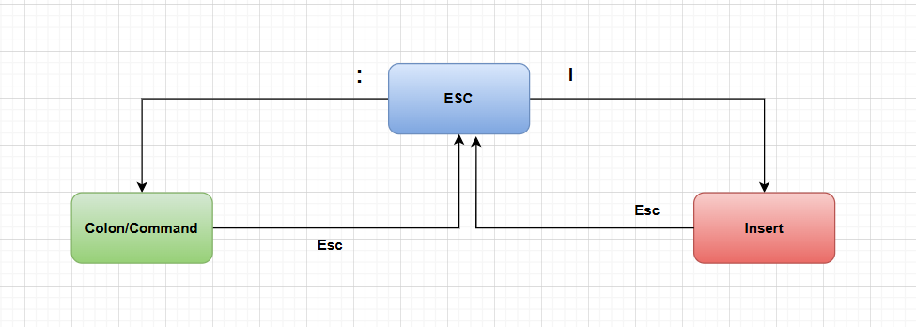
Press : to enter into command mode
COMMAND MODE
:q quit
:wq write and quit
:q! Force quit without changes
:wq! Means “save the file and quit, even if it’s read-only or normally restricted.”
:set nu set line numbers in the file
:set nonu don’t set line numbers
:/<word-to-find> search the word from top to bottom and word is highlighted.
:?<word-to-find> search the word from bottom to top and word is highlighted.
:noh no highlight
:28 d deletes 28th line
:3s/word-to-find/word-to-replace replaces first occurrence in that(3rd) line
:3s/word-to-find/word-to-replace/g replaces all occurrences in that line
:%s/word-to-find/word-to-replace/g replaces all occurrences in file
:%d delete entire content
ESC Mode
U undo
yy copy the line
p paste
10p paste the line 10 times
dd cut the line
gg takes cursor to top
shift+g takes cursor to bottom
Insert Mode
press i

SUDO ACCESS NEED, TO PERFROM ADMIN RELATED ACTIVITIES
Linux Administration
- User management

User management
Create user, add user to any group

useradd <user-name> creates user and group with same name
id <user-name> displays user information (admin credentials not required)
cat /etc/passwd contains user information (admin credentials not required)
cat /etc/group contains group information (admin credentials not required)
In Linux, a user must have only one primary group and at least one secondary group
passwd <user-name> sets password to the user
groupadd <group-name> creates group

usermod -g devops ramesh adds ramesh to devops group (here –g refers to primary group)
usermod -aG testing ramesh adds testing as secondary group (or) we can add a user to n number of groups with this command. (here –aG “G” refers to secondary group. “-a” refers to append)
CRUD means Create Read Update Delete (here Siva explained an incident which is occurred at Singapore …about hacking)
userdel <user-name>
First remove from primary project or projects (we have to reassign the person to default user group which is created by default while creating user id for the first time), then remove ID from company.
{usermod –g <user name> <user name> then userdel <user-name> }

groupdel <group name> that particular group will be deleted
getent group <group name> that particular group details will be displayed

Linux follows key based authentication by default

vim /etc/ssh/sshd_config edit the SSH related configuration
/etc/ssh/sshd_config any mistakes in this file, we can’t get in to the server through ssh. If it happened then we have to factorial reboot the server.
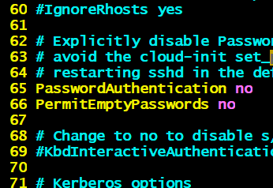 -------------- 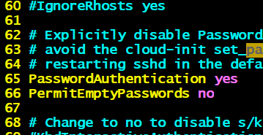
systemctl restart sshd
sshd -t to check config is correct or not(if any issue we will get error after running this command)
key based authentication Ramesh should generate his public key and private key...it is covered in next class

==================My Practice part===================
:/<word to find in the text> hit enter, to navigate among or between lines hit n.

Session-5 (Cover entire video)
- User management
- Permissions and Ownership
- Package management
- Service management
- Network management

USER MANAGEMENT (mostly Linux admin team works on this)
Permissions
r == 4 R indicates read permission
W == 2 W indicates write permission
X == 1 X indicates Execute permission
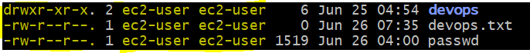
-rw-r--r--. 1 ec2-user ec2-user 0 Feb 4 07:28 practice
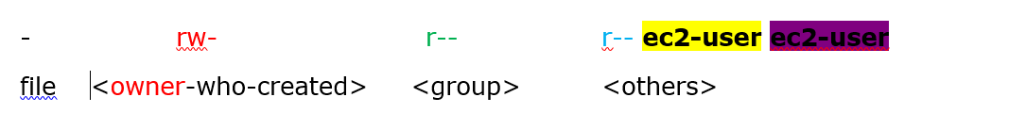
ec2-user Owner Read and Write
ec2-user Group Only Read
Others Other than owner and group only read

Who can change permissions of file or folder?
Ans: owners or root user
Owner/user == u
Group == g
Others == o

chmod <privileges to grant or remove for u, g, o> <file or folder name>
chmod o+w devsecops.txt This command gives write access to others
chmod o-r suresh.txt This command removes read access to others
chmod ugo+rwx suresh.txt
chmod 740 suresh.txt
chmod 777 suresh.txt
chmod 755 suresh.txt

Pub key Authentication for newly added users to the server:-
Admin should ask for saii public key
With root access follow below steps
cd /home/saii/
mkdir .ssh
cd .ssh
touch authorized_keys
vim authorized_keys place the saii’s public key properly and save the file, make sure that no extra spaces.
chown saii:saii authorized_keys
chmod 400 authorized_keys

chown -R saii:saii .ssh here -R means regressive.

chmod 700 -R .ssh/ Apply the change recursively — to the directory and all files/subdirectories inside

ls –l
cd
then some configurations needs to change
vim /etc/ssh/sshd_config
uncomment PubkeyAuthentication yes and save it
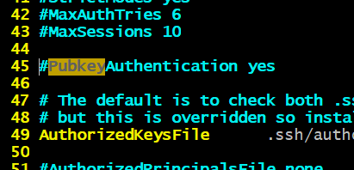-------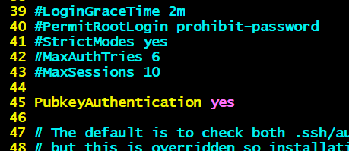
sshd -t
systemctl restart sshd

ssh -i saii.pem saii@IP

Package management
Windows laptops are configured with URL to pull the updates.
Usually one package depends on other packages...
/etc/yum.repos.d/ here we have all repos URL, which are used to install packages when we need.

Yum and dnf commands are part of RHEL
yum install <package-name>
dnf install <package-name> apt-get is for ubuntu
apt install git
dnf remove <package-name>
dnf update <package-name>
sudo su -
dnf install git –y
dnf install gcc -y
dnf remove git –y
dnf remove gcc -y
dnf update git -y
dnf list installed displays all already installed inside Linux
dnf list installed | wc -l it gives us count value of number of packages installed in server.
dnf list available all – installed(all minus installed means what are the extra apps that we can install)

Service Management
ssh -i <private-key> suresh@IP
request goes to IP, checks SSH is running on port number 22...

systemctl status sshd d for demon and to login to server, sshd should be ALWAYS in running state.

http service or server, for http service nginx or apache (nginx is latest one apache is old trend)

dnf install nginx -y to install packages with only one instruction or query.
systemctl start nginx to start nginx service
systemctl status nginx to check status
http://IP:80 ----- ekkada port number 80 physical ga mana ki kanpinchadu.
systemctl stop nginx
systemctl restart nginx restart
systemctl enable nginx services will start automatically
systemctl disable nginx
Few packages are just utilities, they are command line packages.
Example: systemctl start git invalid
Few packages are service related, we can start/stop/restart/enable.
systemctl start nginx
systemctl status nginx

Process Management
TL
Senior
Junior
Fresher

TL TASK-1 Senior
Senior TASK-2 Junior
Junior TASK-3 Fresher

For TASK-3, TASK-2 is the parent.
For TASK-2, TASK-1 is the parent.

Process in linux everything is process
echo "Hello World" creates one process instance id
gives the result and then mark the process as completed

ps simple search of all app’s or service’s process status
ps -ef advanced search

PPID parent process instance id

dnf install nginx-y
systemctl start nginx
ps -ef | grep nginx
Foreground and background
sleep 10 & [ampersand ani palakalli it will allow that instruction(sleep) run in background…..sleep for 10 seconds]
sleep 100 &
ps -ef | grep sleep

kill PID request to stop ------It terminates that PID
kill -9 PID order to stop (here nine is mandatory one) ------It kills that PID

Network Management(it will discussed with AWS VPC) for troubleshooting
netstat –lntp to check ports (list of network ports in operation)
systemctl status nginx
ps -ef | grep nginx
netstat -lntp check port is open or not
=============== My Practice part =================
for renaming: mv filename < save as>
example: - mv passwd END
If SSH’s PID is killed all users disconnects from server and not able to connect back to fix this we have to reboot server.

