What is Port Forwarding?
- Port forwarding lets computers on the internet connect to a specific computer or service inside a private (home) network.
- It’s like opening a small door in your router to let certain traffic go to the right computer.

Example: Remote Desktop Connection
- Suppose your friend wants to control your PC remotely using Remote Desktop (RDP).
- Remote Desktop uses port 3389 to communicate.
- Your friend sends a request to your public IP address with port 3389.
- When the request reaches your router, it needs to know which computer inside your home to send it to.
Without port forwarding, your router won’t know where to send this request — so the connection fails.
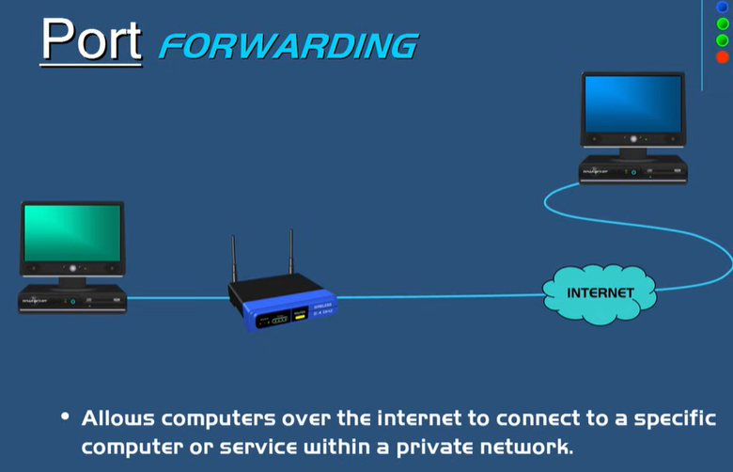

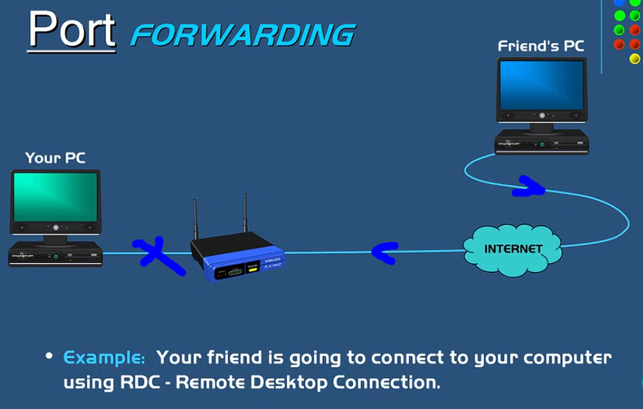

How to Set Up Port Forwarding
- Find your router’s IP address:
  - Open Command Prompt → type ipconfig → look for Default Gateway (this is your router’s internal IP).
- Find your computer’s IP address (also shown in ipconfig).
- Login to your router:
  - Open a web browser → enter router’s IP (e.g., 192.168.1.1).
- Go to the Port Forwarding section.
- Add a new rule:
  - Name: Remote Desktop
  - Port number: 3389
  - IP Address: Your computer’s IP (e.g., 192.168.1.2)
- Save settings.
- Now, when your friend connects using port 3389, the router forwards the connection to your computer.
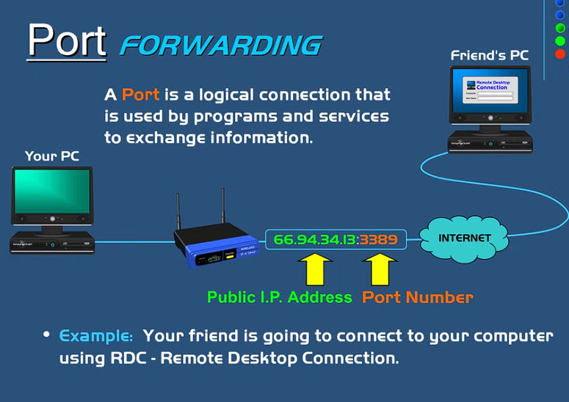--------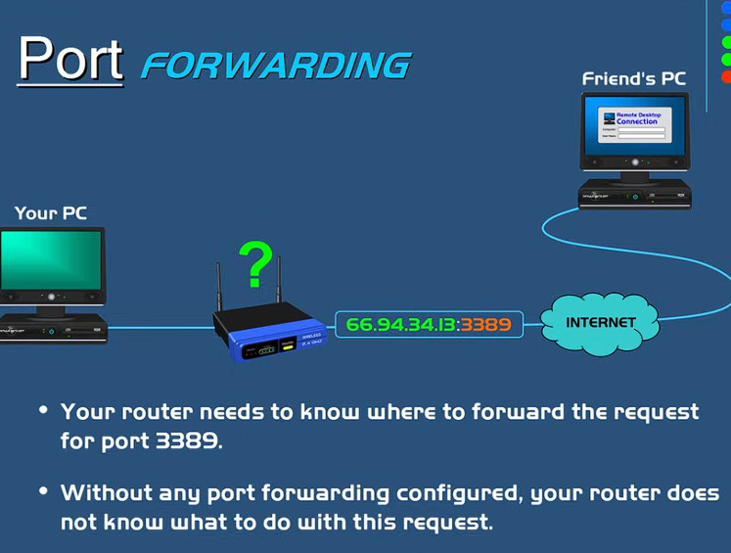

Analogy: Phone System
- Think of a company phone system:
  - The phone number reaches the company.
  - The extension number directs the call to the right department.
- In networking:
  - The IP address is like the phone number.
  - The port number is like the extension.
  - The router acts like the phone operator.
  - The computers inside are like the different departments.

Ports in Networking
- A port is a logical connection (not physical).
- Each port is linked to a specific service or application.
- Ports identify what kind of traffic is coming in (web, email, file transfer, etc.).
Common Port | Use
20, 21 | FTP (File Transfer Protocol)
80 | Web pages (HTTP)
443 | Secure web pages (HTTPS)
3389 | Remote Desktop (RDP)
- Port numbers range from 0 to 65,535.
- Well-known ports: 0–1023 (used by standard services like web, email, etc.).

Summary
- Port forwarding = router instruction that says:
“When data comes in on this port, send it to this computer.”
- It helps outside computers access specific services in a private network.
- It’s useful for gaming servers, remote desktop, web servers, etc

