

System Planning
Monthly Status Report

Report Highlights

- ERCOT is currently reviewing proposed transmission improvements with a total estimated cost of $8.879 billion as of December 31, 2025.
- Transmission Projects endorsed in 2025 total $14.036 billion as of December 31, 2025.
- All projects (in engineering, routing, licensing, and construction) total approximately $33.345 billion as of October 1, 2025.
- Transmission Projects energized in 2025 total approximately $1.677 billion (as of October 1, 2025).
- Transmission Projects planned to energize during the remainder of 2025 total approximately $2.299 billion (as of October 1, 2025).

Regional Planning Group Reviews
RPG Projects under Review:
- Oncor has submitted the Connell 345/138-kV Switch and Connell to Rockhound 345-kV Double-Circuit Line Project (RPG Project ID: 24RPG020). This is a Tier 1 project that is estimated to cost $110.62 million. ERCOT completed the independent review on November 19, and the recommended project is estimated to cost $110.62 million. TAC voted unanimously to endorse the project on November 19, 2025. ERCOT Board of Directors endorsed the project on December 9, 2025, and ERCOT has issued the ERCOT endorsement letter.
- TNMP has submitted the Galveston Region Project (RPG Project ID: 24RPG039). This is a Tier 1 project that is estimated to cost $133.73 million. ERCOT completed the independent review on December 19, and the recommended project is estimated to cost $95.90 million. ERCOT reclassified the project as a Tier 2 project and will issue the ERCOT endorsement letter.
- Oncor has submitted the Southern DFW Load Interconnection and General Grid Strengthening Project (RPG Project ID: 25RPG004). This is a Tier 1 project that is estimated to cost $1,219 million. This project is currently under ERCOT’s independent review.
- Oncor and LCRA TSC have submitted the Muscovy and Voss Lake 345/138-kV Project (RPG Project ID: 25RPG009). This is a Tier 1 project that is estimated to cost $381.83 million. This project is currently under ERCOT’s independent review.
- STEC has submitted the Ammonia Plant Load Project (RPG Project ID: 25RPG012). This is a Tier 2 project that is estimated to cost $65.47 million. This project is currently under ERCOT’s independent review.
- CPS Energy has submitted the Reactive Power Planning Project (RPG Project ID: 25RPG013). This is a Tier 1 project that is estimated to cost $116.50 million. This project is currently under ERCOT’s independent review.
- STEC has submitted the Nueces Green Ammonia Load Interconnection Project (RPG Project ID: 25RPG016). This is a Tier 2 project that is estimated to cost $74.00 million. This project is currently under ERCOT’s independent review.
- CPS Energy has submitted the Helotes 345/138-kV Switching Station and Autotransformer Addition at Eastside Switching Station Project (RPG Project ID: 25RPG017). This is a Tier 1 project that is estimated to cost $110.00 million. This project is currently under ERCOT’s independent review.
- CPS Energy has submitted the Large Load Additions Project (RPG Project ID: 25RPG020). This is a Tier 1 project that is estimated to cost $333.70 million. This project is currently under ERCOT’s independent review.
- Oncor and AEPSC have submitted the Drill Hole to Sand Lake to Solstice 765-kV Line Project (RPG Project ID: 25RPG022). This is a Tier 1 project that is estimated to cost $742.20 million. ERCOT has completed the independent review on November 12, and the recommended project is estimated to cost $742.2 million. TAC voted to endorse the project on November 19, 2025. ERCOT Board of Directors endorsed the project on December 9, 2025, and ERCOT has issued the ERCOT endorsement letter.
- AEPSC has submitted the Blessing Area Improvements Project (RPG Project ID: 25RPG024). This is a Tier 1 project that is estimated to cost $256.00 million. This project was withdrawn by AEPSC on December 4 and ERCOT concluded the independent review on December 4. ERCOT will not post an independent report on ERCOT MIS – Regional Planning page and will not issue an endorsement letter for this project.
- AEP Texas, CPS Energy, Oncor and CNP have submitted the Texas 765-kV-STEP Eastern Backbone Project (RPG Project ID: 25RPG025). This is a Tier 1 project that is estimated to cost $9,384 million. ERCOT has completed the independent review on November 12, and the recommended project is estimated to cost $9,384 million. TAC voted to endorse the project on November 19, 2025. ERCOT Board of Directors endorsed the project on December 9, 2025, and ERCOT has issued the ERCOT endorsement letter.
- Oncor has submitted the Paris Switch to Monticello Switch 345-kV Line Rebuild Project (RPG Project ID: 25RPG026). This is a Tier 1 project that is estimated to cost $231.75 million. This project is currently under ERCOT’s independent review.
- CNP has submitted the P.H. Robinson to W.A. Parish 345-kV Hardening Project (RPG Project ID: 25RPG028). This is a Tier 1 project that is estimated to cost $511.31 million. This project is currently under ERCOT’s independent review.
- Oncor has submitted the Oncor Skyview 345/138-kV Switch Project (RPG Project ID: 25RPG033). This is a Tier 2 project that is estimated to cost $56.82 million. This project is currently under ERCOT’s independent review.
- LP&L has submitted the West Loop Project (RPG Project ID: 25RPG037). This is a Tier 1 project that is estimated to cost $309.00 million. This project is currently under ERCOT’s independent review.
- Oncor and LST have submitted the Navarro and Ellis Area Reliability Project (RPG Project ID: 25RPG038). This is a Tier 1 project that is estimated to cost $759.95 million. This project is currently under ERCOT’s independent review.
- STEC has submitted the Southeast Brownsville Large Load Transmission System Improvements Project (RPG Project ID: 25RPG039). This is a Tier 2 project that is estimated to cost $96.35 million. This project is currently under ERCOT’s independent review.
- Oncor has submitted the Set 1 North & Central Texas Reliability Project (RPG Project ID: 25RPG040). This is a Tier 1 project that is estimated to cost $1,798 million. This project is currently under ERCOT’s independent review.
- Oncor has submitted the Set 1 North Central & South Central Texas Reliability Project (RPG Project ID: 25RPG041). This is a Tier 1 project that is estimated to cost $943.92 million. This project is currently under ERCOT’s independent review.
- Oncor has submitted the Set 2 North & Central Texas Reliability Project (RPG Project ID: 25RPG042). This is a Tier 1 project that is estimated to cost $1,330 million. This project is currently under ERCOT’s independent review.
- Oncor has submitted the Set 2 North Central & South Central Texas Reliability Project (RPG Project ID: 25RPG043). This is a Tier 1 project that is estimated to cost $440.79 million. This project is currently under ERCOT’s independent review.
- BEC has submitted the Whitney Autotransformer Upgrade Project (RPG Project ID: 25RPG044). This is a Tier 3 project that is estimated to cost $33.50 million. This project is currently in the RPG comment period.
- AEPSC has submitted the Alice Area Improvements Transmission Project (RPG Project ID: 25RPG045). This is a Tier 3 project that is estimated to cost $67.00 million. This project is currently in the RPG comment period.

RPG Project Reviews Completed in 2025:
RPG Project ID | RPG Project Name | Submitted Entity | Tier | Estimated Cost  ($ Millions) | Review Completion Month
24RPG037 | Partial Rebuild of 138-kV Ckt.63 West Galveston to Moody Project | CNP | Reclassified from Tier 3 to Tier 4 per Protocol | 26.20 | January
24RPG038 | Bergheim Substation Upgrade Project | LCRA TSC & PEC | Tier 3 | 66.35 | January
24RPG041 | Buck Canyon and Binturong 345-kV Synchronous Condenser Stations Project | WETT | Tier 3 | 98.61 | January
24RPG017 | Venus Switch to Sam Switch 345-kV Line Project | Oncor | Tier 1 | 118.90 | February
24RPG021 | Forney 345/138-kV Switch Rebuild Project | Oncor | Tier 1 | 100.40 | February
24RPG022 | Wilmer 345/138-kV Switch Project | Oncor | Tier 1 | 158.20 | February
25RPG002 | East Munday 138-kV Station Rebuild Project | AEPSC | Reclassified from Tier 3 to Tier 4 per Protocol | 28.30 | February
25RPG005 | Pitchfork 345-kV Substation Addition Project | WETT | Tier 3 | 57.57 | March
25RPG006 | Resubmission for Salado Switch to Hutto Switch 138-kV Line Project | Oncor | Tier 3 | 87.60 | March
24RPG031 | Central Texas 345-kV Transmission Project | LST | Tier 1 (Withdrawn) | 342.00 | April
24RPG032 | Southwest Houston 345-kV Reliability Project | CNP | Tier 1 (Not Recommend or Endorsed) | 569.32 | April
25RPG007 | Salt Flat Road to Barr Ranch to Reiter 138-kV Second Circuit Project | Oncor | Tier 3 | 63.88 | April
25RPG008 | Wolf Switch to Reiter Switch 138-kV Line Project | Oncor | Tier 3 | 52.65 | April
25RPG010 | 138-kV Flewellen to Fort Bend Upgrades Project | CNP | Tier 3 | 72.86 | April
24RPG024 | Hartring to Upland 138-kV Line and Benedum Autotransformer Addition Project | Oncor & LCRA TSC | Tier 2 | 97.70 | May
24RPG035 | Aransas Pass to Rincon 69-kV Line Rebuild Project | AEPSC | Tier 2 | 34.00 | May
24RPG040 | Roscoe Area Upgrades Project | Oncor | Tier 2 | 84.30 | May
25RPG011 | 138-kV West Columbia to Needville Upgrades Project | CNP | Tier 3 | 95.11 | May
24RPG015 | Delaware Basin State 5 Project | Oncor | Tier 1 | 855.30 | June
24RPG029 | Tredway 138-kV Switch and Expanse to Tredway 138-kV 2nd Circuit Project | Oncor | Tier 1 | 119.03 | June
25RPG014 | Cedar Bayou Autotransformer Upgrades Project | CNP | Tier 3 | 26.30 | June
25RPG015 | Buchanan to Burnet Transmission Line Overhaul Project | LCRA TSC | Tier 3 | 36.20 | June
25RPG019 | Lamesa Switch to Willow Valley Switch 138-kV Line Rebuild Project | Oncor | Tier 3 | 74.50 | July
25RPG021 | Victoria to Warburton 138-kV Line Rebuild Project | AEPSC | Tier 3 | 35.50 | July
25RPG003 | Hamilton County Conversion Project | BEC | Tier 2 | 84.00 | August
25RPG023 | Dunham 345/138-kV Switch Project | Oncor | Tier 3 | 21.30 | August
25RPG027 | Royse Switch to Edgewood 69-kV Line Conversion to 138-kV Project | Oncor | Reclassified from Tier 3 to Tier 4 per Protocol | 44.72 | August
24RPG028 | Baytown Area Load Addition Project | CNP | Tier 1 | 545.30 | September
25RPG001 | Texas A&M University System RELLIS Campus Reliability Project | BTU | Tier 1 | 281.20 | September
25RPG029 | Hillsboro Switch to Elm Mott Switch 69-kV Line Rebuild Project | Oncor | Reclassified from Tier 3 to Tier 4 per Protocol | 52.85 | September
25RPG030 | Bonham Switch to Toco Switch 69-kV Line Rebuild Project | Oncor | Reclassified from Tier 3 to Tier 4 per Protocol | 72.83 | September
25RPG031 | Sam Switch Resiliency Project | LST | Tier 3 | 17.00 | September
25RPG032 | Fort Stockton Plant 138-kV Transmission Station Rebuild Project | AEPSC | Tier 3 | 25.70 | September
25RPG034 | Mulberry Creek 138-kV Transmission Station Rebuild Project | AEPSC | Tier 3 | 32.00 | October
25RPG035 | McDonald Road Switch to Polecat Creek Switch 138-kV Line Project | Oncor | Tier 3 | 26.66 | October
25RPG036 | Abilene Northwest 138-kV Transmission Station Rebuild Project | AEPSC | Tier 3 | 33.00 | October
25RPG018 | Childress Area Transmission Improvement Project | AEPSC | Tier 2 | 77.30 | November
24RPG020 | Connell 345/138-kV Switch and Connell to Rockhound 345-kV Double-Circuit Line Project | Oncor | Tier 1 | 110.62 | December
24RPG039 | Galveston Region Project | TNMP | Tier 2 | 95.90 | December
25RPG022 | Drill Hole to Sand Lake to Solstice 765-kV Line Project | Oncor & AEPSC | Tier 1 | 742.20 | December
25RPG024 | Blessing Area Improvements Project | AEPSC | Tier 1 (Withdrawn) | 256.00 | December
25RPG025 | Texas 765-kV-STEP Eastern Backbone Project | Oncor, CPS, CNP & AEP Texas | Tier 1 | 9,384.00 | December

More information on current and past RPG projects can be found on the ERCOT MIS Secure (digital certificate required): https://mis.ercot.com/secure/data-products/grid/regional-planning
Past email communication on RPG projects can be found on the ERCOT listserv by signing up for the REGPLANGROUP list: http://lists.ercot.com/scripts/wa-ERCOT.exe?A0=REGPLANGROUP

Planning Model Activities
The short-term calendar of major planning model events is as follows:
- By January 30, 2026 TPIT will be posted
- By June 5, 2026 26SSWG Cases will be posted
- By June 12, 2026 26SSWG Contingency and Planning Data Dictionary will be posted

The following table shows interconnection projects that met Planning Guide section 6.9(1) and 6.9(2) and were modeled in the SSWG cases as a full model or as a simple model in accordance with Planning Guide section 6.9.

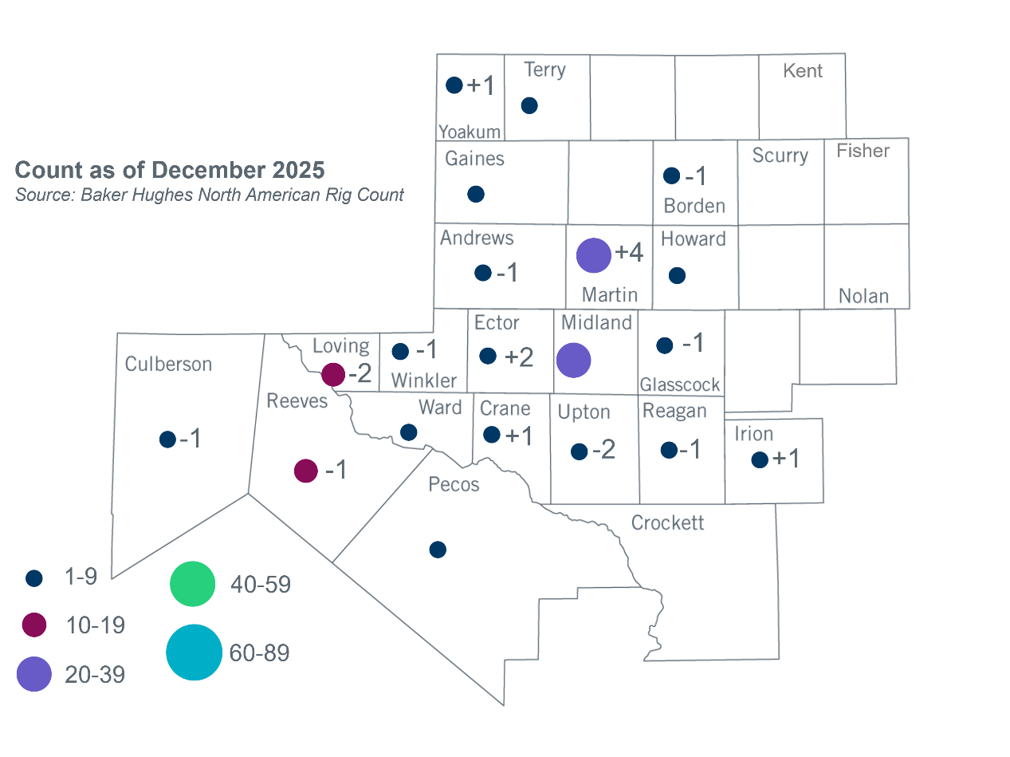
Permian Basin Oil Rig Count

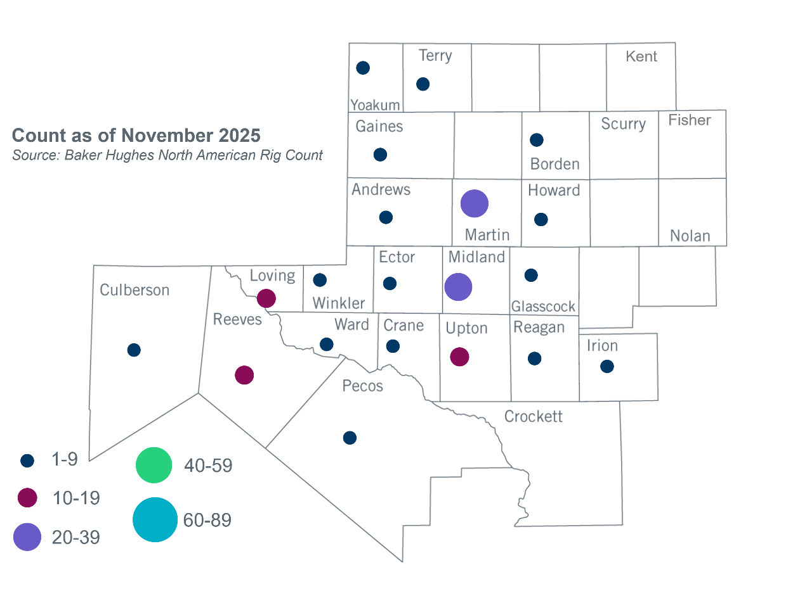

Other Notable Activities

- ERCOT presented the 2026 Long-Term System Assessment (LTSA) current trends scenario capacity expansion results at the December 2025 RPG meeting.

Based on the Total Project Estimated Cost for all future projects listed in the Transmission Project Information and Tracking (TPIT) report. TPIT is updated three times each year based on information TSPs provide in Model on Demand (MOD) as specified in the ERCOT Steady State Working Group Procedure Manual. The latest TPIT is available at https://www.ercot.com/gridinfo/planning.
+/- symbol indicates the increase or decrease from the previous month in oil rigs present in each county. There are 150 rigs, including a decrease of 2 oil rigs, in the Permian Basin from November to December.

