

System Planning
Monthly Status Report

Report Highlights

- ERCOT is currently reviewing proposed transmission improvements with a total estimated cost of $595.72 million as of December 31, 2022.
- Transmission Projects endorsed in 2022 total $3.311 billion as of December 31, 2022.
- All projects (in engineering, routing, licensing, and construction) total approximately $11.093 billion as of October 1, 2022.
- Transmission Projects energized in 2022 total approximately $1.198 billion (as of October 1, 2022).

Regional Planning Group Reviews
RPG Projects under Review:
- REC has submitted the Tawakoni Area Transmission Project (RPG Project ID: 22RPG021). This is a Tier 2 project that is estimated to cost $27.5 million. ERCOT completed the independent review on December 15, and ERCOT will not issue an ERCOT endorsement letter for this project, as it is needed to solely meet REC Planning Criteria.STEC has submitted the Hondo Creek to Pearson 69 kV Transmission Line Rebuild Project (RPG Project ID: 22RPG022). This is a Tier 2 project that is estimated to cost $37.5 million. ERCOT completed the independent review on December 6, and ERCOT has issued the ERCOT endorsement letter.
- PEC has submitted the Wimberley Loop Project (RPG Project ID: 22RPG026). This is a Tier 2 project that is estimated to cost $77.32 million. This project is currently under ERCOT’s independent review.
- Oncor has submitted the Tesoro 345/138 kV Switch Project (RPG Project ID: 22RPG032). This is a Tier 3 project that is estimated to cost $50.2 million. The RPG review of this project was completed on November 7, and ERCOT has issued an acceptance letter.
- CNP has submitted the Clute Substation Addition Project Project (RPG Project ID: 22RPG038). This is a Tier 3 project that is estimated to cost $46.2 million. The RPG review of this project was completed on December 1, and ERCOT will not issue an acceptance letter for this project, as it is needed to solely meet Centerpoint Energy Transmission System Design Criteria.
- Oncor has submitted the Eagle Mountain 345/138 kV Switch Rebuild Project (RPG Project ID: 22RPG039). This is a Tier 3 project that is estimated to cost $57.0 million. The RPG review of this project was completed on December 2. Pursuant to the Protocol Section 3.11.4.3.1 (d), this project has been reclassified as a Tier 4 neutral project.
- AEPSC has submitted the Dupont to Joslin 138 kV Line Rebuild Project (RPG Project ID: 22RPG040). This is a Tier 3 project that is estimated to cost $46.4 million. The RPG review of this project was completed on December 8. Pursuant to the Protocol Section 3.11.4.3.1 (d), this project has been reclassified as a Tier 4 neutral project.
- CNP has submitted the Sienna to Dewalt to Missouri City 138 kV ckt 02 Line Rebuild Project (RPG Project ID: 22RPG041). This is a Tier 3 project that is estimated to cost $56.03 million. The RPG review of this project was completed on December 15. Pursuant to the Protocol Section 3.11.4.3.1 (d), this project has been reclassified as a Tier 4 neutral project.
- AEPSC has submitted the Carver to Maxwell 138 kV Line Rebuild Project (RPG Project ID: 22RPG042). This is a Tier 3 project that is estimated to cost $69.1 million. The RPG review of this project was completed on December 28. Pursuant to the Protocol Section 3.11.4.3.1 (d), this project has been reclassified as a Tier 4 neutral project.
- AEPSC has submitted the Haskell to Munday 69 kV Line Rebuild Project (RPG Project ID: 22RPG043). This is a Tier 3 project that is estimated to cost $31.0 million. This project is currently in the RPG comment period.
- AEPSC has submitted the Escondido to Hamilton Road 138 kV Line Rebuild Project (RPG Project ID: 22RPG044). This is a Tier 3 project that is estimated to cost $73.5 million. This project is currently in the RPG comment period.
- Oncor has submitted the Yucca to Moss 138 kV Line Project (RPG Project ID: 22RPG045). This is a Tier 3 project that is estimated to cost $60.7 million. This project is currently in the RPG comment period.
- Oncor has submitted the Peppervine to Temple 69 kV Line Conversion Project (RPG Project ID: 22RPG046). This is a Tier 3 project that is estimated to cost $36.0 million. This project is currently in the RPG comment period.
- Oncor has submitted the Peck to Drive 138 kV Line Project (RPG Project ID: 22RPG047). This is a Tier 2 project that is estimated to cost $36.2 million. This project is currently in the RPG comment period.
- CPS has submitted the San Antonio South Reliability Project (RPG Project ID: 22RPG048). This is a Tier 1 project that is estimated to cost $281.0 million. This project is currently in the RPG comment period.

RPG Project Reviews Completed in 2022:
RPG Project ID | RPG Project Name | Submitted Entity | Tier | Estimated Cost  ($ Millions) | Review Completion Month
21RPG021 | Mulberry Creek 345 kV Station Improvements Project | AEPSC/Oncor | Reclassified from Tier 3 to Tier 4 per Protocol | 49.2 | January
21RPG022 | Marshall Ford-Ruther Ford 138 kV Line Rebuild Project | PEC | Reclassified from Tier 3 to Tier 4 per Protocol | 28.8 | January
21RPG023 | Barrilla Junction 69 kV loop Rebuild and Conversion Project | AEPSC | Tier 3 | 44 | January
21RPG024 | Tungsten 138/69 kV Station Transmission Project | AEPSC | Reclassified from Tier 3 to Tier 4 per Protocol | 34.9 | January
22RPG001 | Greens Bayou to Clinton 138 kV Conversion Project | CNP | Reclassified from Tier 3 to Tier 4 per Protocol | 88.5 | February
22RPG002 | Abilene South to Putnam 138 kV Transmission Line Rebuild Project | AEPSC | Reclassified from Tier 3 to Tier 4 per Protocol | 31.5 | March
22RPG004 | Pulsar to Victoria 138 kV Line Rebuild project | AEPSC | Reclassified from Tier 3 to Tier 4 per Protocol | 75.7 | March
22RPG006 | Consavvy 345/138 kV Switch Project | Oncor | Tier 3 | 90.2 | April
22RPG007 | Lenorah Area 345/138 kV Project | Oncor/WETT | Tier 3 | 45.2 | April
20RPG019 | Nacogdoches Southeast Switch – Redland Switch – Lufkin Switch 345 kV Loop | Oncor | Tier 2 | 71.26 | April
22RPG008 | Bowman Switch 345/138 kV Autotransformers Project | Oncor | Tier 3 | 13 | April
22RPG009 | Eden to North Brady 69 kV Line Rebuild Project | AEPSC | Reclassified from Tier 3 to Tier 4 per Protocol | 34 | April
22RPG011 | Fayetteville – Salem Transmission Line Rehabilitation Project | LCRA TSC | Reclassified from Tier 3 to Tier 4 per Protocol | 77.8 | May
22RPG012 | Partial Rebuild 69 kV Deepwater to Clinton Ckt 33 Project | CNP | Reclassified from Tier 3 to Tier 4 per Protocol | 55.91 | May
22RPG013 | Wolf Switch - Moss Switch 138 kV Line Rebuild Project | Oncor | Tier 3 to Tier 4 Pursuant to the Protocol Section 3.11.4.3.1 (d) | 56.2 | June
22RPG014 | Red Oak Area Upgrades project | Oncor | Tier 3 | 63 | June
22RPG016 | Hutto East - Brushy Creek 138kV Line Project | Oncor | Tier 3 | 29.7 | June
22RPG017 | McGregor Phillips – Waco West 69 kV Line Conversion Project | Oncor | Tier 3 to Tier 4 Pursuant to the Protocol Section 3.11.4.3.1 (d) | 38.8 | June
22RPG018 | Marshall Ford – McNeil Transmission Line Storm Hardening Project | LCRA TSC | Tier 3 to Tier 4 Pursuant to the Protocol Section 3.11.4.3.1 (d) | 34.1 | July
22RPG019 | Partial Rebuild of 69 kV HOC to Dunlavy Ckt 40 Project | CNP | Tier 3 to Tier 4 Pursuant to the Protocol Section 3.11.4.3.1 (d) | 31.39 | July
22RPG015 | Tyler Switch – Forest Grove Switch 138 kV Line Project | Oncor | Tier 3 to Tier 4 Pursuant to the Protocol Section 3.11.4.3.1 (d) | 62.7 | July
22RPG005 | Hays Energy – Kendall Corridor Transmission Line Rehabilitation Projects | LCRA TSC | Tier 1 to Tier 4 Pursuant to the Protocol Section 3.11.4.3.1 (d) | 399.9 | July
22RPG020 | Belknap to Fort Griffin 69 kV Line Rebuild Project | AEPSC | Tier 3 to Tier 4 Pursuant to the Protocol Section 3.11.4.3.1 (d) | 27.6 | July
22RPG003 | Roanoke Area Upgrades Project | Oncor | Tier 1 | 285.9 | August
22RPG010 | Bearkat – North McCamey – Sand Lake 345-kV Transmission Line Addition Project | LCRA TSC, Oncor, WETT | Tier 1 | 477.6 | August
22RPG023 | Hill Country 345/138 kV Autotransformer Replacement Project | CPS | Tier 3 | 6.9 | August
22RPG024 | Wolf-General Tire-Odessa EHV 138 kV Line Rebuild Project | Oncor | Tier 3 to Tier 4 Pursuant to the Protocol Section 3.11.4.3.1 (d) | 60.77 | September
22RPG025 | Yucca Drive - Courtney Creek 69 kV Line Conversion to 138 kV Project | Oncor | Tier 3 | 65 | September
22RPG027 | East Hutto Area 345/138 kV Project | Oncor, LCRA TSC | Tier 3 | 61.6 | September
22RPG028 | Ballinger to Santa Anna 69 kV Transmission Line Rebuild Project | AEPSC | Tier 3 to Tier 4 Pursuant to the Protocol Section 3.11.4.3.1 (d) | 64.8 | September
22RPG029 | Fairland – Lago Vista Transmission Line Rehabilitation Project | LCRA TSC | Tier 3 to Tier 4 Pursuant to the Protocol Section 3.11.4.3.1 (d) | 26.9 | October
22RPG030 | Buchanan CTEC – Pitsburg Transmission Line Overhaul Project | LCRA TSC | Tier 3 to Tier 4 Pursuant to the Protocol Section 3.11.4.3.1 (d) | 32.9 | October
22RPG031 | Lakeway - Marble Falls Transmission Line Strom Hardening Project | LCRA PEC | Tier 3 to Tier 4 Pursuant to the Protocol Section 3.11.4.3.1 (d) | 94.2 | November
22RPG032 | Tesoro 345/138 kV Switch Project | Oncor | Tier 3 | 50.2 | November
22RPG033 | Mountain Top-Blanco-Devils Hill Line Rebuild and Voltage Upgrade Project | PEC | Tier 3 to Tier 4 Pursuant to the Protocol Section 3.11.4.3.1 (d) | 37.0 | November
22RPG034 | Temple – Minerva 69 kV Line Rebuild Project | Oncor | Tier 3 to Tier 4 Pursuant to the Protocol Section 3.11.4.3.1 (d) | 54.9 | November
22RPG035 | Palestine - Crockett 69 kV Line Rebuild Project | Oncor | Tier 3 to Tier 4 Pursuant to the Protocol Section 3.11.4.3.1 (d) | 50.9 | November
22RPG036 | Taylor Switch – Holland 69 kV Line Section Rebuild Project | Oncor | Tier 3 to Tier 4 Pursuant to the Protocol Section 3.11.4.3.1 (d) | 60.8 | November
22RPG037 | West Columbia to Burke 138 kV ckt 02 Rebuild Project | CNP | Tier 3 to Tier 4 Pursuant to the Protocol Section 3.11.4.3.1 (d) | 43.2 | November
22RPG021 | Tawakoni Area Transmission Project | REC | Tier 2 | 42.4 | December
22RPG022 | Hondo Creek to Pearson 69 kV Transmission Line Rebuild Project | STEC | Tier 2 | 37.5 | December
22RPG038 | Clute Substation Addition Project | CNP | Tier 3 | 46.2 | December
22RPG039 | Eagle Mountain 345/138 kV Switch Rebuild Project | Oncor | Tier 3 to Tier 4 Pursuant to the Protocol Section 3.11.4.3.1 (d) | 57.0 | December
22RPG040 | Dupont to Joslin 138 kV Line Rebuild Project | AEPSC | Tier 3 to Tier 4 Pursuant to the Protocol Section 3.11.4.3.1 (d) | 46.4 | December
22RPG041 | Sienna to Dewalt to Missouri City 138 kV ckt 02 Line Rebuild Project | CNP | Tier 3 to Tier 4 Pursuant to the Protocol Section 3.11.4.3.1 (d) | 56.03 | December
22RPG042 | Carver to Maxwell 138 kV Line Rebuild Project | AEPSC | Tier 3 to Tier 4 Pursuant to the Protocol Section 3.11.4.3.1 (d) | 69.1 | December

More information on current and past RPG projects can be found on the ERCOT MIS Secure (digital certificate required): https://mis.ercot.com/secure/data-products/grid/regional-planning
Past email communication on RPG projects can be found on the ERCOT listserv by signing up for the REGPLANGROUP list: http://lists.ercot.com/scripts/wa-ERCOT.exe?A0=REGPLANGROUP

Planning Model Activities
The short-term calendar of major planning model events is as follows:
- By January 30, 2023 TPIT will be posted
- By May 30, 2023 23SSWG cases and TPIT will be posted
- By June 16, 2023 23SSWG Contingency definitions & Planning Data Dictionary will be posted
The following table shows interconnection projects that met Planning Guide section 6.9(1) and 6.9(2) and were modeled in the SSWG cases as a full model or as a simple model in accordance with Planning Guide section 6.9.

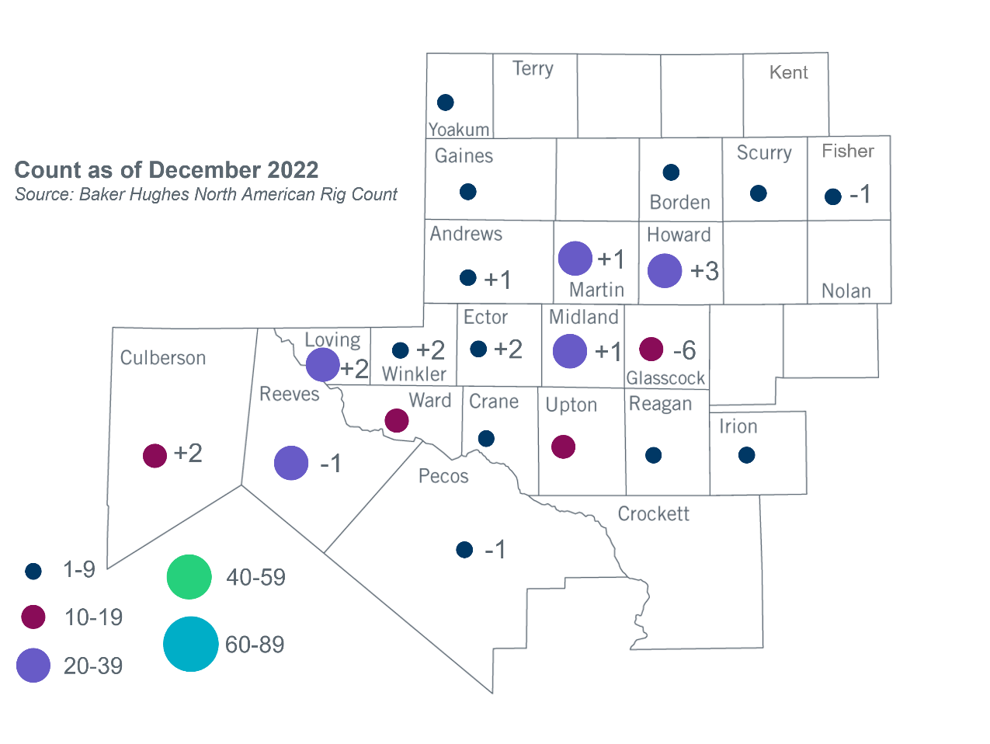
Permian Basin Oil Rig Count
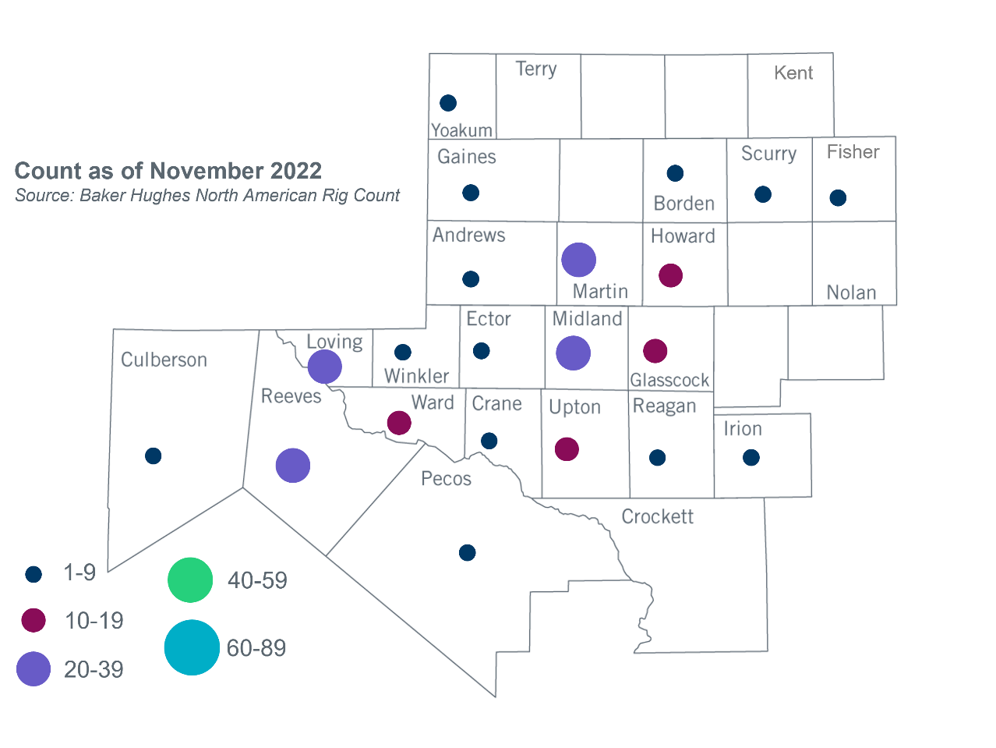

Other Notable Activities
- ERCOT has completed the 2022 Regional Transmission Plan (RTP). The 2022 RTP report was posted to the ERCOT website and MIS Secure on December 22, 2022. Final 2022 reliability and sensitivity cases have also been posted to MIS Secure.
- ERCOT has completed the 2022 Long-Term System Assessment (LTSA). The 2022 LTSA report was posted to the ERCOT website and MIS Secure on December 22, 2022.
- ERCOT posted the 2022 Report on Existing and Potential Electric System Constraints and Needs to the ERCOT website on December 22, 2022.

Based on the Total Project Estimated Cost for all future projects listed in the Transmission Project Information and Tracking (TPIT) report. TPIT is updated three times each year based on information TSPs provide in Model on Demand (MOD) as specified in the ERCOT Steady State Working Group Procedure Manual. The latest TPIT is available at https://www.ercot.com/gridinfo/planning.
Based on the Total Project Estimated Cost for all completed projects with Projected In-Service Dates in 2022 listed in the TPIT.
+/- symbol indicates the increase or decrease from the previous month in oil rigs present in each county. There are 250 rigs, including a increase of 5 oil rigs, in the Permian Basin from November to December 2022.

