

System Planning
Monthly Status Report

Report Highlights

- ERCOT is currently reviewing proposed transmission improvements with a total estimated cost of $479.28 million as of January 31, 2023.
- Transmission Projects endorsed in 2023 total $201.2 million as of January 31, 2023.
- All projects (in engineering, routing, licensing, and construction) total approximately $11.643 billion as of February 1, 2023.
- Transmission Projects energized in 2023 total approximately $149 million (as of February 1, 2023).

Regional Planning Group Reviews
RPG Projects under Review:
- PEC has submitted the Wimberley Loop Project (RPG Project ID: 22RPG026). This is a Tier 2 project that is estimated to cost $77.32 million. This project is currently under ERCOT’s independent review.
- AEPSC has submitted the Haskell to Munday 69 kV Line Rebuild Project (RPG Project ID: 22RPG043). This is a Tier 3 project that is estimated to cost $31.00 million. The RPG review of this project was completed on January 11. Pursuant to the Protocol Section 3.11.4.3.1 (d), this project has been reclassified as a Tier 4 neutral project.
- AEPSC has submitted the Escondido to Hamilton Road 138 kV Line Rebuild Project (RPG Project ID: 22RPG044). This is a Tier 3 project that is estimated to cost $73.50 million. The RPG review of this project was completed on January 17. Pursuant to the Protocol Section 3.11.4.3.1 (d), this project has been reclassified as a Tier 4 neutral project.
- Oncor has submitted the Yucca to Moss 138 kV Line Project (RPG Project ID: 22RPG045). This is a Tier 3 project that is estimated to cost $60.70 million. The RPG review of this project was completed on January 17. Pursuant to the Protocol Section 3.11.4.3.1 (d), this project has been reclassified as a Tier 4 neutral project.
- Oncor has submitted the Peppervine to Temple 69 kV Line Conversion Project (RPG Project ID: 22RPG046). This is a Tier 3 project that is estimated to cost $36.00 million. The RPG review of this project was completed on January 20. Pursuant to the Protocol Section 3.11.4.3.1 (d), this project has been reclassified as a Tier 4 neutral project.
- Oncor has submitted the Peck to Drive 138 kV Line Project (RPG Project ID: 22RPG047). This is a Tier 2 project that is estimated to cost $36.2 million. This project is currently under ERCOT’s independent review.
- CPS has submitted the San Antonio South Reliability Project (RPG Project ID: 22RPG048). This is a Tier 1 project that is estimated to cost $281.0 million. This project is currently under ERCOT’s independent review.
- AEPSC has submitted the Bessel to Falfurrias 138 kV Line Rebuild Project (RPG Project ID: 23RPG001). This is a Tier 3 project that is estimated to cost $84.76 million. This project is currently in the RPG comment period.

RPG Project Reviews Completed in 2023:
RPG Project ID | RPG Project Name | Submitted Entity | Tier | Estimated Cost  ($ Millions) | Review Completion Month
22RPG043 | Haskell to Munday 69 kV Line Rebuild Project | AEPSC | Reclassified from Tier 3 to Tier 4 per Protocol | 31.00 | January
22RPG044 | Escondido to Hamilton Road 138 kV Line Rebuild Project | AEPSC | Reclassified from Tier 3 to Tier 4 per Protocol | 73.50 | January
22RPG045 | Yucca to Moss 138 kV Line Project | Oncor | Reclassified from Tier 3 to Tier 4 per Protocol | 60.70 | January
22RPG046 | Peppervine to Temple 69 kV Line Conversion Project | Oncor | Reclassified from Tier 3 to Tier 4 per Protocol | 36.00 | January

More information on current and past RPG projects can be found on the ERCOT MIS Secure (digital certificate required): https://mis.ercot.com/secure/data-products/grid/regional-planning
Past email communication on RPG projects can be found on the ERCOT listserv by signing up for the REGPLANGROUP list: http://lists.ercot.com/scripts/wa-ERCOT.exe?A0=REGPLANGROUP

Planning Model Activities
The short-term calendar of major planning model events is as follows:
- By January 30, 2023 TPIT will be posted
- By May 30, 2023 23SSWG cases and TPIT will be posted
- By June 16, 2023 23SSWG Contingency definitions & Planning Data Dictionary will be posted
The following table shows interconnection projects that met Planning Guide section 6.9(1) and 6.9(2) and were modeled in the SSWG cases as a full model or as a simple model in accordance with Planning Guide section 6.9.

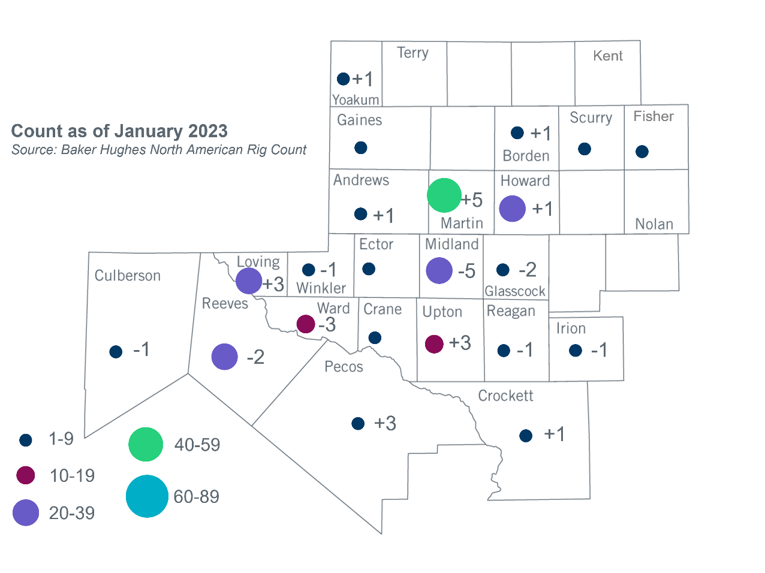
Permian Basin Oil Rig Count
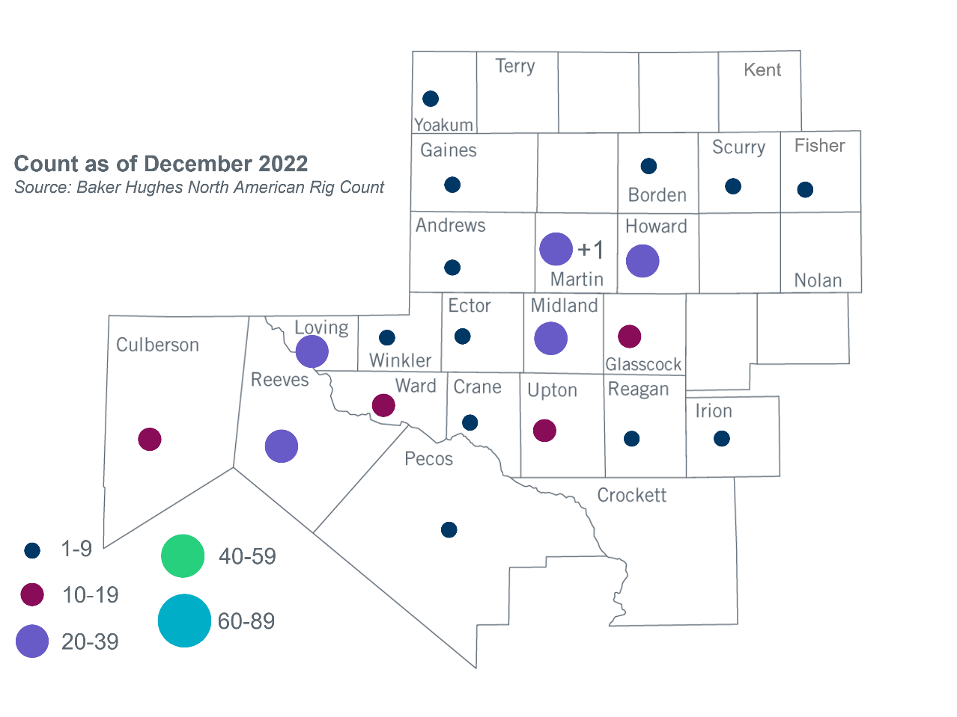

Other Notable Activities
- ERCOT presented the final update for the 2022 Regional Transmission Plan (RTP) at the January RPG meeting.
- ERCOT presented the final update for the 2022 Long-Term System Assessment (LTSA) at the January RPG meeting.
- ERCOT provided an initial 2023 RTP load review update at the January RPG meeting.

Based on the Total Project Estimated Cost for all future projects listed in the Transmission Project Information and Tracking (TPIT) report. TPIT is updated three times each year based on information TSPs provide in Model on Demand (MOD) as specified in the ERCOT Steady State Working Group Procedure Manual. The latest TPIT is available at https://www.ercot.com/gridinfo/planning.
Based on the Total Project Estimated Cost for all completed projects with Projected In-Service Dates in 2023 listed in the TPIT.
+/- symbol indicates the increase or decrease from the previous month in oil rigs present in each county. There are 253 rigs, including a increase of 3 oil rigs, in the Permian Basin from December 2022 to January 2023.

