

System Planning
Monthly Status Report

Report Highlights

- ERCOT is currently reviewing proposed transmission improvements with a total estimated cost of $317.20 million as of March 31, 2023.
- Transmission Projects endorsed in 2023 total $555.15 million as of March 31, 2023.
- All projects (in engineering, routing, licensing, and construction) total approximately $11.643 billion as of February 1, 2023.
- Transmission Projects energized in 2023 total approximately $149 million (as of February 1, 2023).

Regional Planning Group Reviews
RPG Projects under Review:
- Oncor has submitted the Peck to Driver 138 kV Line Project (RPG Project ID: 22RPG047). This is a Tier 2 project that is estimated to cost $36.20 million. This project is currently under ERCOT’s independent review.
- CPS has submitted the San Antonio South Reliability Project (RPG Project ID: 22RPG048). This is a Tier 1 project that is estimated to cost $281.00 million. This project is currently under ERCOT’s independent review.
- GVEC has submitted the Eagle Ford Large Load Interconnection Project (RPG Project ID: 23RPG003). This is a Tier 3 project that is estimated to cost $35.15 million. The RPG review of this project was completed on March 2. No acceptance letter will be issued for this project as ERCOT has not been able to confirm the new load stated in the RPG submission.
- LCRA TSC has submitted the Lockhart to Luling 69-kV Transmission Line Overhaul Project (RPG Project ID: 23RPG004). This is a Tier 3 project that is estimated to cost $33.50 million. The RPG review of this project was completed on March 20. Pursuant to the Protocol Section 3.11.4.3.1 (d), this project has been reclassified as a Tier 4 neutral project.
- AEPSC has submitted the La Palma to Stewart Road Rebuild and Conversion to 138-kV Project (RPG Project ID: 23RPG005). This is a Tier 3 project that is estimated to cost $71.50 million. The RPG review of this project was completed on March 23. Pursuant to the Protocol Section 3.11.4.3.1 (d), this project has been reclassified as a Tier 4 neutral project.
- Oncor has submitted the North Lake 138 kV Switch Rebuild Project (RPG Project ID: 23RPG006). This is a Tier 3 project that is estimated to cost $34.11 million. The RPG review of this project was completed on March 28. Pursuant to the Protocol Section 3.11.4.3.1 (d), this project has been reclassified as a Tier 4 neutral project.

RPG Project Reviews Completed in 2023:
RPG Project ID | RPG Project Name | Submitted Entity | Tier | Estimated Cost  ($ Millions) | Review Completion Month
22RPG043 | Haskell to Munday 69 kV Line Rebuild Project | AEPSC | Reclassified from Tier 3 to Tier 4 per Protocol | 31.00 | January
22RPG044 | Escondido to Hamilton Road 138 kV Line Rebuild Project | AEPSC | Reclassified from Tier 3 to Tier 4 per Protocol | 73.50 | January
22RPG045 | Yucca to Moss 138 kV Line Project | Oncor | Reclassified from Tier 3 to Tier 4 per Protocol | 60.70 | January
22RPG046 | Peppervine to Temple 69 kV Line Conversion Project | Oncor | Reclassified from Tier 3 to Tier 4 per Protocol | 36.00 | January
22RPG026 | Wimberley Loop Project | PEC | Tier 2 | 61.93 | February
23RPG001 | Bessel to Falfurrias 138 kV Line Rebuild Project | AEPSC | Reclassified from Tier 3 to Tier 4 per Protocol | 84.76 | February
23RPG002 | Hamlin to Roby 69 kV Line Rebuild Project | AEPSC | Reclassified from Tier 3 to Tier 4 per Protocol | 33.00 | February
23RPG003 | Eagle Ford Large Load Interconnection Project | GVEC | Tier 3 | 35.15 | March
23RPG004 | Lockhart to Luling 69-kV Transmission Line Overhaul Project | LCRA TSC | Reclassified from Tier 3 to Tier 4 per Protocol | 33.50 | March
23RPG005 | La Palma to Stewart Road Rebuild and Conversion to 138-kV Project | AEPSC | Reclassified from Tier 3 to Tier 4 per Protocol | 71.50 | March
23RPG006 | North Lake 138 kV Switch Rebuild | Oncor | Reclassified from Tier 3 to Tier 4 per Protocol | 34.11 | March

More information on current and past RPG projects can be found on the ERCOT MIS Secure (digital certificate required): https://mis.ercot.com/secure/data-products/grid/regional-planning
Past email communication on RPG projects can be found on the ERCOT listserv by signing up for the REGPLANGROUP list: http://lists.ercot.com/scripts/wa-ERCOT.exe?A0=REGPLANGROUP

Planning Model Activities
The short-term calendar of major planning model events is as follows:
- By May 30, 2023 23SSWG cases and TPIT will be posted
- By June 16, 2023 23SSWG Contingency definitions & Planning Data Dictionary will be posted
The following table shows interconnection projects that met Planning Guide section 6.9(1) and 6.9(2) and were modeled in the SSWG cases as a full model or as a simple model in accordance with Planning Guide section 6.9.

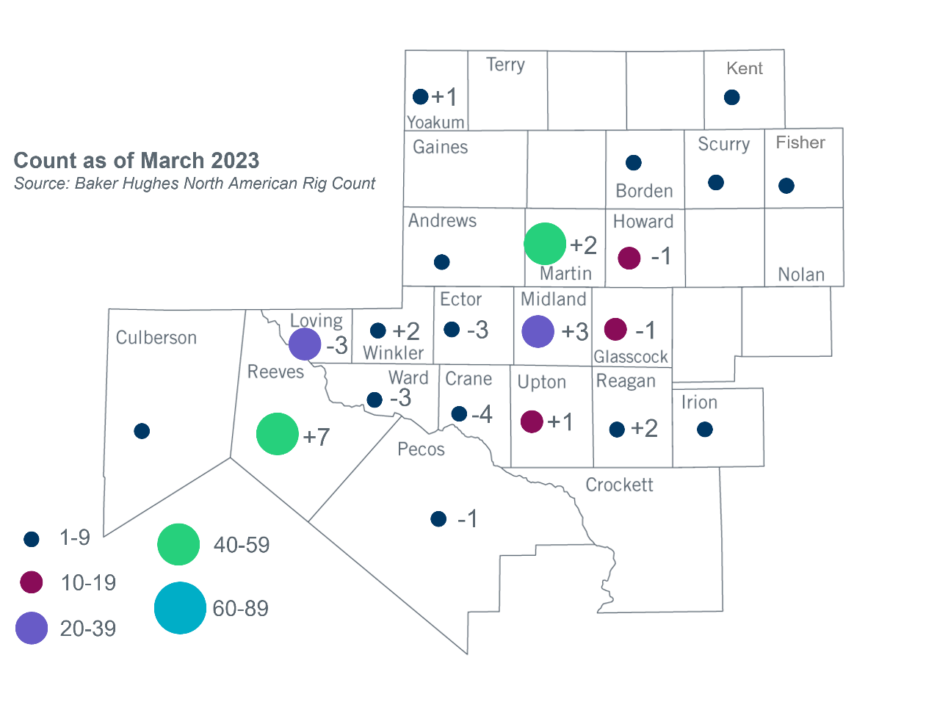
Permian Basin Oil Rig Count
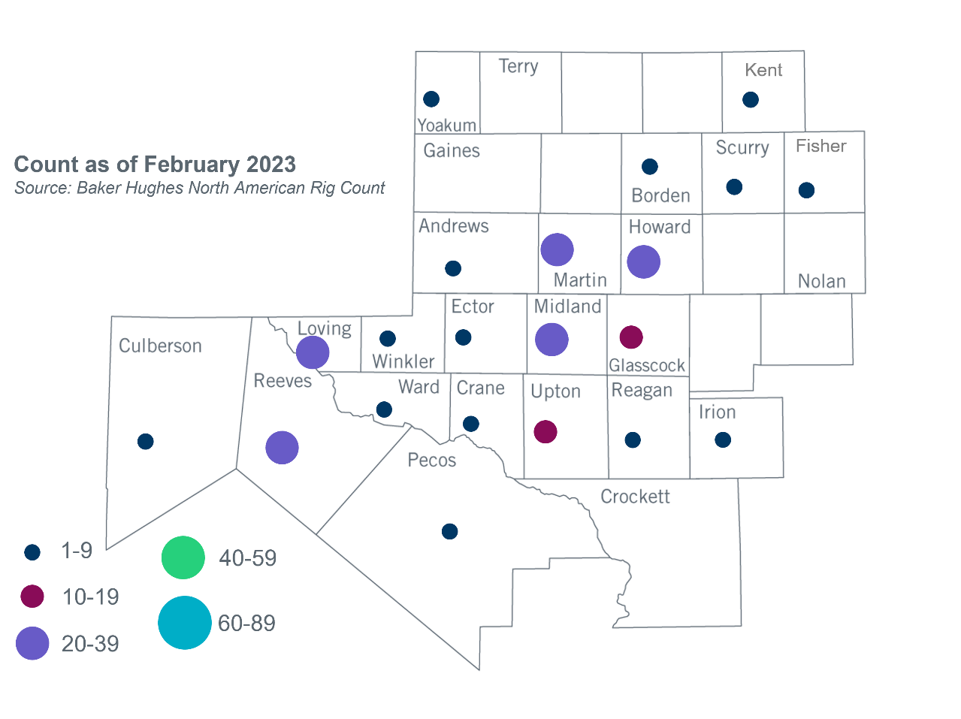

Other Notable Activities
- ERCOT presented the 2023 Regional Transmission Plan (RTP) load review update at the March RPG meeting.
- ERCOT presented the 2024 Long-Term System Assessment (LTSA) overview at the March RPG meeting.
- S&P Global Commodity Insights (formerly IHS Markit) performed analysis to forecast the oil and gas load for Permian Basin at Oncor’s request in 2019, and then updated their load forecast based on the study they performed in 2022 with collaboration with sponsor companies. The updated results were presented at the March RPG meeting.

Based on the Total Project Estimated Cost for all future projects listed in the Transmission Project Information and Tracking (TPIT) report. TPIT is updated three times each year based on information TSPs provide in Model on Demand (MOD) as specified in the ERCOT Steady State Working Group Procedure Manual. The latest TPIT is available at https://www.ercot.com/gridinfo/planning.
Based on the Total Project Estimated Cost for all completed projects with Projected In-Service Dates in 2023 listed in the TPIT.
+/- symbol indicates the increase or decrease from the previous month in oil rigs present in each county. There are 246 rigs, including an increase of 3 oil rigs, in the Permian Basin from February to March 2023.

