

System Planning
Monthly Status Report

Report Highlights

- ERCOT is currently reviewing proposed transmission improvements with a total estimated cost of $1.297 billion as of April 30, 2022.
- Transmission Projects endorsed in 2022 total $606.26 million as of April 30, 2022.
- All projects (in engineering, routing, licensing, and construction) total approximately $8.00 billion as of October 1, 2021.
- Transmission Projects energized in 2021 total approximately $1.438 billion (as of October 1, 2021).

Regional Planning Group Reviews
RPG Projects under Review:
- Oncor has submitted the Nacogdoches Southeast Switch – Redland Switch – Lufkin Switch 345-kV Loop Project (RPG Project ID: 20RPG019). This is a Tier 2 project that is estimated to cost $71.3 million. ERCOT has completed the independent review on April 12, and ERCOT has issued the ERCOT endorsement letter.
- Oncor has submitted the Roanoke Area Upgrades Project (RPG Project ID: 22RPG003). This is a Tier 1 project that is estimated to cost $285.9 million. This project is currently under ERCOT’s independent review.
- LCRA TSC has submitted the Hays Energy – Kendall Corridor Transmission Line Rehabilitation Projects (RPG Project ID: 22RPG005). This is a Tier 1 project that is estimated to cost $399.9 million. This project is currently under ERCOT’s independent review.
- LCRA TSC, Oncor, and WETT have jointly submitted the Bearkat – North McCamey – Sand Lake 345-kV Transmission Line Addition Project (RPG Project ID: 22RPG010). This is a Tier 1 project that is estimated to cost $477.6 million. This project is currently in the RPG comment period.
- LCRA TSC has submitted the Fayetteville – Salem Transmission Line Rehabilitation Project (RPG Project ID: 22RPG011). This is a Tier 3 project that is estimated to cost $77.8 million. This project is currently in the RPG comment period.
- CNP has submitted the Partial Rebuild 69-kV Deepwater to Clinton Ckt 33 Project (RPG Project ID: 22RPG012). This is a Tier 3 project that is estimated to cost $55.91 million. This project is currently in the RPG comment period.
- Oncor has submitted the Consavvy 345/138-kV Switch Project (RPG Project ID: 22RPG006). This is a Tier 3 project that is estimated to cost $90.2 million. The RPG review of this project was completed on April 4, and ERCOT has issued the acceptance letter.
- Oncor and WETT have jointly submitted the Lenorah Area 345/138-kV Project (RPG Project ID: 22RPG007). This is a Tier 3 project that is estimated to cost $45.2 million. The RPG review of this project was completed on April 4, and ERCOT has issued the acceptance letter.
- Oncor has submitted the Bowman Switch 345/138-kV Autotransformers Project (RPG Project ID: 22RPG008). This is a Tier 3 project that is estimated to cost $13 million. The RPG review of this project was completed on April 13, and ERCOT has issued the acceptance letter.
- AEPSC has submitted the Eden to North Brady 69-kV Line Rebuild Project (RPG Project ID: 22RPG009). This is a Tier 3 project that is estimated to cost $34 million. The RPG review of this project was completed on April 14. Pursuant to the Protocol Section 3.11.4.3.1 (d), this project has been reclassified as a Tier 4 neutral project.
RPG Project Reviews Completed in 2022:
RPG Project ID | RPG Project Name | Submitted Entity | Tier | Estimated Cost  ($ Millions) | Review Completion Month
21RPG021 | Mulberry Creek 345 kV Station Improvements Project | AEPSC/Oncor | Reclassified from Tier 3 to Tier 4 per Protocol | 49.2 | January
21RPG022 | Marshall Ford-Ruther Ford 138 kV Line Rebuild Project | PEC | Reclassified from Tier 3 to Tier 4 per Protocol | 28.8 | January
21RPG023 | Barrilla Junction 69 kV loop Rebuild and Conversion Project | AEPSC | Tier 3 | 44 | January
21RPG024 | Tungsten 138/69 kV Station Transmission Project | AEPSC | Reclassified from Tier 3 to Tier 4 per Protocol | 34.9 | January
22RPG001 | Greens Bayou to Clinton 138 kV Conversion Project | CNP | Reclassified from Tier 3 to Tier 4 per Protocol | 88.5 | February
22RPG002 | Abilene South to Putnam 138 kV Transmission Line Rebuild Project | AEPSC | Reclassified from Tier 3 to Tier 4 per Protocol | 31.5 | March
22RPG004 | Pulsar to Victoria 138 kV Line Rebuild project | AEPSC | Reclassified from Tier 3 to Tier 4 per Protocol | 75.7 | March
22RPG006 | Consavvy 345/138 kV Switch Project | Oncor | Tier 3 | 90.2 | April
22RPG007 | Lenorah Area 345/138 kV Project | Oncor/WETT | Tier 3 | 45.2 | April
20RPG019 | Nacogdoches Southeast Switch – Redland Switch – Lufkin Switch 345 kV Loop | Oncor | Tier 2 | 71.26 | April
22RPG008 | Bowman Switch 345/138 kV Autotransformers Project | Oncor | Tier 3 | 13 | April
22RPG009 | Eden to North Brady 69 kV Line Rebuild Project | AEPSC | Reclassified from Tier 3 to Tier 4 per Protocol | 34 | April

More information on current and past RPG projects can be found on the ERCOT MIS Secure (digital certificate required): https://mis.ercot.com/secure/data-products/grid/regional-planning
Past email communication on RPG projects can be found on the ERCOT listserv by signing up for the REGPLANGROUP list: http://lists.ercot.com/scripts/wa-ERCOT.exe?A0=REGPLANGROUP

Planning Model Activities
The short-term calendar of major planning model events is as follows:
- By March 1, 2022 21SSWG Update 2 cases, in PSS/E 35, and TPIT will be posted
- By March 15, 2022 21SSWG Contingency definitions & Planning Data Dictionary will be posted
The following table shows interconnection projects that met Planning Guide section 6.9(1) and 6.9(2) and were modeled in the SSWG cases as a full model or as a simple model in accordance with Planning Guide section 6.9.

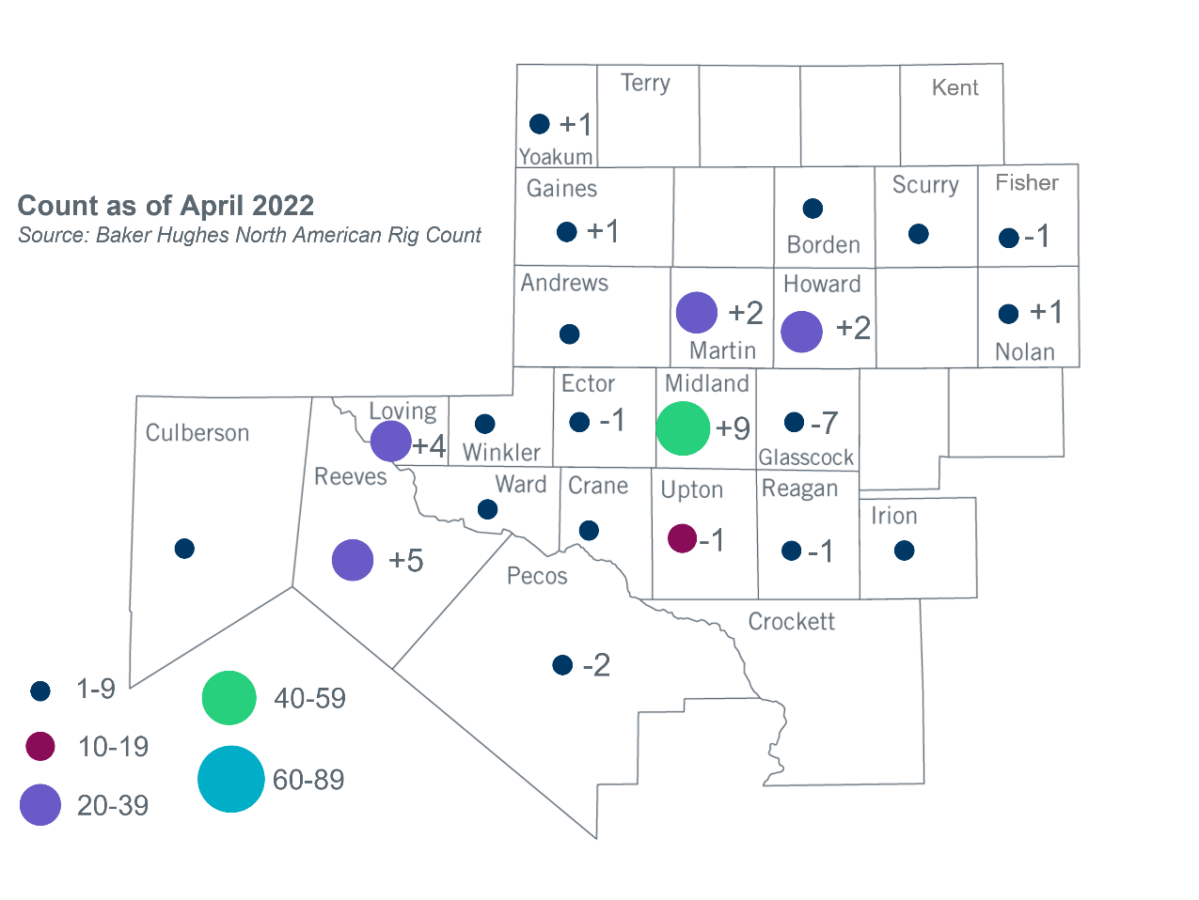
Permian Basin Oil Rig Count
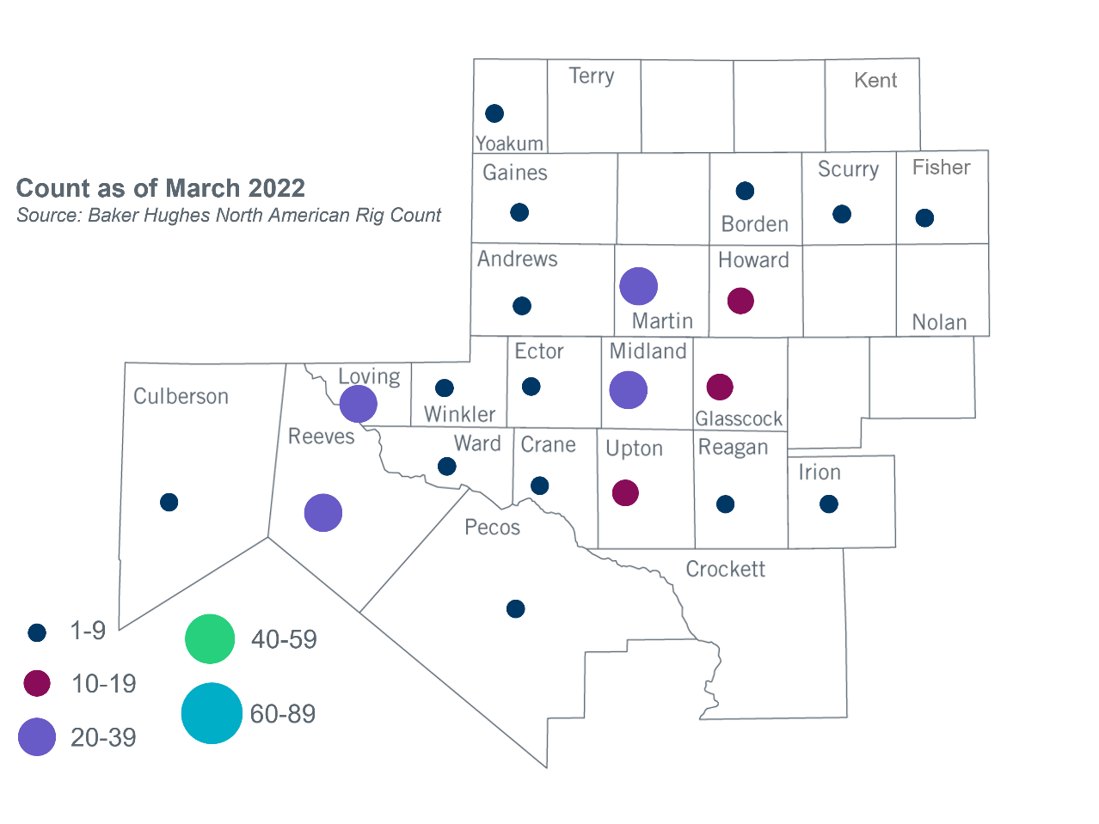

Other Notable Activities

- ERCOT presented the study results of the proposed integration of the remainder of LP&L’s Load to the RPG in April. ERCOT plans to issue a study report within Q2, 2022.
- ERCOT presented assumptions to be used in the 2022 RTP economic analysis to the RPG in April.

Based on the Total Project Estimated Cost for all future projects listed in the Transmission Project Information and Tracking (TPIT) report. TPIT is updated three times each year based on information TSPs provide in Model on Demand (MOD) as specified in the ERCOT Steady State Working Group Procedure Manual. The latest TPIT is available at https://www.ercot.com/gridinfo/planning.
Based on the Total Project Estimated Cost for all completed projects with Projected In-Service Dates in 2021 listed in the TPIT.
+/- symbol indicates the increase or decrease from the previous month in oil rigs present in each county. There are 238 rigs, including an increase of 12 oil rigs, in the Permian Basin from March to April 2022.

