

System Planning
Monthly Status Report

Report Highlights

- ERCOT is currently reviewing proposed transmission improvements with a total estimated cost of $2.414 billion as of August 31, 2024.
- Transmission Projects endorsed in 2024 total $2.817 billion as of August 31, 2024.
- All projects (in engineering, routing, licensing, and construction) total approximately $14.183 billion as of June 1, 2024.
- Transmission Projects energized in 2024 total approximately $2.160 billion (as of June 1, 2024).

Regional Planning Group Reviews
RPG Projects under Review:
- Oncor has submitted the Temple Area Project (RPG Project ID: 24RPG001). This is a Tier 1 project that is estimated to cost $120.70 million. ERCOT has completed the independent review on July 26, and the recommended project is estimated to cost $272.60 million. TAC voted unanimously to endorse the project on July 31, 2024. The ERCOT Board of Directors endorsed the project on August 20, 2024, and ERCOT has issued the ERCOT endorsement letter.
- CPS Energy has submitted the Eastside 345/138-kV Switching Station Project (RPG Project ID: 24RPG003). This is a Tier 1 project that is estimated to cost $158.00 million. ERCOT has completed the independent review on July 26, and the recommended project is estimated to cost $47.00 million. Pursuant to the Protocol Section 3.11.4.3.1(c), this project has been reclassified as a Tier 3 project, and ERCOT has issued an acceptance letter.
- CPS Energy has submitted the Omicron Reliability Project (RPG Project ID: 24RPG004). This is a Tier 2 project that is estimated to cost $42.50 million. ERCOT completed the independent review on July 26, and the recommended project is estimated to cost $45.70 million. ERCOT has issued the ERCOT endorsement letter.
- REC has submitted the Canton Area Loop Project (RPG Project ID: 24RPG007). This is a Tier 2 project that is estimated to cost $22.61 million. ERCOT completed the independent review on August 23, and the recommended project is estimated to cost $26.03 million. ERCOT will not issue an endorsement letter for this project, as it is needed to solely meet REC planning criteria.
- AEPSC has submitted the Brownsville Area Improvements Transmission Project (RPG Project ID: 24RPG008). This is a Tier 1 project that is estimated to cost $387.70 million. This project is currently under ERCOT’s independent review.
- Oncor has submitted the Delaware Basin Stages 3 and 4 Project (RPG Project ID: 24RPG010). This is a Tier 1 project that is estimated to cost $202.20 million. This project is currently under ERCOT’s independent review.
- Oncor has submitted the Delaware Basin State 5 Project (RPG Project ID: 24RPG015). This is a Tier 1 project that is estimated to cost $744.60 million. This project is currently under ERCOT’s independent review.
- REC has submitted the Rand Area Loop Project (RPG Project ID: 24RPG016). This is a Tier 2 project that is estimated to cost $32.20 million. This project is currently under ERCOT’s independent review.
- Oncor has submitted the Venus Switch to Sam Switch 345-kV Line Project (RPG Project ID: 24RPG017). This is a Tier 1 project that is estimated to cost $118.90 million. This project is currently under ERCOT’s independent review.
- Oncor has submitted the Salado Switch to Hutto Switch 138-kV Line Project (RPG Project ID: 24RPG018). This is a Tier 3 project that is estimated to cost $87.60 million. The RPG review of this project was completed on July 8, and ERCOT has issued an acceptance letter.
- Oncor has submitted the Connell 345/138-kV Switch and Connell to Rockhound 345-kV Double-Circuit Line Project (RPG Project ID: 24RPG020). This is a Tier 1 project that is estimated to cost $110.62 million. This project is currently under ERCOT’s independent review.
- Oncor has submitted the Forney 345/138-kV Switch Rebuild Project (RPG Project ID: 24RPG021). This is a Tier 1 project that is estimated to cost $103.50 million. This project is currently under ERCOT’s independent review.
- Oncor has submitted the Wilmer 345/138-kV Switch Project (RPG Project ID: 24RPG022). This is a Tier 1 project that is estimated to cost $158.20 million. This project is currently under ERCOT’s independent review.
- WETT has submitted the WETT Delaware Basin Stage 5 Project Alternative (RPG Project ID: 24RPG023). This is a Tier 1 project that is estimated to cost $305.50 million. This project is currently in the RPG study mode
- Oncor and LCRA TSC have submitted the Hartring to Upland 138-kV Line and Benedum Autotransformer Addition Project (RPG Project ID: 24RPG024). This is a Tier 2 project that is estimated to cost $94.00 million. This project is currently in the RPG comment period.
- Oncor has submitted the Gunter 345/138-kV Switch Project (RPG Project ID: 24RPG025). This is a Tier 3 project that is estimated to cost $51.20 million. This project is currently in the RPG comment period.
- CNP has submitted the Jordan/Mont Belvieu Area Improvement Project (RPG Project ID: 24RPG026). This is a Tier 3 project that is estimated to cost $76.89 million. This project is currently in the RPG comment period.
- WETT has submitted the Long Draw Second 345/138-kV Autotransformer Project (RPG Project ID: 24RPG027). This is a Tier 3 project that is estimated to cost $28.00 million. This project is currently in the RPG comment period.

RPG Project Reviews Completed in 2024:
RPG Project ID | RPG Project Name | Submitted Entity | Tier | Estimated Cost  ($ Millions) | Review Completion Month
24RPG002 | Rockhound 345/138-kV Switch and Grey Well Draw to Buffalo 2nd 138-kV Circuit Project | Oncor | Tier 3 | 97.00 | February
23RPG028 | Rio Medina Project | STEC | Tier 2 | 71.70 | February
23RPG023 | Pecos County Transmission Improvement Project | TNMP | Tier 1 | 114.80 | February
24RPG005 | Montfort Switch to Shankle Switch 138-kV Line Project | Oncor | Tier 3 | 33.80 | February
24RPG006 | Prairieland 345/138-kV Switch and Prairieland Switch to Quartz Sand Switch/Hog Mountain Pod 138-kV Line Project | Oncor | Tier 3 | 56.00 | March
23RPG032 | San Antonio South Reliability II Project  (San Miguel to Marion 345-KV Project) | BEC | Tier 1 | 435.00 | April
24RPG009 | Sonora to Uvalde to Campwood to Bandera Area Transmission Project | AEPSC, LCRA TSC & BEC | Reclassified from Tier 3 to Tier 4 per Protocol | 76.00 | April
24RPG011 | Gonzales STATCOM Transmission Project | AEPSC | Reclassified from Tier 3 to Tier 4 per Protocol | 34.50 | April
24RPG012 | Clute to Velasco ckt 26 Upgrades Project | CNP | Tier 3 | 68.23 | May
24RPG013 | FPP Yard 2 to Lytton Springs Transmission Line Overhaul Project | LCRA TSC & AEN | Reclassified from Tier 3 to Tier 4 per Protocol | 60.00 | May
24RPG014 | Sim Gideon to Cedar Hill Transmission Line Upgrade Project | LCRA TSC | Tier 3 | 77.90 | May
23RPG034 | West Texas 345-kV Infrastructure Rebuild Project | Oncor | Tier 1 | 1,120.00 | June
23RPG003 | Energy Eastside 345/138-kV Switching Station Project | CPS Energy | Reclassified from Tier 1 to Tier 3 per Protocol | 47.00 | July
23RPG004 | Omicron Reliability Project | CPS Energy | Tier 2 | 45.70 | July
24RPG018 | Salado Switch to Hutto Switch 138-kV Line Project | Oncor | Tier 3 | 87.60 | July
24RPG019 | Vineyard Switch to Cypress Waters 138-kV Circuit Addition Project | Oncor | Tier 3 | 93.04 | July
24RPG001 | Temple Area Project | Oncor | Tier 1 | 272.60 | August
24RPG007 | Canton Area Loop Project | REC | Tier 2 | 26.03 | August

More information on current and past RPG projects can be found on the ERCOT MIS Secure (digital certificate required): https://mis.ercot.com/secure/data-products/grid/regional-planning
Past email communication on RPG projects can be found on the ERCOT listserv by signing up for the REGPLANGROUP list: http://lists.ercot.com/scripts/wa-ERCOT.exe?A0=REGPLANGROUP

Planning Model Activities
The short-term calendar of major planning model events is as follows:
- By October 15, 2024 24SSWG_U1 Cases and TPIT will be posted
- By November 8, 2024 24SSWG_U1 Contingencies and Data Dictionary will be posted
The following table shows interconnection projects that met Planning Guide section 6.9(1) and 6.9(2) and were modeled in the SSWG cases as a full model or as a simple model in accordance with Planning Guide section 6.9.

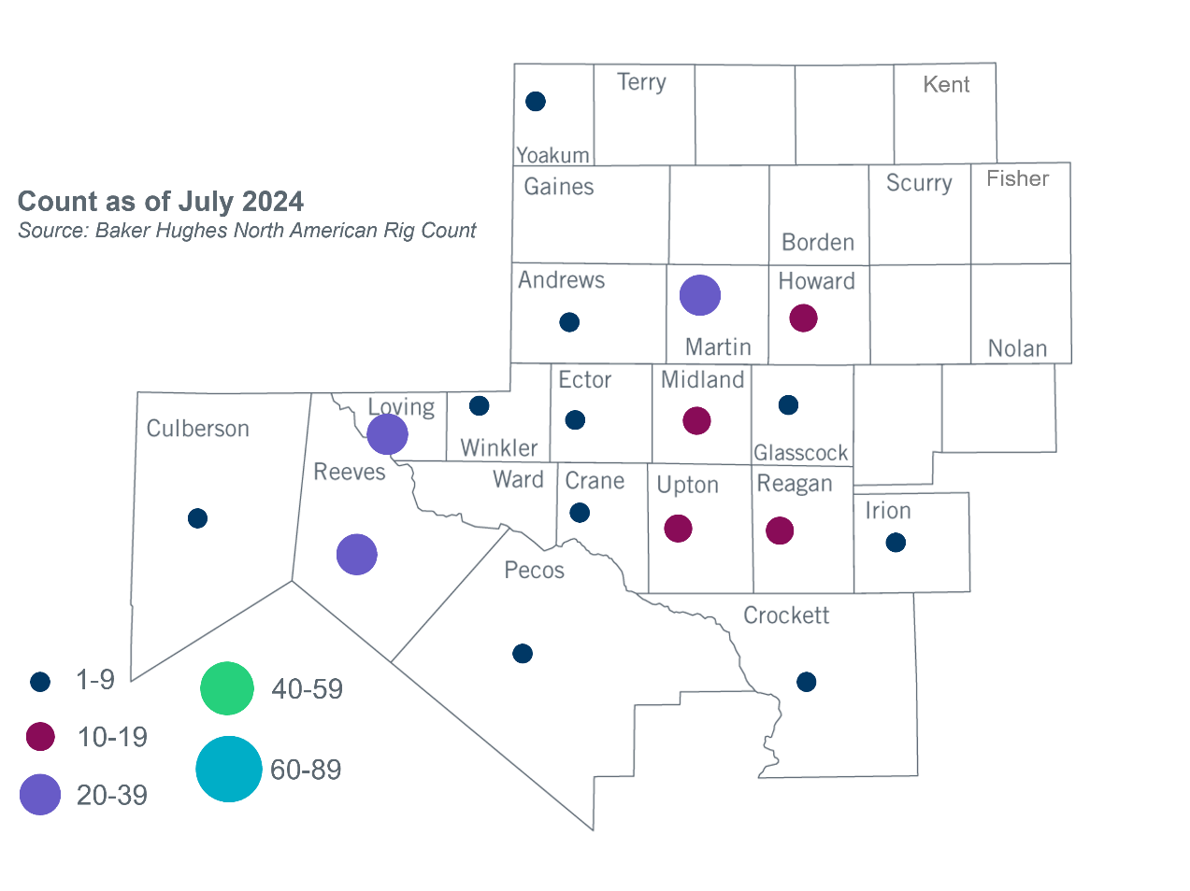
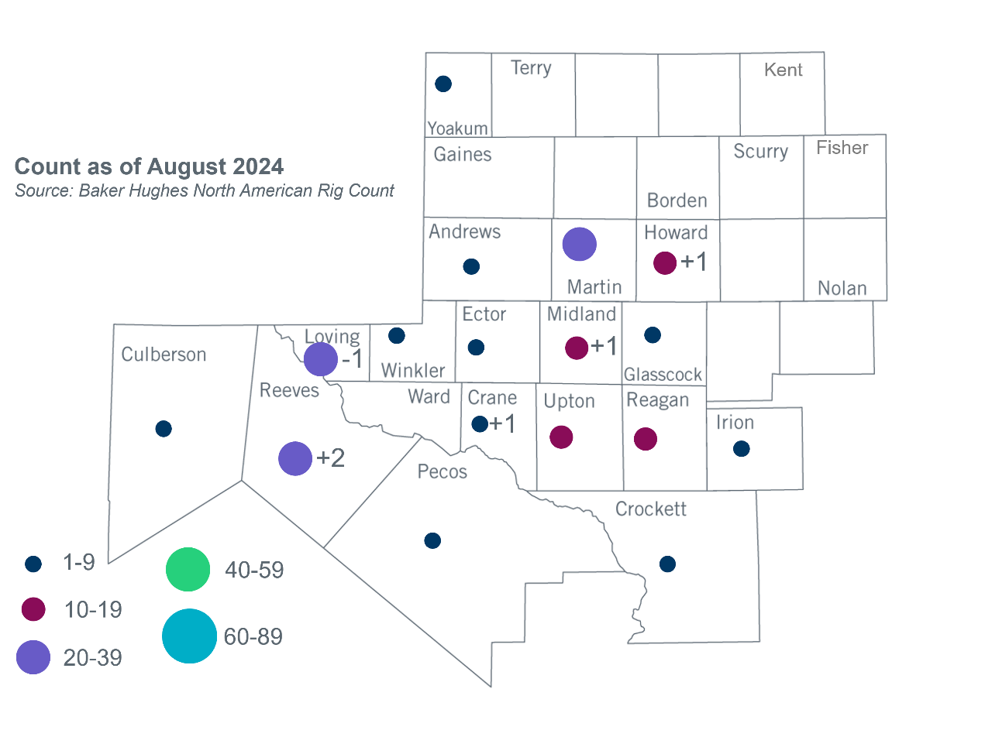
Permian Basin Oil Rig Count
Other Notable Activities
- PUCT held a workshop for the Permian Basin reliability plan study on August 22, 2024.
- ERCOT presented the capacity expansion results of the 2024 Long-Term System Assessment (LTSA) high large load adoption scenario at the August 2024 RPG meeting.
- ERCOT presented the 2024 Regional Transmission Plan (RTP) economic study stability interface limits updates at the August 2024 RPG meeting.

Based on the Total Project Estimated Cost for all future projects listed in the Transmission Project Information and Tracking (TPIT) report. TPIT is updated three times each year based on information TSPs provide in Model on Demand (MOD) as specified in the ERCOT Steady State Working Group Procedure Manual. The latest TPIT is available at https://www.ercot.com/gridinfo/planning.
Based on the Total Project Estimated Cost for all completed projects with Projected In-Service Dates in 2024 listed in the TPIT.
+/- symbol indicates the increase or decrease from the previous month in oil rigs present in each county. There are 196 rigs, including a increase of 5 oil rigs, in the Permian Basin from July to August 2024.

