

System Planning
Monthly Status Report

Report Highlights

- ERCOT is currently reviewing proposed transmission improvements with a total estimated cost of $464.36 million as of February 28, 2022.
- Transmission Projects endorsed in 2022 total $245.40 million as of February 28, 2022.
- All projects (in engineering, routing, licensing, and construction) total approximately $8.00 billion as of October 1, 2021.
- Transmission Projects energized in 2021 total approximately $1.438 billion (as of October 1, 2021).

Regional Planning Group Reviews
RPG Projects under Review:
- Oncor has submitted the Nacogdoches Southeast Switch – Redland Switch – Lufkin Switch 345-kV Loop Project (RPG Project ID: 20RPG019). This is a Tier 2 project that is estimated to cost $71.3 million. This project is currently under ERCOT’s independent review.
- CNP has submitted the Greens Bayou to Clinton 138-kV Conversion Project (RPG Project ID: 22RPG001). This is a Tier 3 project that is estimated to cost $88.5 million. The RPG review of this project was completed on February 14. Pursuant to the Protocol Section 3.11.4.3.1 (d), this project has been reclassified as a Tier 4 neutral project.
- AEPSC has submitted the Abilene South to Putnam 138-kV Transmission Line Rebuild Project (RPG Project ID: 22RPG002). This is a Tier 3 project that is estimated to cost $31.5 million. This project is currently in the RPG comment period.
- Oncor has submitted the Roanoke Area Upgrades Project (RPG Project ID: 22RPG003). This is a Tier 1 project that is estimated to cost $285.9 million. This project is currently in the RPG comment period.
- AEPSC has submitted the Pulsar to Victoria 138-kV line Rebuild Project (RPG Project ID: 22RPG004). This is a Tier 3 project that is estimated to cost $75.7 million. This project is currently in the RPG comment period.

RPG Project Reviews Completed in 2022:
RPG Project ID | RPG Project Name | Submitted Entity | Tier | Estimated Cost  ($ Millions) | Review Completion Month
21RPG021 | Mulberry Creek 345 kV Station Improvements Project | AEPSC/Oncor | Reclassified from Tier 3 to Tier 4 per Protocol | 49.2 | January
21RPG022 | Marshall Ford-Ruther Ford 138 kV Line Rebuild Project | PEC | Reclassified from Tier 3 to Tier 4 per Protocol | 28.8 | January
21RPG023 | Barrilla Junction 69 kV loop Rebuild and Conversion Project | AEPSC | Tier 3 | 44 | January
21RPG024 | Tungsten 138/69 kV Station Transmission Project | AEPSC | Reclassified from Tier 3 to Tier 4 per Protocol | 34.9 | January
22RPG001 | Greens Bayou to Clinton 138 kV Conversion Project | CNP | Reclassified from Tier 3 to Tier 4 per Protocol | 88.5 | February

More information on current and past RPG projects can be found on the ERCOT MIS Secure (digital certificate required): https://mis.ercot.com/secure/data-products/grid/regional-planning
Past email communication on RPG projects can be found on the ERCOT listserv by signing up for the REGPLANGROUP list: http://lists.ercot.com/scripts/wa-ERCOT.exe?A0=REGPLANGROUP

Planning Model Activities
The short-term calendar of major planning model events is as follows:
- By March 1, 2022 21SSWG Update 2 cases, in PSS/E 35, and TPIT will be posted
- By March 15, 2022 21SSWG Contingency definitions & Planning Data Dictionary will be posted
The following table shows interconnection projects that met Planning Guide section 6.9(1) and 6.9(2) and were modeled in the SSWG cases as a full model or as a simple model in accordance with Planning Guide section 6.9.

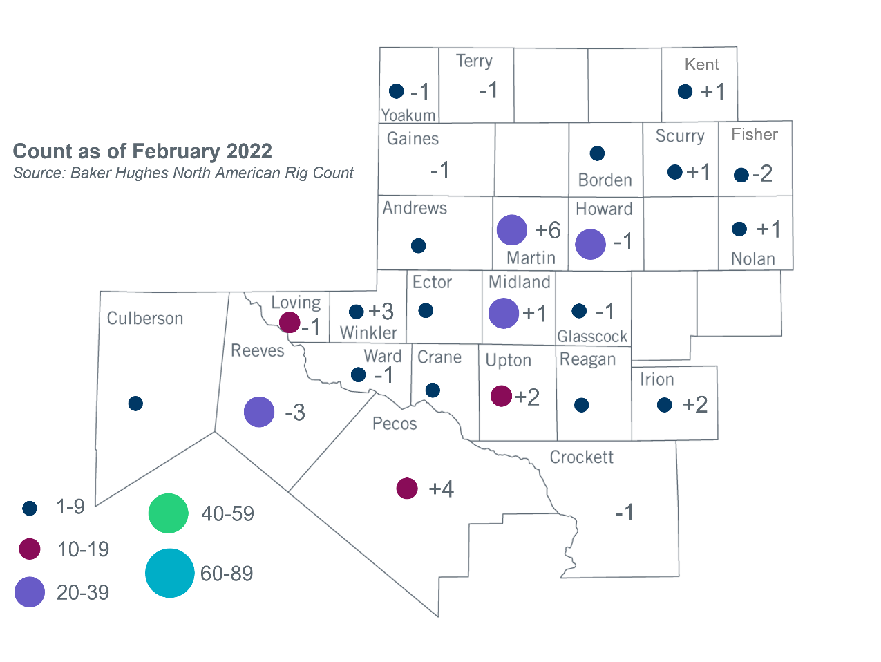
Permian Basin Oil Rig Count
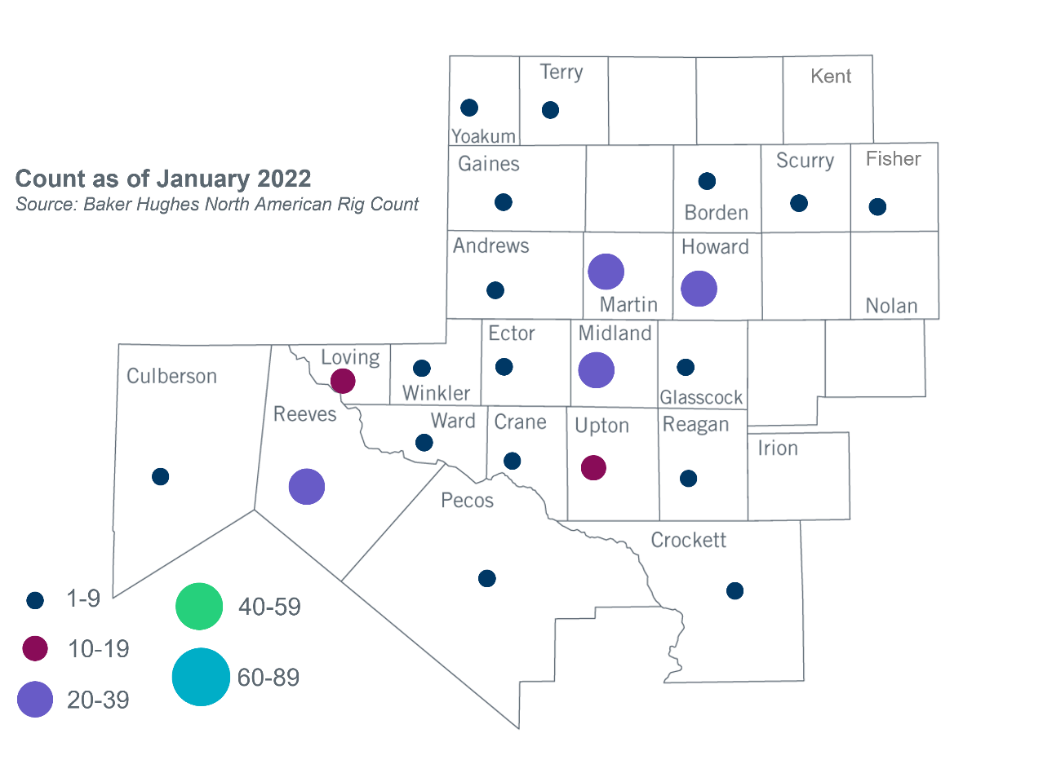

Other Notable Activities
- ERCOT provided a status update on the 2022 Long-Term System Assessment (LTSA) to the Regional Planning Group (RPG) in February.
- ERCOT provided an update on the 2022 Regional Transmission Plan (RTP) scope to the RPG in February.
- ERCOT is conducting a study for the proposed integration of the remainder of LP&L’s Load and plans to complete the study within Q2, 2022.

Based on the Total Project Estimated Cost for all future projects listed in the Transmission Project Information and Tracking (TPIT) report. TPIT is updated three times each year based on information TSPs provide in Model on Demand (MOD) as specified in the ERCOT Steady State Working Group Procedure Manual. The latest TPIT is available at https://www.ercot.com/gridinfo/planning.
Based on the Total Project Estimated Cost for all completed projects with Projected In-Service Dates in 2021 listed in the TPIT.
+/- symbol indicates the increase or decrease from the previous month in oil rigs present in each county. There are 210 rigs, including an increase of 10 oil rigs, in the Permian Basin from January to February 2022.

