

System Planning
Monthly Status Report

Report Highlights

- ERCOT is currently reviewing proposed transmission improvements with a total estimated cost of $4.402 billion as of February 28, 2025.
- Transmission Projects endorsed in 2025 total $596.96 million as of February 28, 2025.
- All projects (in engineering, routing, licensing, and construction) total approximately $16.866 billion as of February 1, 2025.
- Transmission Projects energized in 2025 total approximately $386.78 million (as of February 1, 2025).

Regional Planning Group Reviews
RPG Projects under Review:
- Oncor has submitted the Delaware Basin State 5 Project (RPG Project ID: 24RPG015). This is a Tier 1 project that is estimated to cost $744.60 million. This project is currently under ERCOT’s independent review.
- Oncor has submitted the Venus Switch to Sam Switch 345-kV Line Project (RPG Project ID: 24RPG017). This is a Tier 1 project that is estimated to cost $118.90 million. ERCOT has completed the independent review on December 20, and the recommended project is estimated to cost $118.90 million. TAC voted unanimously to endorse the project on January 22, 2025. ERCOT Board of Directors endorsed the project on February 4, 2025, and ERCOT has issued the ERCOT endorsement letter.
- Oncor has submitted the Connell 345/138-kV Switch and Connell to Rockhound 345-kV Double-Circuit Line Project (RPG Project ID: 24RPG020). This is a Tier 1 project that is estimated to cost $110.62 million. This project is currently under ERCOT’s independent review.
- Oncor has submitted the Forney 345/138-kV Switch Rebuild Project (RPG Project ID: 24RPG021). This is a Tier 1 project that is estimated to cost $103.50 million. ERCOT has completed the independent review on December 20, and the recommended project is estimated to cost $100.40 million. TAC voted unanimously to endorse the project on January 22, 2025. ERCOT Board of Directors endorsed the project on February 4, 2025, and ERCOT has issued the ERCOT endorsement letter.
- Oncor has submitted the Wilmer 345/138-kV Switch Project (RPG Project ID: 24RPG022). This is a Tier 1 project that is estimated to cost $158.20 million. ERCOT has completed the independent review on December 20, and the recommended project is estimated to cost $158.20 million. TAC voted unanimously to endorse the project on January 22, 2025. ERCOT Board of Directors endorses the project on February 4, 2025, and ERCOT has issued the ERCOT endorsement letter.
- WETT has submitted the WETT Delaware Basin Stage 5 Project Alternative (RPG Project ID: 24RPG023). This is a Tier 1 project that is estimated to cost $305.50 million. This project is currently under ERCOT’s independent review.
- Oncor and LCRA TSC have submitted the Hartring to Upland 138-kV Line and Benedum Autotransformer Addition Project (RPG Project ID: 24RPG024). This is a Tier 2 project that is estimated to cost $94.00 million. This project is currently under ERCOT’s independent review.
- CNP has submitted the Baytown Area Load Addition Project (RPG Project ID: 24RPG028). This is a Tier 1 project that is estimated to cost $141.65 million. This project is currently under ERCOT’s independent review.
- Oncor has submitted the Tredway 138-kV Switch and Expanse to Tredway 138-kV 2nd Circuit Project (RPG Project ID: 24RPG029). This is a Tier 1 project that is estimated to cost $119.03 million. This project is currently under ERCOT’s independent review.
- LST has submitted the Central Texas 345-kV Transmission Project (RPG Project ID: 24RPG031). This is a Tier 1 project that is estimated to cost $342.00 million. This project is currently under ERCOT’s independent review.
- CNP has submitted the Southwest Houston 345-kV Reliability Project (RPG Project ID: 24RPG032). This is a Tier 1 project that is estimated to cost $569.32 million. This project is currently under ERCOT’s independent review.
- AEPSC has submitted the Aransas Pass to Rincon 69-kV Line Rebuild Project (RPG Project ID: 24RPG035). This is a Tier 2 project that is estimated to cost $33.00 million. This project is currently under ERCOT’s independent review.
- TNMP has submitted the Galveston Region Project (RPG Project ID: 24RPG039). This is a Tier 1 project that is estimated to cost $133.73 million. This project is currently under ERCOT’s independent review.
- Oncor has submitted the Roscoe Area Upgrades Project (RPG Project ID: 24RPG040). This is a Tier 2 project that is estimated to cost $83.00 million. This project is currently under ERCOT’s independent review.
- WETT has submitted the Buck Canyon and Binturong 345-kV Synchronous Condenser Stations Project (RPG Project ID: 24RPG041). This is a Tier 3 project that is estimated to cost $98.61 million. The RPG review of this project was completed on January 27, and ERCOT has issued an acceptance letter.
- BTU has submitted the Texas A&M University System RELLIS Campus Reliability Project (RPG Project ID: 25RPG001). This is a Tier 1 project that is estimated to cost $271.50 million. This project is currently under ERCOT’s independent review.
- AEPSC has submitted the East Munday 138-kV Station Rebuild Project (RPG Project ID: 25RPG002). This is a Tier 3 project that is estimated to cost $28.30 million. The RPG review of this project was completed on February 12. Pursuant to the Protocol Section 3.11.4.3.1 (d), this project has been reclassified as a Tier 4 neutral project.
- BEC has submitted the Hamilton County Conversion Project (RPG Project ID: 25RPG003). This is a Tier 2 project that is estimated to cost $90.00 million. This project is currently under ERCOT’s independent review.
- Oncor has submitted the Southern DFW Load Interconnection and General Grid Strengthening Project (RPG Project ID: 25RPG004). This is a Tier 1 project that is estimated to cost $1,219 million. This project is currently in the RPG comment period.
- WETT has submitted the Pitchfork 345-kV Substation Addition Project (RPG Project ID: 25RPG005). This is a Tier 3 project that is estimated to cost $57.57 million. This project is currently in the RPG comment period.
- Oncor has submitted the Resubmission for Salado Switch to Hutto Switch 138-kV Line Project (RPG Project ID: 25RPG006). This is a Tier 3 project that is estimated to cost $87.60 million. This project is currently in the RPG comment period.

RPG Project Reviews Completed in 2025:
RPG Project ID | RPG Project Name | Submitted Entity | Tier | Estimated Cost  ($ Millions) | Review Completion Month
24RPG037 | Partial Rebuild of 138-kV Ckt.63 West Galveston to Moody Project | CNP | Reclassified from Tier 3 to Tier 4 per Protocol | 26.20 | January
24RPG0378 | Bergheim Substation Upgrade Project | LCRA TSC & PEC | Tier 3 | 66.35 | January
24RPG041 | Buck Canyon and Binturong 345-kV Synchronous Condenser Stations Project | WETT | Tier 3 | 98.61 | January
24RPG017 | Venus Switch to Sam Switch 345-kV Line Project | Oncor | Tier 1 | 118.90 | February
24RPG021 | Forney 345/138-kV Switch Rebuild Project | Oncor | Tier 1 | 100.40 | February
24RPG022 | Wilmer 345/138-kV Switch Project | Oncor | Tier 1 | 158.20 | February
25RPG002 | East Munday 138-kV Station Rebuild Project | AEPSC | Reclassified from Tier 3 to Tier 4 per Protocol | 28.30 | February

More information on current and past RPG projects can be found on the ERCOT MIS Secure (digital certificate required): https://mis.ercot.com/secure/data-products/grid/regional-planning
Past email communication on RPG projects can be found on the ERCOT listserv by signing up for the REGPLANGROUP list: http://lists.ercot.com/scripts/wa-ERCOT.exe?A0=REGPLANGROUP

Planning Model Activities
The short-term calendar of major planning model events is as follows:
- By May 30, 2025 25SSWG Cases and TPIT will be posted
- By June 6, 2025 25SSWG Contingency and Planning Data Dictionary will be posted
The following table shows interconnection projects that met Planning Guide section 6.9(1) and 6.9(2) and were modeled in the SSWG cases as a full model or as a simple model in accordance with Planning Guide section 6.9.

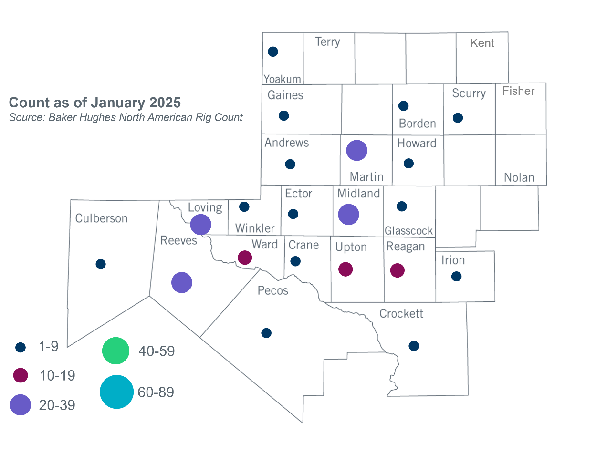
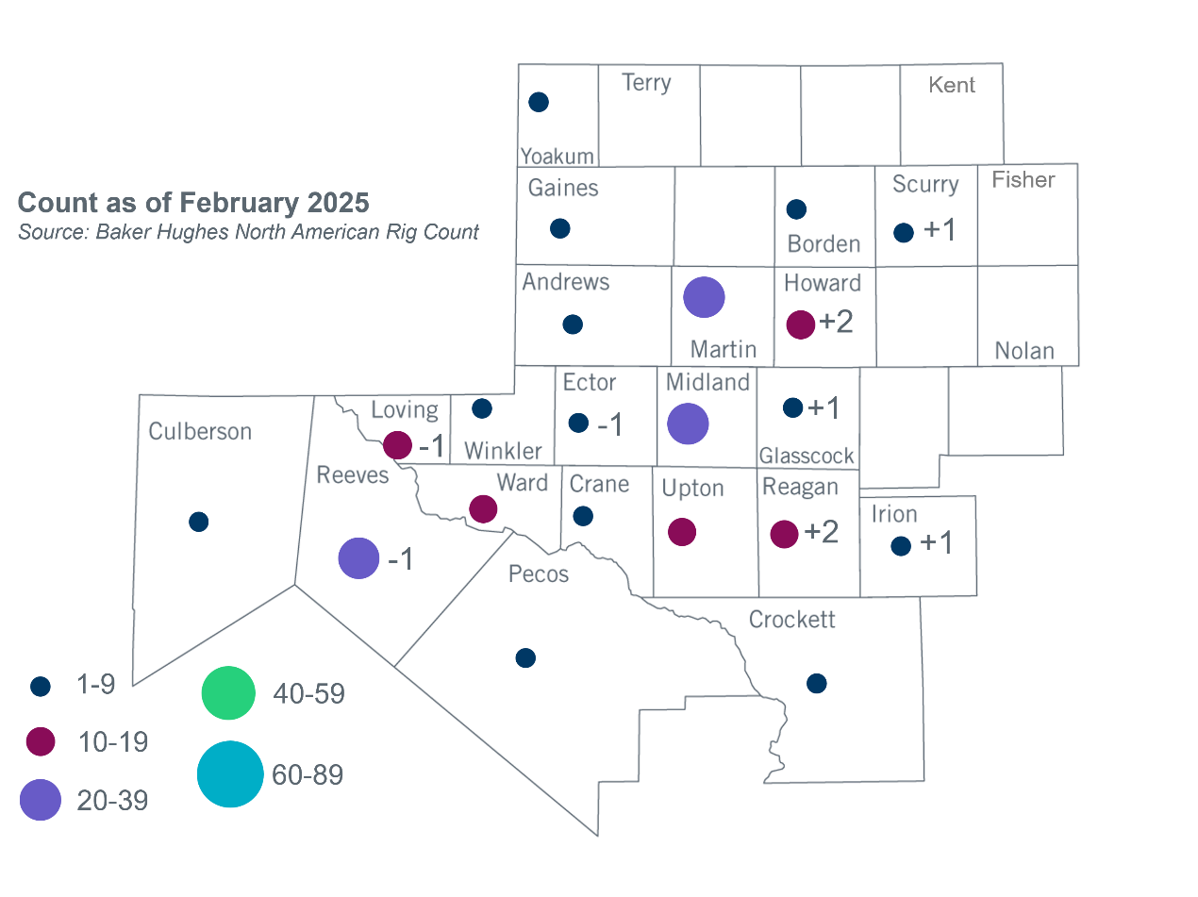
Permian Basin Oil Rig Count

Based on the Total Project Estimated Cost for all future projects listed in the Transmission Project Information and Tracking (TPIT) report. TPIT is updated three times each year based on information TSPs provide in Model on Demand (MOD) as specified in the ERCOT Steady State Working Group Procedure Manual. The latest TPIT is available at https://www.ercot.com/gridinfo/planning.
+/- symbol indicates the increase or decrease from the previous month in oil rigs present in each county. There are 197 rigs, including an increase of 4 oil rigs, in the Permian Basin from January to February.

