

System Planning
Monthly Status Report

Report Highlights

- ERCOT is currently reviewing proposed transmission improvements with a total estimated cost of $159.76 million as of January 31, 2022.
- Transmission Projects endorsed in 2022 total $156.9 million as of January 31, 2022.
- All projects (in engineering, routing, licensing, and construction) total approximately $8.00 billion as of October 1, 2021.
- Transmission Projects energized in 2021 total approximately $1.438 billion as of October 1, 2021.

Regional Planning Group Reviews
RPG Projects under Review:
- Oncor has submitted the Nacogdoches Southeast Switch – Redland Switch – Lufkin Switch 345-kV Loop Project (RPG Project ID: 20RPG019). This is a Tier 2 project that is estimated to cost $71.3 million. This project is currently under ERCOT’s independent review.
- CNP has submitted the Greens Bayou to Clinton 138-kV Conversion Project (RPG Project ID: 22RPG001). This is a Tier 3 project that is estimated to cost $88.5 million. This project is currently in the RPG comment period.
- AEPSC and Oncor have jointly submitted the Mulberry Creek 345-kV Station Improvements Project (RPG Project ID: 21RPG021). This is a Tier 3 project that is estimated to cost $49.2 million. The RPG review of this project was completed on January 13. Pursuant to the Protocol Section 3.11.4.3.1 (d), this project has been reclassified as a Tier 4 neutral project.
- PEC has submitted the Marshall Ford-Ruther Ford 138-kV Line Rebuild Project (RPG Project ID: 21RPG022). This is a Tier 3 project that is estimated to cost $28.8 million. The RPG review of this project was completed on January 13. Pursuant to the Protocol Section 3.11.4.3.1 (d), this project has been reclassified as a Tier 4 neutral project.
- AEPSC has submitted the Barrilla Junction 69-kV Loop Rebuild and Conversion Project (RPG Project ID: 21RPG023). This is a Tier 3 project that is estimated to cost $44 million. RPG review for this project was concluded on January 14, and ERCOT has issued the acceptance letter.
- AEPSC has submitted the Tungsten 138/69-kV Station Transmission Project (RPG Project ID: 21RPG024). This is a Tier 3 project that is estimated to cost $34.9 million. The RPG review of this project was completed on January 18. Pursuant to the Protocol Section 3.11.4.3.1 (d), this project has been reclassified as a Tier 4 neutral project.

RPG Project Reviews Completed in 2022:
RPG Project ID | RPG Project Name | Submitted Entity | Tier | Estimated Cost  ($ Millions) | Review Completion Month
21RPG021 | Mulberry Creek 345 kV Station Improvements Project | AEPSC/Oncor | Reclassified from Tier 3 to Tier 4 per Protocol | 49.2 | January
21RPG022 | Marshall Ford-Ruther Ford 138 kV Line Rebuild Project | PEC | Reclassified from Tier 3 to Tier 4 per Protocol | 28.8 | January
21RPG023 | Barrilla Junction 69 kV loop Rebuild and Conversion Project | AEPSC | Tier 3 | 44 | January
21RPG024 | Tungsten 138/69 kV Station Transmission Project | AEPSC | Reclassified from Tier 3 to Tier 4 per Protocol | 34.9 | January

More information on current and past RPG projects can be found on the ERCOT MIS Secure (digital certificate required): https://mis.ercot.com/secure/data-products/grid/regional-planning
Past email communication on RPG projects can be found on the ERCOT listserv by signing up for the REGPLANGROUP list: http://lists.ercot.com/scripts/wa-ERCOT.exe?A0=REGPLANGROUP

Planning Model Activities
The short-term calendar of major planning model events is as follows:
- By March 1, 2022 21SSWG Update 2 cases, in PSS/E 35, and TPIT will be posted
- By March 15, 2022 21SSWG Contingency definitions & Planning Data Dictionary will be posted
The following table shows interconnection projects that met Planning Guide section 6.9(1) and 6.9(2) and were modeled in the SSWG cases as a full model or as a simple model in accordance with Planning Guide section 6.9.

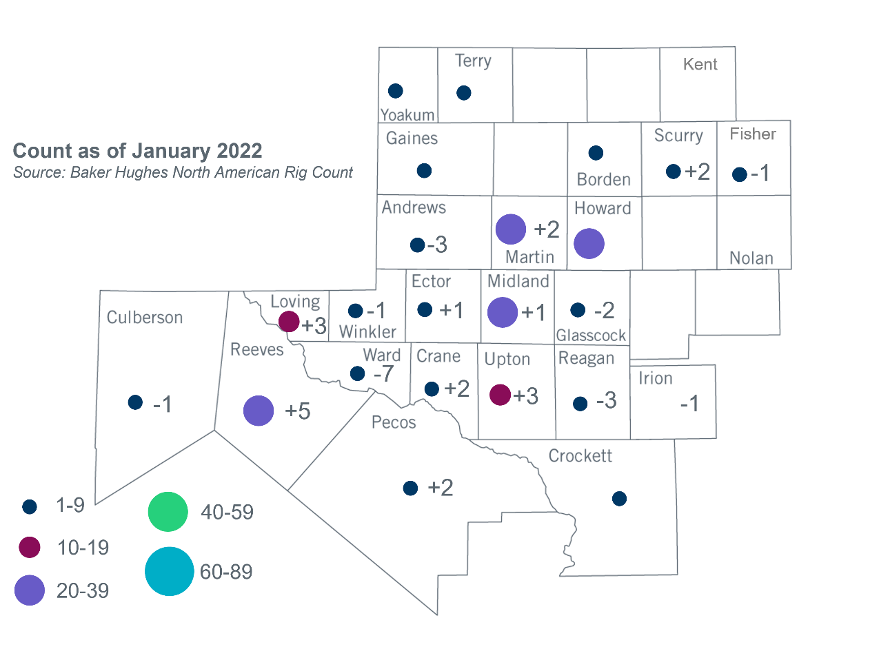
Permian Basin Oil Rig Count
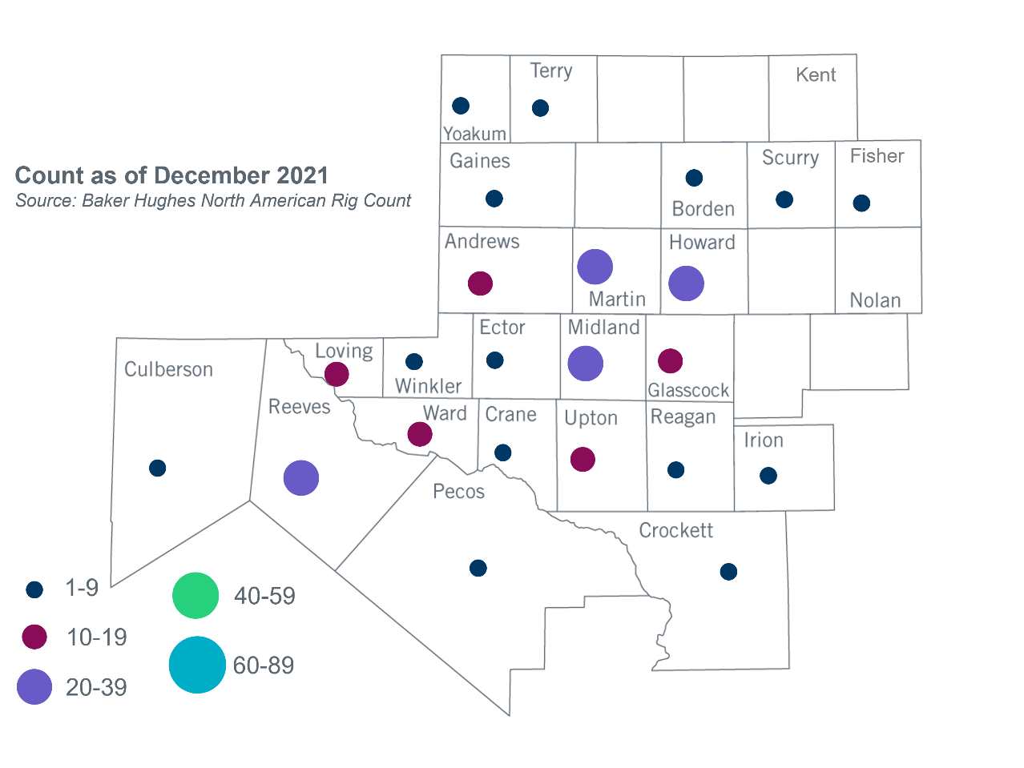

Other Notable Activities
- ERCOT posted the Long-Term West Texas Export Study report to the ERCOT website on January 14, 2022. ERCOT also provided a high-level overview of the study to the Regional Planning Group (RPG) in January.
- ERCOT provided an initial 2022 Regional Transmission Plan (RTP) load review update to RPG in January. Information on Transmission Service Provider (TSP) load-share ratios used for the load review process were posted to the MIS Secure Area on January 31, 2022.

Based on the Total Project Estimated Cost for all future projects listed in the Transmission Project Information and Tracking (TPIT) report. TPIT is updated three times each year based on information TSPs provide in Model on Demand (MOD) as specified in the ERCOT Steady State Working Group Procedure Manual. The latest TPIT is available at https://www.ercot.com/gridinfo/planning.
Based on the Total Project Estimated Cost for all completed projects with Projected In-Service Dates in 2021 listed in the TPIT.
+/- symbol indicates the increase or decrease from the previous month in oil rigs present in each county. There are 200 rigs, including an increase of 2 oil rigs, in the Permian Basin from December 2021 to January 2022.

