

System Planning
Monthly Status Report

Report Highlights

- ERCOT is currently reviewing proposed transmission improvements with a total estimated cost of $1,012.86 Million as of January 31, 2021.
- Transmission Projects endorsed in 2021 total $106.1 Million as of January 31, 2021.
- All projects (in engineering, routing, licensing and construction) total approximately $7.6 Billion as of October 1, 2020.
- Transmission Projects energized in 2020 total about $1.20 Billion as of October 1, 2020.

Regional Planning Group Reviews
- AEPSC has submitted the LRGV Import Project. This is a Tier 1 project that is estimated to cost $73.4 million. AEPSC has also requested that ERCOT provide a conditional endorsement for an additional $357.2 million project. ERCOT’s independent review has been conducted in accordance with Protocol Section 3.11.4.9(3), and this project is currently placed on hold until the LNG loads are confirmed.
- STEC has submitted the Lower Rio Grande Valley Transmission Expansion Project. This is a Tier 1 project that is estimated to cost $511 million. ERCOT’s independent review has been conducted in accordance with Protocol Section 3.11.4.9(3), and this project is currently placed on hold until the LNG loads are confirmed.
- Oncor has submitted the Nacogdoches Southeast Switch – Redland Switch – Lufkin Switch 345-kV Loop Project. This is a Tier 2 project that is estimated to cost $71.26 million. This project is currently under ERCOT’s independent review.
- AEPSC has submitted the Hamilton Road to Maxwell 138-kV Line Rebuild Project. This is a Tier 3 project that is estimated to cost $34 million. The RPG Project review of this project was completed on January 19, and ERCOT has issued an acceptance letter.
- Oncor has submitted the Royse - Commerce 69-kV Line Conversion to 138-kV Project. This is a Tier 3 project that is estimated to cost $72.1 million. The RPG Project review of this project was completed on January 20, and ERCOT will issue an acceptance letter.

More information on current and past RPG projects can be found on the ERCOT MIS Secure (digital certificate required): https://mis.ercot.com/public/data-products/grid/regional-planning
Past email communication on RPG projects can be found on the ERCOT listserv by signing up for the REGPLANGROUP list: http://lists.ercot.com/scripts/wa-ERCOT.exe?A0=REGPLANGROUP

Planning Model Activities
The short-term calendar of major planning model events is as follows:
- By March 1, 2021 20SSWG Update 2 cases and TPIT are posted
- By March 31, 2021 20SSWGU2 Contingency definitions and Planning Data Dictionary are posted
The following table shows interconnection projects that met Planning Guide section 6.9(1) and 6.9(2) and were modeled in the SSWG cases as a full model or as a simple model in accordance with Planning Guide section 6.9.

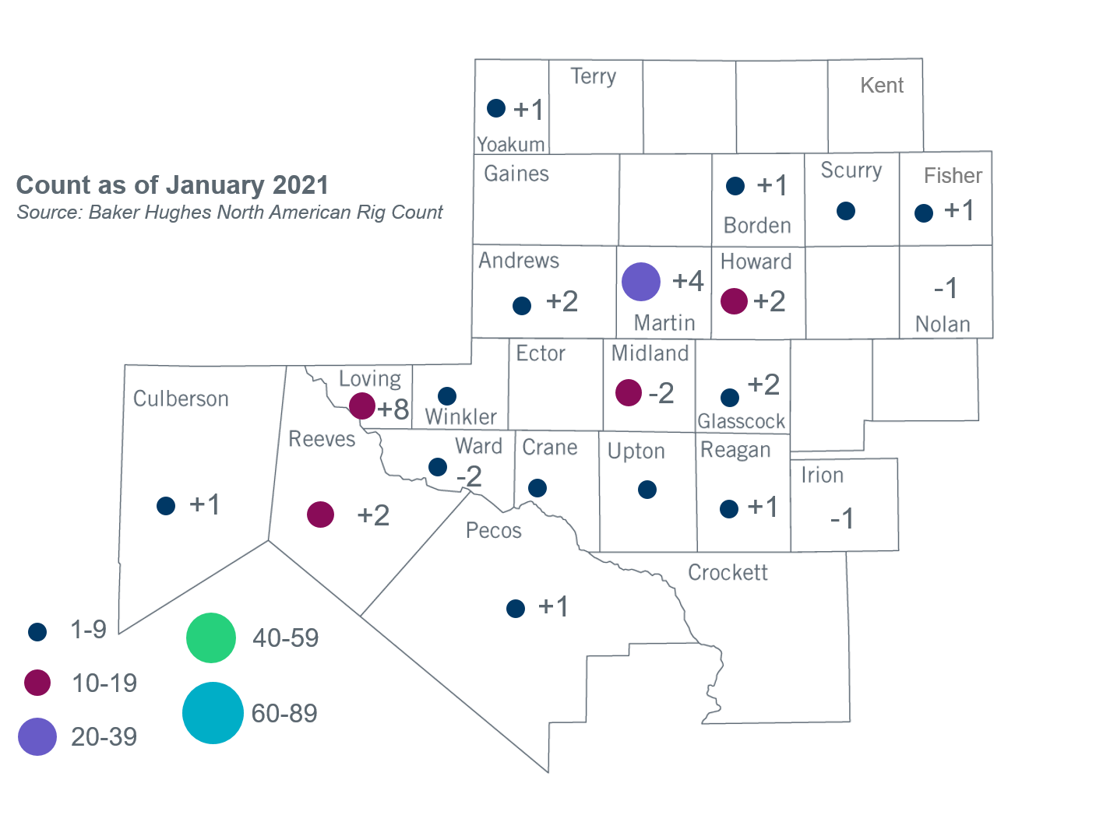
Permian Basin Oil Rig Count
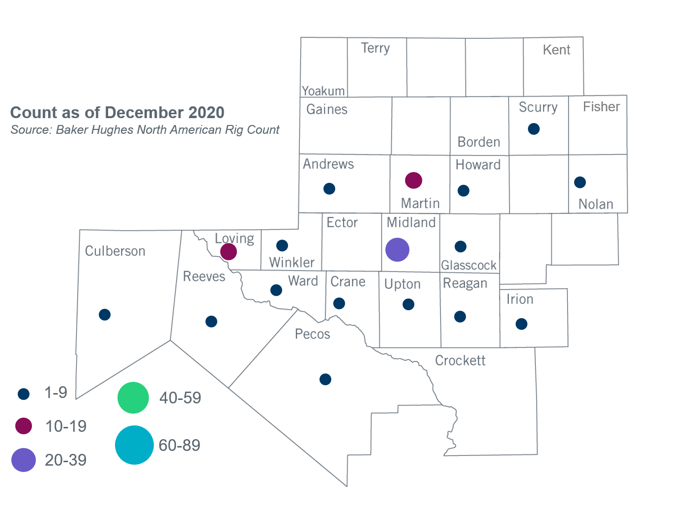

Other Notable Activities
- ERCOT is conducting the West Texas Export Study and plans to complete the study in June, 2021.
- ERCOT is conducting the South Texas Stability Study and plans to complete the study in June, 2021.
- The SPWG will begin building the 2021 CY base case in January 2021.
- ERCOT presented on the 2021 Regional Transmission Plan (RTP) initial load review to the Regional Planning Group (RPG) in January. Reliability cases including the initial bounded load values were posted to MIS Secure for review by TSPs.
- A draft 2021 RTP Scope and Process document was posted to the January RPG meeting page.

+/- symbol indicates the increase or decrease from the previous month in oil rigs present in each county. There are 128 rigs, including a total increase of 20 oil rigs, in the Permian Basin from December 2020 to January 2021.

