

System Planning
Monthly Status Report

Report Highlights

- ERCOT is currently reviewing proposed transmission improvements with a total estimated cost of $763.50 million as of July 31, 2022.
- Transmission Projects endorsed in 2022 total $1.483 billion as of July 31, 2022.
- All projects (in engineering, routing, licensing, and construction) total approximately $9.275 billion as of June 1, 2022.
- Transmission Projects energized in 2022 total approximately $1.523 billion (as of June 1, 2022).

Regional Planning Group Reviews
RPG Projects under Review:
- Oncor has submitted the Roanoke Area Upgrades Project (RPG Project ID: 22RPG003). This is a Tier 1 project that is estimated to cost $285.9 million. ERCOT has completed the independent review, and TAC voted unanimously to endorse the project on July 27. ERCOT will present the recommendation for BOD endorsement on August 16.
- LCRA TSC, Oncor, and WETT have jointly submitted the Bearkat – North McCamey – Sand Lake 345-kV Transmission Line Addition Project (RPG Project ID: 22RPG010). This is a Tier 1 project that is estimated to cost $477.6 million. ERCOT has completed the independent review, and TAC voted unanimously to endorse the project on July 27. ERCOT will present the recommendation for BOD endorsement on August 16.
- Oncor has submitted the Tyler Switch – Forest Grove Switch 138-kV Line Project (RPG Project ID: 22RPG015). This is a Tier 3 project that is estimated to cost $62.7 million. The RPG review of this project was completed on July 13. Pursuant to the Protocol Section 3.11.4.3.1 (d), this project has been reclassified as a Tier 4 neutral project.
- LCRA TSC has submitted the Marshall Ford – McNeil Transmission Line Storm Hardening Project (RPG Project ID: 22RPG018). This is a Tier 3 project that is estimated to cost $34.1 million. The RPG review of this project was completed on July 8. Pursuant to the Protocol Section 3.11.4.3.1 (d), this project has been reclassified as a Tier 4 neutral project.
- CNP has submitted the Partial Rebuild of 69-kV HOC to Dunlavy Ckt 40 Project (RPG Project ID: 22RPG019). This is a Tier 3 project that is estimated to cost $31.39 million. The RPG review of this project was completed on July 14. Pursuant to the Protocol Section 3.11.4.3.1 (d), this project has been reclassified as a Tier 4 neutral project.
- AEPSC has submitted the Belknap to Fort Griffin 69-kV Line Rebuild Project (RPG Project ID: 22RPG020). This is a Tier 3 project that is estimated to cost $27.6 million. The RPG review of this project was completed on July 22. Pursuant to the Protocol Section 3.11.4.3.1 (d), this project has been reclassified as a Tier 4 neutral project.
- LCRA TSC has submitted the Hays Energy – Kendall Corridor Transmission Line Rehabilitation Projects (RPG Project ID: 22RPG005). This is a Tier 1 project that is estimated to cost $399.9 million. ERCOT has completed the independent review on July 19, and this project has been reclassified as a Tier 4 neutral project pursuant to the Protocol Section 3.11.4.3.1 (d).

RPG Project Reviews Completed in 2022:
RPG Project ID | RPG Project Name | Submitted Entity | Tier | Estimated Cost  ($ Millions) | Review Completion Month
21RPG021 | Mulberry Creek 345 kV Station Improvements Project | AEPSC/Oncor | Reclassified from Tier 3 to Tier 4 per Protocol | 49.2 | January
21RPG022 | Marshall Ford-Ruther Ford 138 kV Line Rebuild Project | PEC | Reclassified from Tier 3 to Tier 4 per Protocol | 28.8 | January
21RPG023 | Barrilla Junction 69 kV loop Rebuild and Conversion Project | AEPSC | Tier 3 | 44 | January
21RPG024 | Tungsten 138/69 kV Station Transmission Project | AEPSC | Reclassified from Tier 3 to Tier 4 per Protocol | 34.9 | January
22RPG001 | Greens Bayou to Clinton 138 kV Conversion Project | CNP | Reclassified from Tier 3 to Tier 4 per Protocol | 88.5 | February
22RPG002 | Abilene South to Putnam 138 kV Transmission Line Rebuild Project | AEPSC | Reclassified from Tier 3 to Tier 4 per Protocol | 31.5 | March
22RPG004 | Pulsar to Victoria 138 kV Line Rebuild project | AEPSC | Reclassified from Tier 3 to Tier 4 per Protocol | 75.7 | March
22RPG006 | Consavvy 345/138 kV Switch Project | Oncor | Tier 3 | 90.2 | April
22RPG007 | Lenorah Area 345/138 kV Project | Oncor/WETT | Tier 3 | 45.2 | April
20RPG019 | Nacogdoches Southeast Switch – Redland Switch – Lufkin Switch 345 kV Loop | Oncor | Tier 2 | 71.26 | April
22RPG008 | Bowman Switch 345/138 kV Autotransformers Project | Oncor | Tier 3 | 13 | April
22RPG009 | Eden to North Brady 69 kV Line Rebuild Project | AEPSC | Reclassified from Tier 3 to Tier 4 per Protocol | 34 | April
22RPG011 | Fayetteville – Salem Transmission Line Rehabilitation Project | LCRA TSC | Reclassified from Tier 3 to Tier 4 per Protocol | 77.8 | May
22RPG012 | Partial Rebuild 69 kV Deepwater to Clinton Ckt 33 Project | CNP | Reclassified from Tier 3 to Tier 4 per Protocol | 55.91 | May
22RPG013 | Wolf Switch - Moss Switch 138 kV Line Rebuild Project | Oncor | Tier 3 to Tier 4 Pursuant to the Protocol Section 3.11.4.3.1 (d) | 56.2 | June
22RPG014 | Red Oak Area Upgrades project | Oncor | Tier 3 | 63 | June
22RPG016 | Hutto East - Brushy Creek 138kV Line Project | Oncor | Tier 3 | 29.7 | June
22RPG017 | McGregor Phillips – Waco West 69 kV Line Conversion Project | Oncor | Tier 3 to Tier 4 Pursuant to the Protocol Section 3.11.4.3.1 (d) | 38.8 | June
22RPG018 | Marshall Ford – McNeil Transmission Line Storm Hardening Project | LCRA TSC | Tier 3 to Tier 4 Pursuant to the Protocol Section 3.11.4.3.1 (d) | 34.1 | July
22RPG019 | Partial Rebuild of 69 kV HOC to Dunlavy Ckt 40 Project | CNP | Tier 3 to Tier 4 Pursuant to the Protocol Section 3.11.4.3.1 (d) | 31.39 | July
22RPG015 | Tyler Switch – Forest Grove Switch 138 kV Line Project | Oncor | Tier 3 to Tier 4 Pursuant to the Protocol Section 3.11.4.3.1 (d) | 62.7 | July
22RPG005 | Hays Energy – Kendall Corridor Transmission Line Rehabilitation Projects | LCRA TSC | Tier 1 to Tier 4 Pursuant to the Protocol Section 3.11.4.3.1 (d) | 399.9 | July
22RPG020 | Belknap to Fort Griffin 69 kV Line Rebuild Project | AEPSC | Tier 3 to Tier 4 Pursuant to the Protocol Section 3.11.4.3.1 (d) | 27.6 | July

More information on current and past RPG projects can be found on the ERCOT MIS Secure (digital certificate required): https://mis.ercot.com/secure/data-products/grid/regional-planning
Past email communication on RPG projects can be found on the ERCOT listserv by signing up for the REGPLANGROUP list: http://lists.ercot.com/scripts/wa-ERCOT.exe?A0=REGPLANGROUP

Planning Model Activities
The short-term calendar of major planning model events is as follows:
- By October 15, 2022 22SSWG Update 1 cases, in PSS/E 35, and TPIT will be posted
- By November 1, 2022 22SSWG Update 1 Contingency definitions & Planning Data Dictionary will be posted
The following table shows interconnection projects that met Planning Guide section 6.9(1) and 6.9(2) and were modeled in the SSWG cases as a full model or as a simple model in accordance with Planning Guide section 6.9.

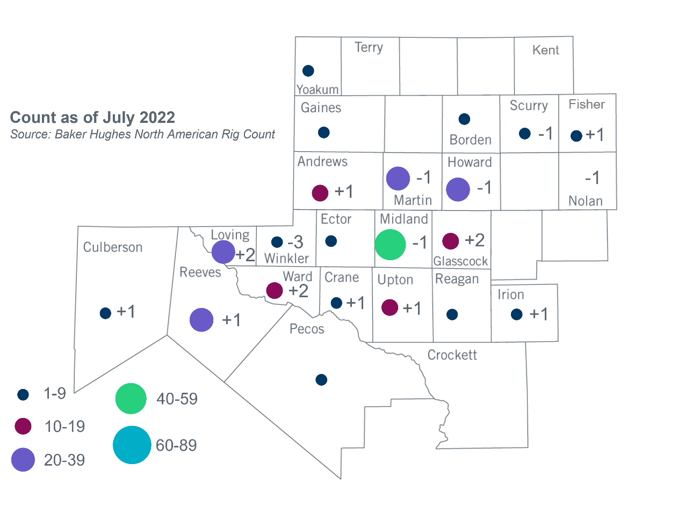
Permian Basin Oil Rig Count
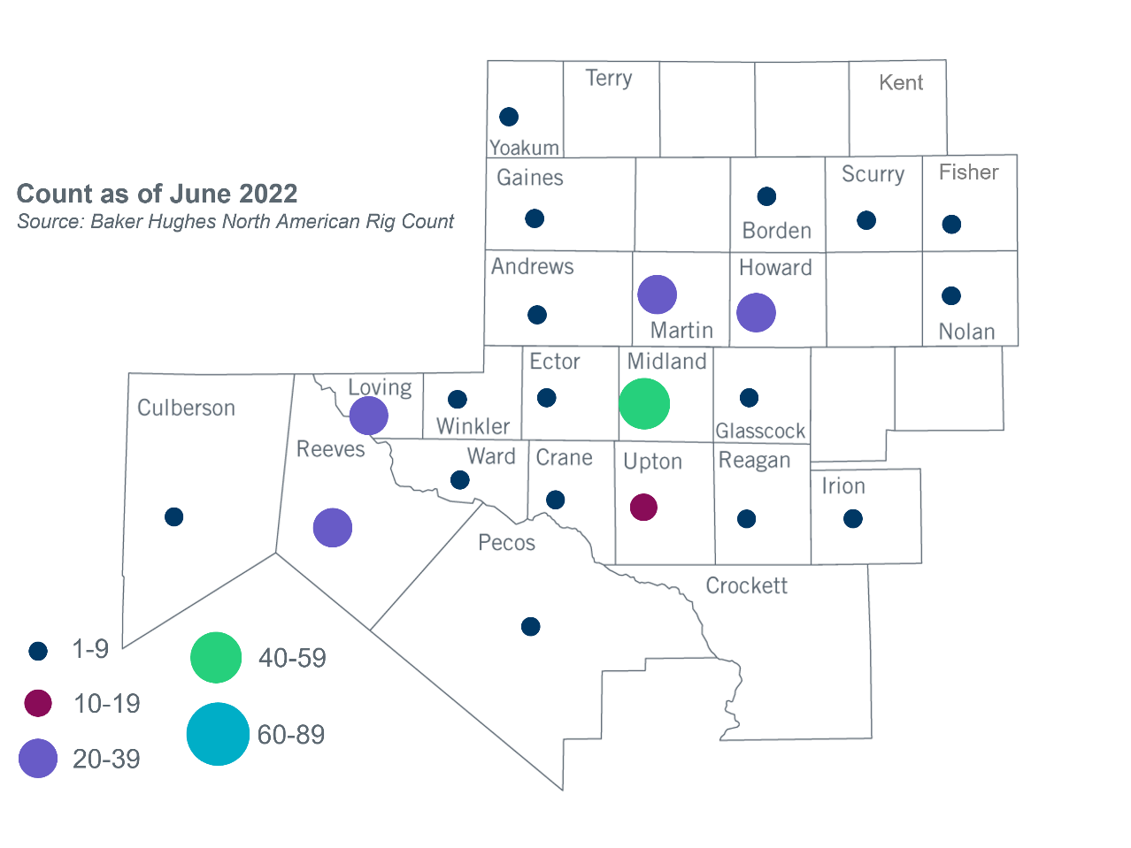

Other Notable Activities

Based on the Total Project Estimated Cost for all future projects listed in the Transmission Project Information and Tracking (TPIT) report. TPIT is updated three times each year based on information TSPs provide in Model on Demand (MOD) as specified in the ERCOT Steady State Working Group Procedure Manual. The latest TPIT is available at https://www.ercot.com/gridinfo/planning.
Based on the Total Project Estimated Cost for all completed projects with Projected In-Service Dates in 2022 listed in the TPIT.
+/- symbol indicates the increase or decrease from the previous month in oil rigs present in each county. There are 240 rigs, including a increase of 8 oil rigs, in the Permian Basin from June to July 2022.

