

System Planning
Monthly Status Report

Report Highlights

- ERCOT is currently reviewing proposed transmission improvements with a total estimated cost of $3.726 billion as of May 31, 2025.
- Transmission Projects endorsed in 2025 total $1.243 billion as of May 31, 2025.
- All projects (in engineering, routing, licensing, and construction) total approximately $16.866 billion as of February 1, 2025.
- Transmission Projects energized in 2025 total approximately $386.78 million (as of February 1, 2025).

Regional Planning Group Reviews
RPG Projects under Review:
- Oncor has submitted the Delaware Basin State 5 Project (RPG Project ID: 24RPG015). This is a Tier 1 project that is estimated to cost $744.60 million. ERCOT has completed the combined independent review on May 16, and the recommended project is estimated to cost $855.3 million. TAC voted unanimously to endorse the project on May 28, 2025. ERCOT will present the recommendation for Board of Directors endorsement on June 24, 2025.
- Oncor has submitted the Connell 345/138-kV Switch and Connell to Rockhound 345-kV Double-Circuit Line Project (RPG Project ID: 24RPG020). This is a Tier 1 project that is estimated to cost $110.62 million. This project is currently under ERCOT’s independent review.
- WETT has submitted the WETT Delaware Basin Stage 5 Project Alternative (RPG Project ID: 24RPG023). This is a Tier 1 project that is estimated to cost $305.50 million. ERCOT has completed the combined independent review on May 16, and the recommended project is estimated to cost $855.3 million. TAC voted unanimously to endorse the project on May 28, 2025. ERCOT will present the recommendation for Board of Directors endorsement on June 24, 2025.
- Oncor and LCRA TSC have submitted the Hartring to Upland 138-kV Line and Benedum Autotransformer Addition Project (RPG Project ID: 24RPG024). This is a Tier 2 project that is estimated to cost $94.00 million. ERCOT completed the independent review on May 2, and the recommended project is estimated to cost $97.70 million. ERCOT has issued the ERCOT endorsement letter.
- CNP has submitted the Baytown Area Load Addition Project (RPG Project ID: 24RPG028). This is a Tier 1 project that is estimated to cost $141.65 million. This project is currently under ERCOT’s independent review.
- Oncor has submitted the Tredway 138-kV Switch and Expanse to Tredway 138-kV 2nd Circuit Project (RPG Project ID: 24RPG029). This is a Tier 1 project that is estimated to cost $119.03 million. ERCOT completed the independent review on April 18, and the recommended project is estimated to cost $119.03 million. TAC voted unanimously to endorse the project on April 23, 2025. ERCOT will present the recommendation for Board of Directors endorsement on June 24, 2025.
- AEPSC has submitted the Aransas Pass to Rincon 69-kV Line Rebuild Project (RPG Project ID: 24RPG035). This is a Tier 2 project that is estimated to cost $33.00 million. ERCOT completed the independent review on May 16, and the recommended project is estimated to cost $34.00 million. ERCOT has issued the ERCOT endorsement letter.
- TNMP has submitted the Galveston Region Project (RPG Project ID: 24RPG039). This is a Tier 1 project that is estimated to cost $133.73 million. This project is currently under ERCOT’s independent review.
- Oncor has submitted the Roscoe Area Upgrades Project (RPG Project ID: 24RPG040). This is a Tier 2 project that is estimated to cost $83.00 million. ERCOT completed the independent review on May 30, and the recommended project is estimated to cost $84.30 million. ERCOT will issue the ERCOT endorsement letter.
- BTU has submitted the Texas A&M University System RELLIS Campus Reliability Project (RPG Project ID: 25RPG001). This is a Tier 1 project that is estimated to cost $271.50 million. This project is currently under ERCOT’s independent review.
- BEC has submitted the Hamilton County Conversion Project (RPG Project ID: 25RPG003). This is a Tier 2 project that is estimated to cost $90.00 million. This project is currently under ERCOT’s independent review.
- Oncor has submitted the Southern DFW Load Interconnection and General Grid Strengthening Project (RPG Project ID: 25RPG004). This is a Tier 1 project that is estimated to cost $1,219 million. This project is currently under ERCOT’s independent review.
- Oncor has submitted the Wolf Switch to Reiter Switch 138-kV Line Project (RPG Project ID: 25RPG008). This is a Tier 3 project that is estimated to cost $52.65 million. The RPG review of this project was completed on April 7, and ERCOT has issued an acceptance letter.
- Oncor and LCRA TSC have submitted the Muscovy and Voss Lake 345/138-kV Project (RPG Project ID: 25RPG009). This is a Tier 1 project that is estimated to cost $381.83 million. This project is currently under ERCOT’s independent review.
- CNP has submitted the 138-kV Flewellen to Fort Bend Upgrades Project (RPG Project ID: 25RPG010). This is a Tier 3 project that is estimated to cost $72.86 million. The RPG review of this project was completed on April 18, and ERCOT has issued an acceptance letter.
- CNP has submitted the 138-kV West Columbia to Needville Upgrades Project (RPG Project ID: 25RPG011). This is a Tier 3 project that is estimated to cost $95.11 million. The RPG review of this project was completed on May 28, and ERCOT will issue an acceptance letter.
- STEC has submitted the Ammonia Plant Load Project (RPG Project ID: 25RPG012). This is a Tier 2 project that is estimated to cost $65.47 million. This project is currently in the RPG study mode.
- CPS Energy has submitted the Reactive Power Planning Project (RPG Project ID: 25RPG013). This is a Tier 1 project that is estimated to cost $116.50 million. This project is currently in the RPG comment period.
- CNP has submitted the Cedar Bayou Autotransformer Upgrades Project (RPG Project ID: 25RPG014). This is a Tier 3 project that is estimated to cost $26.30 million. This project is currently in the RPG comment period.

RPG Project Reviews Completed in 2025:
RPG Project ID | RPG Project Name | Submitted Entity | Tier | Estimated Cost  ($ Millions) | Review Completion Month
24RPG037 | Partial Rebuild of 138-kV Ckt.63 West Galveston to Moody Project | CNP | Reclassified from Tier 3 to Tier 4 per Protocol | 26.20 | January
24RPG038 | Bergheim Substation Upgrade Project | LCRA TSC & PEC | Tier 3 | 66.35 | January
24RPG041 | Buck Canyon and Binturong 345-kV Synchronous Condenser Stations Project | WETT | Tier 3 | 98.61 | January
24RPG017 | Venus Switch to Sam Switch 345-kV Line Project | Oncor | Tier 1 | 118.90 | February
24RPG021 | Forney 345/138-kV Switch Rebuild Project | Oncor | Tier 1 | 100.40 | February
24RPG022 | Wilmer 345/138-kV Switch Project | Oncor | Tier 1 | 158.20 | February
25RPG002 | East Munday 138-kV Station Rebuild Project | AEPSC | Reclassified from Tier 3 to Tier 4 per Protocol | 28.30 | February
25RPG005 | Pitchfork 345-kV Substation Addition Project | WETT | Tier 3 | 57.57 | March
25RPG006 | Resubmission for Salado Switch to Hutto Switch 138-kV Line Project | Oncor | Tier 3 | 87.60 | March
24RPG031 | Central Texas 345-kV Transmission Project | LST | Tier 1 (Withdrawn) | 342.00 | April
24RPG032 | Southwest Houston 345-kV Reliability Project | CNP | Tier 1 (Not Recommend or Endorsed) | 569.32 | April
25RPG007 | Salt Flat Road to Barr Ranch to Reiter 138-kV Second Circuit Project | Oncor | Tier 3 | 63.88 | April
25RPG008 | Wolf Switch to Reiter Switch 138-kV Line Project | Oncor | Tier 3 | 52.65 | April
25RPG010 | 138-kV Flewellen to Fort Bend Upgrades Project | CNP | Tier 3 | 72.86 | April
24RPG024 | Hartring to Upland 138-kV Line and Benedum Autotransformer Addition Project | Oncor & LCRA TSC | Tier 2 | 97.70 | May
24RPG035 | Aransas Pass to Rincon 69-kV Line Rebuild Project | AEPSC | Tier 2 | 34.00 | May
24RPG040 | Roscoe Area Upgrades Project | Oncor | Tier 2 | 84.30 | May
25RPG011 | 138-kV West Columbia to Needville Upgrades Project | CNP | Tier 3 | 95.11 | May

More information on current and past RPG projects can be found on the ERCOT MIS Secure (digital certificate required): https://mis.ercot.com/secure/data-products/grid/regional-planning
Past email communication on RPG projects can be found on the ERCOT listserv by signing up for the REGPLANGROUP list: http://lists.ercot.com/scripts/wa-ERCOT.exe?A0=REGPLANGROUP

Planning Model Activities
The short-term calendar of major planning model events is as follows:
- By June 20, 2025 25SSWG Cases and TPIT will be posted
- By June 27, 2025 25SSWG Contingency and Planning Data Dictionary will be posted
The following table shows interconnection projects that met Planning Guide section 6.9(1) and 6.9(2) and were modeled in the SSWG cases as a full model or as a simple model in accordance with Planning Guide section 6.9.

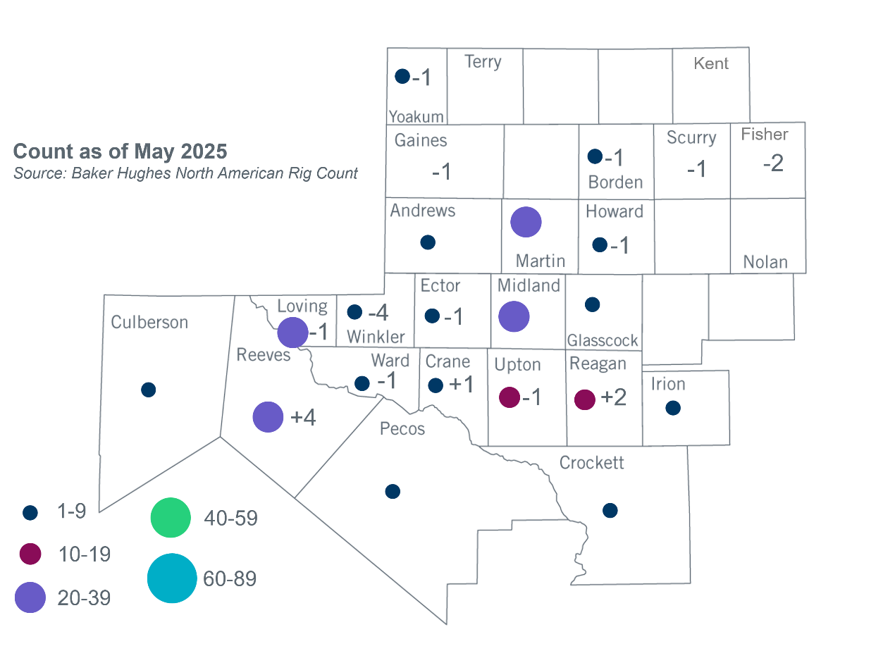
Permian Basin Oil Rig Count

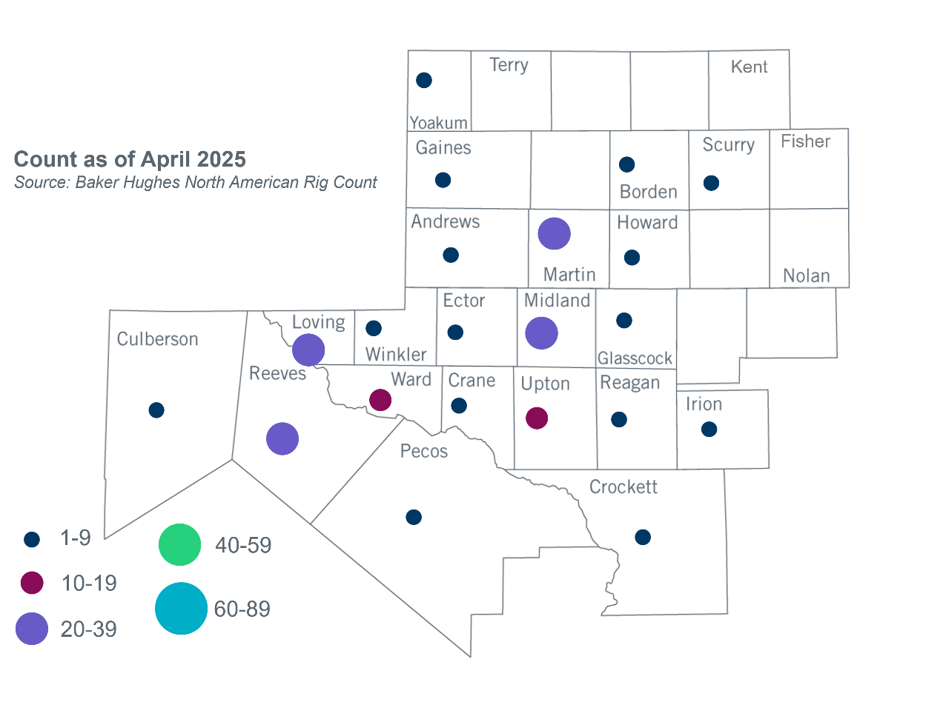

Other Notable Activities

- ERCOT presented the 2026 Long-Term System Assessment (LTSA) update at the May 2025 RPG meeting.
- ERCOT presented the weather year selection methodology updates for the 2025 Regional Transmission Plan (RTP) economic study at the May 2025 RPG meeting.

Based on the Total Project Estimated Cost for all future projects listed in the Transmission Project Information and Tracking (TPIT) report. TPIT is updated three times each year based on information TSPs provide in Model on Demand (MOD) as specified in the ERCOT Steady State Working Group Procedure Manual. The latest TPIT is available at https://www.ercot.com/gridinfo/planning.
+/- symbol indicates the increase or decrease from the previous month in oil rigs present in each county. There are 185 rigs, including a decrease of 7 oil rigs, in the Permian Basin from April to May.

