

System Planning
Monthly Status Report

Report Highlights

- ERCOT is currently reviewing proposed transmission improvements with a total estimated cost of $2.182 billion as of April 30, 2024.
- Transmission Projects endorsed in 2024 total $918.80 million as of April 30, 2024.
- All projects (in engineering, routing, licensing, and construction) total approximately $13.933 billion as of February 1, 2024.
- Transmission Projects energized in 2024 total approximately $789.5 million (as of February 1, 2024).

Regional Planning Group Reviews
RPG Projects under Review:
- BEC has submitted the San Miguel to Marion 345-KV Project (RPG Project ID: 23RPG032). This is a Tier 1 project that is estimated to cost $258.50 million. ERCOT has completed the independent review on April 10, redesgitnating the project as the San Anonio South Reliability II project and the recommended project is estimated to cost $435.00 million. TAC voted unanimously to endorse the project on April 15, 2024. The ERCOT Board of Directors endorsed the project on April 23, 2024, and ERCOT has issued the ERCOT endorsement letter.
- Oncor has submitted the West Texas 345-kV Infrastructure Rebuild Project (RPG Project ID: 23RPG034). This is a Tier 1 project that is estimated to cost $1.120 billion. This project is currently under ERCOT’s independent review.
- Oncor has submitted the Temple Area Project (RPG Project ID: 24RPG001). This is a Tier 1 project that is estimated to cost $120.70 million. This project is currently under ERCOT’s independent review.
- CPS Energy has submitted the Eastside 345/138-kV Switching Station Project (RPG Project ID: 24RPG003). This is a Tier 1 project that is estimated to cost $158.00 million. This project is currently under ERCOT’s independent review.
- CPS Energy has submitted the Omicron Reliability Project (RPG Project ID: 24RPG004). This is a Tier 2 project that is estimated to cost $42.50 million. This project is currently under ERCOT’s independent review.
- Oncor has submitted the Prairieland 345/138-kV Switch and Prairieland Switch to Quartz Sand Switch/Hog Mountain Pod 138-kV Line Project (RPG Project ID: 24RPG006). This is a Tier 3 project that is estimated to cost $56.00 million. The RPG review of this project was completed on March 18, and ERCOT has issued an acceptance letter.
- REC has submitted the Canton Area Loop Project (RPG Project ID: 24RPG007). This is a Tier 2 project that is estimated to cost $22.61 million. This project is currently under ERCOT’s independent review.
- AEPSC has submitted the Brownsville Area Improvements Transmission Project (RPG Project ID: 24RPG008). This is a Tier 1 project that is estimated to cost $387.70 million. This project is currently under ERCOT’s independent review.
- AEPSC, LCRA TSC and BEC have submitted the Sonora to Uvalde to Campwood to Bandera Area Transmission Project (RPG Project ID: 24RPG009). This is a Tier 3 project that is estimated to cost $76.00 million. The RPG review of this project was completed on April 12. Pursuant to the Protocol Section 3.11.4.3.1 (d), this project has been reclassified as a Tier 4 neutral project.
- Oncor has submitted the Delaware Basin Stages 3 and 4 Project (RPG Project ID: 24RPG010). This is a Tier 1 project that is estimated to cost $202.20 million. This project is currently under ERCOT’s independent review.
- AEPSC has submitted the Gonzales STATCOM Transmission Project (RPG Project ID: 24RPG011). This is a Tier 3 project that is estimated to cost $34.50 million. The RPG review of this project was completed on April 19. Pursuant to the Protocol Section 3.11.4.3.1 (d), this project has been reclassified as a Tier 4 neutral project.
- CNP has submitted the Clute to Velasco ckt 26 Upgrades Project (RPG Project ID: 24RPG012). This is a Tier 3 project that is estimated to cost $68.23 million. This project is currently in the RPG comment period.
- LCRA TSC and AEN have submitted the FPP Yard 2 to Lytton Springs Transmission Line Overhaul Project (RPG Project ID: 24RPG013). This is a Tier 3 project that is estimated to cost $60.00 million. This project is currently in the RPG comment period.

RPG Project Reviews Completed in 2024:
RPG Project ID | RPG Project Name | Submitted Entity | Tier | Estimated Cost  ($ Millions) | Review Completion Month
24RPG002 | Rockhound 345/138-kV Switch and Grey Well Draw to Buffalo 2nd 138-kV Circuit Project | Oncor | Tier 3 | 97.00 | February
23RPG028 | Rio Medina Project | STEC | Tier 2 | 71.70 | February
23RPG023 | Pecos County Transmission Improvement Project | TNMP | Tier 1 | 114.80 | February
24RPG005 | Montfort Switch to Shankle Switch 138-kV Line Project | Oncor | Tier 3 | 33.80 | February
24RPG006 | Prairieland 345/138-kV Switch and Prairieland Switch to Quartz Sand Switch/Hog Mountain Pod 138-kV Line Project | Oncor | Tier 3 | 56.00 | March
23RPG032 | San Antonio South Reliability II Project  (San Miguel to Marion 345-KV Project) | BEC | Tier 1 | 435.00 | April
24RPG009 | Sonora to Uvalde to Campwood to Bandera Area Transmission Project | AEPSC, LCRA TSC & BEC | Reclassified from Tier 3 to Tier 4 per Protocol | 76.00 | April
24RPG011 | Gonzales STATCOM Transmission Project | AEPSC | Reclassified from Tier 3 to Tier 4 per Protocol | 34.50 | April

More information on current and past RPG projects can be found on the ERCOT MIS Secure (digital certificate required): https://mis.ercot.com/secure/data-products/grid/regional-planning
Past email communication on RPG projects can be found on the ERCOT listserv by signing up for the REGPLANGROUP list: http://lists.ercot.com/scripts/wa-ERCOT.exe?A0=REGPLANGROUP

Planning Model Activities
The short-term calendar of major planning model events is as follows:
- By May 31, 2024 24SSWG Cases and TPIT will be posted
- By June 7, 2024 24SSWG Contingencies and Data Dictionary will be posted
The following table shows interconnection projects that met Planning Guide section 6.9(1) and 6.9(2) and were modeled in the SSWG cases as a full model or as a simple model in accordance with Planning Guide section 6.9.

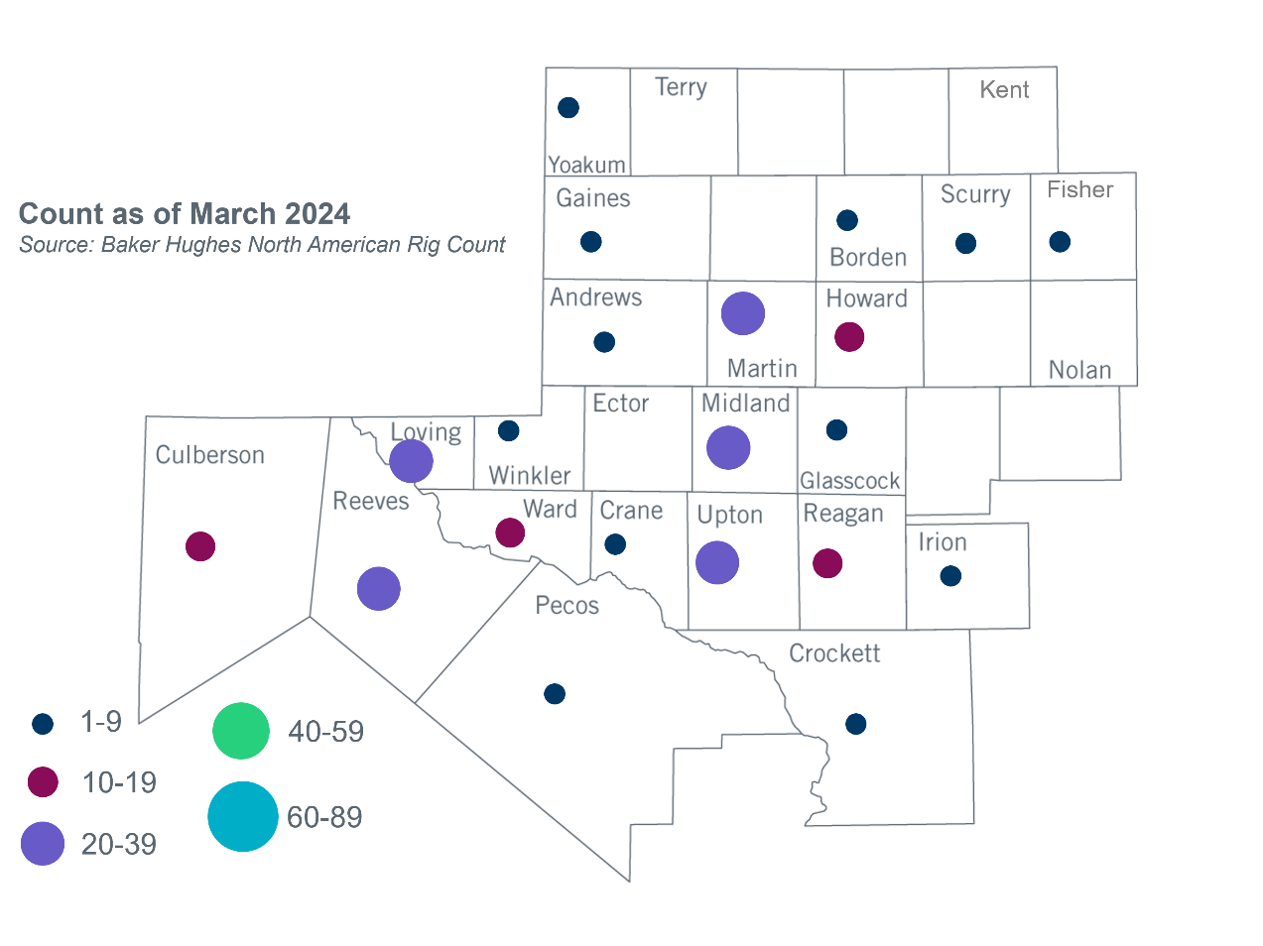
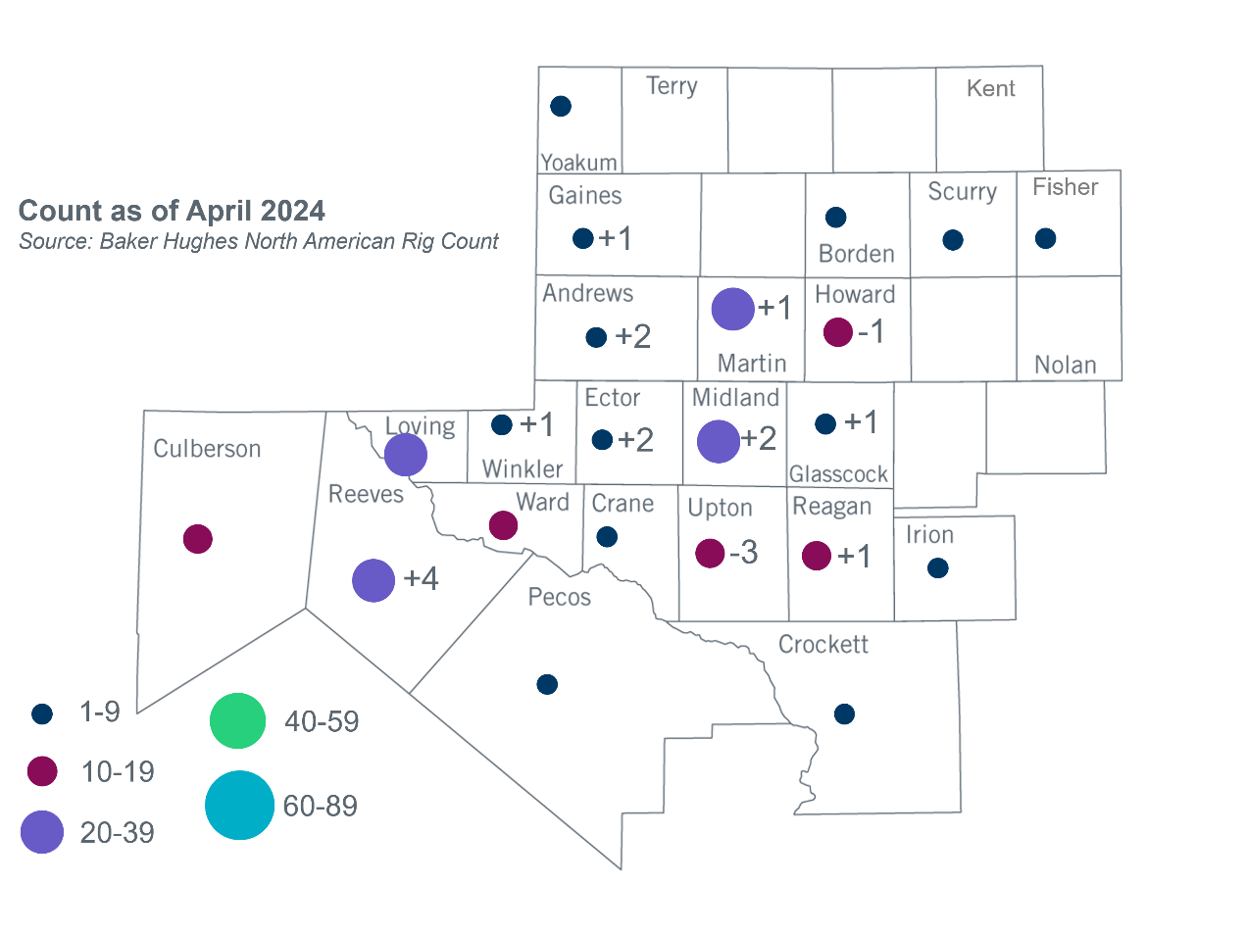
Permian Basin Oil Rig Count
Other Notable Activities
- ERCOT is working on the Permian Basin reliability plan study as directed by HB5066 and by the PUC.
- ERCOT presented the 2024 Regional Transmission Plan (RTP) load review final update at the April 2024 RPG meeting.
- ERCOT presented the 2024 RTP generation assumptions update at the April 2024 RPG meeting.

Based on the Total Project Estimated Cost for all future projects listed in the Transmission Project Information and Tracking (TPIT) report. TPIT is updated three times each year based on information TSPs provide in Model on Demand (MOD) as specified in the ERCOT Steady State Working Group Procedure Manual. The latest TPIT is available at https://www.ercot.com/gridinfo/planning.
Based on the Total Project Estimated Cost for all completed projects with Projected In-Service Dates in 2023 listed in the TPIT.
+/- symbol indicates the increase or decrease from the previous month in oil rigs present in each county. There are 215 rigs, including an increase of 12 oil rigs, in the Permian Basin from March to April 2024.

