

System Planning
Monthly Status Report

Report Highlights

- ERCOT is currently reviewing proposed transmission improvements with a total estimated cost of $1.525 billion as of December 31, 2023.
- Transmission Projects endorsed in 2023 total $3.231 billion as of December 31, 2023.
- All projects (in engineering, routing, licensing, and construction) total approximately $13.537 billion as of October 12, 2023.
- Transmission Projects energized in 2023 total approximately $1.553 billion (as of October 12, 2023).

Regional Planning Group Reviews
RPG Projects under Review:
- TNMP has submitted the Silverleaf and Cowpen 345/138-kV Stations Project (RPG Project ID: 23RPG013). This is a Tier 1 project that is estimated to cost $299.00 million. ERCOT has completed the independent review on November 27, and the recommended project is estimated to cost $273.10 million. TAC voted unanimously to endorse the project on December 4, 2023. The ERCOT Board of Directors endorsed the project on December 19, 2023, and ERCOT will issue the ERCOT endorsement letter.
- Oncor has submitted the Arlington Reliability Enhancement Project (RPG Project ID: 23RPG018). This is a Tier 2 project that is estimated to cost $72.00 million. ERCOT completed the independent review on December 20, and the recommended project is estimated to cost $73.00 million. ERCOT will not issue an ERCOT endorsement letter for this project, as it is needed to solely meet Oncor Transmission Planning Criteria.
- TNMP has submitted the Pecos County Transmission Improvement Project (RPG Project ID: 23RPG023). This is a Tier 1 project that is estimated to cost $108.00 million. This project is currently under ERCOT’s independent review.
- WETT has submitted the Synchronous Condensers Project (RPG Project ID: 23RPG026). This is a Tier 1 project that is estimated to cost $468.00 million. ERCOT has completed the independent review on November 27, and the recommended project is estimated to cost $467.70 million. TAC voted unanimously to endorse the project on December 4, 2023. The ERCOT Board of Directors endorsed the project on December 19, 2023, and ERCOT will issue the ERCOT endorsement letter.
- LCRA TSC has submitted the Bakersfield Dynamic Reactive Substation Upgrade Project (RPG Project ID: 23RPG027). This is a Tier 1 project that is estimated to cost $145.00 million. ERCOT has completed the independent review on November 27, and the recommended project is estimated to cost $144.50 million. TAC voted unanimously to endorse the project on December 4, 2023. The ERCOT Board of Directors endorsed the project on December 19, 2023, and ERCOT will issue the ERCOT endorsement letter.
- STEC has submitted the Rio Medina Project (RPG Project ID: 23RPG028). This is a Tier 2 project that is estimated to cost $38.00 million. This project is currently under ERCOT’s independent review.
- Oncor has submitted the West Texas Synchronous Condenser Project (RPG Project ID: 23RPG029). This is a Tier 1 project that is estimated to cost $280.00 million. ERCOT has completed the independent review on November 27, and the recommended project is estimated to cost $280.00 million. TAC voted unanimously to endorse the project on December 4, 2023. The ERCOT Board of Directors endorsed the project on December 19, 2023, and ERCOT will issue the ERCOT endorsement letter.
- BEC has submitted the San Miguel to Marion 345-KV Project (RPG Project ID: 23RPG032). This is a Tier 1 project that is estimated to cost $258.50 million. This project is currently under ERCOT’s independent review.
- Oncor has submitted the West Texas 345-kV Infrastructure Rebuild Project (RPG Project ID: 23RPG034). This is a Tier 1 project that is estimated to cost $1.120 billion. This project is currently under ERCOT’s independent review.

RPG Project Reviews Completed in 2023:
RPG Project ID | RPG Project Name | Submitted Entity | Tier | Estimated Cost  ($ Millions) | Review Completion Month
22RPG043 | Haskell to Munday 69 kV Line Rebuild Project | AEPSC | Reclassified from Tier 3 to Tier 4 per Protocol | 31.00 | January
22RPG044 | Escondido to Hamilton Road 138 kV Line Rebuild Project | AEPSC | Reclassified from Tier 3 to Tier 4 per Protocol | 73.50 | January
22RPG045 | Yucca to Moss 138 kV Line Project | Oncor | Reclassified from Tier 3 to Tier 4 per Protocol | 60.70 | January
22RPG046 | Peppervine to Temple 69 kV Line Conversion Project | Oncor | Reclassified from Tier 3 to Tier 4 per Protocol | 36.00 | January
22RPG026 | Wimberley Loop Project | PEC | Tier 2 | 61.93 | February
23RPG001 | Bessel to Falfurrias 138 kV Line Rebuild Project | AEPSC | Reclassified from Tier 3 to Tier 4 per Protocol | 84.76 | February
23RPG002 | Hamlin to Roby 69 kV Line Rebuild Project | AEPSC | Reclassified from Tier 3 to Tier 4 per Protocol | 33.00 | February
23RPG003 | Eagle Ford Large Load Interconnection Project | GVEC | Tier 3 | 35.15 | March
23RPG004 | Lockhart to Luling 69-kV Transmission Line Overhaul Project | LCRA TSC | Reclassified from Tier 3 to Tier 4 per Protocol | 33.50 | March
23RPG005 | La Palma to Stewart Road Rebuild and Conversion to 138-kV Project | AEPSC | Reclassified from Tier 3 to Tier 4 per Protocol | 71.50 | March
23RPG006 | North Lake 138 kV Switch Rebuild | Oncor | Reclassified from Tier 3 to Tier 4 per Protocol | 34.11 | March
22RPG047 | Peck to Driver 138 kV Line Project | Oncor | Tier 2 | 36.20 | May
23RPG007 | Asherton to Uvalde 138-kV Conversion Project | AEPSC | Tier 3 | 56.00 | May
23RPG008 | Fort Stockton Plant to Lynx 138-kV Line Rebuild Project | AEPSC | Reclassified from Tier 3 to Tier 4 per Protocol | 44.90 | May
23RPG009 | Spraberry to Polecat 138-kV Line Rebuild Project | Oncor | Tier 3 | 56.90 | May
23RPG010 | Big Spring West to Stanton East 138-kV Line Rebuild Project | Oncor | Tier 3 | 52.00 | May
23RPG011 | Morgan Creek to McDonald Road 138-kV Line Project | Oncor | Tier 3 | 40.20 | May
23RPG012 | Stone Lake Area Upgrades Project | CNP | Tier 3 | 74.38 | May
23RPG014 | Lamesa to Jim Payne POI to Paul Davis Tap 138-kV Line Rebuild Project | Oncor | Tier 3 | 36.80 | June
23RPG015 | Cuero Substation Upgrade Project | LCRA TSC | Reclassified from Tier 3 to Tier 4 per Protocol | 25.90 | June
23RPG016 | Tributary Switch – Vincent Rebuild Project | Oncor | Tier 3 | 29.30 | July
23RPG017 | Watermill 345/138-kV Switch Project | Oncor | Tier 3 | 74.90 | July
22RPG048 | San Antonio South Reliability Project | CPS | Tier 1 | 329.10 | August
23RPG019 | Stanton Loop South Dynamic Reactive Power Project | Oncor | Tier 3 | 96.90 | August
23RPG020 | Hackberry Switch to DFW D East 2 138-kV Double-Circuit Line Section Project | Oncor | Tier 3 | 80.00 | August
23RPG021 | West Columbia to Big Creek ckt 89 Reconductor Project | CNP | Reclassified from Tier 3 to Tier 4 per Protocol | 64.17 | September
23RPG022 | McLennan County Transmission Project | Oncor | Tier 3 | 42.31 | September
23RPG024 | Big Foot to Dilley Switch 138-kV Conversion Project | AEPSC | Reclassified from Tier 3 to Tier 4 per Protocol | 53.10 | September
23RPG025 | Britmoore to Bellaire Ckt 24 Upgrade Project | CNP | Tier 3 | 90.10 | September
23RPG030 | Walleye Creek 345/138-kV Switch Project | Oncor | Tier 3 | 74.00 | October
23RPG031 | 345-kV Jeanetta Autotransformer Upgrades Project | CNP | Tier 3 | 47.08 | October
23RPG033 | Watermill to Seagoville 138 kV Line Project | Oncor | Tier 3 | 33.00 | November
23RPG013 | Silverleaf and Cowpen 345/138-kV Stations Project | TNMP | Tier 1 | 273.10 | December
23RPG018 | Arlington Reliability Enhancement Project | Oncor | Tier 2 | 73.00 | December
23RPG026 | Synchronous Condensers Project | WETT | Tier 1 | 467.70 | December
23RPG026 | Bakersfield Dynamic Reactive Substation Upgrade Project | LCRA TSC | Tier 1 | 144.50 | December
23RPG029 | West Texas Synchronous Condenser Project | Oncor | Tier 1 | 280.00 | December

More information on current and past RPG projects can be found on the ERCOT MIS Secure (digital certificate required): https://mis.ercot.com/secure/data-products/grid/regional-planning
Past email communication on RPG projects can be found on the ERCOT listserv by signing up for the REGPLANGROUP list: http://lists.ercot.com/scripts/wa-ERCOT.exe?A0=REGPLANGROUP

Planning Model Activities
The short-term calendar of major planning model events is as follows:
- By February 1, 2024 TPIT will be posted
- By May 31, 2024 24SSWG Cases and TPIT will be posted

The following table shows interconnection projects that met Planning Guide section 6.9(1) and 6.9(2) and were modeled in the SSWG cases as a full model or as a simple model in accordance with Planning Guide section 6.9.

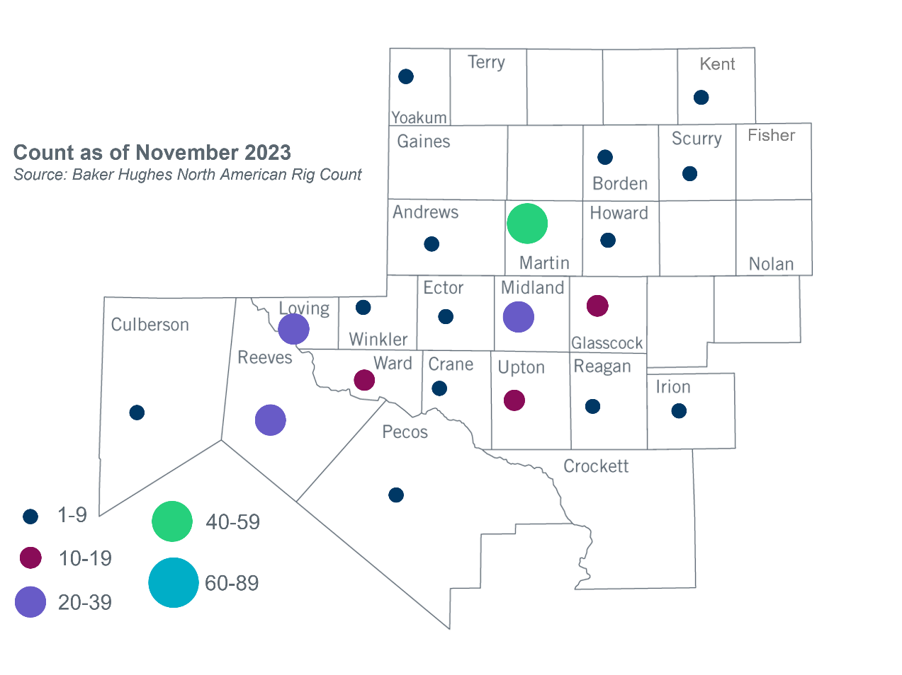
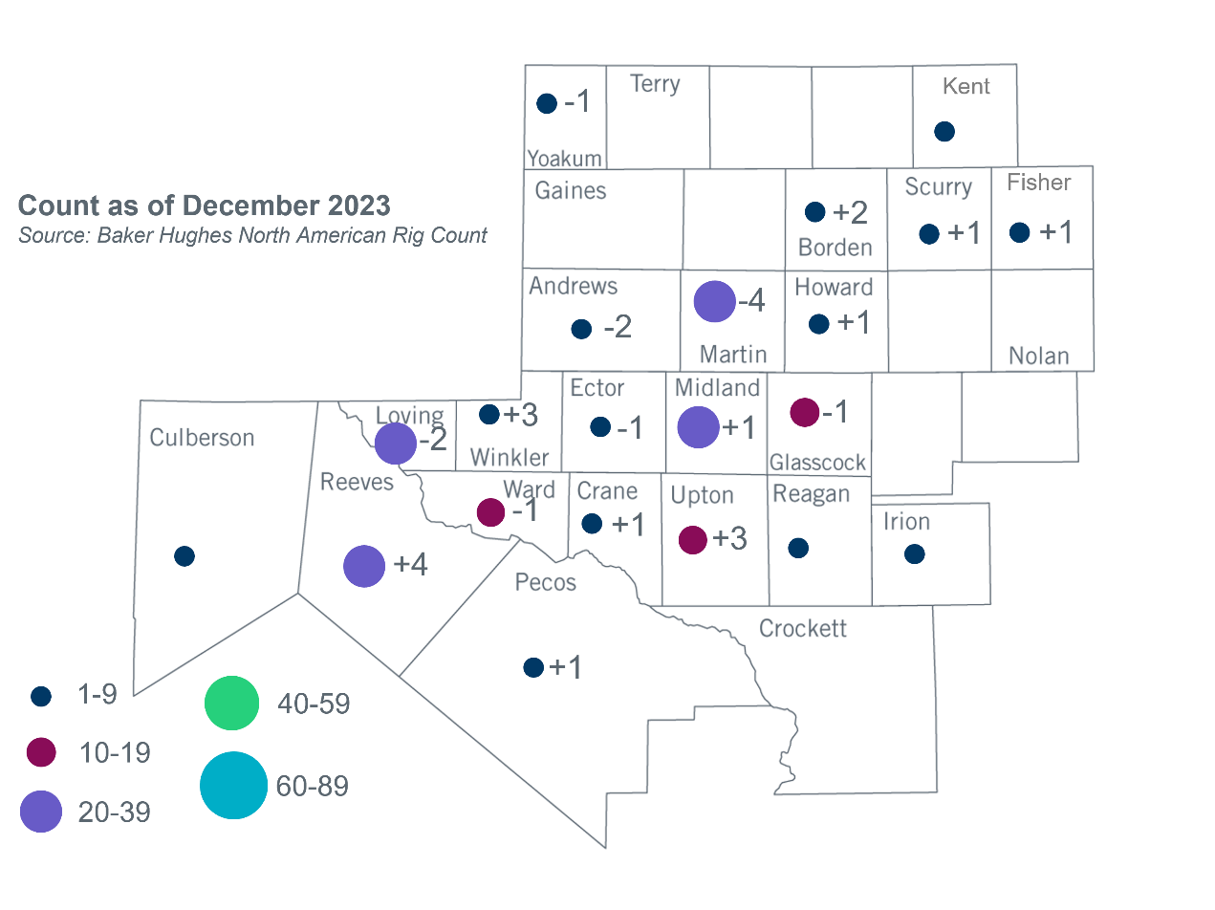
Permian Basin Oil Rig Count
Other Notable Activities
- ERCOT is continuing to work with the TSPs to collect the Permian Basin Load data to initiate the Permian Basin reliability plan study in 2024 as directed by HB5066 and by the PUC.
- ERCOT presented the preliminary results for the 2023 Regional Transmission Plan economic study at the December 2023 RPG meeting.
- ERCOT presented the 2024 Long-Term Load Forecast (LTLF) at the December 2023 RPG meeting.

Based on the Total Project Estimated Cost for all future projects listed in the Transmission Project Information and Tracking (TPIT) report. TPIT is updated three times each year based on information TSPs provide in Model on Demand (MOD) as specified in the ERCOT Steady State Working Group Procedure Manual. The latest TPIT is available at https://www.ercot.com/gridinfo/planning.
Based on the Total Project Estimated Cost for all completed projects with Projected In-Service Dates in 2023 listed in the TPIT.
+/- symbol indicates the increase or decrease from the previous month in oil rigs present in each county. There are 211 rigs, including an increase of 6 oil rigs, in the Permian Basin from November to December 2023.

