

System Planning
Monthly Status Report

Report Highlights

- ERCOT is currently reviewing proposed transmission improvements with a total estimated cost of $3.150 billion as of December 31, 2024.
- Transmission Projects endorsed in 2024 total $3.785 billion as of December 31, 2024.
- All projects (in engineering, routing, licensing, and construction) total approximately $16.504 billion as of October 1, 2024.
- Transmission Projects energized in 2024 total approximately $2.435 billion (as of October 1, 2024).

Regional Planning Group Reviews
RPG Projects under Review:
- AEPSC has submitted the Brownsville Area Improvements Transmission Project (RPG Project ID: 24RPG008). This is a Tier 1 project that is estimated to cost $387.70 million. ERCOT has completed the independent review on September 27, and the recommended project is estimated to cost $423.80 million. TAC voted unanimously to endorse the project on October 30, 2024. ERCOT Board of Directors endorsed the project on December 3, 2024, and ERCOT has issued the ERCOT endorsement letter.
- Oncor has submitted the Delaware Basin Stages 3 and 4 Project (RPG Project ID: 24RPG010). This is a Tier 1 project that is estimated to cost $202.20 million. ERCOT has completed the independent review on November 14, and the recommended project is estimated to cost $202.20 million. TAC voted unanimously to endorse the project on November 20, 2024. ERCOT Board of Directors endorsed the project on December 3, 2024, and ERCOT has issued the ERCOT endorsement letter.
- Oncor has submitted the Delaware Basin State 5 Project (RPG Project ID: 24RPG015). This is a Tier 1 project that is estimated to cost $744.60 million. This project is currently under ERCOT’s independent review.
- Oncor has submitted the Venus Switch to Sam Switch 345-kV Line Project (RPG Project ID: 24RPG017). This is a Tier 1 project that is estimated to cost $118.90 million. ERCOT has completed the independent review on December 20, and the recommended project is estimated to cost $118.90 million. ERCOT will present the recommended project to TAC on January 22 and present the recommendation for Board of Directors endorsement on February 4.
- Oncor has submitted the Connell 345/138-kV Switch and Connell to Rockhound 345-kV Double-Circuit Line Project (RPG Project ID: 24RPG020). This is a Tier 1 project that is estimated to cost $110.62 million. This project is currently under ERCOT’s independent review.
- Oncor has submitted the Forney 345/138-kV Switch Rebuild Project (RPG Project ID: 24RPG021). This is a Tier 1 project that is estimated to cost $103.50 million. ERCOT has completed the independent review on December 20, and the recommended project is estimated to cost $100.40 million. ERCOT will present the recommended project to TAC on January 22 and present the recommendation for Board of Directors endorsement on February 4.
- Oncor has submitted the Wilmer 345/138-kV Switch Project (RPG Project ID: 24RPG022). This is a Tier 1 project that is estimated to cost $158.20 million. ERCOT has completed the independent review on December 20, and the recommended project is estimated to cost $158.20 million. ERCOT will present the recommended project to TAC on January 22 and present the recommendation for Board of Directors endorsement on February 4.
- WETT has submitted the WETT Delaware Basin Stage 5 Project Alternative (RPG Project ID: 24RPG023). This is a Tier 1 project that is estimated to cost $305.50 million. This project is currently under ERCOT’s independent review.
- Oncor and LCRA TSC have submitted the Hartring to Upland 138-kV Line and Benedum Autotransformer Addition Project (RPG Project ID: 24RPG024). This is a Tier 2 project that is estimated to cost $94.00 million. This project is currently under ERCOT’s independent review.
- CNP has submitted the Baytown Area Load Addition Project (RPG Project ID: 24RPG028). This is a Tier 1 project that is estimated to cost $141.65 million. This project is currently under ERCOT’s independent review.
- Oncor has submitted the Tredway 138-kV Switch and Expanse to Tredway 138-kV 2nd Circuit Project (RPG Project ID: 24RPG029). This is a Tier 1 project that is estimated to cost $119.03 million. This project is currently under ERCOT’s independent review.
- LST has submitted the Central Texas 345-kV Transmission Project (RPG Project ID: 24RPG031). This is a Tier 1 project that is estimated to cost $342.00 million. This project is currently under ERCOT’s independent review.
- CNP has submitted the Southwest Houston 345-kV Reliability Project (RPG Project ID: 24RPG032). This is a Tier 1 project that is estimated to cost $569.32 million. This project is currently under ERCOT’s independent review.
- CNP has submitted the MINING 69-kV Substation Conversion Project (RPG Project ID: 24RPG033). This is a Tier 3 project that is estimated to cost $34.12 million. The RPG review of this project was completed on December 3. Pursuant to the Protocol Section 3.11.4.3.1 (d), this project has been reclassified as a Tier 4 neutral project.
- LCRA TSC has submitted the Redwood to San Marcos Transmission Line Upgrade Project (RPG Project ID: 24RPG034). This is a Tier 3 project that is estimated to cost $46.40 million. The RPG review of this project was completed on December 3, and ERCOT will issue an acceptance letter.
- AEPSC has submitted the Aransas Pass to Rincon 69-kV Line Rebuild Project (RPG Project ID: 24RPG035). This is a Tier 2 project that is estimated to cost $33.00 million. This project is currently under ERCOT’s independent review.
- AEPSC has submitted the South Padre Island Rebuild Transmission Project (RPG Project ID: 24RPG036). This is a Tier 3 project that is estimated to cost $44.50 million. The RPG review of this project was completed on December 27. Pursuant to the Protocol Section 3.11.4.3.1 (d), this project has been reclassified as a Tier 4 neutral project.
- CNP has submitted the Partial Rebuild of 138-kV Ckt.63 West Galveston to Moody Project (RPG Project ID: 24RPG037). This is a Tier 3 project that is estimated to cost $26.20 million. This project is currently in the RPG comment period.
- LCRA TSC and PEC have submitted the Bergheim Substation Upgrade Project (RPG Project ID: 24RPG038). This is a Tier 3 project that is estimated to cost $66.35 million. This project is currently in the RPG comment period.
- TNMP has submitted the Galveston Region Project (RPG Project ID: 24RPG039). This is a Tier 1 project that is estimated to cost $133.73 million. This project is currently in the RPG comment period.
- Oncor has submitted the Roscoe Area Upgrades Project (RPG Project ID: 24RPG040). This is a Tier 2 project that is estimated to cost $83.00 million. This project is currently in the RPG comment period.

RPG Project Reviews Completed in 2024:
RPG Project ID | RPG Project Name | Submitted Entity | Tier | Estimated Cost  ($ Millions) | Review Completion Month
24RPG002 | Rockhound 345/138-kV Switch and Grey Well Draw to Buffalo 2nd 138-kV Circuit Project | Oncor | Tier 3 | 97.00 | February
23RPG028 | Rio Medina Project | STEC | Tier 2 | 71.70 | February
23RPG023 | Pecos County Transmission Improvement Project | TNMP | Tier 1 | 114.80 | February
24RPG005 | Montfort Switch to Shankle Switch 138-kV Line Project | Oncor | Tier 3 | 33.80 | February
24RPG006 | Prairieland 345/138-kV Switch and Prairieland Switch to Quartz Sand Switch/Hog Mountain Pod 138-kV Line Project | Oncor | Tier 3 | 56.00 | March
23RPG032 | San Antonio South Reliability II Project  (San Miguel to Marion 345-KV Project) | BEC | Tier 1 | 435.00 | April
24RPG009 | Sonora to Uvalde to Campwood to Bandera Area Transmission Project | AEPSC, LCRA TSC & BEC | Reclassified from Tier 3 to Tier 4 per Protocol | 76.00 | April
24RPG011 | Gonzales STATCOM Transmission Project | AEPSC | Reclassified from Tier 3 to Tier 4 per Protocol | 34.50 | April
24RPG012 | Clute to Velasco ckt 26 Upgrades Project | CNP | Tier 3 | 68.23 | May
24RPG013 | FPP Yard 2 to Lytton Springs Transmission Line Overhaul Project | LCRA TSC & AEN | Reclassified from Tier 3 to Tier 4 per Protocol | 60.00 | May
24RPG014 | Sim Gideon to Cedar Hill Transmission Line Upgrade Project | LCRA TSC | Tier 3 | 77.90 | May
23RPG034 | West Texas 345-kV Infrastructure Rebuild Project | Oncor | Tier 1 | 1,120.00 | June
23RPG003 | Energy Eastside 345/138-kV Switching Station Project | CPS Energy | Reclassified from Tier 1 to Tier 3 per Protocol | 47.00 | July
23RPG004 | Omicron Reliability Project | CPS Energy | Tier 2 | 45.70 | July
24RPG018 | Salado Switch to Hutto Switch 138-kV Line Project | Oncor | Tier 3 | 87.60 | July
24RPG019 | Vineyard Switch to Cypress Waters 138-kV Circuit Addition Project | Oncor | Tier 3 | 93.04 | July
24RPG001 | Temple Area Project | Oncor | Tier 1 | 272.60 | August
24RPG007 | Canton Area Loop Project | REC | Tier 2 | 26.03 | August
24RPG025 | Gunter 345/138-kV Switch Project | Oncor | Tier 3 | 51.20 | September
24RPG026 | Jordan/Mont Belvieu Area Improvement Project | CNP | Tier 3 | 76.89 | September
24RPG027 | Long Draw Second 345/138-kV Autotransformer Project | WETT | Tier 3 | 28.00 | September
24RPG030 | Partial Rebuild of 138-kV Ckt.05A Sienna Tap to Missouri City Tap Project | CNP | Reclassified from Tier 3 to Tier 4 per Protocol | 28.56 | October
24RPG016 | Rand Area Loop Project | REC | Tier 2 | 32.20 | October
24RPG008 | Brownsville Area Improvements Transmission Project | AEPSC | Tier 1 | 423.80 | December
24RPG010 | Delaware Basin Stages 3 and 4 Project | Oncor | Tier 1 | 202.20 | December
24RPG033 | MINING 69-kV Substation Conversion Project | CNP | Reclassified from Tier 3 to Tier 4 per Protocol | 34.12 | December
24RPG034 | Redwood to San Marcos Transmission Line Upgrade Project | LCRA TSC | Tier 3 | 46.40 | December
24RPG036 | South Padre Island Rebuild Transmission Project | AEPSC | Reclassified from Tier 3 to Tier 4 per Protocol | 44.50 | December

More information on current and past RPG projects can be found on the ERCOT MIS Secure (digital certificate required): https://mis.ercot.com/secure/data-products/grid/regional-planning
Past email communication on RPG projects can be found on the ERCOT listserv by signing up for the REGPLANGROUP list: http://lists.ercot.com/scripts/wa-ERCOT.exe?A0=REGPLANGROUP

Planning Model Activities
The short-term calendar of major planning model events is as follows:
- By January 1, 2025 TPIT will be posted
- By May 30, 2025 25SSWG Cases will be posted
The following table shows interconnection projects that met Planning Guide section 6.9(1) and 6.9(2) and were modeled in the SSWG cases as a full model or as a simple model in accordance with Planning Guide section 6.9.

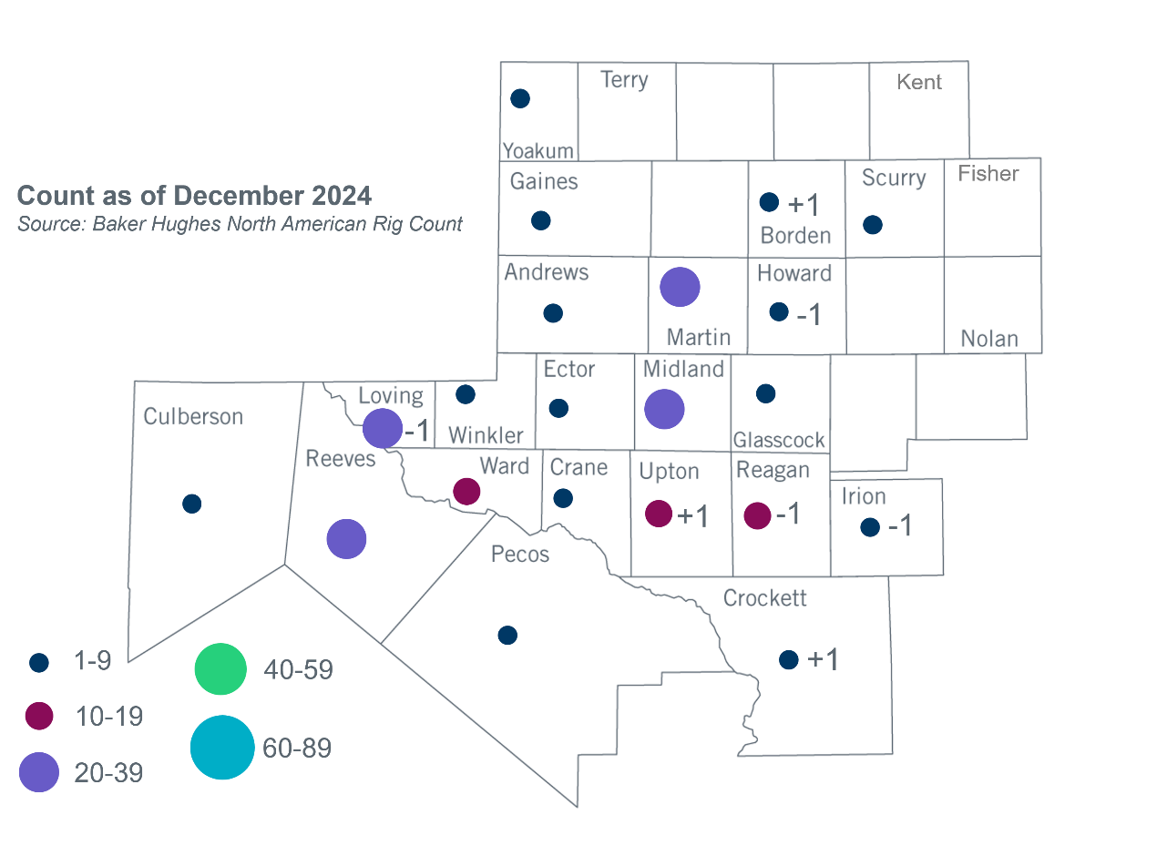
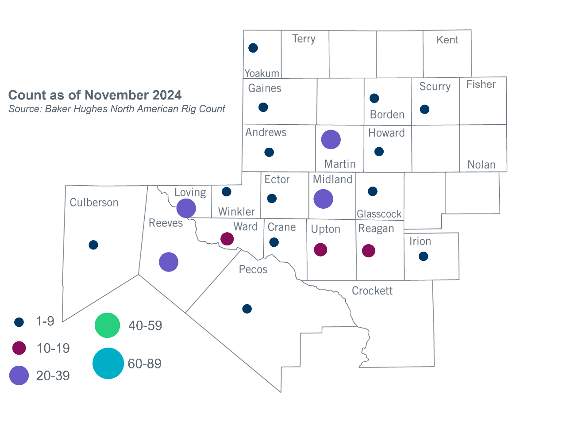
Permian Basin Oil Rig Count
Other Notable Activities

- ERCOT provided an update on the Extra-High Voltage (EHV) infrastructure at the December 2024 RPG meeting.
- ERCOT presented the 2024 Regional Transmission Plan economic analysis update at the December 2024 RPG meeting.

Based on the Total Project Estimated Cost for all future projects listed in the Transmission Project Information and Tracking (TPIT) report. TPIT is updated three times each year based on information TSPs provide in Model on Demand (MOD) as specified in the ERCOT Steady State Working Group Procedure Manual. The latest TPIT is available at https://www.ercot.com/gridinfo/planning.
+/- symbol indicates the increase or decrease from the previous month in oil rigs present in each county. There are 200 rigs, including a decrease of 1 oil rig, in the Permian Basin from November to December 2024.

