

System Planning
Monthly Status Report

Report Highlights

- ERCOT is currently reviewing proposed transmission improvements with a total estimated cost of $3.357 billion as of January 31, 2025.
- Transmission Projects endorsed in 2025 total $191.16 million as of January 31, 2025.
- All projects (in engineering, routing, licensing, and construction) total approximately $16.866 billion as of February 1, 2025.
- Transmission Projects energized in 2025 total approximately $386.78 million (as of February 1, 2025).

Regional Planning Group Reviews
RPG Projects under Review:
- Oncor has submitted the Delaware Basin State 5 Project (RPG Project ID: 24RPG015). This is a Tier 1 project that is estimated to cost $744.60 million. This project is currently under ERCOT’s independent review.
- Oncor has submitted the Venus Switch to Sam Switch 345-kV Line Project (RPG Project ID: 24RPG017). This is a Tier 1 project that is estimated to cost $118.90 million. ERCOT has completed the independent review on December 20, and the recommended project is estimated to cost $118.90 million. TAC voted unanimously to endorse the project on January 22, 2025. ERCOT will present the recommendation for Board of Directors endorsement on February 4, 2025.
- Oncor has submitted the Connell 345/138-kV Switch and Connell to Rockhound 345-kV Double-Circuit Line Project (RPG Project ID: 24RPG020). This is a Tier 1 project that is estimated to cost $110.62 million. This project is currently under ERCOT’s independent review.
- Oncor has submitted the Forney 345/138-kV Switch Rebuild Project (RPG Project ID: 24RPG021). This is a Tier 1 project that is estimated to cost $103.50 million. ERCOT has completed the independent review on December 20, and the recommended project is estimated to cost $100.40 million. TAC voted unanimously to endorse the project on January 22, 2025. ERCOT will present the recommendation for Board of Directors endorsement on February 4, 2025.
- Oncor has submitted the Wilmer 345/138-kV Switch Project (RPG Project ID: 24RPG022). This is a Tier 1 project that is estimated to cost $158.20 million. ERCOT has completed the independent review on December 20, and the recommended project is estimated to cost $158.20 million. TAC voted unanimously to endorse the project on January 22, 2025. ERCOT will present the recommendation for Board of Directors endorsement on February 4, 2025.
- WETT has submitted the WETT Delaware Basin Stage 5 Project Alternative (RPG Project ID: 24RPG023). This is a Tier 1 project that is estimated to cost $305.50 million. This project is currently under ERCOT’s independent review.
- Oncor and LCRA TSC have submitted the Hartring to Upland 138-kV Line and Benedum Autotransformer Addition Project (RPG Project ID: 24RPG024). This is a Tier 2 project that is estimated to cost $94.00 million. This project is currently under ERCOT’s independent review.
- CNP has submitted the Baytown Area Load Addition Project (RPG Project ID: 24RPG028). This is a Tier 1 project that is estimated to cost $141.65 million. This project is currently under ERCOT’s independent review.
- Oncor has submitted the Tredway 138-kV Switch and Expanse to Tredway 138-kV 2nd Circuit Project (RPG Project ID: 24RPG029). This is a Tier 1 project that is estimated to cost $119.03 million. This project is currently under ERCOT’s independent review.
- LST has submitted the Central Texas 345-kV Transmission Project (RPG Project ID: 24RPG031). This is a Tier 1 project that is estimated to cost $342.00 million. This project is currently under ERCOT’s independent review.
- CNP has submitted the Southwest Houston 345-kV Reliability Project (RPG Project ID: 24RPG032). This is a Tier 1 project that is estimated to cost $569.32 million. This project is currently under ERCOT’s independent review.
- LCRA TSC has submitted the Redwood to San Marcos Transmission Line Upgrade Project (RPG Project ID: 24RPG034). This is a Tier 3 project that is estimated to cost $46.40 million. The RPG review of this project was completed on December 3, and ERCOT has issued an acceptance letter.
- AEPSC has submitted the Aransas Pass to Rincon 69-kV Line Rebuild Project (RPG Project ID: 24RPG035). This is a Tier 2 project that is estimated to cost $33.00 million. This project is currently under ERCOT’s independent review.
- CNP has submitted the Partial Rebuild of 138-kV Ckt.63 West Galveston to Moody Project (RPG Project ID: 24RPG037). This is a Tier 3 project that is estimated to cost $26.20 million. The RPG review of this project was completed on January 2. Pursuant to the Protocol Section 3.11.4.3.1 (d), this project has been reclassified as a Tier 4 neutral project.
- LCRA TSC and PEC have submitted the Bergheim Substation Upgrade Project (RPG Project ID: 24RPG038). This is a Tier 3 project that is estimated to cost $66.35 million. The RPG review of this project was completed on January 13, and ERCOT has issued an acceptance letter.
- TNMP has submitted the Galveston Region Project (RPG Project ID: 24RPG039). This is a Tier 1 project that is estimated to cost $133.73 million. This project is currently under ERCOT’s independent review.
- Oncor has submitted the Roscoe Area Upgrades Project (RPG Project ID: 24RPG040). This is a Tier 2 project that is estimated to cost $83.00 million. This project is currently under ERCOT’s independent review.
- WETT has submitted the Buck Canyon and Binturong 345-kV Synchronous Condenser Stations Project (RPG Project ID: 24RPG041). This is a Tier 3 project that is estimated to cost $98.61 million. The RPG review of this project was completed on January 27, and ERCOT will issue an acceptance letter.
- BTU has submitted the Texas A&M University System RELLIS Campus Reliability Project (RPG Project ID: 25RPG001). This is a Tier 1 project that is estimated to cost $271.50 million. This project is currently in the RPG comment period.
- AEPSC has submitted the East Munday 138-kV Station Rebuild Project (RPG Project ID: 25RPG002). This is a Tier 3 project that is estimated to cost $28.30 million. This project is currently in the RPG comment period.

RPG Project Reviews Completed in 2025:
RPG Project ID | RPG Project Name | Submitted Entity | Tier | Estimated Cost  ($ Millions) | Review Completion Month
24RPG037 | Partial Rebuild of 138-kV Ckt.63 West Galveston to Moody Project | CNP | Reclassified from Tier 3 to Tier 4 per Protocol | 26.20 | January
24RPG0378 | Bergheim Substation Upgrade Project | LCRA TSC & PEC | Tier 3 | 66.35 | January
24RPG041 | Buck Canyon and Binturong 345-kV Synchronous Condenser Stations Project | WETT | Tier 3 | 98.61 | January

More information on current and past RPG projects can be found on the ERCOT MIS Secure (digital certificate required): https://mis.ercot.com/secure/data-products/grid/regional-planning
Past email communication on RPG projects can be found on the ERCOT listserv by signing up for the REGPLANGROUP list: http://lists.ercot.com/scripts/wa-ERCOT.exe?A0=REGPLANGROUP

Planning Model Activities
The short-term calendar of major planning model events is as follows:
- By May 30, 2025 25SSWG Cases and TPIT will be posted
- By June 6, 2025 25SSWG Contingency and Planning Data Dictionary will be posted
The following table shows interconnection projects that met Planning Guide section 6.9(1) and 6.9(2) and were modeled in the SSWG cases as a full model or as a simple model in accordance with Planning Guide section 6.9.

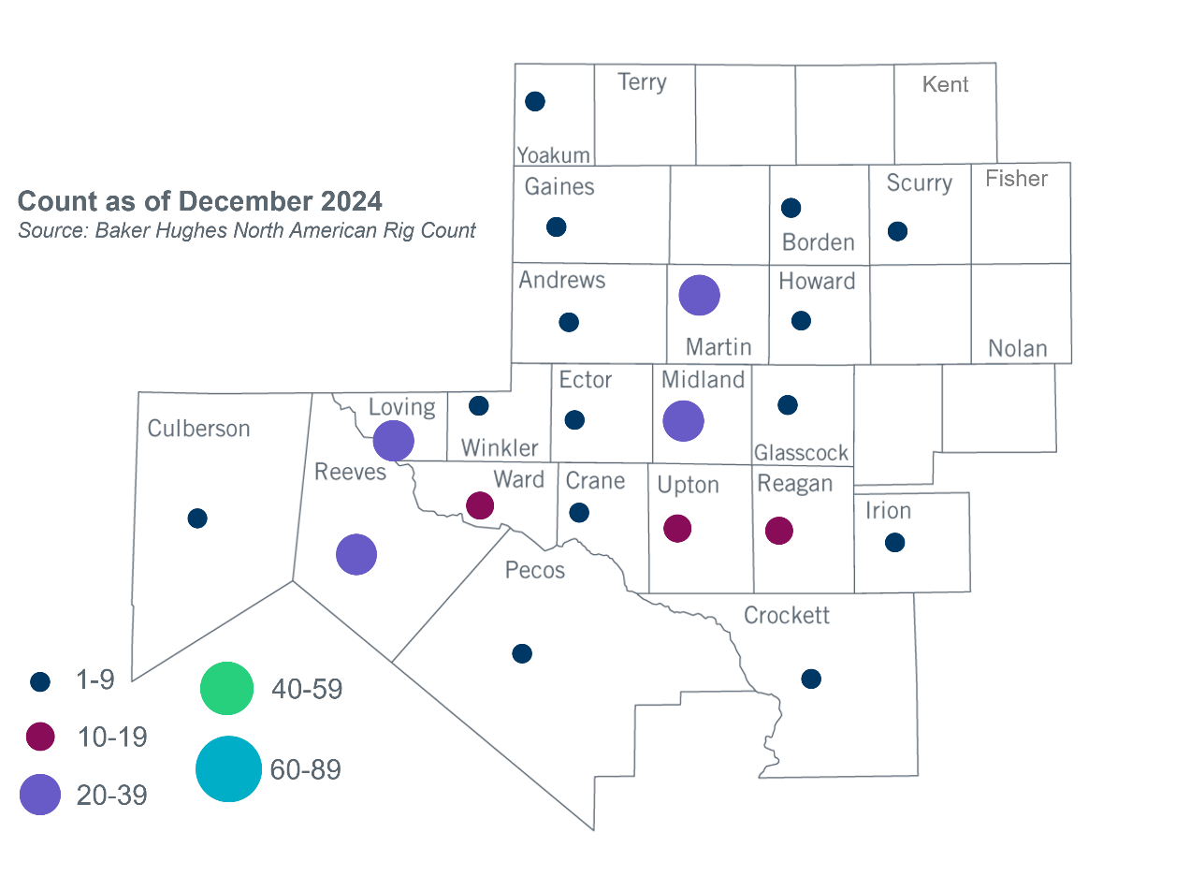
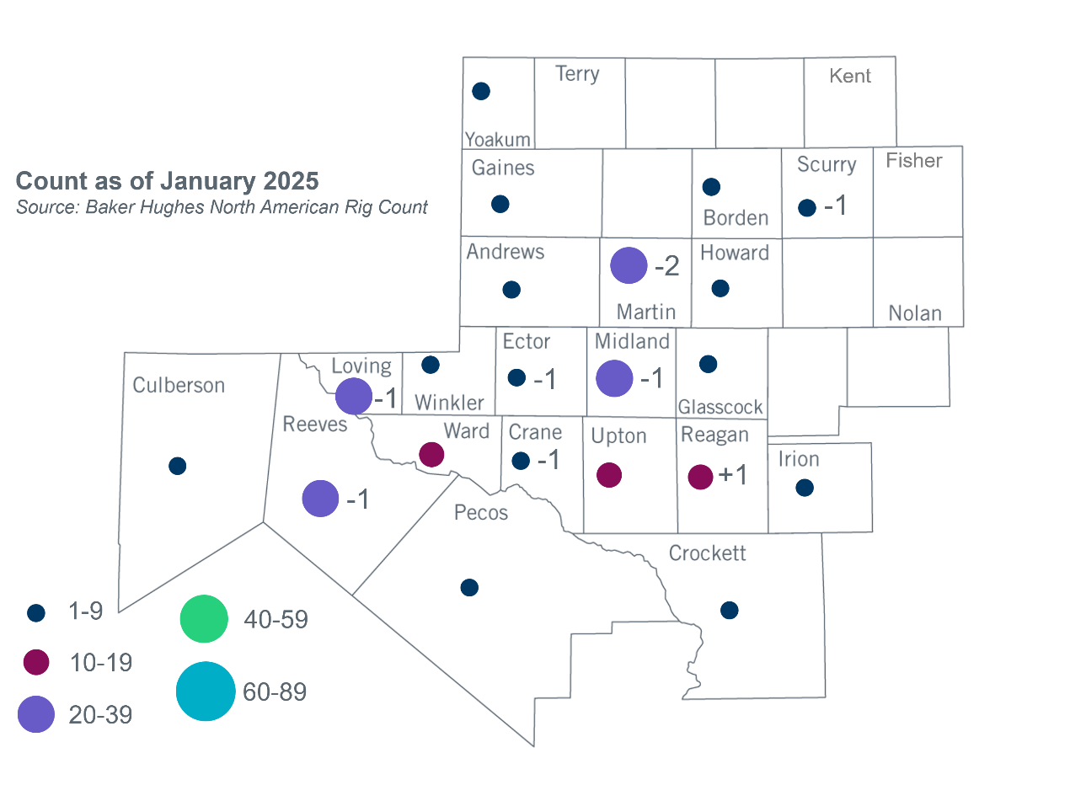
Permian Basin Oil Rig Count
Other Notable Activities

- ERCOT held an EHV 765-kV workshop on January 27, 2025 to provide additional analysis results and comparison of the 2024 Regional Transmission Plan (RTP) 345-kV and 765-kV plans..
- ERCOT presented the 2024 RTP final update at the January 2025 RPG meeting.
- ERCOT presented the 2024 Grid Reliability and Resiliency Assessment final update at the January 2025 RPG meeting.
- ERCOT presented the 2024 Long-Term System Assessment review at the January 2025 RPG meeting.

Based on the Total Project Estimated Cost for all future projects listed in the Transmission Project Information and Tracking (TPIT) report. TPIT is updated three times each year based on information TSPs provide in Model on Demand (MOD) as specified in the ERCOT Steady State Working Group Procedure Manual. The latest TPIT is available at https://www.ercot.com/gridinfo/planning.
+/- symbol indicates the increase or decrease from the previous month in oil rigs present in each county. There are 193 rigs, including a decrease of 7 oil rigs, in the Permian Basin from December 2024 to January 2025.

