

System Planning
Monthly Status Report

Report Highlights

- ERCOT is currently reviewing proposed transmission improvements with a total estimated cost of $609.30 million as of June 30, 2023.
- Transmission Projects endorsed in 2023 total $978.43million as of June 30, 2023.
- All projects (in engineering, routing, licensing, and construction) total approximately $12.469 billion as of February 1, 2023.
- Transmission Projects energized in 2023 total approximately $442 million (as of May 12, 2023).

Regional Planning Group Reviews
RPG Projects under Review:
- CPS has submitted the San Antonio South Reliability Project (RPG Project ID: 22RPG048). This is a Tier 1 project that is estimated to cost $281.00 million. ERCOT has completed the independent review on June 23, and the recommended project is estimated to cost $329.10 million. ERCOT will present the recommended project to TAC on July 25 and present the recommendation for BOD endorsement on August 31.
- AEPSC has submitted the Asherton to Uvalde 138-kV Conversion Project (RPG Project ID: 23RPG007). This is a Tier 3 project that is estimated to cost $56.00 million. The RPG review of this project was completed on May 19, and ERCOT has issued an acceptance letter.
- Oncor has submitted the Morgan Creek to McDonald Road 138-kV Line Project (RPG Project ID: 23RPG011). This is a Tier 3 project that is estimated to cost $40.20 million. The RPG review of this project was completed on May 26, and ERCOT has issued an acceptance letter.
- CNP has submitted the Stone Lake Area Upgrades Project (RPG Project ID: 23RPG012). This is a Tier 3 project that is estimated to cost $74.38 million. The RPG review of this project was completed on May 26, and ERCOT has issued an acceptance letter.
- TNMP has submitted the Silverleaf and Cowpen 345/138-kV Stations Project (RPG Project ID: 23RPG013). This is a Tier 1 project that is estimated to cost $299.00 million. This project is currently in the RPG study mode.
- Oncor has submitted the Lamesa to Jim Payne POI to Paul Davis Tap 138-kV Line Rebuild Project (RPG Project ID: 23RPG014). This is a Tier 3 project that is estimated to cost $36.80 million. The RPG review of this project was completed on June 20, and ERCOT will issue an acceptance letter.
- LCRA TSC has submitted the Cuero Substation Upgrade Project (RPG Project ID: 23RPG015). This is a Tier 3 project that is estimated to cost $25.90 million. The RPG review of this project was completed on June 26. Pursuant to the Protocol Section 3.11.4.3.1 (d), this project has been reclassified as a Tier 4 neutral project.
- Oncor has submitted the Oncor Tributary Switch to Vincent Rebuild Project (RPG Project ID: 23RPG016). This is a Tier 3 project that is estimated to cost $29.30 million. This project is currently in the RPG comment period.

RPG Project Reviews Completed in 2023:
RPG Project ID | RPG Project Name | Submitted Entity | Tier | Estimated Cost  ($ Millions) | Review Completion Month
22RPG043 | Haskell to Munday 69 kV Line Rebuild Project | AEPSC | Reclassified from Tier 3 to Tier 4 per Protocol | 31.00 | January
22RPG044 | Escondido to Hamilton Road 138 kV Line Rebuild Project | AEPSC | Reclassified from Tier 3 to Tier 4 per Protocol | 73.50 | January
22RPG045 | Yucca to Moss 138 kV Line Project | Oncor | Reclassified from Tier 3 to Tier 4 per Protocol | 60.70 | January
22RPG046 | Peppervine to Temple 69 kV Line Conversion Project | Oncor | Reclassified from Tier 3 to Tier 4 per Protocol | 36.00 | January
22RPG026 | Wimberley Loop Project | PEC | Tier 2 | 61.93 | February
23RPG001 | Bessel to Falfurrias 138 kV Line Rebuild Project | AEPSC | Reclassified from Tier 3 to Tier 4 per Protocol | 84.76 | February
23RPG002 | Hamlin to Roby 69 kV Line Rebuild Project | AEPSC | Reclassified from Tier 3 to Tier 4 per Protocol | 33.00 | February
23RPG003 | Eagle Ford Large Load Interconnection Project | GVEC | Tier 3 | 35.15 | March
23RPG004 | Lockhart to Luling 69-kV Transmission Line Overhaul Project | LCRA TSC | Reclassified from Tier 3 to Tier 4 per Protocol | 33.50 | March
23RPG005 | La Palma to Stewart Road Rebuild and Conversion to 138-kV Project | AEPSC | Reclassified from Tier 3 to Tier 4 per Protocol | 71.50 | March
23RPG006 | North Lake 138 kV Switch Rebuild | Oncor | Reclassified from Tier 3 to Tier 4 per Protocol | 34.11 | March
22RPG047 | Peck to Driver 138 kV Line Project | Oncor | Tier 2 | 36.20 | May
23RPG007 | Asherton to Uvalde 138-kV Conversion Project | AEPSC | Tier 3 | 56.00 | May
23RPG008 | Fort Stockton Plant to Lynx 138-kV Line Rebuild Project | AEPSC | Reclassified from Tier 3 to Tier 4 per Protocol | 44.90 | May
23RPG009 | Spraberry to Polecat 138-kV Line Rebuild Project | Oncor | Tier 3 | 56.90 | May
23RPG010 | Big Spring West to Stanton East 138-kV Line Rebuild Project | Oncor | Tier 3 | 52.00 | May
23RPG011 | Morgan Creek to McDonald Road 138-kV Line Project | Oncor | Tier 3 | 40.20 | May
23RPG012 | Stone Lake Area Upgrades Project | CNP | Tier 3 | 74.38 | May
23RPG014 | Lamesa to Jim Payne POI to Paul Davis Tap 138-kV Line Rebuild Project | Oncor | Tier 3 | 36.80 | June
23RPG015 | Cuero Substation Upgrade Project | LCRA TSC | Reclassified from Tier 3 to Tier 4 per Protocol | 25.90 | June

More information on current and past RPG projects can be found on the ERCOT MIS Secure (digital certificate required): https://mis.ercot.com/secure/data-products/grid/regional-planning
Past email communication on RPG projects can be found on the ERCOT listserv by signing up for the REGPLANGROUP list: http://lists.ercot.com/scripts/wa-ERCOT.exe?A0=REGPLANGROUP

Planning Model Activities
The short-term calendar of major planning model events is as follows:
- By June 23, 2023 23SSWG Contingency definitions & Planning Data Dictionary will be posted
- By October 15, 2023 23SSWG_U1 cases and TPIT will be posted
- By November 10, 2023 23SSWG_U1 Contingency set & Planning Data Dictionary will be posted
The following table shows interconnection projects that met Planning Guide section 6.9(1) and 6.9(2) and were modeled in the SSWG cases as a full model or as a simple model in accordance with Planning Guide section 6.9.

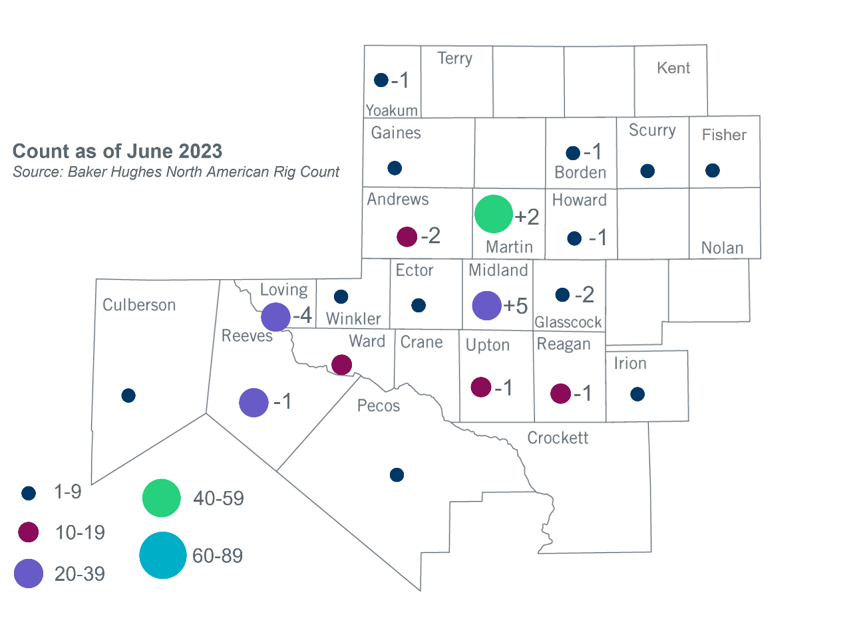
Permian Basin Oil Rig Count
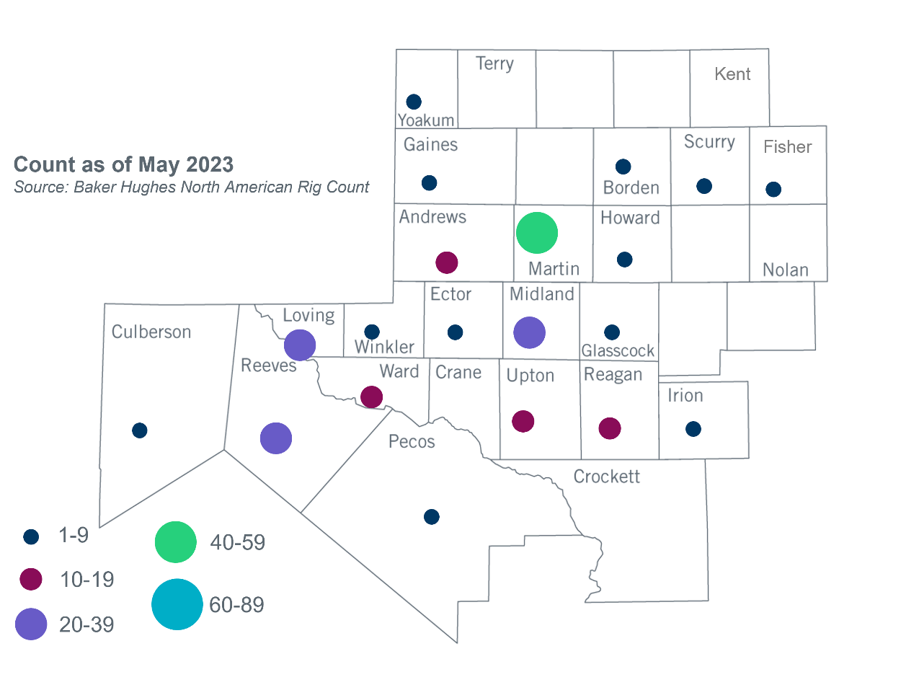
Other Notable Activities
- ERCOT presented the 2022 Regional Transmission Plan (RTP) economic study update at the June RPG meeting.
- ERCOT has completed the assessment of synchronous condensers to strengthen the West Texas System. The study report was posted to the ERCOT website on June 27, 2023.

Based on the Total Project Estimated Cost for all future projects listed in the Transmission Project Information and Tracking (TPIT) report. TPIT is updated three times each year based on information TSPs provide in Model on Demand (MOD) as specified in the ERCOT Steady State Working Group Procedure Manual. The latest TPIT is available at https://www.ercot.com/gridinfo/planning.
Based on the Total Project Estimated Cost for all completed projects with Projected In-Service Dates in 2023 listed in the TPIT.
+/- symbol indicates the increase or decrease from the previous month in oil rigs present in each county. There are 232 rigs, including a decrease of 6 oil rigs, in the Permian Basin from May to June 2023.

