

System Planning
Monthly Status Report

Report Highlights

- ERCOT is currently reviewing proposed transmission improvements with a total estimated cost of $2.121 billion as of June 30, 2024.
- Transmission Projects endorsed in 2024 total $2.245 billion as of June 30, 2024.
- All projects (in engineering, routing, licensing, and construction) total approximately $14.183 billion as of June 1, 2024.
- Transmission Projects energized in 2024 total approximately $2.160 billion (as of June 1, 2024).

Regional Planning Group Reviews
RPG Projects under Review:
- Oncor has submitted the West Texas 345-kV Infrastructure Rebuild Project (RPG Project ID: 23RPG034). This is a Tier 1 project that is estimated to cost $1.120 billion. ERCOT has completed the independent review on May 16, and the recommended project is estimated to cost $1.120 billion. TAC voted unanimously to endorse the project on May 22, 2024. The ERCOT Board of Directors endorsed the project on June 18, 2024, and ERCOT will issue the ERCOT endorsement letter.
- Oncor has submitted the Temple Area Project (RPG Project ID: 24RPG001). This is a Tier 1 project that is estimated to cost $120.70 million. This project is currently under ERCOT’s independent review.
- CPS Energy has submitted the Eastside 345/138-kV Switching Station Project (RPG Project ID: 24RPG003). This is a Tier 1 project that is estimated to cost $158.00 million. This project is currently under ERCOT’s independent review.
- CPS Energy has submitted the Omicron Reliability Project (RPG Project ID: 24RPG004). This is a Tier 2 project that is estimated to cost $42.50 million. This project is currently under ERCOT’s independent review.
- REC has submitted the Canton Area Loop Project (RPG Project ID: 24RPG007). This is a Tier 2 project that is estimated to cost $22.61 million. This project is currently under ERCOT’s independent review.
- AEPSC has submitted the Brownsville Area Improvements Transmission Project (RPG Project ID: 24RPG008). This is a Tier 1 project that is estimated to cost $387.70 million. This project is currently under ERCOT’s independent review.
- Oncor has submitted the Delaware Basin Stages 3 and 4 Project (RPG Project ID: 24RPG010). This is a Tier 1 project that is estimated to cost $202.20 million. This project is currently under ERCOT’s independent review.
- LCRA TSC has submitted the Sim Gideon to Cedar Hill Transmission Line Upgrade Project (RPG Project ID: 24RPG014). This is a Tier 3 project that is estimated to cost $77.90 million. The RPG review of this project was completed on May 24, and ERCOT has issued an acceptance letter.
- Oncor has submitted the Delaware Basin State 5 Project (RPG Project ID: 24RPG015). This is a Tier 1 project that is estimated to cost $744.60 million. This project is currently under ERCOT’s independent review.
- REC has submitted the Rand Area Loop Project (RPG Project ID: 24RPG016). This is a Tier 2 project that is estimated to cost $32.20 million. This project is currently under ERCOT’s independent review.
- Oncor has submitted the Venus Switch to Sam Switch 345-kV Line Project (RPG Project ID: 24RPG017). This is a Tier 1 project that is estimated to cost $118.90 million. This project is currently in the RPG comment period.
- Oncor has submitted the Salado Switch to Hutto Switch 138-kV Line Project (RPG Project ID: 24RPG018). This is a Tier 3 project that is estimated to cost $87.60 million. This project is currently in the RPG comment period.
- Oncor has submitted the Vineyard Switch to Cypress Waters 138-kV Circuit Addition Project (RPG Project ID: 24RPG019). This is a Tier 3 project that is estimated to cost $93.04 million. This project is currently in the RPG comment period.
- Oncor has submitted the Connell 345/138-kV Switch and Connell to Rockhound 345-kV Double-Circuit Line Project (RPG Project ID: 24RPG020). This is a Tier 1 project that is estimated to cost $110.62 million. This project is currently in the RPG comment period.

RPG Project Reviews Completed in 2024:
RPG Project ID | RPG Project Name | Submitted Entity | Tier | Estimated Cost  ($ Millions) | Review Completion Month
24RPG002 | Rockhound 345/138-kV Switch and Grey Well Draw to Buffalo 2nd 138-kV Circuit Project | Oncor | Tier 3 | 97.00 | February
23RPG028 | Rio Medina Project | STEC | Tier 2 | 71.70 | February
23RPG023 | Pecos County Transmission Improvement Project | TNMP | Tier 1 | 114.80 | February
24RPG005 | Montfort Switch to Shankle Switch 138-kV Line Project | Oncor | Tier 3 | 33.80 | February
24RPG006 | Prairieland 345/138-kV Switch and Prairieland Switch to Quartz Sand Switch/Hog Mountain Pod 138-kV Line Project | Oncor | Tier 3 | 56.00 | March
23RPG032 | San Antonio South Reliability II Project  (San Miguel to Marion 345-KV Project) | BEC | Tier 1 | 435.00 | April
24RPG009 | Sonora to Uvalde to Campwood to Bandera Area Transmission Project | AEPSC, LCRA TSC & BEC | Reclassified from Tier 3 to Tier 4 per Protocol | 76.00 | April
24RPG011 | Gonzales STATCOM Transmission Project | AEPSC | Reclassified from Tier 3 to Tier 4 per Protocol | 34.50 | April
24RPG012 | Clute to Velasco ckt 26 Upgrades Project | CNP | Tier 3 | 68.23 | May
24RPG013 | FPP Yard 2 to Lytton Springs Transmission Line Overhaul Project | LCRA TSC & AEN | Reclassified from Tier 3 to Tier 4 per Protocol | 60.00 | May
24RPG014 | Sim Gideon to Cedar Hill Transmission Line Upgrade Project | LCRA TSC | Tier 3 | 77.90 | May
23RPG034 | West Texas 345-kV Infrastructure Rebuild Project | Oncor | Tier 1 | 1,120.00 | June

More information on current and past RPG projects can be found on the ERCOT MIS Secure (digital certificate required): https://mis.ercot.com/secure/data-products/grid/regional-planning
Past email communication on RPG projects can be found on the ERCOT listserv by signing up for the REGPLANGROUP list: http://lists.ercot.com/scripts/wa-ERCOT.exe?A0=REGPLANGROUP

Planning Model Activities
The short-term calendar of major planning model events is as follows:
- By October 15, 2024 24SSWG_U1 Cases and TPIT will be posted
- By November 8, 2024 24SSWG_U1 Contingencies and Data Dictionary will be posted
The following table shows interconnection projects that met Planning Guide section 6.9(1) and 6.9(2) and were modeled in the SSWG cases as a full model or as a simple model in accordance with Planning Guide section 6.9.

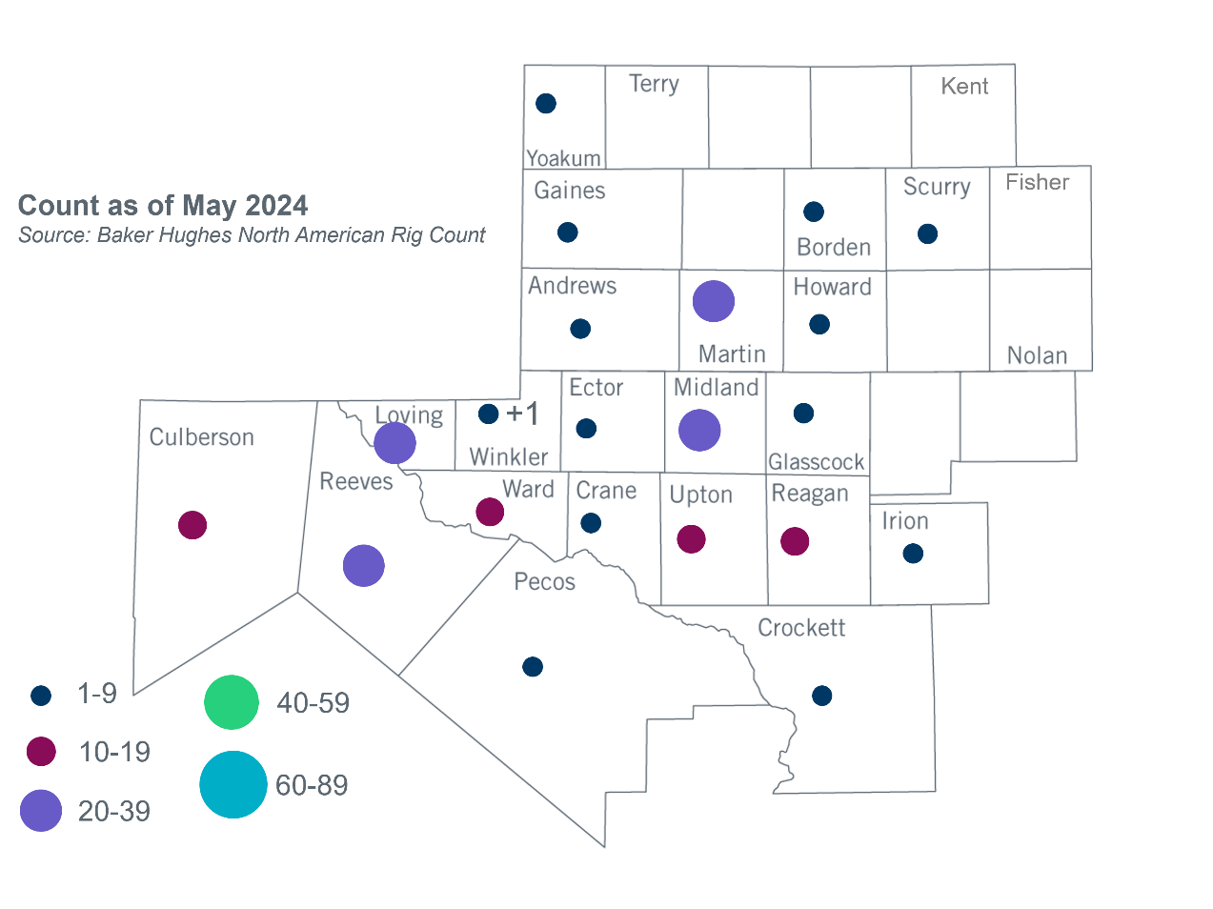
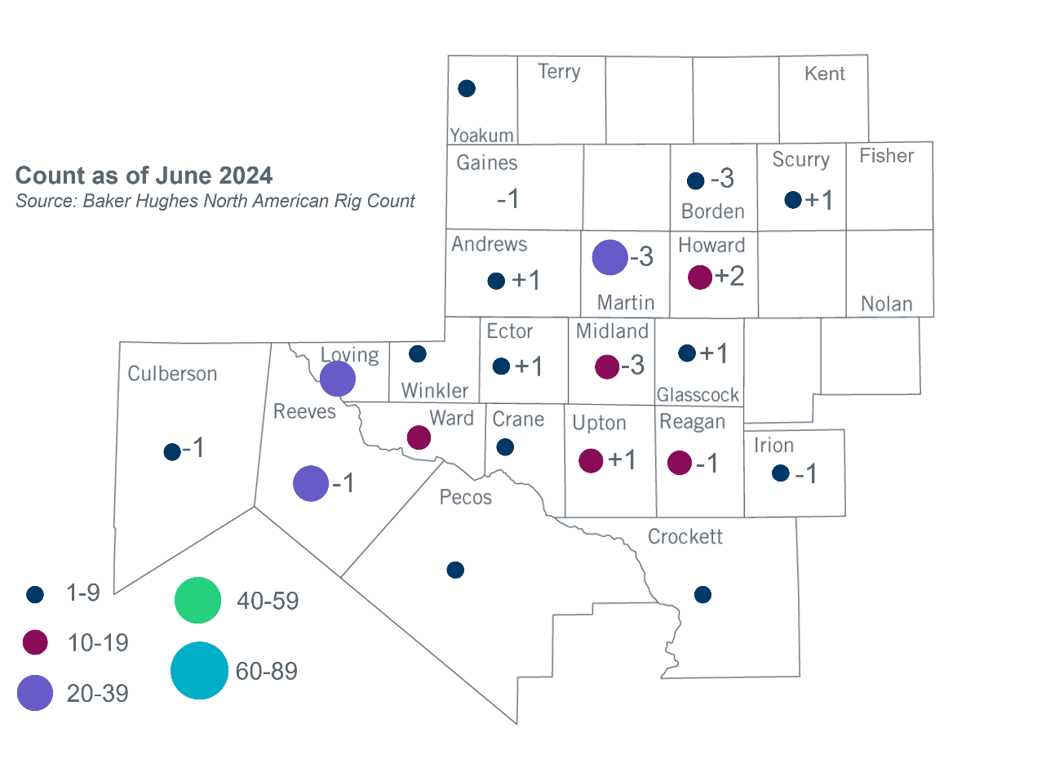
Permian Basin Oil Rig Count
Other Notable Activities
- ERCOT is working on the Permian Basin reliability plan study as directed by HB5066 and by the PUC.
- ERCOT presented the 2024 Grid Reliability and Resiliency Assessment scope at the June 2024 RPG meeting.
- ERCOT presented the introduction of the Extra-High Voltage infrastructure study at the June 2024 RPG meeting.
- ERCOT posted the 2024 Regional Transmission Plan initial reliability cases on 6/25/2024.

Based on the Total Project Estimated Cost for all future projects listed in the Transmission Project Information and Tracking (TPIT) report. TPIT is updated three times each year based on information TSPs provide in Model on Demand (MOD) as specified in the ERCOT Steady State Working Group Procedure Manual. The latest TPIT is available at https://www.ercot.com/gridinfo/planning.
Based on the Total Project Estimated Cost for all completed projects with Projected In-Service Dates in 2023 listed in the TPIT.
+/- symbol indicates the increase or decrease from the previous month in oil rigs present in each county. There are 199 rigs, including a decrease of 6 oil rigs, in the Permian Basin from May to June 2024.

