

System Planning
Monthly Status Report

Report Highlights

- ERCOT is currently reviewing proposed transmission improvements with a total estimated cost of $2.423 billion as of March 31, 2024.
- Transmission Projects endorsed in 2024 total $373.30 million as of March 31, 2024.
- All projects (in engineering, routing, licensing, and construction) total approximately $13.933 billion as of February 1, 2024.
- Transmission Projects energized in 2024 total approximately $789.5 million (as of February 1, 2024).

Regional Planning Group Reviews
RPG Projects under Review:
- TNMP has submitted the Pecos County Transmission Improvement Project (RPG Project ID: 23RPG023). This is a Tier 1 project that is estimated to cost $108.00 million. ERCOT has completed the independent review on January 18, and the recommended project is estimated to cost $114.80 million. TAC voted unanimously to endorse the project on January 24, 2024. The ERCOT Board of Directors endorsed the project on February 27, 2024, and ERCOT has issued the ERCOT endorsement letter.
- STEC has submitted the Rio Medina Project (RPG Project ID: 23RPG028). This is a Tier 2 project that is estimated to cost $38.00 million. ERCOT completed the independent review on February 16, and the recommended project is estimated to cost $71.70 million. ERCOT has issued the ERCOT endorsement letter.
- BEC has submitted the San Miguel to Marion 345-KV Project (RPG Project ID: 23RPG032). This is a Tier 1 project that is estimated to cost $258.50 million. This project is currently under ERCOT’s independent review.
- Oncor has submitted the West Texas 345-kV Infrastructure Rebuild Project (RPG Project ID: 23RPG034). This is a Tier 1 project that is estimated to cost $1.120 billion. This project is currently under ERCOT’s independent review.
- Oncor has submitted the Temple Area Project (RPG Project ID: 24RPG001). This is a Tier 1 project that is estimated to cost $120.70 million. This project is currently under ERCOT’s independent review.
- CPS Energy has submitted the Eastside 345/138-kV Switching Station Project (RPG Project ID: 24RPG003). This is a Tier 1 project that is estimated to cost $158.00 million. This project is currently under ERCOT’s independent review.
- CPS Energy has submitted the Omicron Reliability Project (RPG Project ID: 24RPG004). This is a Tier 2 project that is estimated to cost $42.50 million. This project is currently under ERCOT’s independent review.
- Oncor has submitted the Montfort Switch to Shankle Switch 138-kV Line Project (RPG Project ID: 24RPG005). This is a Tier 3 project that is estimated to cost $33.80 million. The RPG review of this project was completed on February 29, and ERCOT has issued an acceptance letter.
- Oncor has submitted the Prairieland 345/138-kV Switch and Prairieland Switch to Quartz Sand Switch/Hog Mountain Pod 138-kV Line Project (RPG Project ID: 24RPG006). This is a Tier 3 project that is estimated to cost $56.00 million. The RPG review of this project was completed on March 18, and ERCOT will issue an acceptance letter.
- REC has submitted the Canton Area Loop Project (RPG Project ID: 24RPG007). This is a Tier 2 project that is estimated to cost $22.61 million. This project is currently under ERCOT’s independent review.
- AEPSC has submitted the Brownsville Area Improvements Transmission Project (RPG Project ID: 24RPG008). This is a Tier 1 project that is estimated to cost $387.70 million. This project is currently in the RPG comment period.
- AEPSC, LCRA TSC and BEC have submitted the Sonora to Uvalde to Campwood to Bandera Area Transmission Project (RPG Project ID: 24RPG009). This is a Tier 3 project that is estimated to cost $76.00 million. This project is currently in the RPG comment period.
- Oncor has submitted the Delaware Basin Stages 3 and 4 Project (RPG Project ID: 24RPG010). This is a Tier 1 project that is estimated to cost $202.20 million. This project is currently in the RPG comment period.
- AEPSC has submitted the Gonzales STATCOM Transmission Project (RPG Project ID: 24RPG011). This is a Tier 3 project that is estimated to cost $34.50 million. This project is currently in the RPG comment period.

RPG Project Reviews Completed in 2024:
RPG Project ID | RPG Project Name | Submitted Entity | Tier | Estimated Cost  ($ Millions) | Review Completion Month
24RPG002 | Rockhound 345/138-kV Switch and Grey Well Draw to Buffalo 2nd 138-kV Circuit Project | Oncor | Tier 3 | 97.00 | February
23RPG028 | Rio Medina Project | STEC | Tier 2 | 71.70 | February
23RPG023 | Pecos County Transmission Improvement Project | TNMP | Tier 1 | 114.80 | February
24RPG005 | Montfort Switch to Shankle Switch 138-kV Line Project | Oncor | Tier 3 | 33.80 | February
24RPG006 | Prairieland 345/138-kV Switch and Prairieland Switch to Quartz Sand Switch/Hog Mountain Pod 138-kV Line Project | Oncor | Tier 3 | 56.00 | March

More information on current and past RPG projects can be found on the ERCOT MIS Secure (digital certificate required): https://mis.ercot.com/secure/data-products/grid/regional-planning
Past email communication on RPG projects can be found on the ERCOT listserv by signing up for the REGPLANGROUP list: http://lists.ercot.com/scripts/wa-ERCOT.exe?A0=REGPLANGROUP

Planning Model Activities
The short-term calendar of major planning model events is as follows:
- By May 31, 2024 24SSWG Cases and TPIT will be posted
- By June 7, 2024 24SSWG Contingencies and Data Dictionary will be posted
The following table shows interconnection projects that met Planning Guide section 6.9(1) and 6.9(2) and were modeled in the SSWG cases as a full model or as a simple model in accordance with Planning Guide section 6.9.

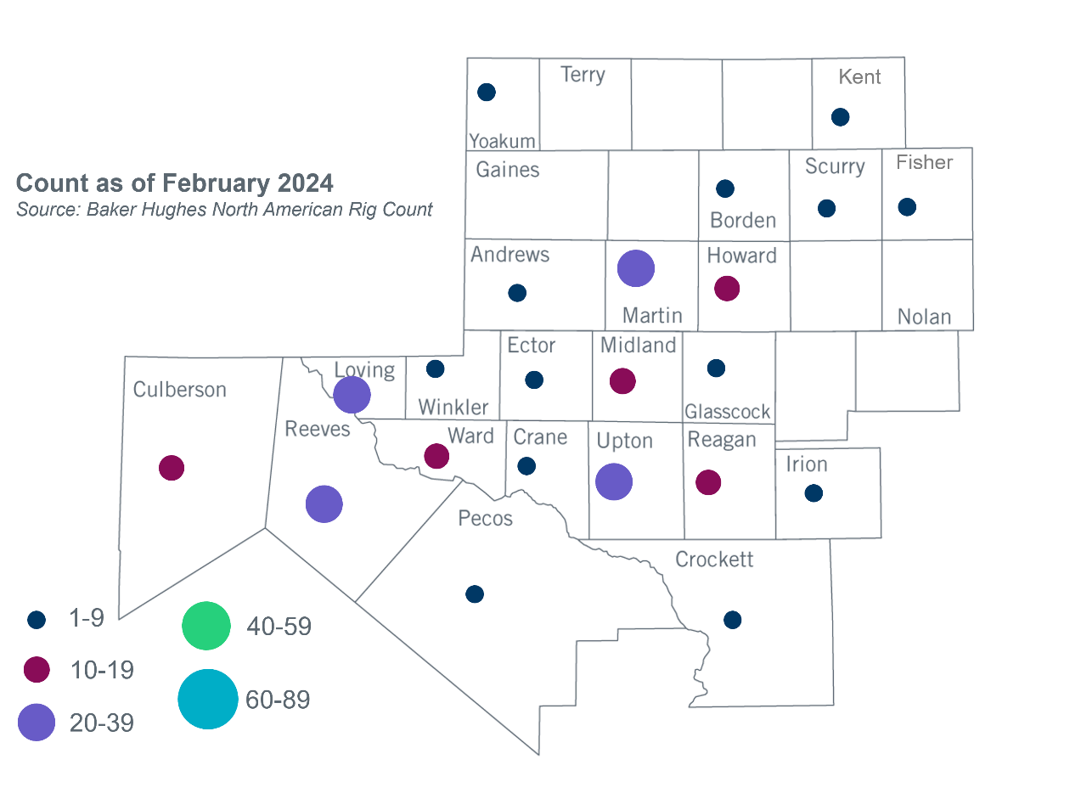
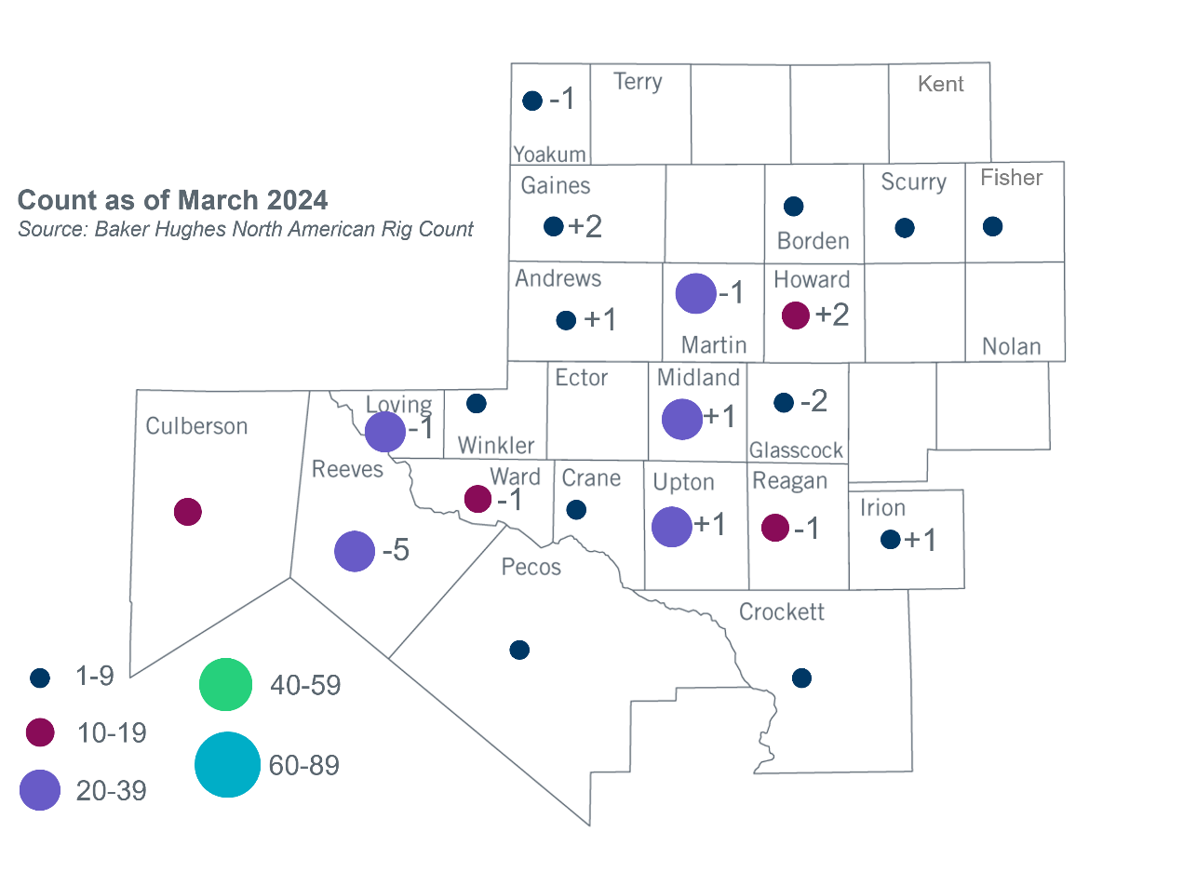
Permian Basin Oil Rig Count
Other Notable Activities
- ERCOT is working on the Permian Basin reliability plan study as directed by HB5066 and by the PUC.
- ERCOT presented the 2024 Regional Transmission Plan (RTP) economic analysis assumptions at the March 2024 RPG meeting.
- ERCOT presented the 2024 RTP load review update at the March 2024 RPG meeting.

Based on the Total Project Estimated Cost for all future projects listed in the Transmission Project Information and Tracking (TPIT) report. TPIT is updated three times each year based on information TSPs provide in Model on Demand (MOD) as specified in the ERCOT Steady State Working Group Procedure Manual. The latest TPIT is available at https://www.ercot.com/gridinfo/planning.
Based on the Total Project Estimated Cost for all completed projects with Projected In-Service Dates in 2023 listed in the TPIT.
+/- symbol indicates the increase or decrease from the previous month in oil rigs present in each county. There are 203 rigs, including a decrease of 6 oil rigs, in the Permian Basin from February to March 2024.

