

System Planning
Monthly Status Report

Report Highlights

- ERCOT is currently reviewing proposed transmission improvements with a total estimated cost of $1.702 billion as of October 31, 2023.
- Transmission Projects endorsed in 2023 total $1.959 billion as of October 31, 2023.
- All projects (in engineering, routing, licensing, and construction) total approximately $13.537 billion as of October 12, 2023.
- Transmission Projects energized in 2023 total approximately $1.553 billion (as of October 12, 2023).

Regional Planning Group Reviews
RPG Projects under Review:
- TNMP has submitted the Silverleaf and Cowpen 345/138-kV Stations Project (RPG Project ID: 23RPG013). This is a Tier 1 project that is estimated to cost $299.00 million. This project is currently under ERCOT’s independent review.
- Oncor has submitted the Arlington Reliability Enhancement Project (RPG Project ID: 23RPG018). This is a Tier 2 project that is estimated to cost $72.00 million. This project is currently under ERCOT’s independent review.
- TNMP has submitted the Pecos County Transmission Improvement Project (RPG Project ID: 23RPG023). This is a Tier 1 project that is estimated to cost $108.00 million. This project is currently under ERCOT’s independent review.
- CNP has submitted the Britmoore to Bellaire Ckt 24 Upgrade Project (RPG Project ID: 23RPG025). This is a Tier 3 project that is estimated to cost $90.10 million. The RPG review of this project was completed on September 28, and ERCOT has issued an acceptance letter.
- WETT has submitted the Synchronous Condensers Project (RPG Project ID: 23RPG026). This is a Tier 1 project that is estimated to cost $468.00 million. This project is currently under ERCOT’s independent review.
- LCRA TSC has submitted the Bakersfield Dynamic Reactive Substation Upgrade Project (RPG Project ID: 23RPG027). This is a Tier 1 project that is estimated to cost $145.00 million. This project is currently under ERCOT’s independent review.
- STEC has submitted the Rio Medina Project (RPG Project ID: 23RPG028). This is a Tier 2 project that is estimated to cost $38.00 million. This project is currently under ERCOT’s independent review.
- Oncor has submitted the West Texas Synchronous Condenser Project (RPG Project ID: 23RPG029). This is a Tier 1 project that is estimated to cost $280.00 million. This project is currently under ERCOT’s independent review.
- Oncor has submitted the Walleye Creek 345/138-kV Switch Project (RPG Project ID: 23RPG030). This is a Tier 3 project that is estimated to cost $74.00 million. The RPG review of this project was completed on October 25, and ERCOT has issued an acceptance letter.
- CNP has submitted the 345-kV Jeanetta Autotransformer Upgrades Project (RPG Project ID: 23RPG031). This is a Tier 3 project that is estimated to cost $47.08 million. The RPG review of this project was completed on October 26, and ERCOT will issue an acceptance letter.
- BEC has submitted the San Miguel to Marion 345-KV Project (RPG Project ID: 23RPG032). This is a Tier 1 project that is estimated to cost $258.50 million. This project is currently under ERCOT’s independent review.
- Oncor has submitted the Watermill to Seagoville 138 kV Line Project (RPG Project ID: 23RPG033). This is a Tier 3 project that is estimated to cost $33.00 million. This project is currently in the RPG comment period.

RPG Project Reviews Completed in 2023:
RPG Project ID | RPG Project Name | Submitted Entity | Tier | Estimated Cost  ($ Millions) | Review Completion Month
22RPG043 | Haskell to Munday 69 kV Line Rebuild Project | AEPSC | Reclassified from Tier 3 to Tier 4 per Protocol | 31.00 | January
22RPG044 | Escondido to Hamilton Road 138 kV Line Rebuild Project | AEPSC | Reclassified from Tier 3 to Tier 4 per Protocol | 73.50 | January
22RPG045 | Yucca to Moss 138 kV Line Project | Oncor | Reclassified from Tier 3 to Tier 4 per Protocol | 60.70 | January
22RPG046 | Peppervine to Temple 69 kV Line Conversion Project | Oncor | Reclassified from Tier 3 to Tier 4 per Protocol | 36.00 | January
22RPG026 | Wimberley Loop Project | PEC | Tier 2 | 61.93 | February
23RPG001 | Bessel to Falfurrias 138 kV Line Rebuild Project | AEPSC | Reclassified from Tier 3 to Tier 4 per Protocol | 84.76 | February
23RPG002 | Hamlin to Roby 69 kV Line Rebuild Project | AEPSC | Reclassified from Tier 3 to Tier 4 per Protocol | 33.00 | February
23RPG003 | Eagle Ford Large Load Interconnection Project | GVEC | Tier 3 | 35.15 | March
23RPG004 | Lockhart to Luling 69-kV Transmission Line Overhaul Project | LCRA TSC | Reclassified from Tier 3 to Tier 4 per Protocol | 33.50 | March
23RPG005 | La Palma to Stewart Road Rebuild and Conversion to 138-kV Project | AEPSC | Reclassified from Tier 3 to Tier 4 per Protocol | 71.50 | March
23RPG006 | North Lake 138 kV Switch Rebuild | Oncor | Reclassified from Tier 3 to Tier 4 per Protocol | 34.11 | March
22RPG047 | Peck to Driver 138 kV Line Project | Oncor | Tier 2 | 36.20 | May
23RPG007 | Asherton to Uvalde 138-kV Conversion Project | AEPSC | Tier 3 | 56.00 | May
23RPG008 | Fort Stockton Plant to Lynx 138-kV Line Rebuild Project | AEPSC | Reclassified from Tier 3 to Tier 4 per Protocol | 44.90 | May
23RPG009 | Spraberry to Polecat 138-kV Line Rebuild Project | Oncor | Tier 3 | 56.90 | May
23RPG010 | Big Spring West to Stanton East 138-kV Line Rebuild Project | Oncor | Tier 3 | 52.00 | May
23RPG011 | Morgan Creek to McDonald Road 138-kV Line Project | Oncor | Tier 3 | 40.20 | May
23RPG012 | Stone Lake Area Upgrades Project | CNP | Tier 3 | 74.38 | May
23RPG014 | Lamesa to Jim Payne POI to Paul Davis Tap 138-kV Line Rebuild Project | Oncor | Tier 3 | 36.80 | June
23RPG015 | Cuero Substation Upgrade Project | LCRA TSC | Reclassified from Tier 3 to Tier 4 per Protocol | 25.90 | June
23RPG016 | Tributary Switch – Vincent Rebuild Project | Oncor | Tier 3 | 29.30 | July
23RPG017 | Watermill 345/138-kV Switch Project | Oncor | Tier 3 | 74.90 | July
22RPG048 | San Antonio South Reliability Project | CPS | Tier 1 | 329.10 | August
23RPG019 | Stanton Loop South Dynamic Reactive Power Project | Oncor | Tier 3 | 96.90 | August
23RPG020 | Hackberry Switch to DFW D East 2 138-kV Double-Circuit Line Section Project | Oncor | Tier 3 | 80.00 | August
23RPG021 | West Columbia to Big Creek ckt 89 Reconductor Project | CNP | Reclassified from Tier 3 to Tier 4 per Protocol | 64.17 | September
23RPG022 | McLennan County Transmission Project | Oncor | Tier 3 | 42.31 | September
23RPG024 | Big Foot to Dilley Switch 138-kV Conversion Project | AEPSC | Reclassified from Tier 3 to Tier 4 per Protocol | 53.10 | September
23RPG025 | Britmoore to Bellaire Ckt 24 Upgrade Project | CNP | Tier 3 | 90.10 | September
23RPG030 | Walleye Creek 345/138-kV Switch Project | Oncor | Tier 3 | 74.00 | October
23RPG031 | 345-kV Jeanetta Autotransformer Upgrades Project | CNP | Tier 3 | 47.08 | October

More information on current and past RPG projects can be found on the ERCOT MIS Secure (digital certificate required): https://mis.ercot.com/secure/data-products/grid/regional-planning
Past email communication on RPG projects can be found on the ERCOT listserv by signing up for the REGPLANGROUP list: http://lists.ercot.com/scripts/wa-ERCOT.exe?A0=REGPLANGROUP

Planning Model Activities
The short-term calendar of major planning model events is as follows:
- By October 15, 2023 23SSWG_U1 cases and TPIT will be posted
- By November 10, 2023 23SSWG_U1 Contingency set & Planning Data Dictionary will be posted
The following table shows interconnection projects that met Planning Guide section 6.9(1) and 6.9(2) and were modeled in the SSWG cases as a full model or as a simple model in accordance with Planning Guide section 6.9.

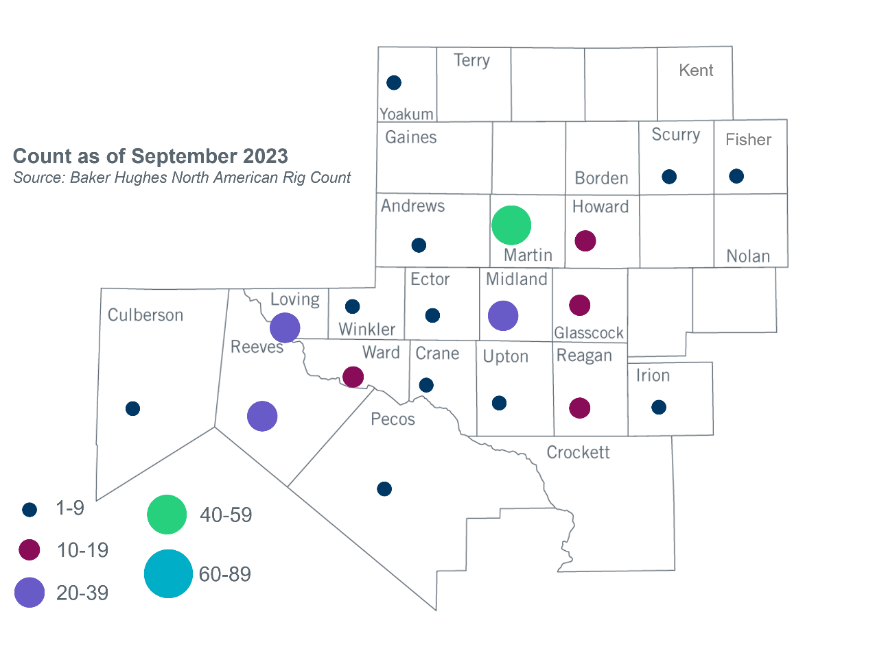
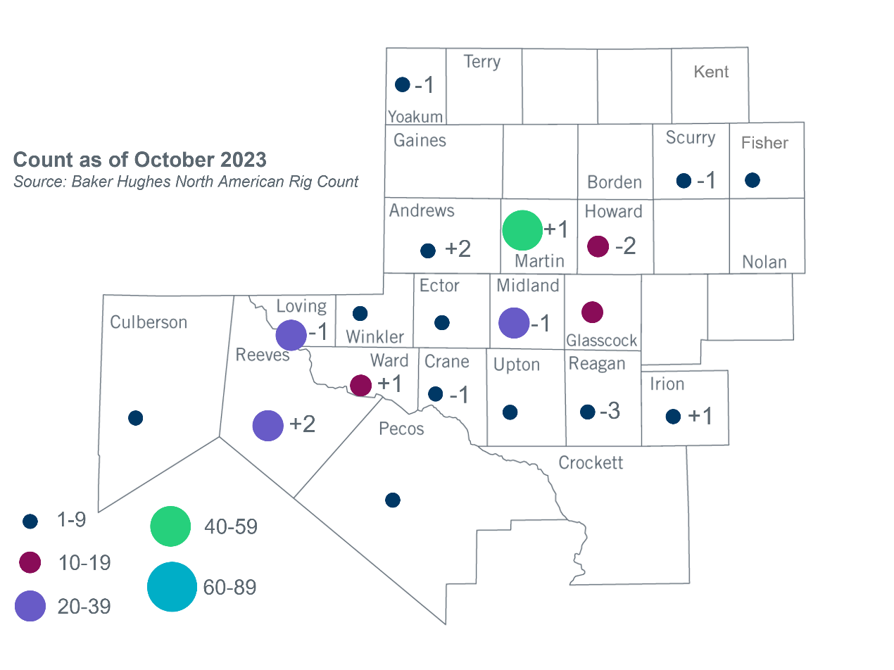
Permian Basin Oil Rig Count
Other Notable Activities
- ERCOT presented the assumptions for the 2023 Regional Transmission Plan (RTP) sensitivity analysis at the October 2023 RPG meeting.

Based on the Total Project Estimated Cost for all future projects listed in the Transmission Project Information and Tracking (TPIT) report. TPIT is updated three times each year based on information TSPs provide in Model on Demand (MOD) as specified in the ERCOT Steady State Working Group Procedure Manual. The latest TPIT is available at https://www.ercot.com/gridinfo/planning.
Based on the Total Project Estimated Cost for all completed projects with Projected In-Service Dates in 2023 listed in the TPIT.
+/- symbol indicates the increase or decrease from the previous month in oil rigs present in each county. There are 204 rigs, including a decrease of 3 oil rigs, in the Permian Basin from September to October 2023.

