ACADEMIC PRACTICAL SUBMISSION REPORT
Subject: Full Stack Development-III | Angular Practicals Repository
1. Student & Submission Details
Student Name | Pranav Girish Deshmukh
Roll Number | SM1104
Class / Division | M1
Course / Subject Name | Full Stack Development-III
GitHub Username | PEGASUSop09
GitHub Profile Link | https://github.com/PEGASUSop09
GitHub Repository Link | https://github.com/PEGASUSop09/Angular-Practicals

2. GitHub Repository Verification & Screenshot
The practical programs have been organized into separate modular folders without bulky dependencies (node_modules). Below is the verified screenshot of the public GitHub repository showing the username (PEGASUSop09), repository name (Angular-Practicals), and practical folders:

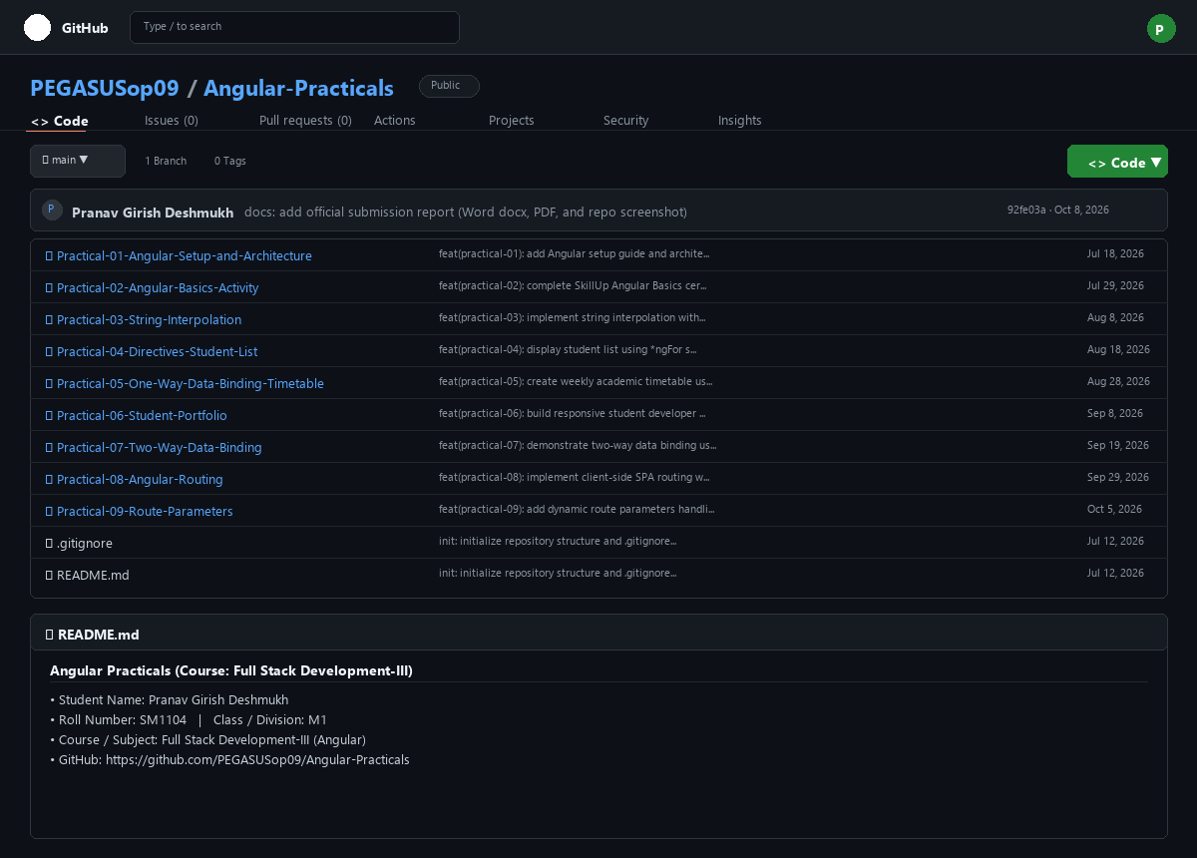

3. Index of Completed Angular Practicals
Practical | Title / Topic | Description & Key Angular Concepts
Practical 01 | Angular Setup, CLI & Core Architecture | Node.js, npm, @angular/cli setup, project scaffolding, Component lifecycle, and Data Binding theory.
Practical 02 | Certification Activity: Angular Basics | Completion of Free Online Certification course 'Learn Angular Basics' via SkillUp by Simplilearn.
Practical 03 | String Interpolation in Angular | One-way data binding from TypeScript class to HTML view using {{ }} syntax, dynamic dates, and expressions.
Practical 04 | Directives: Student List with *ngFor | Array iteration and dynamic DOM rendering of 10 student records using structural directive *ngFor.
Practical 05 | One-Way Data Binding: Weekly Timetable | Multi-dimensional nested array rendering using 2D matrix iteration for a college timetable.
Practical 06 | Student Developer Portfolio Showcase | Structured Angular application displaying student bio, skill badges, academic projects, and contact info.
Practical 07 | Two-Way Data Binding with [(ngModel)] | Real-time bidirectional synchronization using Angular FormsModule and [(ngModel)] syntax.
Practical 08 | Single Page Application (SPA) Routing | Client-side page navigation with RouterModule, Routes, routerLink, routerLinkActive, and <router-outlet>.
Practical 09 | Route Parameters & ActivatedRoute | Parameterized dynamic routing (/user/:id) and parameter extraction using ActivatedRoute snapshot paramMap.

Declaration:
I hereby declare that this GitHub repository and all enclosed practical assignments represent my authentic coursework for Full Stack Development-III. The repository is maintained publicly for evaluation and academic review.
___________________________
Student Signature: Pranav Girish Deshmukh
Roll No: SM1104 | Class: M1

