
Graduate School of Arts and Letters
TOHOKU UNIVERSITY
Identifying Gendered Patterns in Japanese Academic Careers
Promotion Timing, Institutional Mobility, and KAKEN-Related Academic Resources
Doctoral Dissertation Framework
PEI Rongkang
Graduate School of Arts and Letters, Tohoku University
Doctor of Philosophy in Art and Letters
Dissertation framework prepared July 2026

Abstract
Gender inequality in academic careers is visible not only in who reaches senior rank, but also in when advancement occurs and in the organizational and scholarly resources available along the way. This dissertation uses longitudinal researchmap career histories linked to KAKEN project records to examine academic careers in Japan. It brings promotion timing, institutional mobility, and access to academic resources into a common career-course framework while keeping the three empirical studies analytically distinct.
Study 1 identifies where gender differences appear in observed promotion timelines from the PhD to Associate Professor and from Associate Professor to Full Professor. Study 2 asks whether the number of institutional moves is associated with promotion timing and whether that relationship differs by gender. Sequence analysis provides a secondary account of recurring patterns of institutional stability and movement. Study 3 examines KAKEN-related academic resources across two career stages. It considers participation, project leadership, funding, and project-based network position before promotion.
The dissertation contributes to research on gendered organizations and academic careers by treating the ability to move and the accumulation of research resources as career conditions that may be unequally distributed. Researcher-year event-history models preserve right-censoring and temporal order, while the sequence analysis describes longer career pathways. The evidence is descriptive and associational; the observational design does not establish causal effects.

Acknowledgements
I am grateful to my supervisor, committee members, colleagues, and collaborators for their guidance. This section will be completed in the final dissertation.

Table of Contents
Chapter 1. Introduction
Chapter 2. Gender Inequality in Japanese Academic Careers
Chapter 3. Data and Methods
Chapter 4. Study 1: Gendered Promotion Timelines
Chapter 5. Study 2: Institutional Mobility and Promotion Timing
Chapter 6. Study 3: KAKEN Resources and Stage-Specific Promotion
Chapter 7. General Discussion
Chapter 8. Conclusion
Appendices
References

List of Tables
Table 3.1. Core measures and analytical roles
Table A.1. Variable construction and validation
[Additional tables will be inserted as empirical chapters are completed]

List of Figures
Figure 1.1. Dissertation logic
Figure 4.1. Study 1 analytic samples
Figure 4.2. Study 1 observed promotion timelines
[Additional figures will be inserted as empirical chapters are completed]

List of Abbreviations
AP — Associate Professor
FP — Full Professor
KAKEN — Grants-in-Aid for Scientific Research
PI — Principal Investigator
Co-I — Co-Investigator
JST — Japan Science and Technology Agency

Chapter 1. Introduction

1.1 Background
Academic careers unfold through a series of appointments, promotions, institutional moves, and opportunities to secure research support. In Japan, women remain underrepresented at senior academic ranks even as participation in doctoral education and research has expanded. Cross-sectional rank distributions show the outcome of this process, but they reveal little about when inequalities emerge or how careers develop before promotion.

1.2 Research Problem
Three gaps guide the dissertation. Promotion timing is often studied only among people whose transitions are observed. Institutional mobility is commonly treated as individual choice even though the capacity to move depends on organizational opportunity and private circumstances. Research funding is frequently measured as an outcome rather than as a career resource that may have different relevance at different stages.

1.3 Research Questions
RQ1. Where do gender differences appear in observed academic promotion timelines in Japan?
RQ2. How is the number of institutional moves associated with promotion timing, and does this association differ between women and men?
RQ3. How is access to KAKEN-related academic resources associated with promotion across different career stages, and do these associations differ between women and men?

1.4 Theoretical Orientation
The argument draws on gendered organizations, linked lives, status attainment, and cumulative advantage. Organizational rules can appear neutral while rewarding career patterns that are easier for some researchers to sustain. Institutional mobility may open opportunities, but the ability to move may itself be an unequally distributed career resource. Likewise, access to academic resources and the career value attached to those resources may vary by gender and career stage.

1.5 Data and Methodological Overview
The dissertation links researchmap career records to KAKEN project data and organizes them by fiscal year. Study 1 compares observed promotion timelines. Studies 2 and 3 use researcher-year risk sets that retain researchers who have not yet experienced promotion. Study 2 also uses multichannel sequence analysis to describe recurring mobility pathways.

1.6 Dissertation Structure
The empirical sequence is straightforward: timing, mobility, and academic resources. Chapter 4 establishes where gender differences appear. Chapter 5 examines institutional movement. Chapter 6 turns to KAKEN-related resources across career stages.

1.7 Contribution
The dissertation connects career timing to the organizational and scholarly conditions under which promotion occurs. It also extends completed-transition comparisons by retaining right-censored careers in the later studies.

Chapter 2. Gender Inequality in Japanese Academic Careers

2.1 Japanese Academic Career Structure
Japanese academic careers combine rank progression with substantial variation across fields and institutions. The PhD-to-Associate-Professor transition marks entry into a more secure and organizationally recognized position; the later transition to Full Professor reflects a different stage of evaluation and opportunity.

2.2 Promotion and Rank Inequality
Gender gaps in rank can arise through unequal entry into promotion, different timing among those promoted, or differential observation. These processes should not be collapsed into a single measure of advancement (Allison and Long, 1987; Pei et al., 2026).

2.3 Institutional Mobility
Institutional moves can reflect career strategy and constraint. Their meaning depends on when they occur and where they lead. Status-attainment research suggests that mobility can improve organizational position, while segmented labour markets limit the opportunities available to different groups (Bielby and Bielby, 1992; Cañibano et al., 2016).

2.4 KAKEN and Academic Resources
KAKEN participation provides access to project resources and collaboration. PI and Co-I roles mark different forms of project responsibility. These roles are project-specific rather than permanent researcher attributes (JSPS, 2026a; Sato et al., 2021).

2.5 Gendered Organizations and Career Constraints
Gendered-organization theory directs attention from individual preference to organizational practices (Acker, 1990). Linked-lives research adds that career decisions are coordinated with partners and family responsibilities. The same institutional move may therefore carry different career implications for women and men.

2.6 Cumulative Advantage
Early access to funding, leadership, and collaboration can shape later opportunities. Cumulative advantage need not imply an automatic process; it identifies a mechanism through which initially modest differences may grow across career stages (Merton, 1968; DiPrete and Eirich, 2006; Bol et al., 2018).

2.7 Research Gap
Existing work rarely examines promotion timing, institutional movement, and project-based academic resources with the same longitudinal population. The dissertation addresses this gap without treating mobility or funding as exogenous interventions.

Chapter 3. Data and Methods

3.1 Data Sources
researchmap provides career histories, education, affiliations, and researcher profiles (JST, 2026). KAKEN records provide project membership, roles, project categories, and annual budgets (JSPS, 2026a, 2026b). Fiscal year is the common time unit.

3.2 Research Population
The population requires a valid researcher identifier, a plausible PhD year, usable career history, gender for the primary comparison, and field information. Researchers without observed promotion remain in the later risk sets when observation coverage is adequate.

3.3 Researcher and Institution Linkage
Linkage distinguishes the KAKEN website identifier from the JPR researchmap user identifier used for the dissertation cohort. Unlinked project members remain in team-size denominators. Institution aliases are harmonized before institutional moves are counted.

3.4 Career and Promotion Measures
Promotion is the first validated appointment to Associate Professor or Full Professor. Japanese and English title patterns are audited. Time since PhD defines the main analysis clock, and post-event years are excluded from each risk set.

3.5 Institutional Mobility Measures
An institutional move is a change in canonical primary institution between consecutive observed records. The primary measure is cumulative move count before year t. Direction, internal versus external promotion, time since last move, prestige, and institution size are secondary measures.

3.6 KAKEN Resource Measures
KAKEN resources are organized into access, project leadership, funding, and project-based network position. Funding is measured using full exposure and fractional allocation. The original project category is retained.

3.7 Event-History Analysis
Discrete-time event-history models estimate promotion risk with a flexible baseline hazard. Predictors are measured before year t. Complementary log-log models are primary; logistic and Cox specifications provide comparisons.

3.8 Sequence Analysis
Sequence analysis will identify recurring patterns of institutional stability and movement (Abbott and Tsay, 2000; Gauthier et al., 2010). Channel construction, distance alternatives, clustering diagnostics, and sensitivity windows are documented in the Appendix.

3.9 Missing Data and Validation
No KAKEN record is distinguished from failed linkage, and missing career history is not coded as career exit. Sample-flow, missingness, rank-title, and linkage audits accompany each empirical chapter.

3.10 Ethics and Limitations
The analysis uses structured records of professional careers and reports only aggregate results. Temporal ordering improves interpretation but does not remove selection, measurement error, or unobserved confounding.

Chapter 4. Study 1: Gendered Promotion Timelines

4.1 Introduction
Study 1 provides the diagnostic starting point by locating gender differences across two observed promotion transitions.

4.2 Research Question
RQ1. Where do gender differences appear in observed academic promotion timelines in Japan?

4.3 Data and Measures
The completed study uses 74,344 discipline-mapped PhD holders. The observed-transition samples contain 20,808 researchers for PhD to AP and 10,747 for AP to FP; positive-duration samples contain 18,794 and 10,416 researchers, respectively.
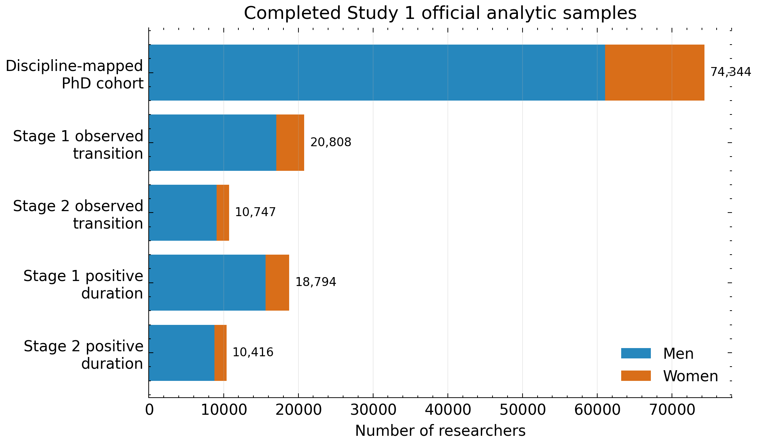
Figure 4.1. Study 1 official analytic and observed-transition samples. Source: Pei et al. (2026).

4.4 Analytical Strategy
Promotion timing is measured between validated milestones. Completed-transition comparisons are interpreted alongside survival-based checks that retain right-censoring.

4.5 Results
The completed analysis identifies the PhD-to-Associate-Professor transition as the main site of observed heterogeneity. Among positive-duration completed transitions, mean timelines are 7.83 years for women and 8.77 years for men from PhD to AP, and 8.22 years for women and 8.60 years for men from AP to FP. These conditional means do not imply that women have a higher probability of promotion.
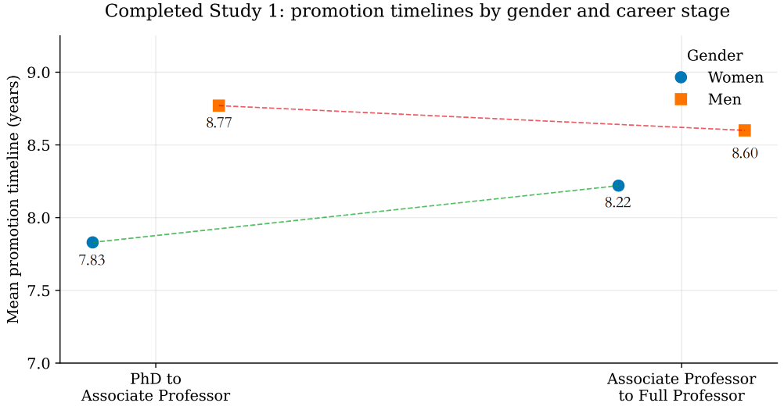
Figure 4.2. Study 1 mean observed promotion timelines by gender and career stage. Source: Pei et al. (2026).

4.6 Discussion
The early-career transition deserves closer attention, but timing alone cannot reveal how organizational opportunities shape advancement. The distinction between transition duration and entry into promotion motivates the risk-set designs that follow.

4.7 Chapter Summary
Study 1 shows where observed timing differences appear. Chapter 5 asks whether institutional movement is related to those promotion timelines.

Chapter 5. Study 2: Institutional Mobility and Promotion Timing

5.1 Introduction
Institutional mobility may offer career opportunities, but the capacity to move is not equally distributed. Study 2 therefore centers on the number of institutional moves rather than treating every feature of mobility as a separate question.

5.2 Theoretical Expectations
H2.1 More institutional moves are associated with promotion timing.
H2.2 The association between move count and promotion timing differs between women and men.
H2.3 Upward moves are more strongly associated with promotion than lateral or downward moves.

5.3 Research Question
RQ2. How is the number of institutional moves associated with promotion timing, and does this association differ between women and men?

5.4 Variables and Measures
The primary predictor is cumulative institutional move count before year t. Secondary measures distinguish upward, lateral, and downward moves, internal and external promotion, time since the last move, and mobility per observed career year. Prestige percentiles and institution size provide context rather than separate theoretical centers.

5.5 Analytical Strategy
The main analysis models time to first Associate Professor appointment. Where coverage permits, the AP-to-FP transition is examined separately. Gender-by-move-count interactions are interpreted through predicted probabilities and marginal effects. Sequence analysis provides a secondary typology of institutional stability and movement.

5.6 Results

Results placeholder
Descriptive finding: [Insert result here]
Main model: [Insert coefficient, uncertainty interval, and interpretation here]
Gender comparison: [Insert predicted probabilities or marginal effects here]
Robustness: [Insert robustness summary here]
Substantive interpretation: [Insert interpretation linked to theory here]

5.7 Robustness Checks
[Insert comparison of move definitions, prestige measures, observation windows, and high-coverage samples here]

5.8 Discussion
[Insert discussion of mobility as opportunity and constraint, linked to gendered organizations and linked lives]

5.9 Chapter Summary
[Insert chapter summary here] Mobility captures movement between organizations; Chapter 6 examines access to academic resources within and across career stages.

Chapter 6. Study 3: KAKEN Resources and Stage-Specific Promotion

6.1 Introduction
Study 3 examines whether access to KAKEN-related academic resources is associated with promotion and whether the association changes across career stages.

6.2 Theoretical Expectations
H3.1 Greater access to KAKEN-related academic resources is associated with faster promotion.
H3.2 The association between KAKEN resources and promotion differs between women and men.
H3.3 The association between KAKEN resources and promotion varies across career stages.

6.3 Research Question
RQ3. How is access to KAKEN-related academic resources associated with promotion across different career stages, and do these associations differ between women and men?

6.4 Variables and Measures
Resources are grouped into participation, project leadership, funding, and project-based network position. Primary measures include any KAKEN participation, PI and Co-I roles, direct funding, degree, PI outdegree, and PI indegree. Weighted degree is reserved for robustness analysis.

6.5 Stage-Specific Analytical Strategy
Separate model families examine PhD to Associate Professor and Associate Professor to Full Professor. Each uses only resources observed before year t. Gender-by-resource and stage-by-resource terms are introduced selectively; three-way interactions require adequate support.

6.6 Results: PhD to Associate Professor

Results placeholder
Descriptive finding: [Insert result here]
Main model: [Insert coefficient, uncertainty interval, and interpretation here]
Gender comparison: [Insert predicted probabilities or marginal effects here]
Robustness: [Insert robustness summary here]
Substantive interpretation: [Insert interpretation linked to theory here]

6.7 Results: Associate Professor to Full Professor

Results placeholder
Descriptive finding: [Insert result here]
Main model: [Insert coefficient, uncertainty interval, and interpretation here]
Gender comparison: [Insert predicted probabilities or marginal effects here]
Robustness: [Insert robustness summary here]
Substantive interpretation: [Insert interpretation linked to theory here]

6.8 Gender Differences in Resource Associations

Results placeholder
Main model: [Insert coefficient, uncertainty interval, and interpretation here]
Gender comparison: [Insert predicted probabilities or marginal effects here]
Robustness: [Insert robustness summary here]
Substantive interpretation: [Insert interpretation linked to theory here]

6.9 Robustness Checks
[Insert comparison of lag windows, funding allocations, linkage-quality samples, and alternative network measures here]

6.10 Discussion
[Insert discussion of cumulative advantage, project leadership, and gendered returns to resources here]

6.11 Chapter Summary
[Insert chapter summary and transition to the General Discussion here]

Chapter 7. General Discussion

7.1 Summary of Findings
[Insert synthesis after the relevant empirical chapters are completed]

7.2 Promotion Timing
[Insert synthesis after the relevant empirical chapters are completed]

7.3 Mobility as a Gendered Career Strategy
[Insert synthesis after the relevant empirical chapters are completed]

7.4 Gendered Access to Academic Resources
[Insert synthesis after the relevant empirical chapters are completed]

7.5 Career-Stage Differences
[Insert synthesis after the relevant empirical chapters are completed]

7.6 Theoretical Contributions
[Insert synthesis after the relevant empirical chapters are completed]

7.7 Policy Implications
[Insert synthesis after the relevant empirical chapters are completed]

7.8 Limitations
[Insert synthesis after the relevant empirical chapters are completed]

7.9 Future Research
[Insert synthesis after the relevant empirical chapters are completed]

Chapter 8. Conclusion
[Insert concise conclusion after all empirical chapters and the General Discussion are complete]

Appendices

Appendix A. Variable Dictionary
[Insert final variable dictionary and provenance table]

Appendix B. Institutional Ranking and Size Construction
THE, QS, and ARWU measures remain separate. Annual percentiles, pre-move medians, coverage rules, and institution-size measures will be documented here.

Appendix C. Mobility Coding
[Insert primary-affiliation hierarchy, move-event rules, direction thresholds, and internal/external promotion validation]

Appendix D. KAKEN and Network Construction
The raw KAKEN project-category field, linkage-status definitions, budget-allocation denominators, role harmonization, and project-year edge construction are documented here.

Appendix E. Robustness Specifications
[Insert alternative lag windows, baseline hazards, sequence distances, clustering diagnostics, and sensitivity samples]

Appendix F. Data-Quality Diagnostics
[Insert sample flow, missingness, title audit, linkage audit, and coverage diagnostics]

Appendix G. Additional Tables and Figures
[Insert supplementary tables and figures]

References
Abbott, A., & Tsay, A. (2000). Sequence analysis and optimal matching methods in sociology: Review and prospect. Sociological Methods & Research, 29(1), 3–33. https://doi.org/10.1177/0049124100029001001
Acker, J. (1990). Hierarchies, jobs, bodies: A theory of gendered organizations. Gender & Society, 4(2), 139–158. https://doi.org/10.1177/089124390004002002
Allison, P. D., & Long, J. S. (1987). Interuniversity mobility of academic scientists. American Sociological Review, 52(5), 643–652. https://doi.org/10.2307/2095600
Bielby, W. T., & Bielby, D. D. (1992). I will follow him: Family ties, gender-role beliefs, and reluctance to relocate for a better job. American Journal of Sociology, 97(5), 1241–1267. https://doi.org/10.1086/229901
Bol, T., de Vaan, M., & van de Rijt, A. (2018). The Matthew effect in science funding. Proceedings of the National Academy of Sciences, 115(19), 4887–4890. https://doi.org/10.1073/pnas.1719557115
Cañibano, C., Fox, M. F., & Otamendi, F. J. (2016). Gender and patterns of temporary mobility among researchers. Science and Public Policy, 43(3), 320–331. https://doi.org/10.1093/scipol/scv042
Clauset, A., Arbesman, S., & Larremore, D. B. (2015). Systematic inequality and hierarchy in faculty hiring networks. Science Advances, 1(1), e1400005. https://doi.org/10.1126/sciadv.1400005
DiPrete, T. A., & Eirich, G. M. (2006). Cumulative advantage as a mechanism for inequality: A review of theoretical and empirical developments. Annual Review of Sociology, 32, 271–297. https://doi.org/10.1146/annurev.soc.32.061604.123127
Fernández-Zubieta, A., Geuna, A., & Lawson, C. (2016). Productivity pay-offs from academic mobility: Should I stay or should I go? Industrial and Corporate Change, 25(1), 91–114. https://doi.org/10.1093/icc/dtv034
Gauthier, J.-A., Widmer, E. D., Bucher, P., & Notredame, C. (2010). Multichannel sequence analysis applied to social science data. Sociological Methodology, 40(1), 1–38. https://doi.org/10.1111/j.1467-9531.2010.01227.x
Huang, J., Gates, A. J., Sinatra, R., & Barabási, A.-L. (2020). Historical comparison of gender inequality in scientific careers across countries and disciplines. Proceedings of the National Academy of Sciences, 117(9), 4609–4616. https://doi.org/10.1073/pnas.1914221117
Japan Science and Technology Agency. (2026). About the researchmap project. https://researchmap.jp/public/about/operations
Japan Society for the Promotion of Science. (2026a). KAKENHI: Types of grants programs. https://www.jsps.go.jp/english/e-grants/grants01.html
Japan Society for the Promotion of Science. (2026b). KAKENHI award trends. https://www.jsps.go.jp/english/e-grants/award_trends.html
Lawson, C., & Shibayama, S. (2015). International research visits and careers: An analysis of bioscience academics in Japan. Science and Public Policy, 42(5), 690–710. https://doi.org/10.1093/scipol/scu084
Li, W., Aste, T., Caccioli, F., & Livan, G. (2019). Early coauthorship with top scientists predicts success in academic careers. Nature Communications, 10, 5170. https://doi.org/10.1038/s41467-019-13130-4
Merton, R. K. (1968). The Matthew effect in science. Science, 159(3810), 56–63. https://doi.org/10.1126/science.159.3810.56
Moher, D., Naudet, F., Cristea, I. A., Miedema, F., Ioannidis, J. P. A., & Goodman, S. N. (2018). Assessing scientists for hiring, promotion, and tenure. PLOS Biology, 16(3), e2004089. https://doi.org/10.1371/journal.pbio.2004089
Nagano, N., Watari, T., Tamaki, Y., & Onigata, K. (2022). Japan's academic barriers to gender equality as seen in a comparison of public and private medical schools. Women's Health Reports, 3(1), 115–123. https://doi.org/10.1089/whr.2021.0082
Nielsen, M. W. (2016). Limits to meritocracy? Gender in academic recruitment and promotion processes. Science and Public Policy, 43(3), 386–399. https://doi.org/10.1093/scipol/scv052
Pei, R., Lyu, Z., Wang, G., Wang, Z., Ye, M., & Fan, X. (2026). Gender inequality in academic promotion trajectories in Japan. Scientific Reports. https://doi.org/10.1038/s41598-026-54562-5
Sato, S., Gygax, P. M., Randall, J., & Schmid Mast, M. (2021). The leaky pipeline in research grant peer review and funding decisions: Challenges and future directions. Higher Education, 82, 145–162. https://doi.org/10.1007/s10734-020-00626-y
Schimanski, L. A., & Alperin, J. P. (2018). The evaluation of scholarship in academic promotion and tenure processes: Past, present, and future. F1000Research, 7, 1605. https://doi.org/10.12688/f1000research.16493.1
Statistics Bureau of Japan. (2025). Statistical handbook of Japan 2025. https://www.stat.go.jp/english/data/handbook/
Takahashi, A. M., & Takahashi, S. (2015). Gender promotion differences in economics departments in Japan: A duration analysis. Journal of Asian Economics, 41, 1–19. https://doi.org/10.1016/j.asieco.2015.09.002
Wang, Y., Jones, B. F., & Wang, D. (2019). Early-career setback and future career impact. Nature Communications, 10, 4331. https://doi.org/10.1038/s41467-019-12189-3
Wapman, K. H., Zhang, S., Clauset, A., & Larremore, D. B. (2022). Quantifying hierarchy and dynamics in US faculty hiring and retention. Nature, 610, 120–127. https://doi.org/10.1038/s41586-022-05222-x
Watanabe, M. (2025). Gender inequality in international research engagement amid transformation to global and neoliberal academia: The case of Japan. Gender, Work & Organization, 32(5), 1812–1822. https://doi.org/10.1111/gwao.13224

