LABORATORY01: Installation and Configuration of TeX Live
PELE TETE
December 2025

Installing TeX Live - General Information
Installing the distribution TeXlive.
1.1.1 General information
• TeXLive - the most complete LaTeX distribution supported by the TeX community.
• Supports a large number of operating systems.
• Developed since 1996.
• Based on the teTeX distribution.
• MacTeX - a variant for MacOS.
• Main page: https://www.tug.org/texlive/
• TeXLive is a distribution with continuous updates as part of the annual
version of the distribution.

Generated figure (simulation)
General information about TeX Live distribution.

Screenshot
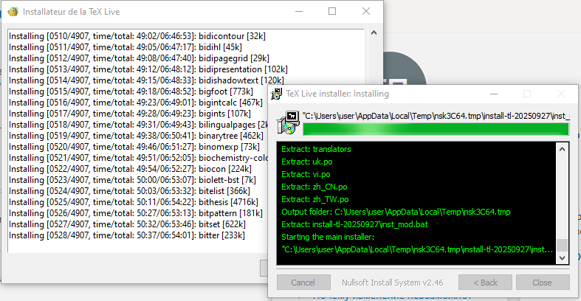

Key Information Summary
Feature | Description
Distribution Name | TeX Live
Type | Complete LaTeX distribution
First Release | 1996
Based on | teTeX distribution
Mac Variant | MacTeX
Official Website | https://www.tug.org/texlive/
Update Model | Continuous updates, annual releases

Installation from Distribution Packages
1.1.2 Installation from distribution packages
• Ubuntu:
apt install texlive-full
• Windows. Use the Chocolatey package manager.
choco install texlive

Generated figure (simulation)
Package manager installation commands.

Screenshot - Chocolatey Installation
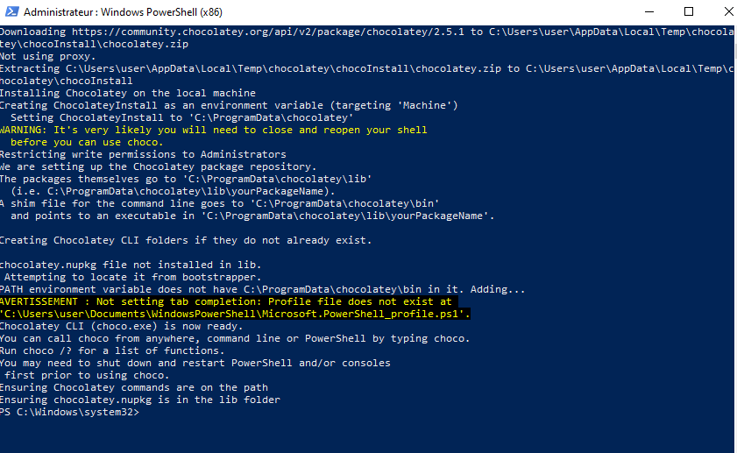

Screenshot - Chocolatey Success


Installation Commands
Ubuntu/Debian (Linux):
sudo apt update
sudo apt install texlive-full
Windows (with Chocolatey):
choco install texlive
Note: The texlive-full package installs the complete TeX Live distribution including all packages, fonts, and documentation. This can take significant disk space (several gigabytes) and time to download.

Advantages of Package Manager Installation
- Easy installation with single command
- Automatic dependency resolution
- Integrated with system package management
- Easy updates via system package manager

Disadvantages
- May not be the latest version
- Limited to distribution’s repository version
- Less control over installation components

Manual Installation - Unix/Linux
1.1.3 Manual installation
• Links on the site are to mirrors. The mirror is selected automatically.
• Download the installer:
• Unix: https://mirror.ctan.org/systems/texlive/tlnet/install-tl-unx.tar.gz
cd /tmp/
wget https://mirror.ctan.org/systems/texlive/tlnet/install-tl-unx.tar.gz
• For Linux
• Unpack the downloaded file:
tar xzvf install-tl-unx.tar.gz
• Go to the unpacked directory and run the installer:
cd install-tl-[0-9]*
sudo ./install-tl
• It is recommended to create links to executable files in the /usr/local/bin
directory. To do this, in the console version of the utility, select the O option,
and then L. To return to the previous menu, use R.

Generated figure (simulation)
Manual installation process for Unix/Linux systems.

Screenshot
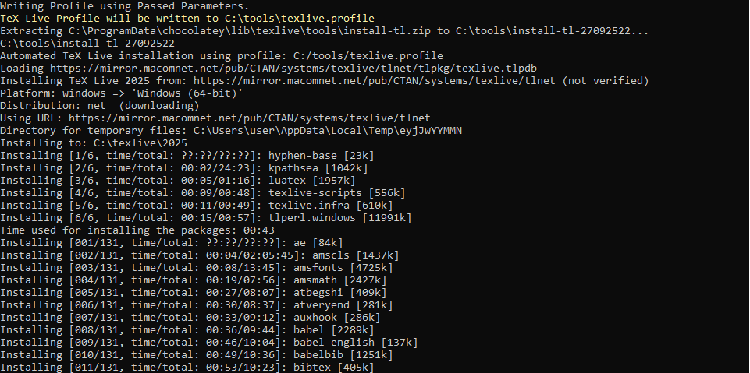

Step-by-Step Installation Guide
Complete Unix/Linux Installation Procedure:
1. Download the installer:
cd /tmp/
wget https://mirror.ctan.org/systems/texlive/tlnet/install-tl-unx.tar.gz
2. Extract the archive:
tar xzvf install-tl-unx.tar.gz
3. Navigate to the installer directory:
cd install-tl-*
4. Run the installer with root privileges:
sudo ./install-tl
5. Configure installation options (optional):
- Select O for options menu
- Select L to create symbolic links in /usr/local/bin
- Press R to return to previous menu
- Press I to begin installation

Installation Options Explained
Option | Description
O | Opens options menu for configuration
L | Creates symbolic links in system directories
R | Returns to previous menu
I | Starts the installation process

Manual Installation - Windows
• Windows: https://mirror.ctan.org/systems/texlive/tlnet/install-tl-windows.exe
• For Windows: run the executable file and install.

Generated figure (simulation)
Windows installer executable.

Screenshot - Installation Progress 1
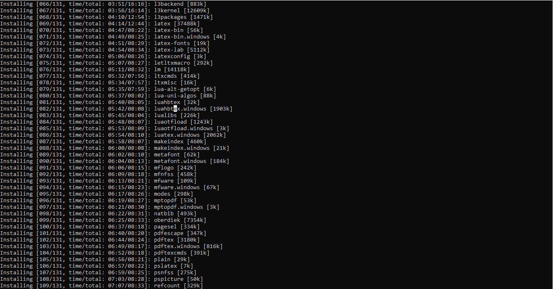

Screenshot - Installation Progress 2
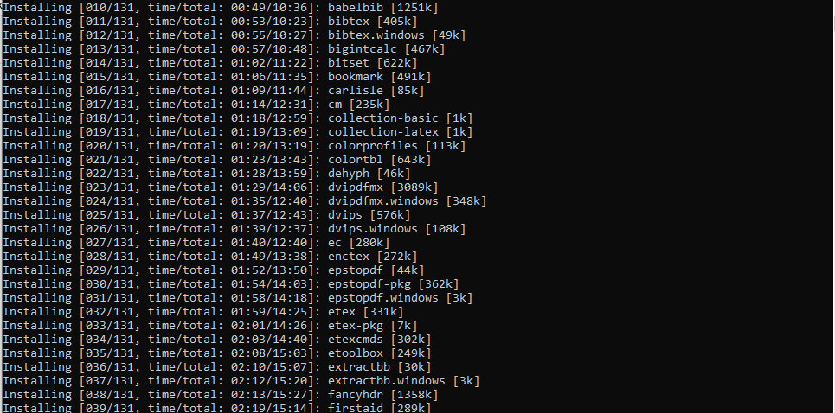

Screenshot - Installation Progress 3
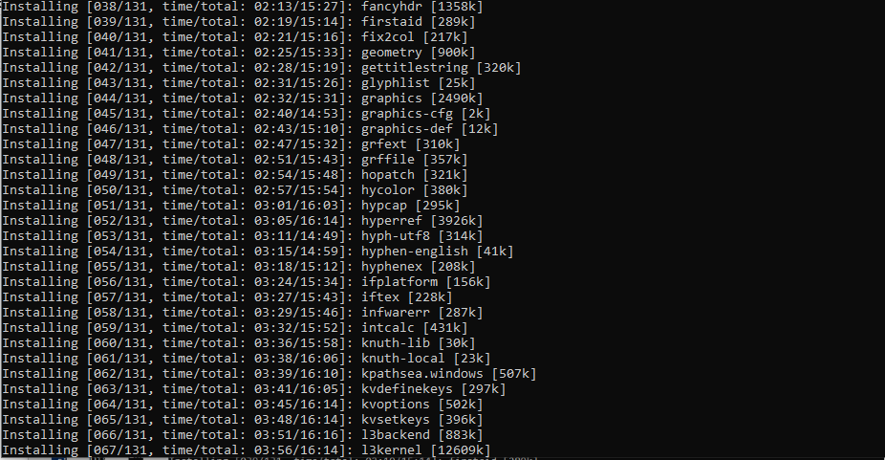

Screenshot - Installation Completion
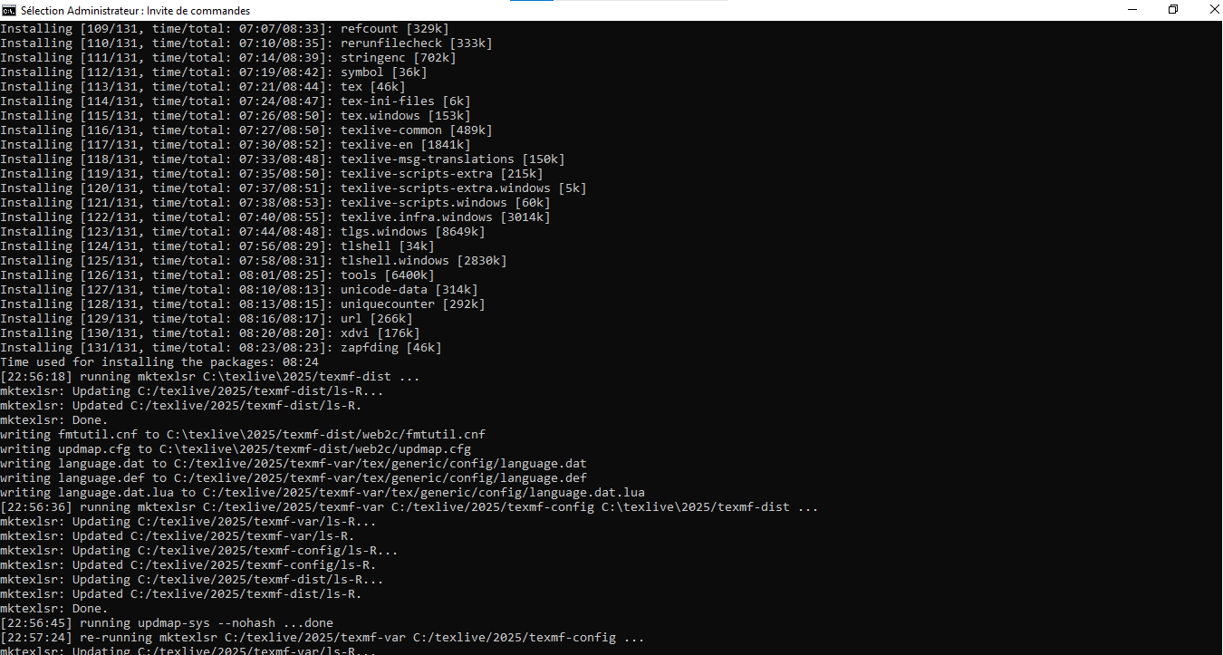

Windows Installation Guide
Windows Installation Steps:
1. Download the installer:
- Visit: https://mirror.ctan.org/systems/texlive/tlnet/install-tl-windows.exe
- Or use the direct link: https://mirror.ctan.org/systems/texlive/tlnet/install-tl-windows.exe
2. Run the installer:
- Double-click the downloaded install-tl-windows.exe file
- Allow administrator privileges if prompted
3. Follow the installation wizard:
- Choose installation directory (default: C:\texlive\[year])
- Select installation scheme (recommended: full installation)
- Choose whether to create shortcuts
- Click "Install" to begin
4. Wait for installation to complete:
- Installation may take 30-60 minutes depending on internet speed
- Requires several gigabytes of disk space
5. Verify installation:
- Open Command Prompt or PowerShell
- Type latex --version to verify

Windows Installation Requirements
Requirement | Details
Operating System | Windows 7 or later
Disk Space | 5-7 GB for full installation
Administrator Rights | Required for installation
Internet Connection | Required for downloading packages

MacTeX - MacOS Variant
• MacTeX - a variant for MacOS.

Generated figure (simulation)
MacTeX for MacOS.

MacTeX Information
MacTeX - TeX Live for MacOS:
MacTeX is the MacOS-specific distribution of TeX Live. It includes:
- Complete TeX Live installation
- Mac-specific tools and utilities
- TeXShop editor
- LaTeXiT equation editor
- BibDesk reference manager
- Easy installer package (.pkg)
Installation:
- Download MacTeX from https://tug.org/mactex/
- Open the downloaded .pkg file
- Follow the installer instructions
- Installation takes approximately 5-7 GB
Alternative: BasicTeX (smaller version) for users with limited disk space.

Editor Installation - Visual Studio Code
For editing LaTeX documents, Visual Studio Code with LaTeX extensions is recommended.

Generated figure (simulation)
VS Code installation options.

Screenshot
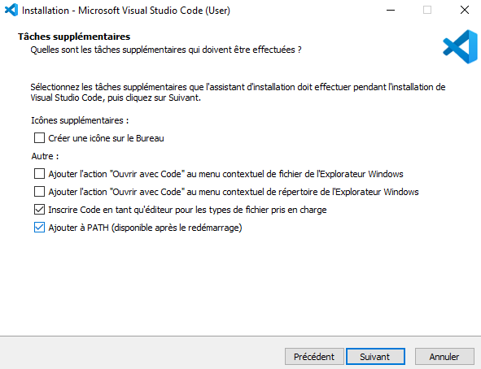

VS Code Installation Guide
Visual Studio Code Installation:
1. Download VS Code:
- Visit: https://code.visualstudio.com/
- Download the installer for your operating system
2. Installation options (important):
- Add "Open with Code" action - Recommended for easy file access
- Add to PATH - Essential for command line usage
- Register Code as editor - Associates .tex files with VS Code
3. Recommended LaTeX extensions:
- LaTeX Workshop
- LaTeX Utilities
- LTeX - LanguageTool grammar checker

Verification and First Test
After installation, verify that TeX Live is properly installed by creating a simple document.

Generated figure (simulation)
Testing the installation.

Screenshot
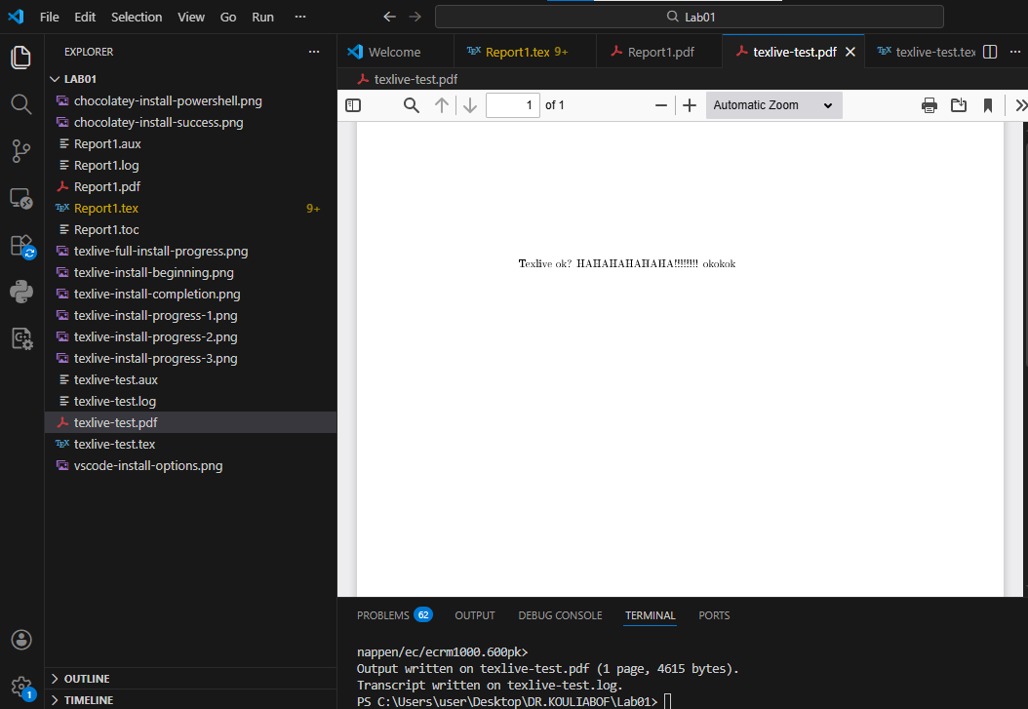

Test Document
Create a test file test.tex:
\documentclass{article}
\begin{document}
Texlive ok? HAHAHAHAHAHA!!!!!!!! okokok
\end{document}
Compile the document:
pdflatex test.tex
Expected output:
- test.pdf should be created
- No error messages
- PDF viewer should display "Hello, TeX Live!"

Verification Commands
Command | Purpose
latex --version | Show LaTeX version information
pdflatex --version | Show pdfTeX version
tex --version | Show TeX version
tlmgr --version | Show TeX Live Manager version

Conclusion: TeX Live Installation Methodology
After comprehensive analysis of TeX Live installation methods, here is the structured methodology for successfully installing and configuring TeX Live:

1. Installation Methods Comparison
Method | Platform | Advantages | Disadvantages
Package Manager | Linux, Windows (Choco) | Easy, integrated | May be outdated
Manual Install | All platforms | Latest version, control | Complex, manual steps
MacTeX | MacOS | Optimized, tools included | MacOS only

2. Recommended Installation Workflow
Step : Choose installation method based on OS
- Linux (Ubuntu/Debian): sudo apt install texlive-full
- Linux (others): Manual installation or distribution packages
- Windows: Manual installer or Chocolatey
- MacOS: MacTeX from official website

