LABORATORY02: Report and Presentation of work on Basic LaTeX Documents
PELE TETE
December 2025

first.tex - Basic LaTeX Document
\documentclass{article}
\usepackage[T1]{fontenc}
\begin{document}
Hey world!
This is a first document.
\end{document}

Generated figure (simulation)
Minimal LaTeX document with a simple text output.

Imported image
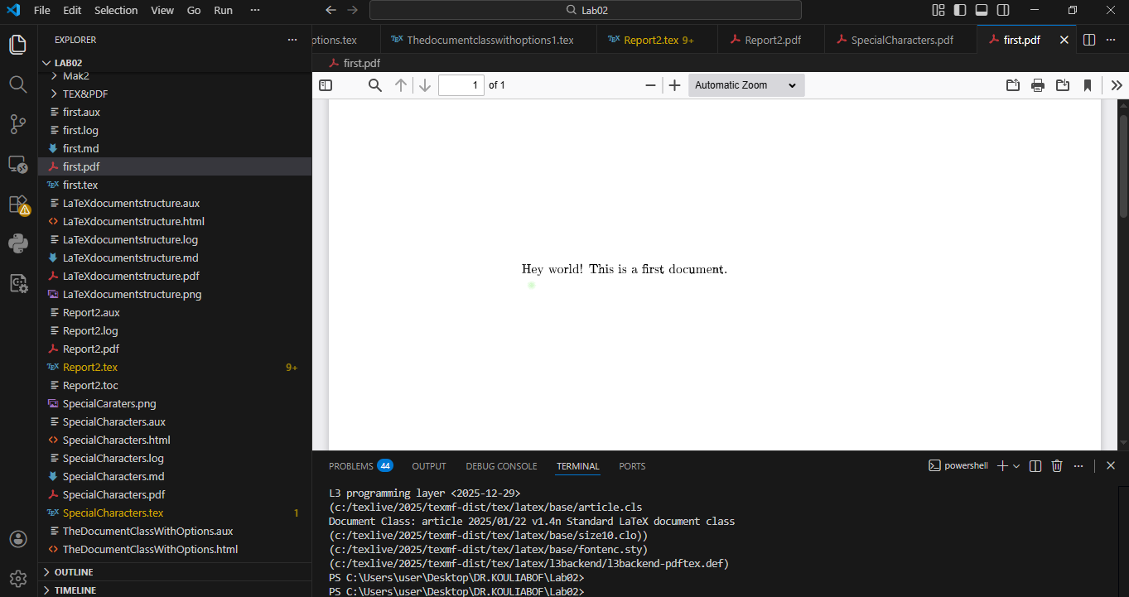

Analysis
This is the most basic LaTeX document structure. It demonstrates:
- Document class declaration (article)
- Font encoding package (T1)
- Document environment
- Simple text output

SpecialCharacters.tex - Special Characters and Symbols
\documentclass{article}
\usepackage[T1]{fontenc}
\begin{document}
\textasciitilde
\ $10 \& 50 cents$
\textasciitilde
%This is 100\% complete
\textasciitilde
\# first of all
\textasciitilde
$\alpha, \beta, \gamma, \delta$
\textasciitilde
\end{document}

Generated figure
Document showing special character handling in LaTeX.

Screenshot
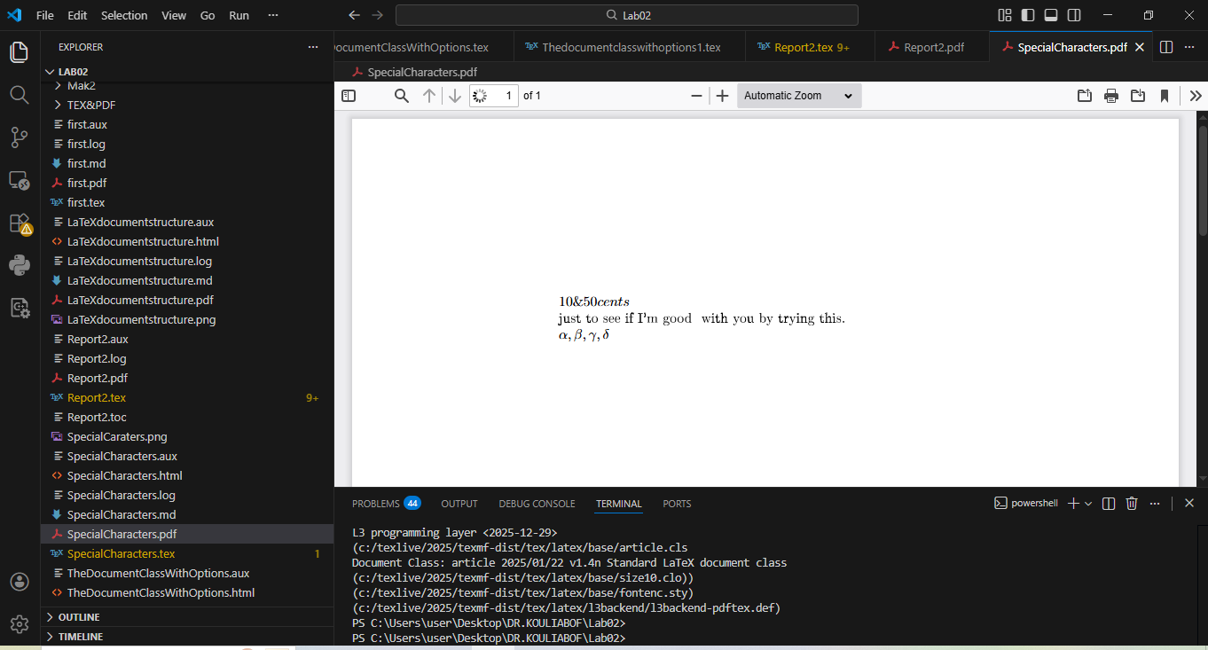

Analysis
This document demonstrates essential special character escapes in LaTeX:
- \textasciitilde : Tilde character ~
- \$ : Dollar sign $ for math mode
- & : Ampersand (requires backslash escape)
- % : Percent sign (comment character, escaped as \%)
- # : Hash symbol (escaped as \#)
- $\alpha, \beta, \gamma, \delta$ : Greek letters in math mode

TheDocumentClassWithOptions.tex - Document Class with Options
%% The document class with options
\documentclass[a4paper,12pt]{article}
%% Select T1 font encoding: suitable for Western European Latin scripts
\usepackage[T1]{fontenc}
%% A comment in the preamble
\begin{document}
%% This is a comment
This is a simple document:The function ln (x),known as the natural logarithm,
has an etymology rooted in the latin term logarithmus naturalis.
The concept of logarithms was developed by John Napier in the early 17th century,
initially as a tool to simplify complex calculations, particularly in astronomy
and navigation.
Napier's original work, Mirifici Logarithmorum Canonis Descriptio Description
of the Wonderful Canon of Logarithms, published in 1614, introduced a system
based on a geometric progression and an arithmetic progression.
His logarithms were not directly the natural logarithm as we understand it today,
but rather a related concept
This is a new:The etymology of the function sin (x)
is a fascinating journey through ancient Indian mathematics, Arabic translations,
and Latin interpretations.
The term SINE ultimately derives from a series of linguistic transformations
and misinterpretations of the Sanskrit word for HALF-CHORD
\end{document}

Generated figure
Document with A4 paper size, 12pt font, and historical content about mathematical functions.

Screenshot
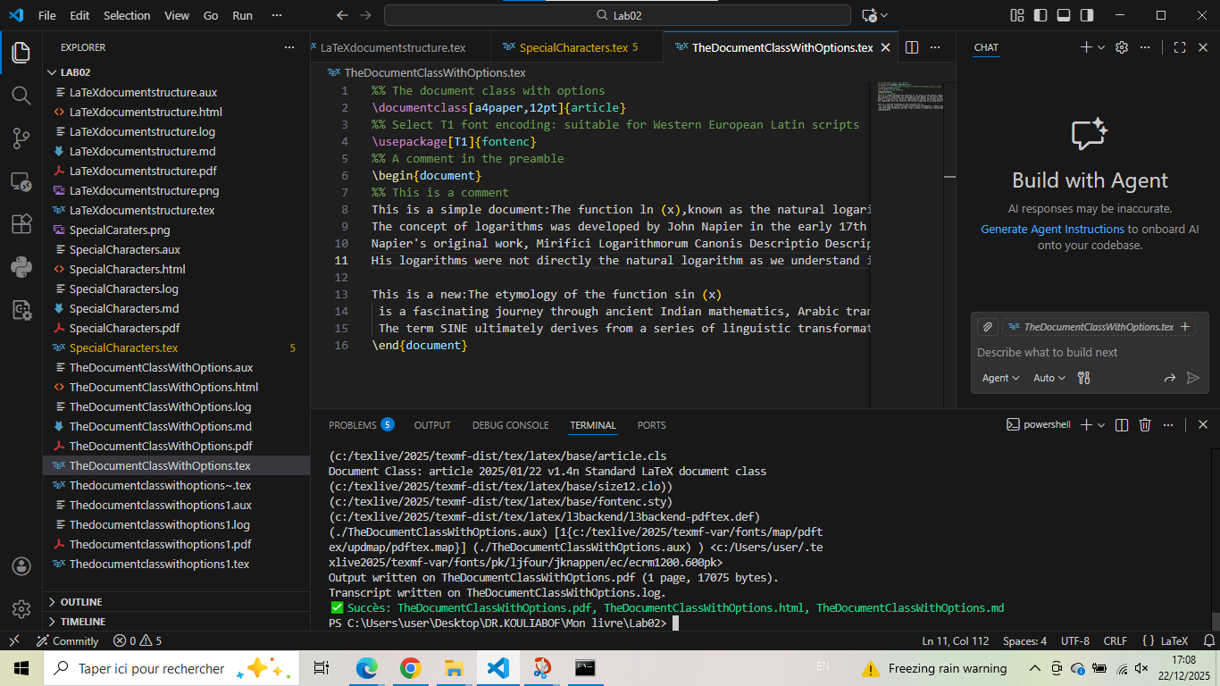

Analysis
This document introduces important LaTeX features:
- Document class options: [a4paper,12pt] specifies paper size and font size
- Comments: Lines beginning with % are comments
- Historical content: Text about the etymology of ln(x) and sin(x)
- Paragraph formatting: Automatic line wrapping

Thedocumentclasswithoptions1.tex - Enhanced Document with Symbols
%% The document class with options
\documentclass[a4paper,12pt]{article}
%% Select T1 font encoding: suitable for Western European Latin scripts
\usepackage[T1]{fontenc}
%% ORIGINE OF FUNCTIONS ln and sinus
\begin{document}
%% This is a comment about the function ln and ~
This is a simple document:The function ln (x),known as the natural logarithm,
has an etymology rooted in the latin term logarithmus naturalis.
The concept of logarithms was developed by John Napier in the early 17th century,
initially as a tool to simplify complex calculations, particularly in astronomy
and navigation.
Napier's original work, Mirifici Logarithmorum Canonis Descriptio Description
of the Wonderful Canon of Logarithms, published in 1614, introduced a system
based on a geometric progression and an arithmetic progression.
His logarithms were not directly the natural logarithm as we understand it today,
but rather a related concept footnote
%\footnote{with a footnote}.
Some other symbol % ()$)
\$5+5=10\$
%% This is a comment about the etymology of the function sinus
~The etymology of the function sin is a fascinating journey through ancient
Indian mathematics, Arabic translations, and Latin interpretations.
The term SINE ultimately derives from a series of linguistic transformations
and misinterpretations of the Sanskrit word for HALF-CHORD
\end{document}

Generated figure
Enhanced document with mathematical expression and special character handling.

Screenshot
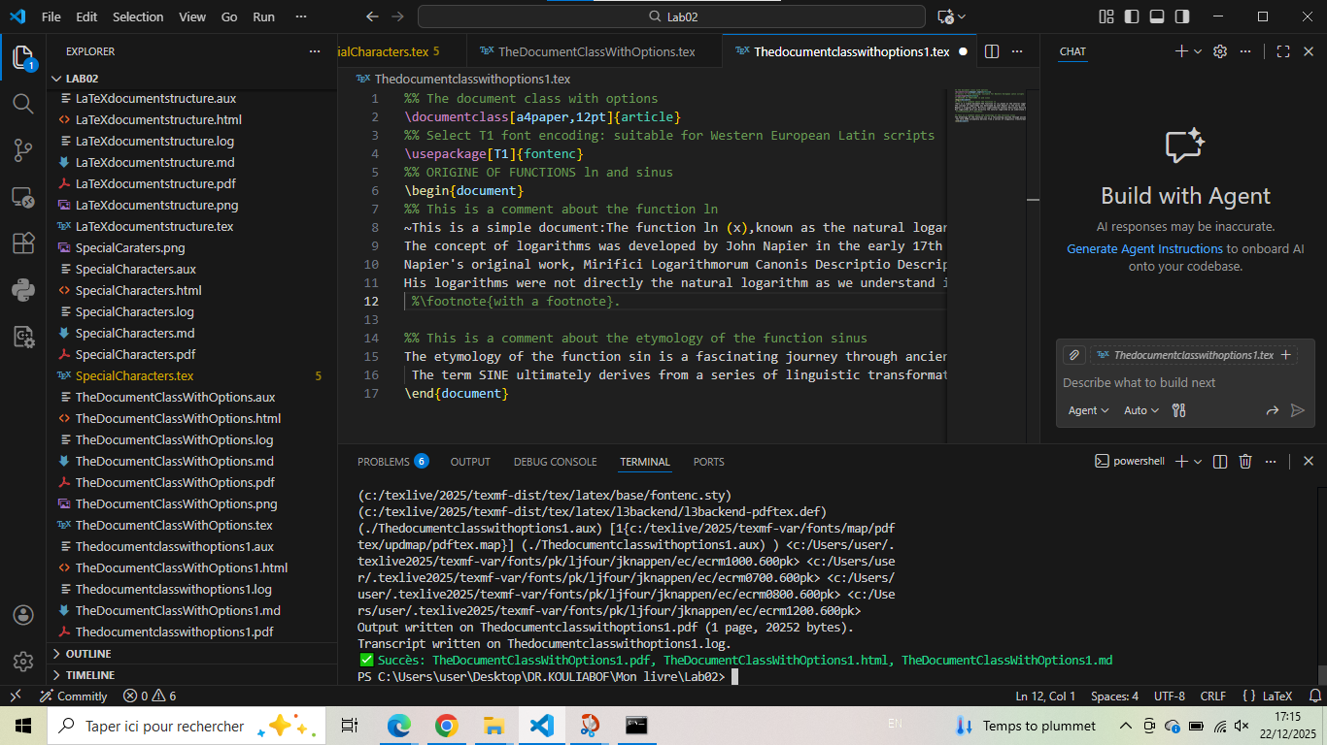

Conclusion: Methodology for creating successful LaTeX documents
After analysis of these basic LaTeX examples, here is the structured methodology for creating successful LaTeX documents:

1. Essential basic structure
\documentclass[a4paper,12pt]{article} % Document class with options
\usepackage[T1]{fontenc} % Font encoding
% Additional packages here
\begin{document}
% Document content here
\end{document}

2. Key concepts demonstrated
Concept | Syntax | Purpose
Document class | \documentclass[...]{...} | Defines document type and global options
Font encoding | \usepackage[T1]{fontenc} | Sets font encoding for proper character rendering
Comments | % Comment text | Non-printed notes in source code
Math mode | $...$ | For mathematical expressions and symbols
Special characters | \#, \%, \&, \$, \textasciitilde | Escape sequences for reserved characters
Greek letters | $\alpha, \beta, $ | Mathematical symbols in math mode
Final reminder: Mastering basic LaTeX document structure, special character handling, and document class options is the foundation for all advanced LaTeX work. These fundamental skills enable the creation of professional academic documents, from simple articles to complex books and presentations.

