LABORATORY03: Report and Presentation of work on Mathematical Mode
PELE TETE
December 2025

MathMode.tex - Basic Math Mode Introduction
\documentclass{article}
\usepackage[T1]{fontenc}
\begin{document}
A sentence with inline mathematics: $y = mx + c$.
A second sentence with inline mathematics: $5^{2}=3^{2}+4^{2}$.
%A second paragraph containing display math.
\[
y = mx + c
\]
%See how the paragraph continues after the display.
\end{document}

Generated figure
Basic inline and display math mode examples.

Screenshot
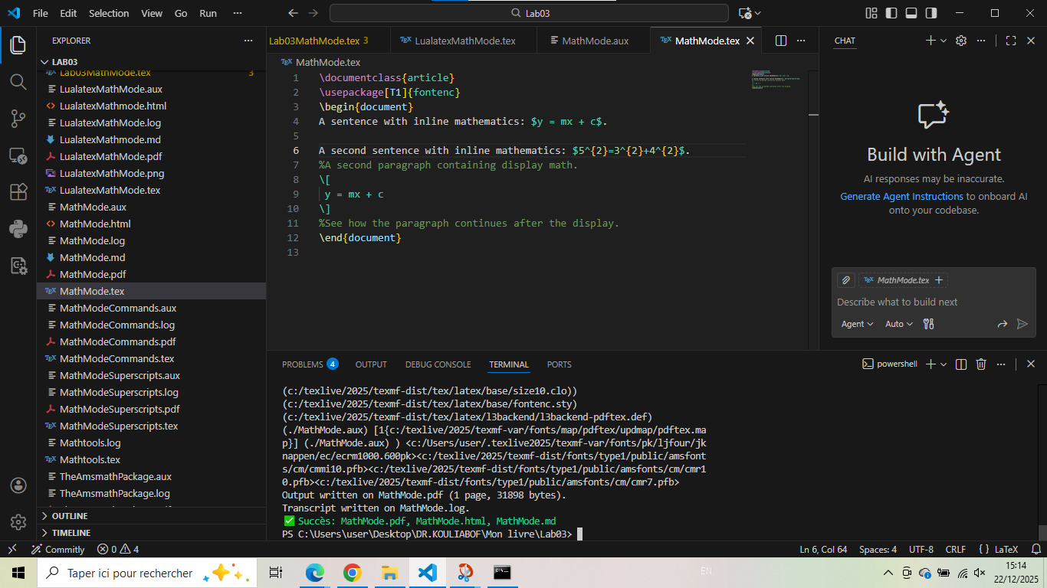

MathModeSuperscripts.tex - Superscripts and Subscripts
\documentclass{article}
\usepackage[T1]{fontenc}
\begin{document}
Superscripts $a^{b}$ and subscripts $a_{b}$.
\end{document}

Generated figure
Demonstration of superscript and subscript notation.

Screenshot
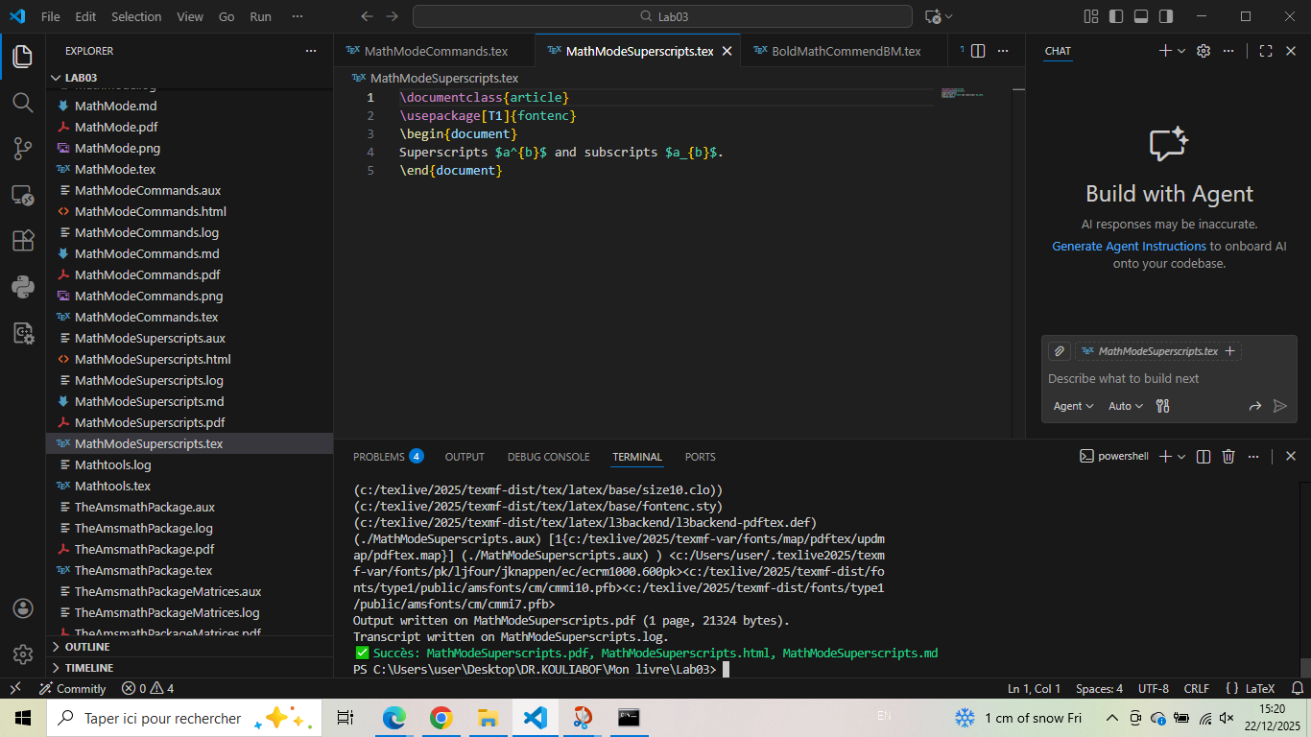

MathModeCommands.tex - Math Commands
\documentclass{article}
\usepackage[T1]{fontenc}
\begin{document}
Some mathematics: $y = 2 \sin \theta^{2}$.
\end{document}

Generated figure
Using mathematical functions like \sin and Greek letters.

Screenshot
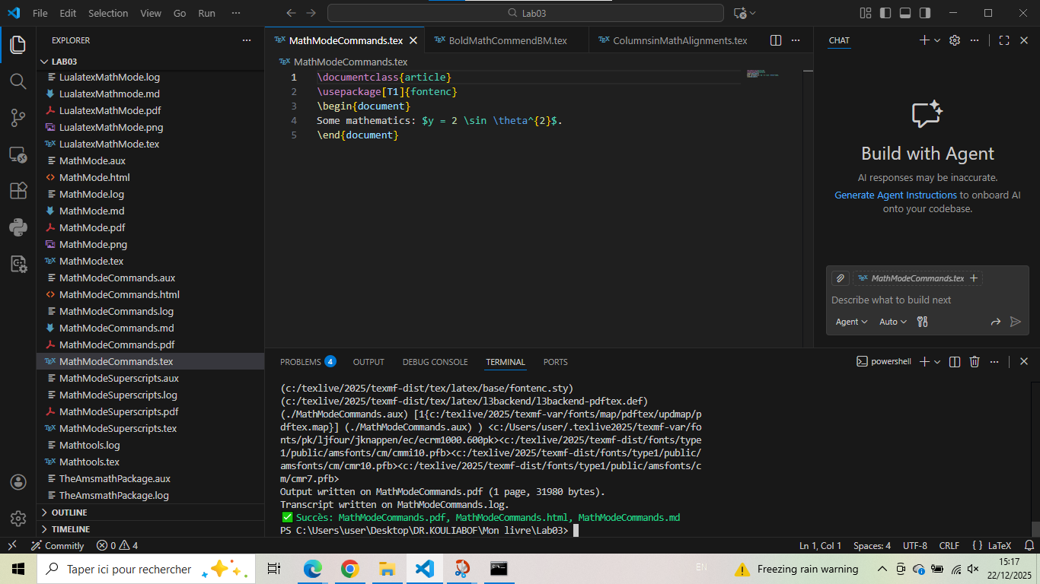

DisplayMathematics.tex - Display Mathematics
\documentclass{article}
\usepackage[T1]{fontenc}
\begin{document}
A paragraph about a larger equation
\[
\int_{-\infty}^{+\infty} e^{-x^2} \, dx
\]
\end{document}

Generated figure
Display math with integral and Gaussian function.

Screenshot
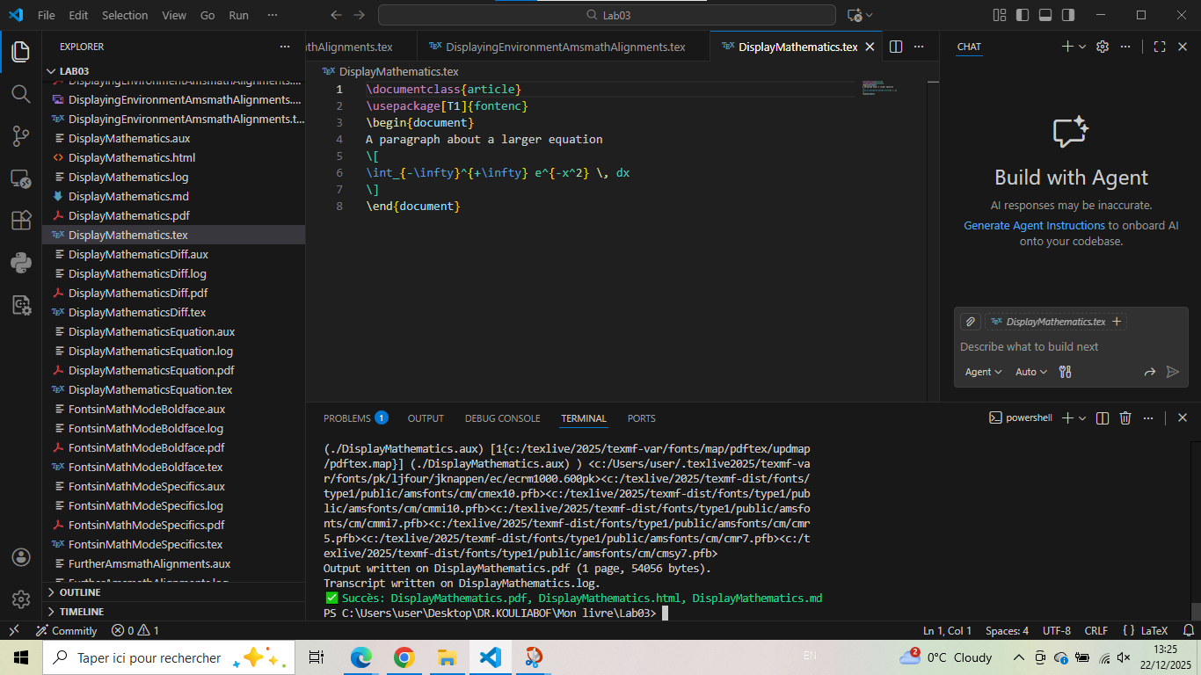

DisplayMathematicsEquation.tex - Numbered Equations
\documentclass{article}
\usepackage[T1]{fontenc}
\begin{document}
A paragraph about a larger equation
\begin{equation}
\int_{-\infty}^{+\infty} e^{-x^2} \, dx
\end{equation}
\end{document}

Generated figure
Numbered equation using equation environment.

Screenshot
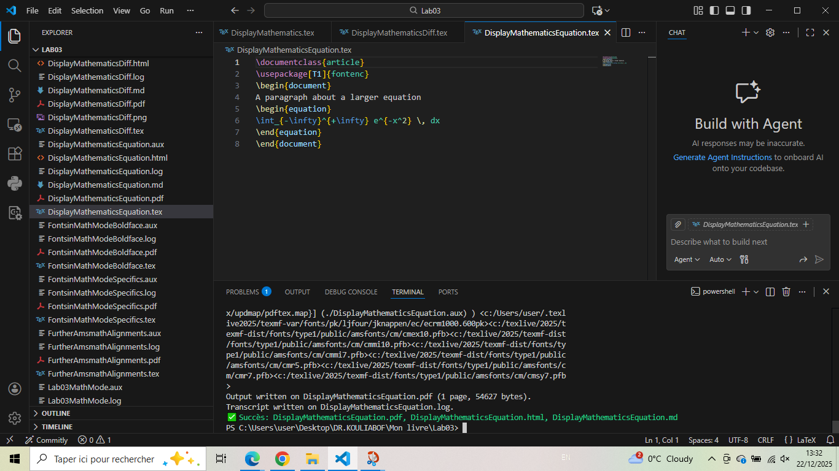

DisplayMathematicsDiff.tex - Custom Differential
\documentclass{article}
\usepackage[T1]{fontenc}
\newcommand{\diff}{\mathop{}\!d} % For italic
% \newcommand{\diff}{\mathop{}\!\mathrm{d}} % For upright
\begin{document}
A paragraph about a larger equation
\[
\int_{-\infty}^{+\infty} e^{-x^2} \diff x
\]
\end{document}

Generated figure
Custom differential command for better spacing.

Screenshot
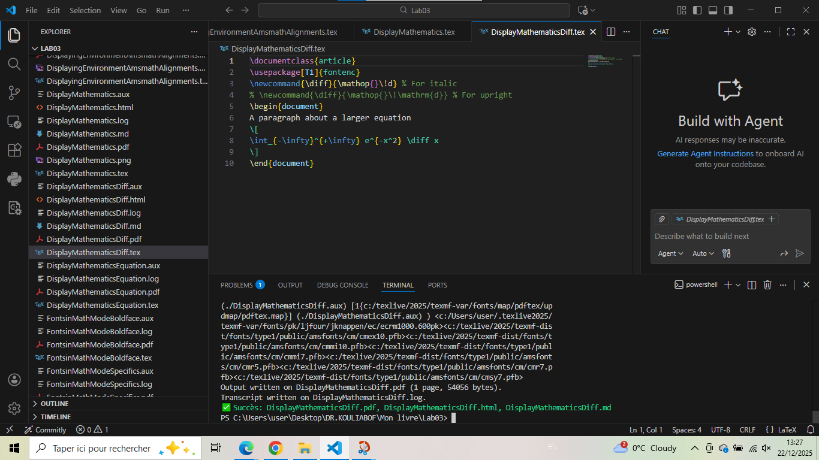

TheAmsmathPackage.tex - AMS Math Package Introduction
\documentclass{article}
\usepackage[T1]{fontenc}
\usepackage{amsmath}
\begin{document}
Solve the following recurrence for $ n,k\geq 0 $:
\begin{align*}
Q_{n,0} &= 1 \quad Q_{0,k} = [k=0]; \\
Q_{n,k} &= Q_{n-1,k}+Q_{n-1,k-1}+\binom{n}{k},\quad\text{for $n$, $k>0$.}
\end{align*}
\end{document}

Generated figure
AMS align environment for multi-line equations.

Screenshot
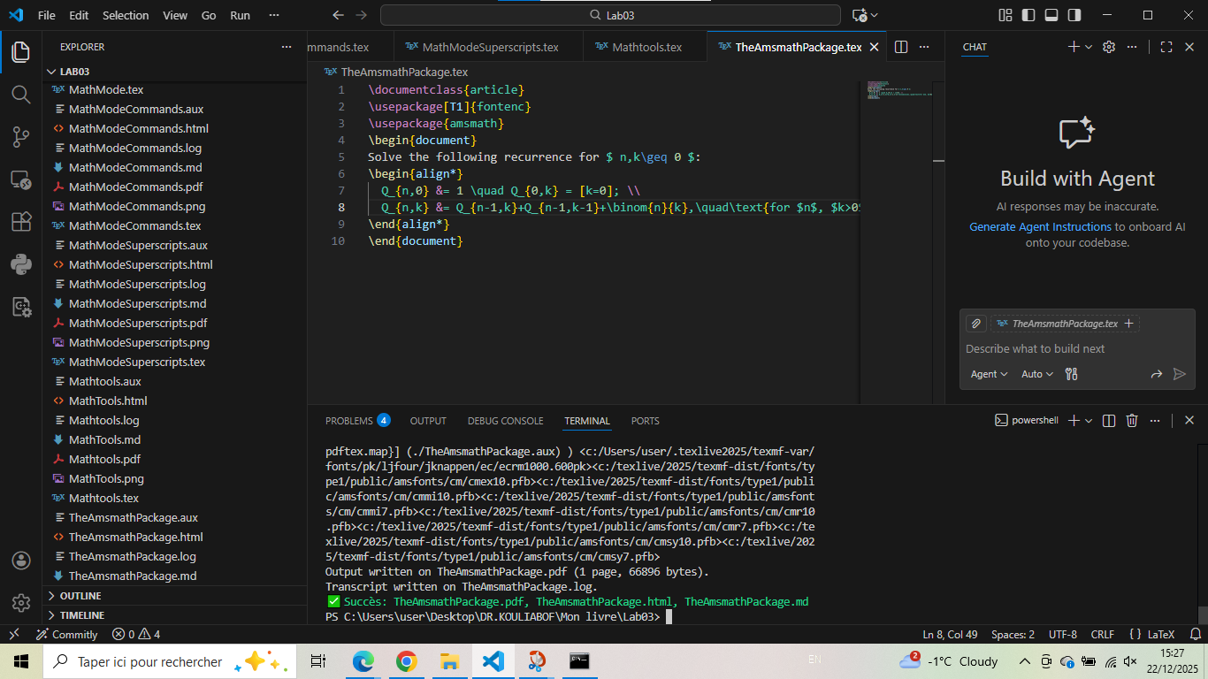

TheAmsmathPackageMatrices.tex - AMS Matrices
\documentclass{article}
\usepackage[T1]{fontenc}
\usepackage{amsmath}
\begin{document}
AMS matrices.
\[
\begin{matrix}
a & b & c \\
d & e & f
\end{matrix}
\quad
\begin{pmatrix}
a & b & c \\
d & e & f
\end{pmatrix}
\quad
\begin{bmatrix}
a & b & c \\
d & e & f
\end{bmatrix}
\]
\end{document}

Generated figure
Different matrix environments from amsmath.

Screenshot
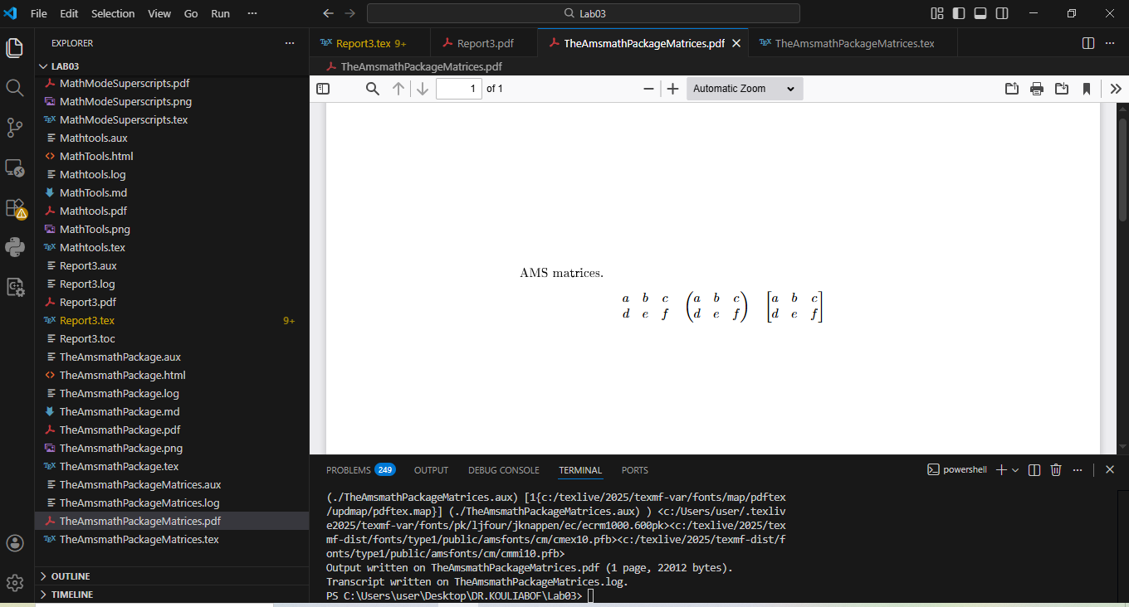

ColumnsinMathAlignments.tex - Column Alignments
\documentclass{article}
\usepackage[T1]{fontenc}
\usepackage{amsmath}
\begin{document}
Aligned equations
\begin{align*}
a &= b+1 & c &= d+2 & e &= f+3 \\
r &= s^{2} & t &=u^{3} & v &= w^{4}
\end{align*}
\end{document}

Generated figure
Multiple columns in align environment.

Screenshot
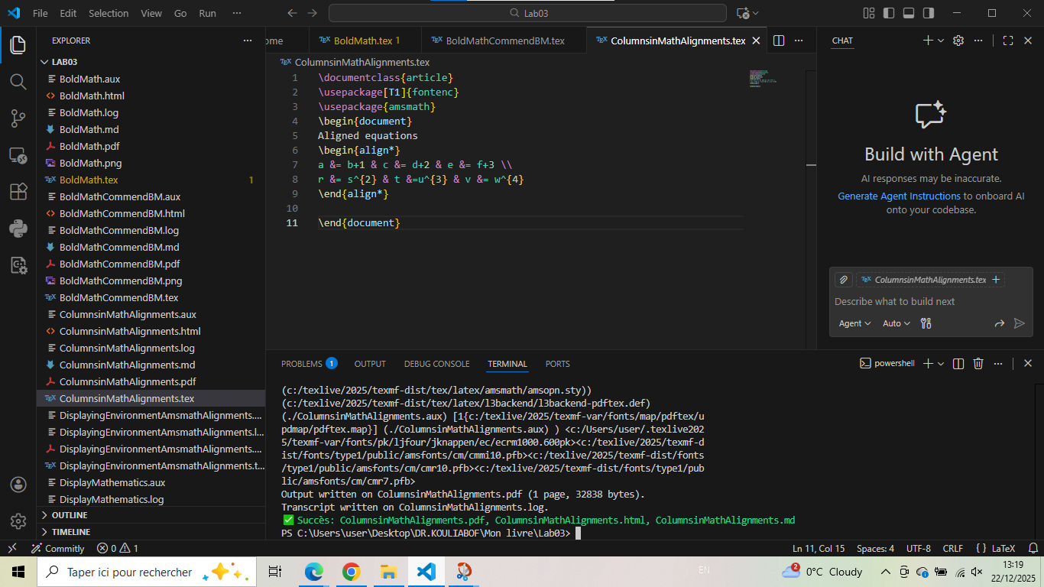

DisplayingEnvironmentAmsmathAlignments.tex - Aligned Subenvironment
\documentclass{article}
\usepackage[T1]{fontenc}
\usepackage{amsmath}
\begin{document}
\begin{itemize}
\item
$\begin{aligned}[t]
a&=b\\
c&=d
\end{aligned}$
\item
$\begin{aligned}
a&=b\\
c&=d
\end{aligned}$
\end{itemize}
\end{document}

Generated figure
Aligned subenvironment with vertical positioning.

Screenshot
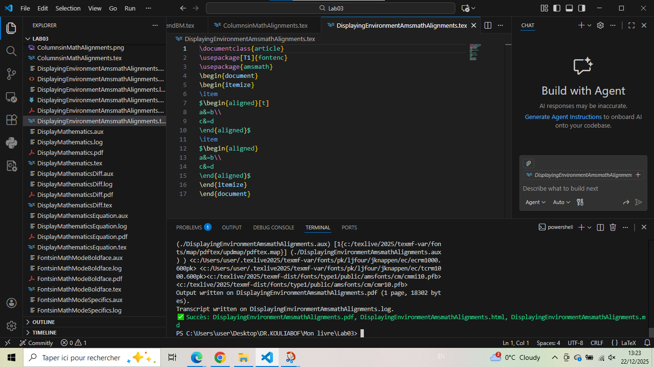

FurtherAmsmathAlignments.tex - Gather and Multline
\documentclass[a4paper]{article}
\usepackage[T1]{fontenc}
\usepackage{amsmath}
\begin{document}
Gather
\begin{gather}
P(x)=ax^{5}+bx^{4}+cx^{3}+dx^{2}+ex +f\\
x^2+x=10
\end{gather}
Multline
\begin{multline*}
(a+b+c+d)x^{5}+(b+c+d+e)x^{4} \\
+(c+d+e+f)x^{3}+(d+e+f+a)x^{2}+(e+f+a+b)x\\
+ (f+a+b+c)
\end{multline*}
\end{document}

Generated figure
Gather and multline environments for multi-line equations.

Screenshot
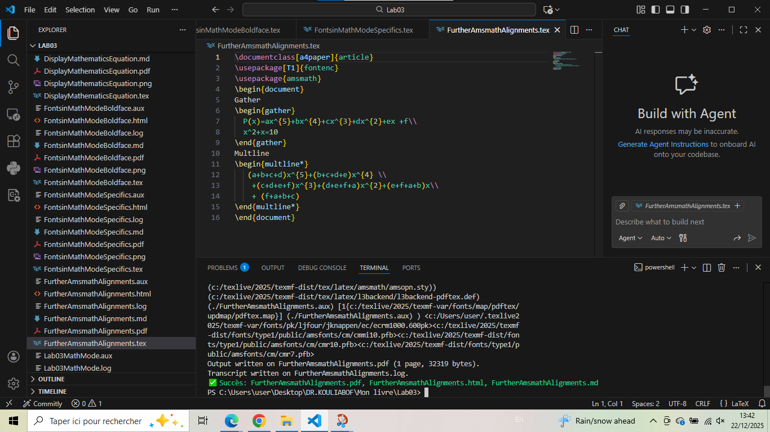

BoldMath.tex - Bold Mathematics
\documentclass[a4paper]{article}
\usepackage[T1]{fontenc}
\begin{document}
$(x+y)(x-y)=x^{2}-y^{2}$
{\boldmath $(x+y)(x-y)=x^{2}-y^{2}$ $\pi r^2$}
$(x+\mathbf{y})(x-\mathbf{y})=x^{2}-{\mathbf{y}}^{2}$
$\mathbf{\pi} r^2$ % bad use of \mathbf
\end{document}

Generated figure
Bold math using \boldsymbol and \mathbf.

Screenshot
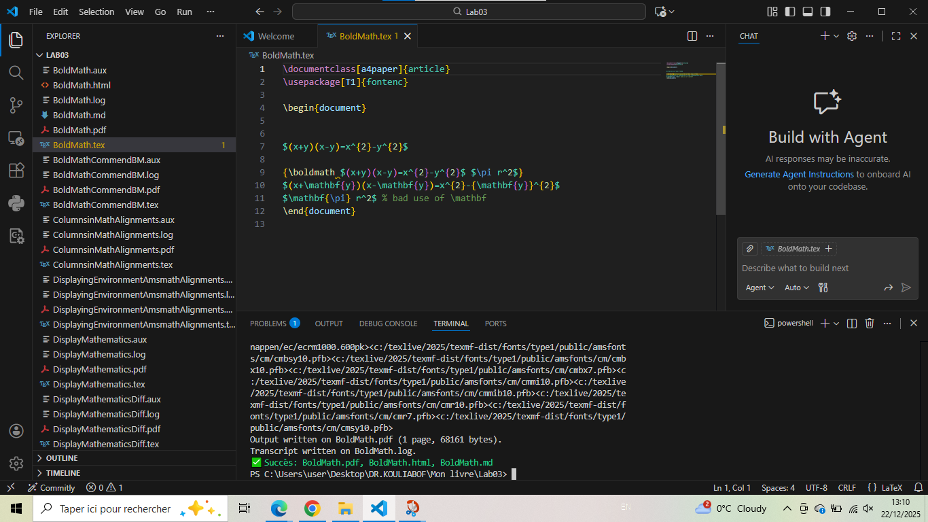

FontsinMathModeBoldface.tex - Boldface in Math
\documentclass{article}
\usepackage[T1]{fontenc}
\begin{document}
The matrix $\mathbf{M}$.
\end{document}

Generated figure
Bold math symbols.

Screenshot
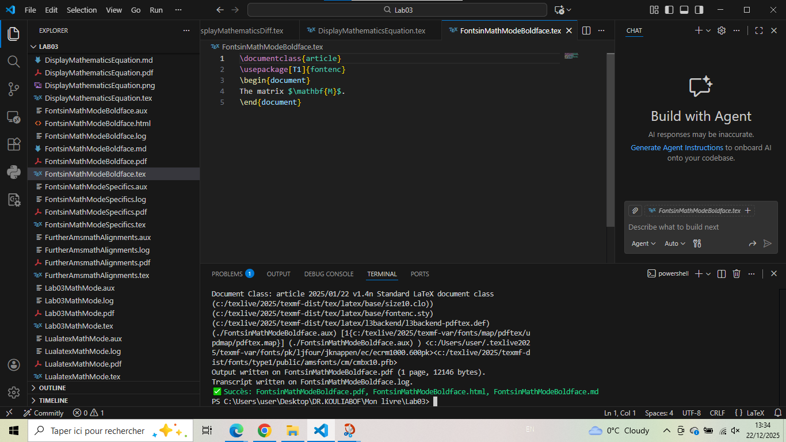

FontsinMathModeSpecifics.tex - Math Font Specifics
\documentclass{article}
\usepackage[T1]{fontenc}
\usepackage{amsmath}
\begin{document}
$\text{bad use } size \neq \mathit{size} \neq \mathrm{size} $
\textit{$\text{bad use } size \neq \mathit{size} \neq \mathrm{size} $}
\end{document}

Generated figure
Different math font styles.

Screenshot
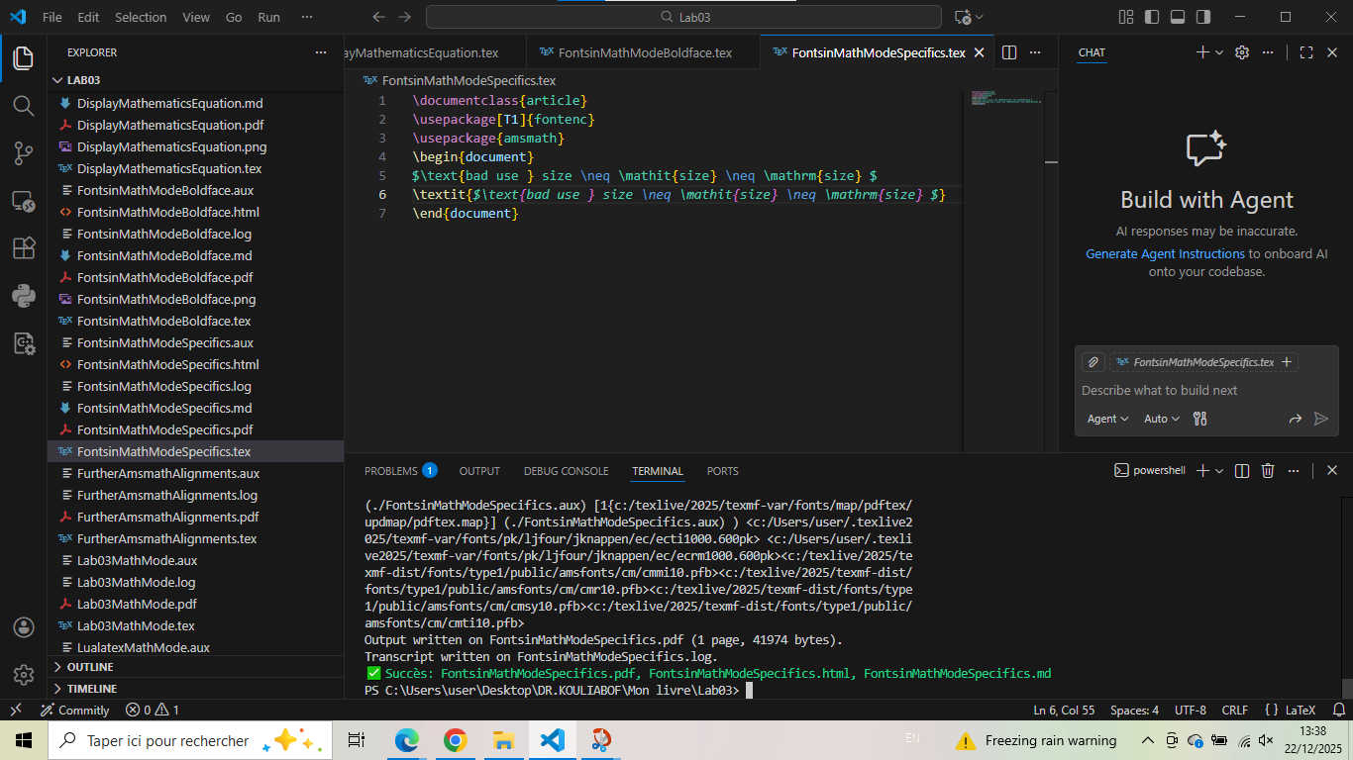

Mathtools.tex - Mathtools Package
\documentclass[a4paper]{article}
\usepackage[T1]{fontenc}
\usepackage{mathtools}
\begin{document}
\[
\begin{pmatrix*}[r]
10&11\\
1&2\\
5&-4
-5&-6
\end{pmatrix*}
\]
\end{document}

Generated figure
Mathtools package with starred matrix for alignment.

Screenshot
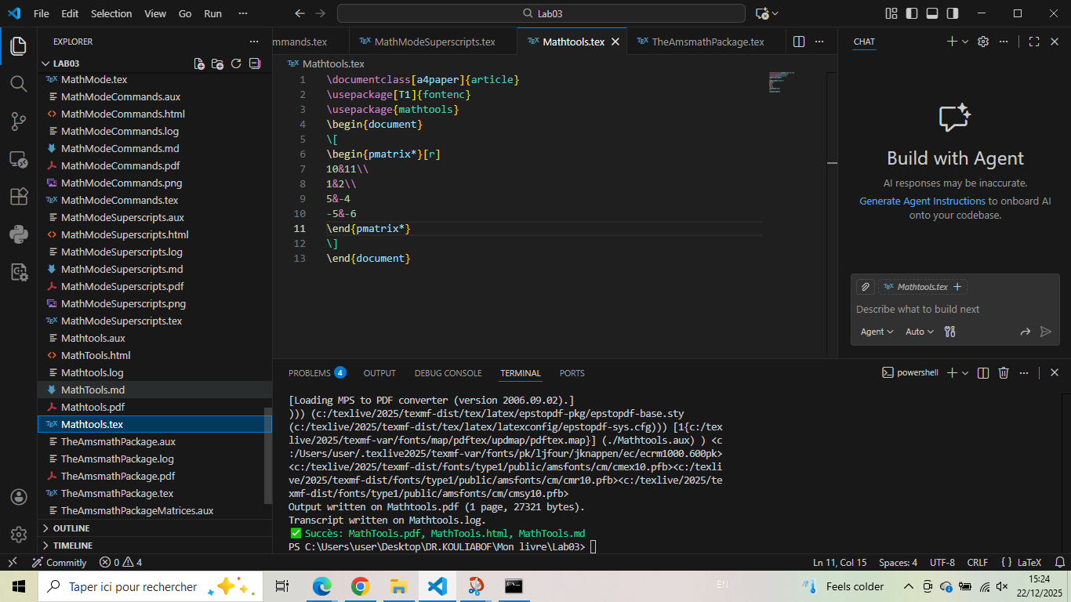

BoldMathCommendBM.tex - pmatrix* Environment
\documentclass[a4paper]{article}
\usepackage[T1]{fontenc}
\usepackage{mathtools}
\begin{document}
\[
\begin{pmatrix*}[r]
10&11\\
1&2\\
-5&-6
\end{pmatrix*}
\]
\end{document}

Generated figure
Matrix with right-aligned negative numbers.

Screenshot
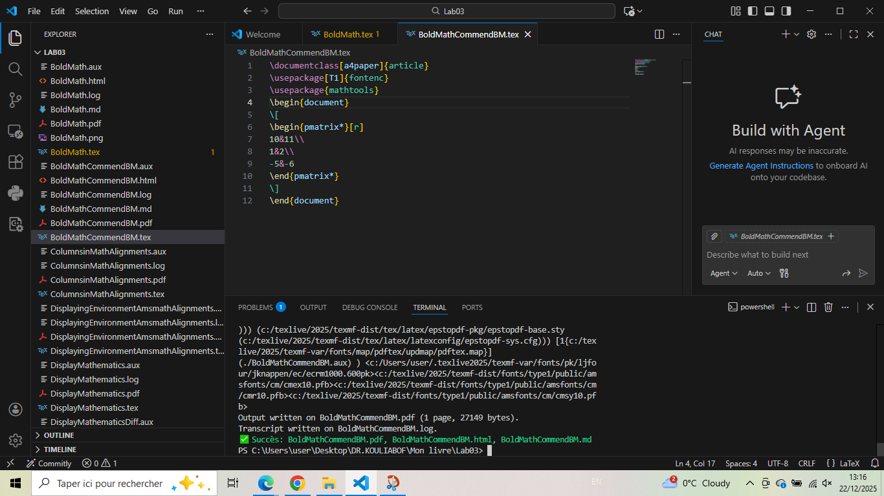

LualatexMathMode.tex - Unicode Math with LuaLaTeX
\documentclass[a4paper]{article}
\usepackage{unicode-math}
\setmainfont{TeX Gyre Pagella}
\setmathfont{TeX Gyre Pagella Math}
\begin{document}
One two three
\[
\log \alpha + \log \beta = \log(\alpha\beta)
\]
Unicode Math Alphanumerics
\[A + \symfrak{A}+\symbf{A}+ \symcal{A} + \symscr{A}+\symbb{A}\]
\end{document}

Generated figure
LuaLaTeX with unicode-math for modern font handling.

Screenshot
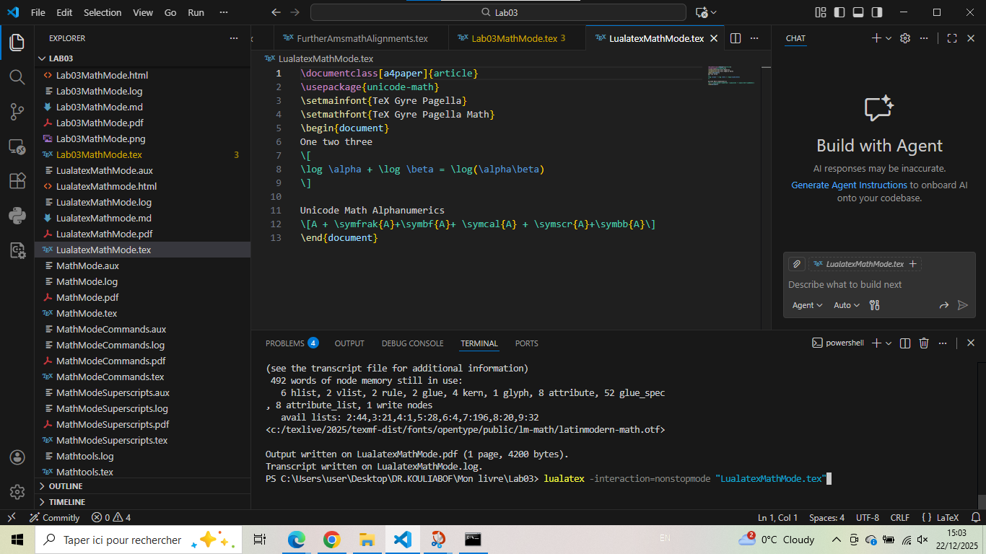

Lab03MathMode.tex - Comprehensive Lab Examples
\documentclass{article}
\usepackage[T1]{fontenc}
\begin{document}
%% 3-1) Math Mode
A sentence with inline mathematics: $y = mx + c$.
A second sentence with inline mathematics: $5^{2}=3^{2}+4^{2}$.
A second paragraph containing display math.
\[
y = mx + c
\]
See how the paragraph continues after the display.
\end{document}
\textasciitilde
%% 3-2) Examples where simple super- and subscripts are entered without braces
\usepackage[T1]{fontenc}
\begin{document}
Superscripts $a^{b}$ and subscripts $a_{b}$.
\end{document}
\textasciitilde
documentclass[a4paper]{article}
\usepackage[T1]{fontenc}
\usepackage{mathtools}
\begin{document}
\[
\begin{pmatrix*}[r]
10&11\\
1&2\\
-5&-6
\end{pmatrix*}
\]
\end{document}
\end{document}

Generated figure
Multiple examples combined from laboratory exercises.

Screenshot
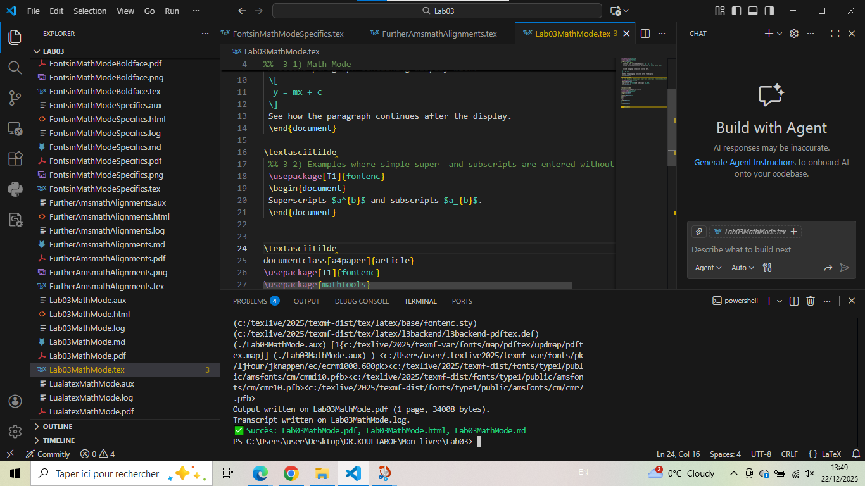

Conclusion: Methodology for Mathematical Typesetting
After comprehensive analysis of mathematical mode examples, here is the structured methodology for effective mathematical typesetting in LaTeX:

1. Essential math mode structures
% Inline math: $...$ or \(...\)
$E = mc^2$
% Display math unnumbered: \[...\]
\[
\int_a^b f(x)\,dx
\]
% Display math numbered: \begin{equation}...\end{equation}
\begin{equation}
\sum_{i=1}^n i = \frac{n(n+1)}{2}
\end{equation}
% Multi-line equations: \begin{align}...\end{align}
\begin{align}
x &= y + z \\
u &= v + w
\end{align}

2. Math mode environments comparison
Environment | Package | Purpose
equation | amsmath | Numbered single equation
align | amsmath | Multi-line alignment with multiple columns
gather | amsmath | Multi-line equations without alignment
multline | amsmath | Single equation split over multiple lines
matrix | amsmath | Unbracketed matrix
pmatrix | amsmath | Matrix with parentheses
bmatrix | amsmath | Matrix with square brackets
pmatrix* | mathtools | Matrix with column alignment options
aligned | amsmath | Subenvironment for blocks within other math

5. Essential practices
Best practices for mathematical typesetting:
1. Always use math mode for mathematics: Never use regular text for mathematical symbols
2. Load amsmath: It’s essential for professional math typesetting
3. Use appropriate brackets: For matrices, choose the right bracket style
4. Be careful with bold: Use \mathbf for variables, \boldsymbol for symbols
5. Differentiate d and e: Consider upright d for differential, italic e for Euler’s number
6. Align at equals signs: Use & in align environments
7. Label important equations: Use \label and \ref for cross-referencing
Final : Mastering mathematical typesetting is essential for scientific writing. Start with simple inline math, progress to displayed equations, then advance to multi-line alignments and matrices. Always use the appropriate packages (amsmath, mathtools) and choose the compilation engine that best suits your needs. Well-formatted mathematics enhances readability and professionalism of academic documents.

