LABORATORY04: Report and Presentation of work on Graphics and Floats
PELE TETE
December 2025

l4-1a.tex - Basic Image Inclusion
\documentclass{article}
\usepackage[T1]{fontenc}
\usepackage{graphicx}
\begin{document}
This picture.
\begin{center}
\includegraphics[height=6cm]{faucon.jpg}
\end{center}
is an imported PDF
\end{document}

Generated figure
Basic image inclusion with fixed height.

Screenshot
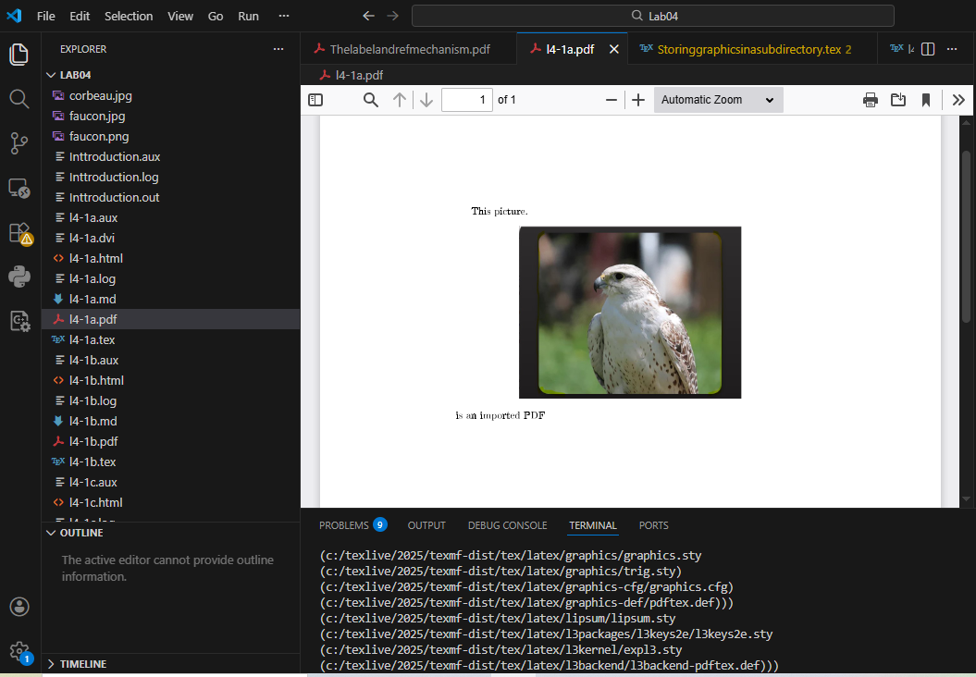

Analysis
This document demonstrates:
- Loading the graphicx package for image support
- Using \includegraphics[height=6cm]{faucon.jpg} to set fixed height
- Centering the image with center environment

l4-1b.tex - Relative Dimensions
\documentclass{article}
\usepackage[T1]{fontenc}
\usepackage{graphicx}
\begin{document}
\begin{center}
\includegraphics[height = 5cm\textheight]{faucon.jpg}
\end{center}
Here you can see faucon in the first image and corbeau in the second
\begin{center}
\includegraphics[width = 6cm\textwidth]{corbeau.jpg}
\end{center}
\end{document}

Generated figure
Images sized relative to text height and text width.

Screenshot
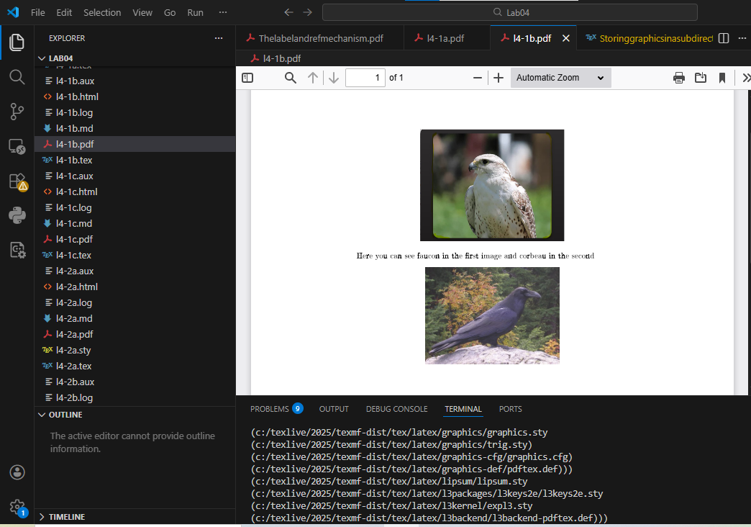

Analysis
This document demonstrates:
- Relative sizing: height = 5cm\textheight
- Relative sizing: width = 6cm\textwidth
- Two images (faucon and corbeau) in the same document

l4-1c.tex - Clipping and Trimming
\documentclass{article}
\usepackage[T1]{fontenc}
\usepackage{graphicx}
\begin{document}
\begin{center}
\includegraphics[clip, trim = 0 0 60 70]{faucon.png}
\end{center}
\end{document}

Generated figure
Image with clipping and trimming.

Screenshot
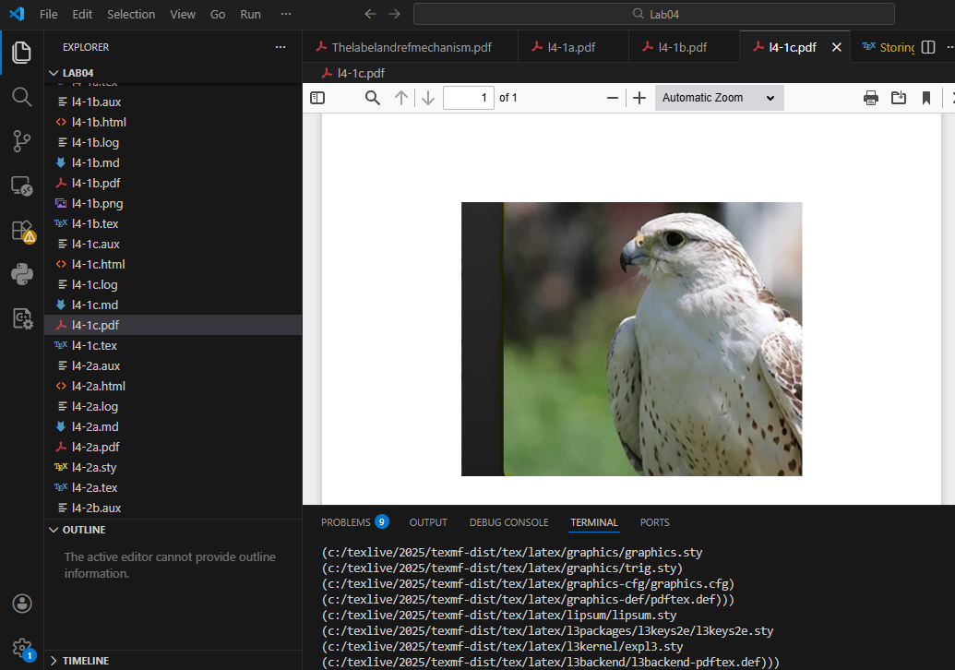

Analysis
This document demonstrates:
- clip option to enable trimming
- trim = left bottom right top to crop image edges
- Removing 60pt from right and 70pt from bottom

l4-2a.tex - Figure Environment with Captions
\documentclass{article}
\usepackage[T1]{fontenc}
\usepackage{graphicx}
\begin{document}
Test location.
\begin{figure}[ht]
\centering
\includegraphics[width=0.8\textwidth]{faucon.jpg}
\caption{faucon en haut}
\includegraphics[height=5cm]{corbeau.jpg}
\caption{corbeau en bas}
\end{figure}
\end{document}

Generated figure
Float environment with multiple images and captions.

Screenshot
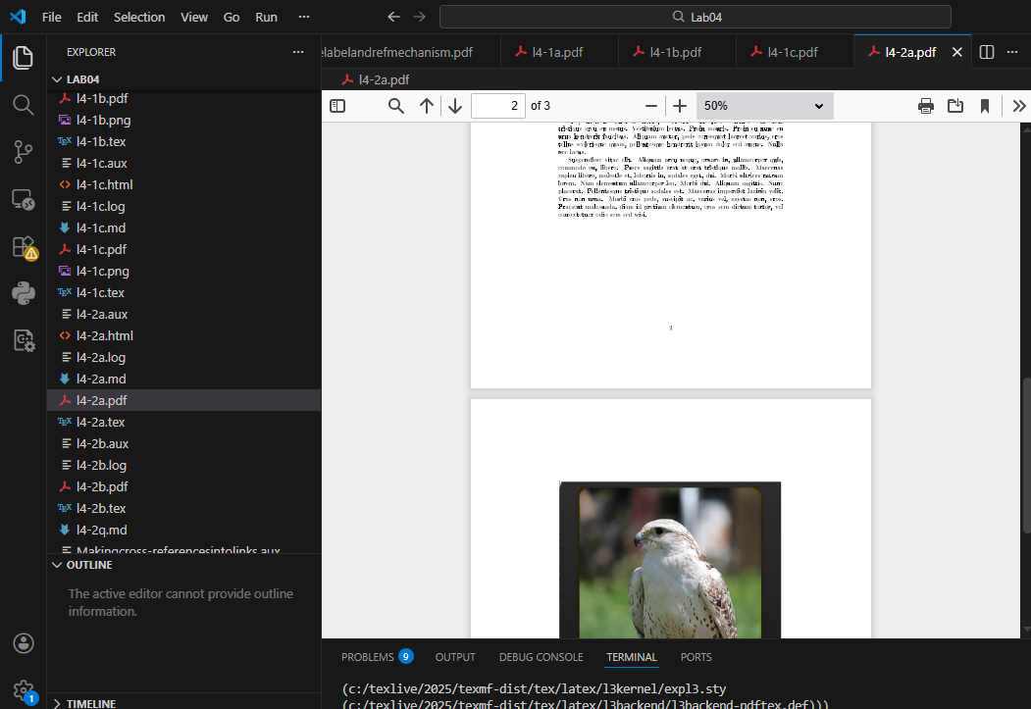

Analysis
This document demonstrates:
- figure float environment with placement specifier [ht]
- \centering for horizontal alignment
- \caption for figure descriptions
- Multiple images in a single float

l4-2b.tex - Float Placement Options
\documentclass{article}
\usepackage[T1]{fontenc}
\usepackage{graphicx}
\begin{document}
Some text before the figure.
\begin{figure}[h]
\centering
\includegraphics[width=0.5\textwidth]{corbeau.jpg}
\caption{corbeau}
\end{figure}
More text after the figure.
\end{document}

Generated figure
Float placement with [h] option.

Screenshot
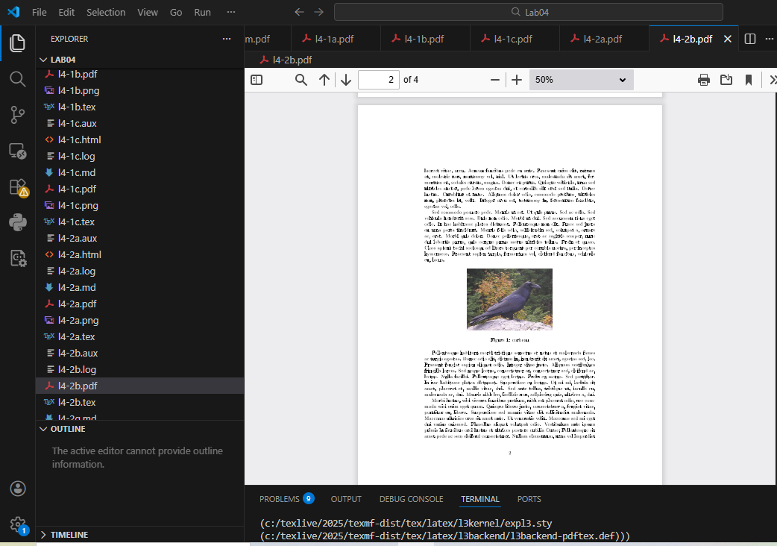

Analysis
This document demonstrates:
- [h] placement specifier for "here"
- Width specified as 0.5\textwidth
- Basic figure float structure

Thelabelandrefmechanism.tex - Labels and References
\documentclass{article}
\usepackage[T1]{fontenc}
\begin{document}
\section{Introduction}
Some exciting text with a reference~\ref{sec:next}.
\section{Next thing}
\label{sec:next}
More text here.
\end{document}

Generated figure
Cross-referencing mechanism.

Screenshot
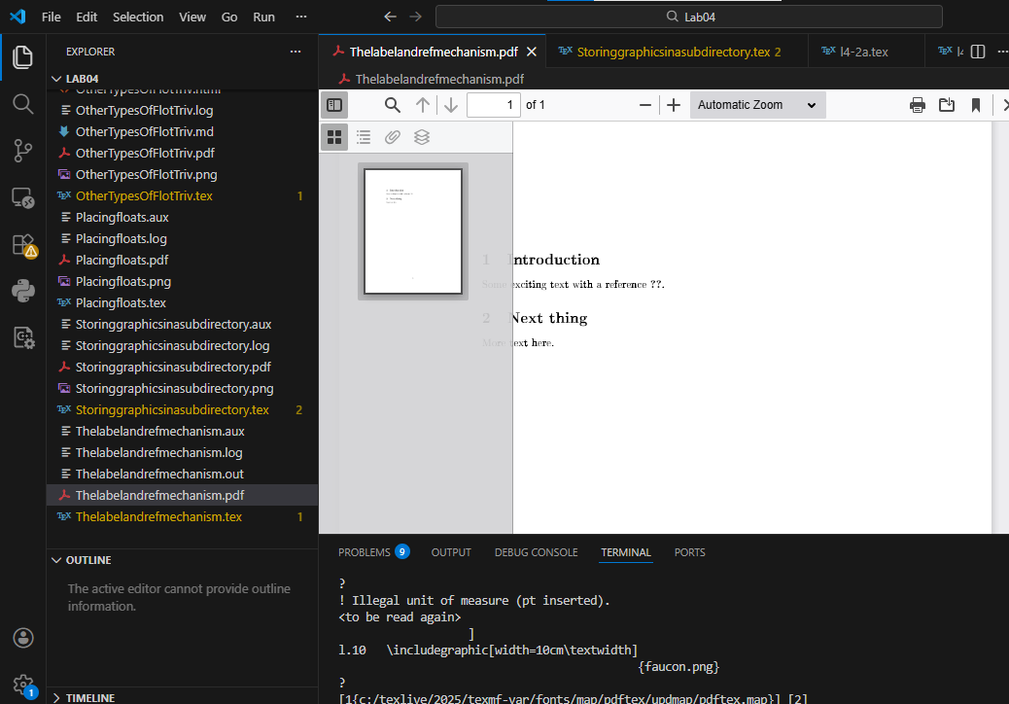

Analysis
This document demonstrates:
- \label{sec:next} to mark a section
- \ref{sec:next} to reference it
- Automatic numbering and cross-referencing
- Requires two compilation passes

Makingcross-referencesintolinks.tex - References with Figures
\documentclass{article}
\usepackage[T1]{fontenc}
\usepackage{graphicx}
\begin{document}
\section{Introduction}
Some exciting text with a reference to Section~\ref{sec:next}.
\section{corbeau et faucon}
\label{sec:next}
\begin{figure}[ht]
\centering
\includegraphics[width=0.8\textwidth]{faucon.jpg}
\caption{faucon en haut}
\includegraphics[height=5cm]{corbeau.jpg}
\caption{corbeau en bas}
\end{figure}
More text here.
\end{document}

Generated figure
Combined cross-references and figures.

Screenshot
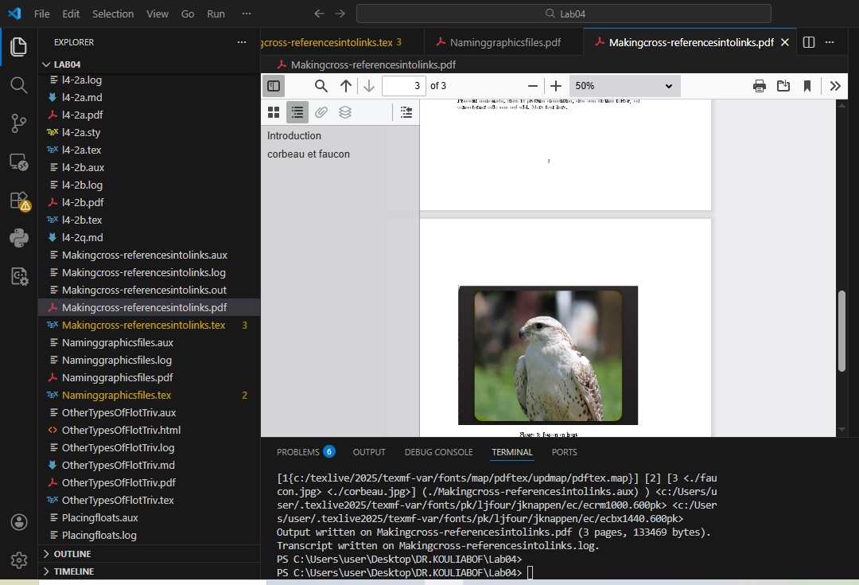

Analysis
This document demonstrates:
- Integration of cross-references with figures
- Section label and reference
- Multiple images with captions in float
- Complete document structure

Naminggraphicsfiles.tex - File Naming Issues
\documentclass{article}
\usepackage[T1]{fontenc}
\usepackage{graphicx}
\begin{document}
Test location
\begin{figure}[ht]
\centering
\includegraphics[width=0.6\textwidth]{faucon.png}
\caption{faucon.png}
\includegraphics[width=0.3\textwidth]{pix/faucon.jpg}
\end{figure}
\end{document}

Generated figure
Image file naming and path issues.

Screenshot
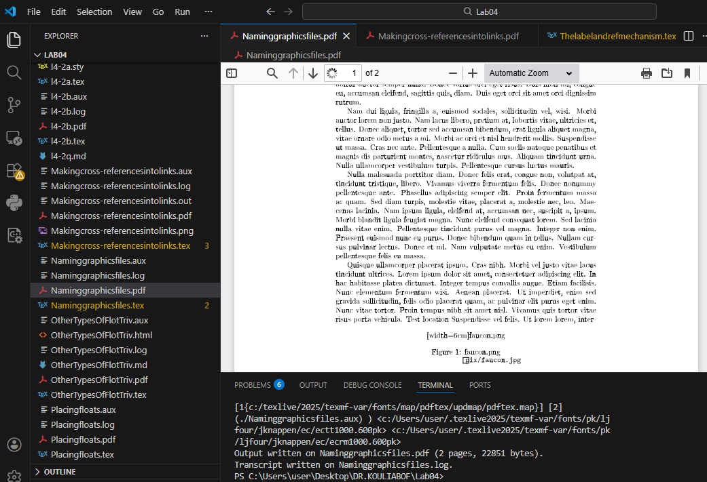

Analysis
This document demonstrates:
- Subdirectory path: pix/faucon.jpg
- Different image formats (.png, .jpg)
- Multiple images in same figure

Storinggraphicsinasubdirectory.tex - Graphics Path
\documentclass{article}
\usepackage[T1]{fontenc}
\usepackage{graphicx}
\graphicspath{{figs/}{pics/}}
\begin{document}
Test location
\begin{figure}[ht]
\centering
\includegraphics[width=0.6\textwidth]{faucon.png}
\caption{faucon.png}
\end{figure}
\end{document}

Generated figure
Setting graphics search path.

Screenshot
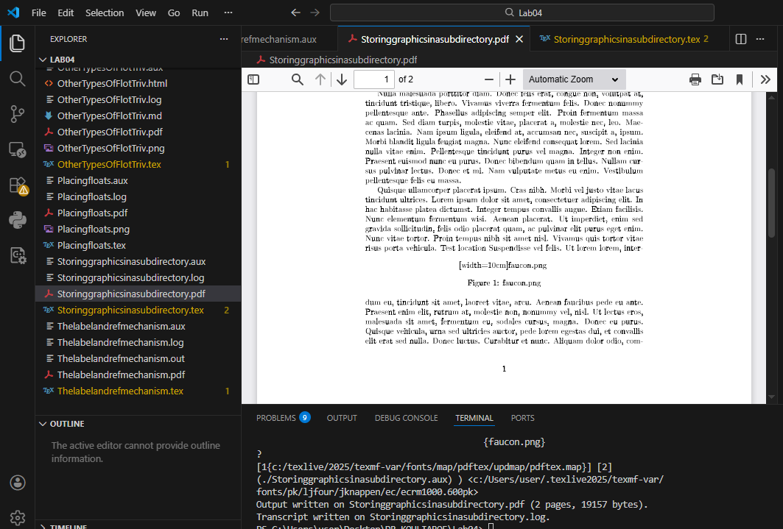

Analysis
This document demonstrates:
- \graphicspath{{figs/}{pics/}} to set search directories
- Organizing images in subdirectories
- Path specification syntax

Placingfloats.tex - Basic Float Placement
\documentclass{article}
\usepackage[T1]{fontenc}
\usepackage{graphicx}
\begin{document}
\begin{figure}[htbp]
\centering
\includegraphics[width=0.7\textwidth]{faucon.png}
\caption{faucon.png}
\end{figure}
\end{document}

Generated figure
Basic float placement options.

Screenshot
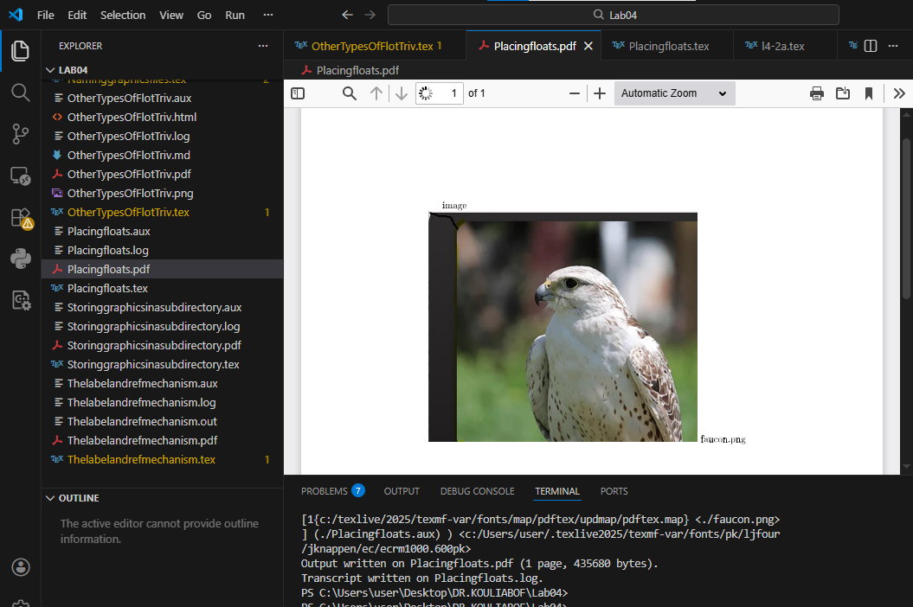

Analysis
This document demonstrates:
- Standard figure environment
- Placement specifier [htbp]
- \centering for alignment
- Caption with description

OtherTypesOfFlotTriv.tex - Custom Float Types
\documentclass{article}
\usepackage[T1]{fontenc}
\usepackage{graphicx}
\newfloat{image}{htbp}{loi}
\usepackage{float}
\begin{document}
\begin{image}
\centering
\includegraphics[width=0.7\textwidth]{faucon.png}
\caption{faucon.png}
\end{image}
\begin{image}
\centering
\includegraphics[width=0.7\textwidth]{corbeau.jpg}
\caption{corbeau.jpg}
\end{image}
\end{document}

Generated figure
Custom float types.

Screenshot
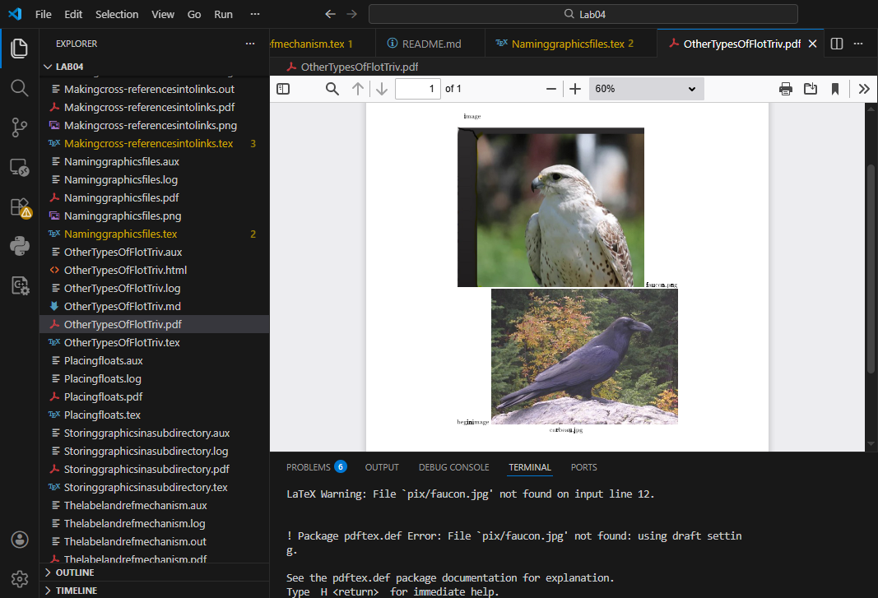

Analysis
This document demonstrates:
- Custom float type image
- \centering for alignment
- Sequential caption numbering
- Different image formats in same float type

Conclusion: Methodology for Graphics and Floats
After comprehensive analysis of graphics and float examples, here is the structured methodology for effectively including images and managing floats in LaTeX:

1. Essential graphics inclusion structure
\documentclass{article}
\usepackage{graphicx} % Required for images
\begin{document}
% Basic image inclusion
\includegraphics[width=0.5\textwidth]{image.jpg}
% Figure float with caption
\begin{figure}[htbp]
\centering
\includegraphics[height=5cm]{image.png}
\caption{Description of image}
\label{fig:label}
\end{figure}
% Cross-reference to figure
As shown in Figure~\ref{fig:label}...
\end{document}

2. Key commands and options
Command/Option | Syntax | Purpose
\includegraphics | \includegraphics[keyvals]{file} | Include image with options
Width option | width=0.5\textwidth | Scale relative to text width
Height option | height=5cm | Set fixed height
Scale option | scale=0.75 | Scale factor
Trim/Clip | clip, trim= l b r t | Crop image edges
Graphics path | \graphicspath{{subdir/}} | Set search directories
\caption | \caption{text} | Add caption to float
\label | \label{fig:name} | Mark for referencing
\ref | \ref{fig:name} | Reference by number

3. Float placement specifiers
Specifier | Meaning
h | Here - approximately at this point in the text
t | Top - at the top of a page
b | Bottom - at the bottom of a page
p | Page - on a separate float page
! | Override - ignore certain restrictions

