LABORATORY06: Report and Presentation of work on Bibliography and Citations
PELE TETE
December 2025

TheBibLaTeXWorkFlowWithNatbib - BibLaTeX and Natbib Workflow
---
bibliography:
- learnlatex.bib
---
The mathematics showcase is from [@Graham1995]. Some more complex citations: [@Graham1995] or @Thomas2008 or possibly . [@Thomas2008 56] [See @Graham1995 45-48] Together [@Thomas2008; @Graham1995]

Generated figure (simulation)
Markdown document with BibLaTeX citations.

Imported image
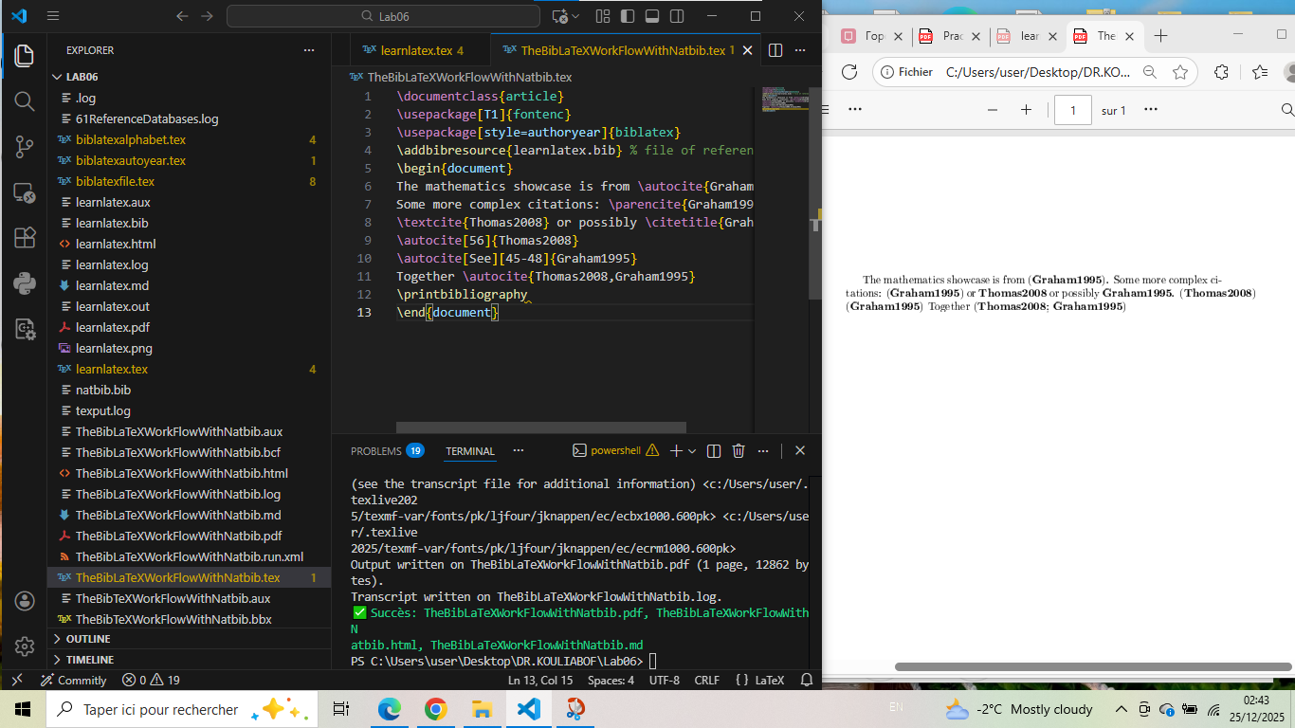

learnlatex - Basic Bibliography Document
---
bibliography:
- Pratical scientific dissertation KOULYABOV C.bib
title: Mon Document avec Bibliographie
---
# Introduction
This document demonstrates how to use a bibliography with LaTeX.
# Citations
Here somes citations:
## scientifics Articles
L'article de Thomas et al. [@Thomas2008] studies iron complexes for
hydrogenase modeling. This research is important for understanding the
redox properties of catalysts.
## Livre de référence
Le livre *Concrete Mathematics* of Graham, Knuth and Patashnik
[@Graham1995] is an essential reference in discrete and concrete
mathematics.
# Conclusion
Les références bibliographiques sont essentielles pour tout travail
académique.

Generated figure (simulation)
Bilingual document with bibliography references.

Screenshot
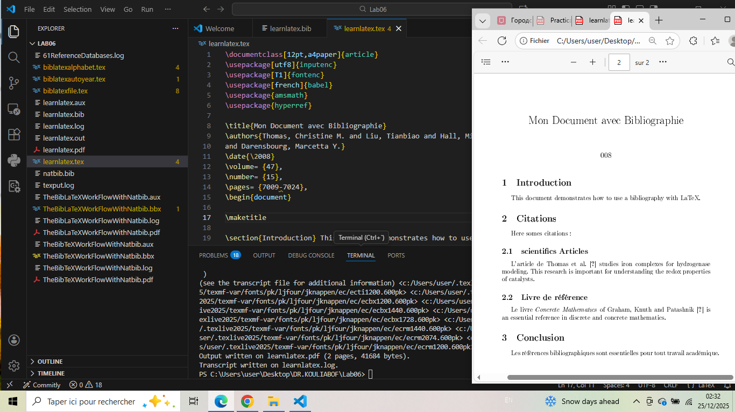

exolatexnatbib - NatBib Examples
---
author:
- Votre Nom
bibliography:
- references.bib
date: 2025-12-25
title: Exemple avec NatBib
---
# Test avec NatBib (Pele T. Koulyabov C. Konstantin L. -2025)
## Citations
Voici quelques citations de notre base de données:
- Citation simple: @Thomas2008
- Citation entre parenthèses: [@Graham1995]
- Citation avec pages: [@Thomas2008 pp. 7010-7015]
- Multiple citations: [@Thomas2008; @Smith2020; @Doe2019]
## Citation qui n'existe pas
Essayons une citation qui n'est pas dans la base: @Nonexistent2023
## New enter
référence dans le fichier .bib: [@Doe2019]

Generated figure
NatBib citation examples with metadata.

Screenshot
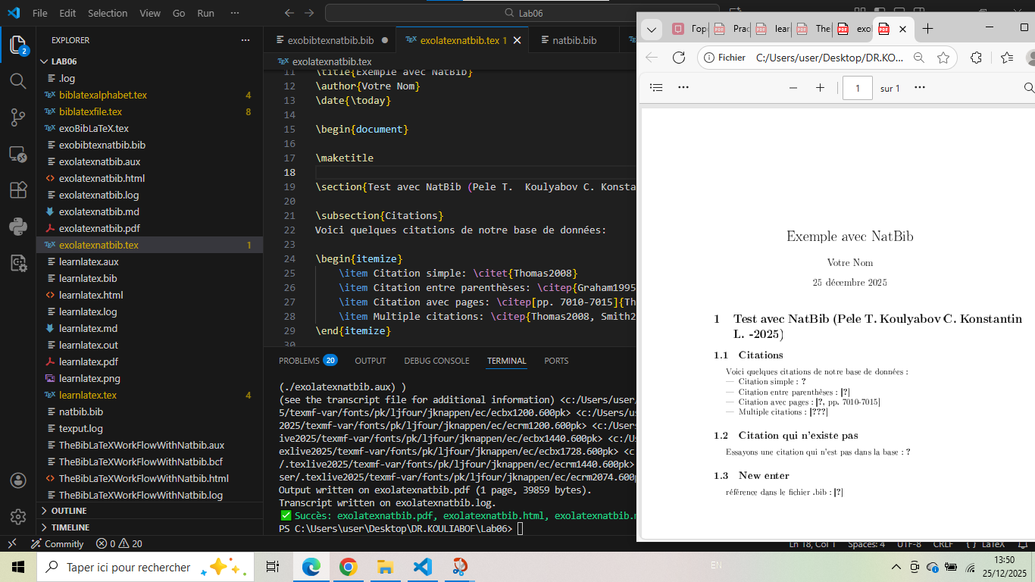

exoBibLaTeX - Comprehensive BibLaTeX Exercise
---
author:
- Votre Nom
bibliography:
- references.bib
date: 2025-12-25
title: Exercice Biblatex - Test Complet
---
# Introduction
Test complet de biblatex avec différentes fonctionnalités.
# Citations de base
## Citations simples
- Article: @Thomas2008
- Livre: [@Graham1995]
- Avec pages: [@Thomas2008 7010-7015]
- Multiple: [@Thomas2008; @Smith2020; @Doe2019]
## Commandes de citation avancées
- Auteur seulement: @Smith2020
- Année seulement: [-@Graham1995]
- Auteur et année: @Thomas2008 ([-@Thomas2008])
# Test de citations manquantes
Citation qui n'existe pas dans la base: @ReferenceManquante2025
# Ajout de nouvelles références
- Référence existante: [@Doe2019]
- Nouvelle référence (à ajouter au .bib): @NouveauLivre2024
# Comparaison des styles
Testez en changeant le style dans le préambule:
- `style=authoryear`: (Auteur, Année)
- `style=numeric`: \[1\], \[2\], \[3\]
- `style=alphabetic`: \[Tho08\], \[Gra95\]

Generated figure
Advanced BibLaTeX testing with style comparisons.

Screenshot
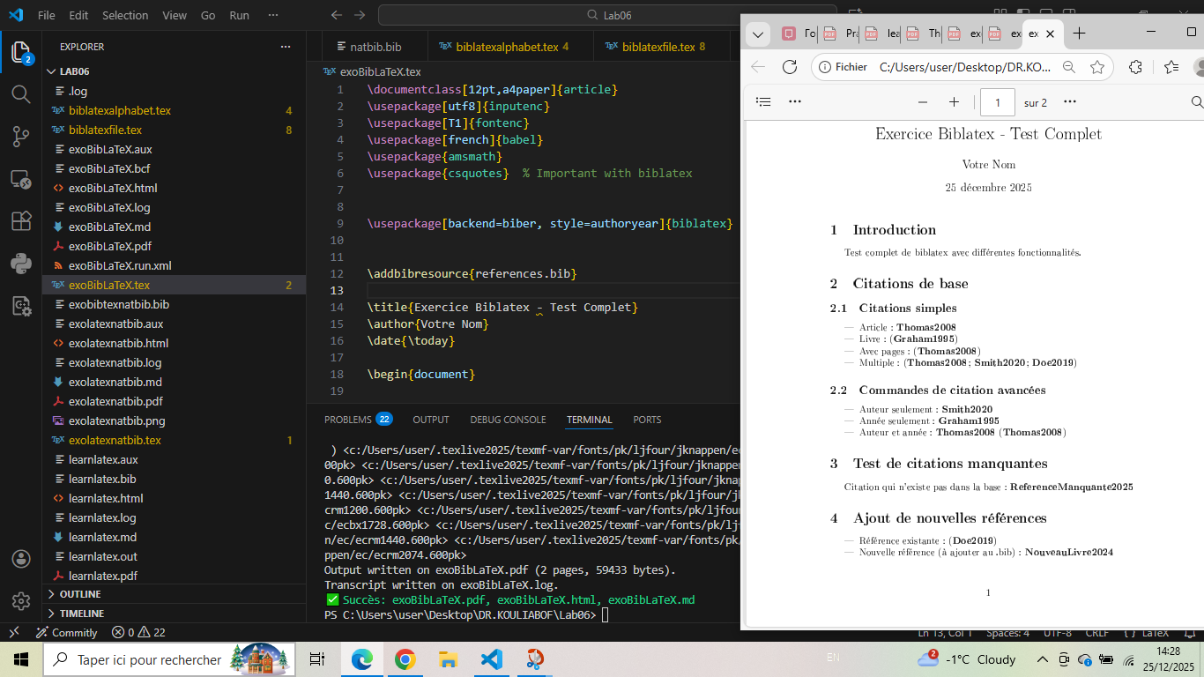

biblatexfile - BibLaTeX with Numerical Style
---
bibliography:
- references.bib
---
# Test biblatex avec style numérique {#test-biblatex-avec-style-numérique .unnumbered}
Voici quelques citations pour tester biblatex :
- Une citation simple [@Thomas2008]
- Une citation de livre [@Graham1995]
- Une citation de conférence [@Smith2020]
- Une citation multiple [@Thomas2008; @Graham1995; @Smith2020]
# Test d'une citation non existante {#test-dune-citation-non-existante .unnumbered}
Essayons de citer quelque chose qui n'existe pas dans la base : [@Unknown2023]
# Test avec un nouveau style {#test-avec-un-nouveau-style .unnumbered}
Nous pouvons facilement changer le style, par exemple en utilisant `style=alphabetic`.

Generated figure
BibLaTeX with numerical style and custom sections.

Screenshot
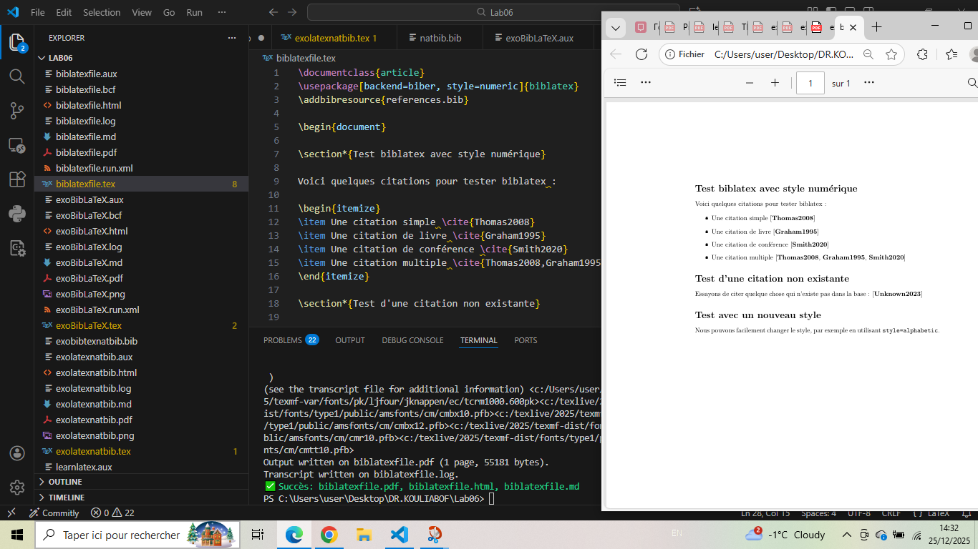

Conclusion: Methodology for Bibliographic Work
After analysis of bibliography and citation examples, here is the structured methodology for academic referencing:

1. Essential document structure for bibliographies
---
author:
- Your Name
title: Document Title
date: YYYY-MM-DD
bibliography:
- references.bib
---

2. Basic citation patterns
Type | BibLaTeX/Natbib | Description
Simple | @AuthorYear | In-text author citation
Parenthetical | [@AuthorYear] | Citation in brackets
With pages | [@AuthorYear pp. X-Y] | Citation with page range
Multiple | [@Author1; @Author2] | Multiple references
Author only | @AuthorYear | Cites author in text
Year only | [-@AuthorYear] | Cites only year

3. Recommended workflow
Step 1: Prepare bibliography file
- Create .bib file with references
- Use consistent formatting
- Include all required fields
Step 2: Document setup
- Specify bibliography file in YAML header
- Choose citation style
- Configure citation commands
Step 3: Cite references
- Use appropriate citation format
- Check reference existence
- Include page numbers when needed
Step 4: Generate bibliography
- Compile document
- Generate bibliography
- Verify citations

4. Best practices
Practice | Description
Consistent formatting | Same style throughout document
Complete references | All required fields in .bib entries
Regular updates | Keep bibliography current
Style compliance | Follow journal/format requirements
Error checking | Verify all citations resolve
Backup .bib files | Keep bibliography files safe

5. Common citation styles
Selecting the right style:
1. Authoryear: (Author, Year) - for humanities and social sciences
2. Numeric: [1], [2], [3] - for sciences and engineering
3. Alphabetic: [Gra95], [Tho08] - for specific journal requirements
4. Chicago: Author (Year) - for history and some social sciences

6. Troubleshooting guide
- Missing citations: Check .bib file entries and compilation order
- Formatting errors: Verify style package compatibility
- Duplicate entries: Use unique keys for each reference
- Unresolved citations: Ensure citation keys match .bib entries
Final recommendation: Start with a well-organized .bib file, use consistent citation practices throughout your document, and always verify the final bibliography before submission. Bibliographic management is crucial for academic credibility and proper attribution of sources.

